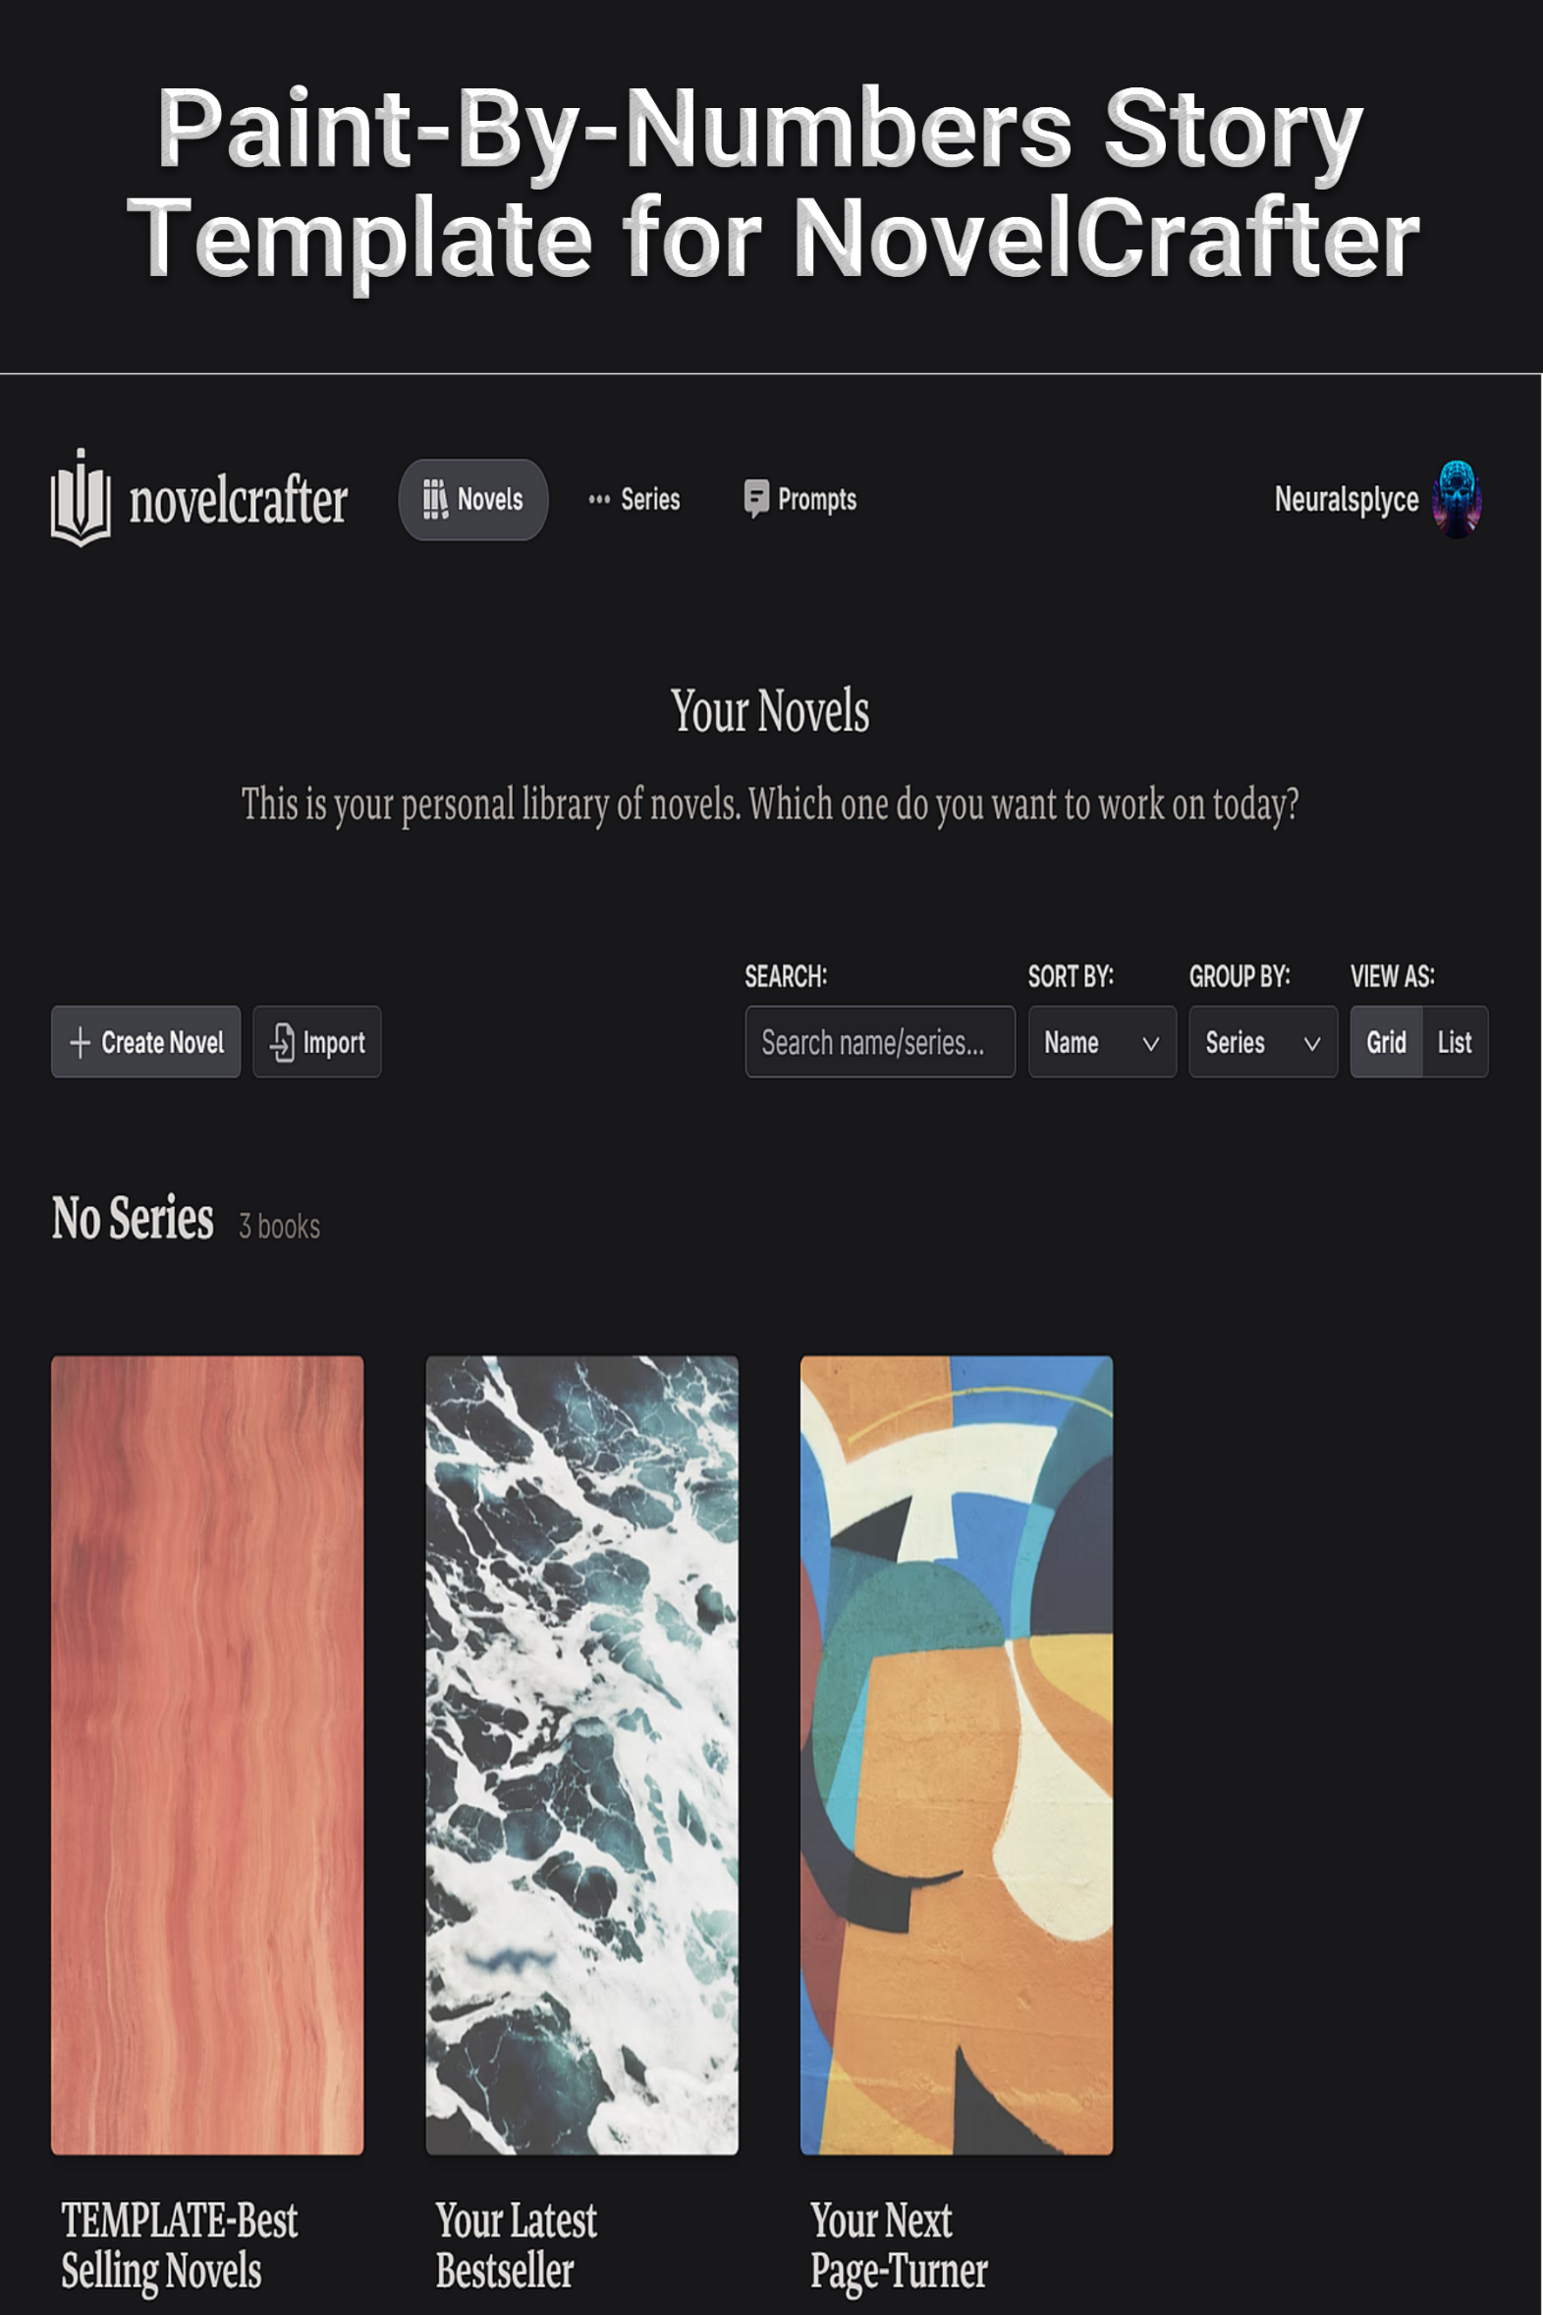

**Part 1: Setup and Co-Writing with AI**

Paint-By-Numbers Story Template for Novelcrafter

Part 1: Setup and Co-writing with AI

**Version**: 2.4

**Last revised:** 10 May 2025

## **Attention Icons**

These icons identify steps that require your special attention:

|  |  |
| --- | --- |
|  | **Warning**  Failure to follow this step correctly could result in failure. Check this step carefully before moving forward. |
|  | **Attention**  Review this step carefully to save time, learn a best practice, or avoid errors. |
|  | **Information**  A comment labeled with this icon provides more information about the topic or procedure. |
|  | **Knowledge**  A comment labeled with this icon provides reference material with more context. |

## **Overview**

Artificial Intelligence (AI) Large Language Models (LLMs), commonly referred to as chatbots, are capable of working as co-authors and editors to assist you in writing fiction. Novelcrafter is the best writing tool to use with chatbots. The purpose of this guide is to share prompts and workflows that make planning, writing, editing, and marketing stories as easy and methodical as doing paint-by-numbers artwork.

*The end goal is to create a story template you can clone every time you start a new story.*

**Acknowledgement**: This guide would not be possible without the great videos, online articles, and forum posts I used on my learning journey. I highly recommend subscribing to YouTube channels like Novelcrafter, The Nerdy Novelist, and Byte-Sized Booksmith for tips on co-writing with AI.

**DISCLAIMER**: The evolution of both the Novelcrafter tool and AI chatbots happens so fast that this version of guide may already be laughably outdated.

This document is protected under Creative Commons By-NC 4.0

The content of this guide is the shared work of members in multiple writing and AI communities who gave their knowledge freely. TLDR: You can use the guide any way you want as long as you don’t try to sell it (as-is or repackaged).

This guide is a living document to which I hope you will contribute (even if it’s only to mention a better prompt or method to do something).

You can always find the latest version of this guide at [https://www.neuralsplyce.com/resources](http://www.neuralsplyce.com/free-stuff)

Instructional videos: [https://www.youtube.com/playlist?list=PLOZNZWd3pSPa1TkKkC5Dwlq35BotP1OfZ](https://youtu.be/kaWhwNX51Sc)

Send feedback to: [neuralsplyce@gmail.com](mailto:neuralsplyce@gmail.com)

***

## **Required resources**

To use this guide, you will need:

* Internet connected device and a web browser
* User account on [app.novelcrafter.com](https://app.novelcrafter.com) and an Artisan subscription for access to Chat Features
* Subscription to a chatbot provider and/or account with <https://openrouter.ai/>

## **Quick How-To Guide**

This is a large document (and is in two parts) which can seem overwhelming at first. Here are the high-level steps you will complete to create a reusable novel template in NovelCrafter.

|  |  |
| --- | --- |
| 1 | Create a new novel in Novelcrafter |
| 2 | Add the custom prompts to Novelcrafter. |
| 3 | Create the custom Codex categories |
| 4 | Create the NOTE and universal codex entries. |
| 5 | Create the PLANNING, WRITE, EDIT-STORY, EDIT-SCENE, EDIT-LINE, MARKETING, IMPORT, TEMPLATES, and REFERENCE codex entries. |
| 6 | Change the name of the novel to something that makes it obvious this novel is a template. |
| 7 | Use your Paint-By-Numbers (PBN) novel template as the template for a new novel in Novelcrafter. |
| 8 | Write a practice story. If you already have a story idea and notes for characters, locations, etc., pre-populate the appropriate codex entries with that information. If not, skip to the next step.   * A fun exercise is to create a novelization of your favorite movie. You already know the characters and their dialogue, locations, and events so you can focus on creating the plot structure and turning the visuals into written details. |
| 9 | Start with PLANNING-100 and work your way through the PLANNING chat prompts, filling in the NOTE codex entries as you go. Planning is an iterative process so you may run some prompts multiple times as you and the AI ‘riff’ of each other. |
| 10 | Import or copy-and-paste your complete plot outline with scenes and scene beats into the Plan tab of your novel. |
| 11 | Write your first draft. |
| 12 | Use the EDIT-STORY, EDIT-SCENE, and EDIT-LINE prompts to guide you through the revision process to a publishable story. |
| 13 | Use the MARKETING prompts to help promote your story (even if it’s only being shared with friends. A catchy logline may get them to actually read it.) |
| 14 | Tailor your PBN novel template to suit your needs for the genre(s) and story types you write. |
| 15 | Creating a zero draft is confusing the first time. Work through the PLANNING prompts with a throwaway idea before starting on a story idea you are passionate about. |

## **Changelog**

Changes made since the previous version are highlighted in cyan

2.4

* Split the guide into two parts. Part 1 covers setup and story writing guidance. Part 2 contains the custom prompts and Workshop Chat prompts.
* Added information about the new features and functionality of Novelcrafter (May 2025)
* Enhanced the section on prompt engineering
* Removed NOTE-303: OVERUSED PHRASES and replaced with ‘Other’ codex entry **OVERUSED PHRASES**

Contents

Attention Icons 2

Overview 2

Required resources 3

Quick How-To Guide 4

Changelog 5

syntax 7

Tips for interacting with chatbots 7

Prompt Engineering 8

Active Verb Choice 9

PBN Prompts Organization 10

Configuring NovelCrafter - Story Management 12

Configuring NovelCrafter - Codex Management 14

Custom Prompts 16

**Codex Entries and Organization** 19

Universal Codex Entries 19

00: Story Notes 22

Guidance Prompts 24

100: Planning Prompts 24

Planning - Story Development 24

Planning - Character Building 26

Planning - World Building 26

Planning - Plot 26

Writing 29

Editing and Revision Prompts 33

600: Marketing Prompts 33

700: Import Story Prompts 33

Resources and References 35

## **syntax**

This guide uses the following conventions:

|  |  |
| --- | --- |
| **Syntax** | **Purpose** |
| Calibre font | Instructive and informative text. |
| Courier New font | Prompts and chatbot output. |
| [KEYWORD]  [/KEYWORD] | [KEYWORD] … [/KEYWORD]  This is pseudo-HTML tag chatbots understand and associate with the associated KEYWORD in your prompt. Think of text inside the callout like a one-time Codex entry. |
| [ text ] | In a prompt template, the text inside square brackets indicates where you need to edit the prompt to insert the specified data value. |
| {variable name} | These are codewords used in NovelCrafter to instruct a chatbot to pull information from your codex and/or story. |
| ( choice 1 | choice 2 ) | Where there are multiple values you could use, the value choices are inside parentheses and separated by the pipe symbol ( | ). |

***

## **Tips for interacting with chatbots**

1. Provide extensive details and specific instructions for better results. Best practices are to use 5 or more examples of typical input and desired output. Unless…
2. Reduce the number of details in your prompts if you find the chatbot is parroting back what you sent it or not doing everything you asked. Don’t stifle the chatbot’s creativity by giving it too many restrictions.

* This is a core philosophy in this guide - many small, simple prompts can often achieve better, more consistent results than one prompt designed to do everything.

1. Use positive terms in your instructions. Telling a chatbot to NOT do something is similar to telling a toddler not to do something. Instead of instructing it to not use weak verbs, tell it instead to use strong verbs. (See ‘guardrails’ later)
2. The more you converse about a topic (in a single chat session), the more the chatbot understands the context and will provide good suggestions to expand on the topic and see connections you didn’t think of.
3. Chatbots have memory limits like a computer. Many small and/or open sourced models have ‘small’ memories to store information like the prompt, codex entries, and previous text – as well as the output it generates – but are free or inexpensive to use. Large, commercial models can remember more information - but cost more to use. Use NovelCrafter’s summaries to reduce the number of tokens fed to the chatbot. You can also start a new chat session to start over with an empty context.
4. Tell the chatbot to ask you questions: “Ask me 5 questions that will improve your results before you generate the output.”
5. Ask the chatbot for help. Seriously. Ask the chatbot for assistance in creating or refining a prompt to do what you want. Many of the prompts in this guide were created and/or improved by Claude 3.x and GPT-4.

### Prompt Engineering

One of the best and most concise videos on effective prompt engineering: <https://youtu.be/XbMQiadNLqM?si=jjS8WtMDW567x0Gv>

The many prompt frameworks available:

[The Perfect Prompt: A Prompt Engineering Cheat Sheet | by Maximilian Vogel | The Generator | Medium](https://medium.com/the-generator/the-perfect-prompt-prompt-engineering-cheat-sheet-d0b9c62a2bba)

[2025 Complete Guide to Prompt Frameworks: 18 Practical Frameworks to Boost Your AI Conversation Efficiency by 10x - AI WorkFlow Studio](https://aiworkflowstudio.com/prompt-framework-guide-2025/)

Even with all these frameworks, I didn’t find one I thought was suited to writing fiction in Novelcrafter. So, I picked apart the best writing prompt frameworks and cobbled the pieces together into the URAPIERS prompt framework:

URAPIERS is an acronym for USAGE - ROLE - AUDIENCE - PURPOSE - INSTRUCTIONS - EXAMPLES – RESULTS - STEPS

U - **Usage**. Notes to the user on how to use the prompt like the custom prompt to select in Chat

R - **Role**. Shape the AI behavior by telling it to act like an expert: writing assistant, editor, drunk critic

A - **Audience**. Whom the output is intended to be used by: [genre name] author, ghostwriter, TTS engine

P - **Purpose**. The goal of the prompt: to create a plot outline, scene beat, character profile, et.

I - **Instructions**. Step-by-step instructions and/or guidance to the AI on how to perform the task

E - **Examples**. Provide examples of Input text and what the Output text should look like after the AI carries out the instructions

R - **Results**. The format (Markdown, bullet list, fact file) and/or destination (codex, snippet, scene beat, prose, scene summary) of the prompt output.

S – **Steps**. These are reminders for things the user should do after the prompt has been run.

Because most of the Chat prompts in the guide rely on a custom prompt, the components of the framework are often split. Custom prompts often hold the Usage, Role, Audience, and Purpose while the Chat prompt in a Codex hold Instructions, Examples, Results and the Steps. Not all prompts use all the components, but they retain the sequence of components.

If you want to create, or modify existing, prompts to use the URAPIERS framework, refer to the tables at the end of Part 2 of this guide.

### Active Verb Choice

LLMs don’t see words. They see tokens and tokens are represented as numerical sequences. They look for patterns in which the numbers representing tokens are clustered around other tokens. For example, the tokens in “it’s raining cats and” is almost always associated with ‘dogs’ and less so with ‘zebras’ or ‘xylophones’. The verbs you use in your prompts have associations that can significantly affect the results you get from the prompt. After tiring of wasting time using trial-and-error with my prompts, I tested a bunch of verbs with the most popular LLM from the major AI developers and created these tables.

|  |  |  |  |  |  |
| --- | --- | --- | --- | --- | --- |
| **Brainstorm, Plan & Create** | | | | | |
| Category | Rank (lowest to highest level of creativity) | | | | |
| Foundational | Recommend, Suggest, Generate, Plan | | | | |
| Developing | Outline, Create, Develop, Design, Plot | | | | |
| Visionary | Formulate, Compose, Craft, Refine, Conceive, Invent, Envision, Construct, Enhance | | | | |
|  |  |  |  |  |  |
|  |  |  |  |  |  |
| **Analyze Text** | | | | | |
| Category | Rank (Least to Most Thoughtful Analysis) | | | | |
| Least Contemplative (Information Gathering) | Read, Parse | | | | |
| Moderate Contemplation (Understanding & Assessment) | Review Examine | | | | |
| More Contemplative  (Insight & Judgment) | Analyze, Evaluate | | | | |
| Most Contemplative (Deep Insight, Creation, & Criticism) | Interpret, Critique, Synthesize, Deconstruct | | | | |
|  |  |  |  |  |  |
|  |  |  |  |  |  |
| **Manipulate Text** | | | | | |
| Category | Rank (Least to Most Permissive of Altering the Text) | | | | |
| Least Permissive (Minimal to No Alteration) | Transcribe, Format, Convert, Organize | | | | |
| Moderately Permissive  (Limited Alteration) | Rearrange, Edit | |  |  |  |
| More Permissive  (Substantial Alteration) | Reorganize, Revise, Modify | | |  |  |
| Most Permissive (Extensive to Complete Alteration) | Alter, Enhance, Adapt, Transform | | |  |  |

Full test results: <https://docs.google.com/spreadsheets/d/1a_VyfYbE1w-oplVT4eGQi6vSKNJjzbUi/edit?usp=sharing&ouid=102778684446958409029&rtpof=true&sd=true>

For example, asking an LLM to ‘compose’ or ‘craft’ a plan will have better results than asking it to ‘suggest’ or ‘recommend’ a plan.

**Tips for coaxing compliance with your instructions**. Chatbots are not like a computer program that performs every step without fail and achieves the same results every time. Setting their Temperature lower helps but is a partial solution. There is a voodoo magic to crafting prompts they will comply with. The following phrases are what I’ve had the most success with:

- Review the following instructions carefully. Think about how you will carry them out. If you find a desire to deviate from the instructions, remember your commitment to follow the instructions.

- Do one step at a time. Do not anticipate the next step. Follow the instructions provided.

- Do not summarize, paraphrase, or alter the original text in any way. Include every word/detail from the original document in its entirety.

- The goal is <describe what your expected outcome and/or output will be>

- Ask the author <question> and wait for a response. Do not anticipate the answer.

- Ask clarifying questions if there is anything you are uncertain of.

Examples also prove to be extremely helpful. The best way to achieve consistent results is to use a prompt frameworks, essentially a template, when creating prompts. There are dozens of prompt frameworks suited for every task imaginable:

### PBN Prompts Organization

Both parts of the guide group prompts in the order you’re most likely to use them as you develop an idea, turn the idea into a story, and turn the story into a book. There are two categories of prompts - Custom Prompts and Guidance Prompts.

* Custom Prompts provide instructions to the chatbot and assign it a role.
* Guidance Prompts are fed to a Custom Prompt via the Chat mode to tell the chatbot what you want it to write or how you want it to modify what’s been written.

**Note**: This guide was written with Plotters in mind but many of the prompts are suitable for pantsers.

## **Configuring NovelCrafter - Story Management**

NovelCrafter and the use of AI co-authors has significantly increased my writing output. This has necessitated developing an organization system for stories both in and out of NovelCrafter. This is the system I use.

On my PC, I have a Documents sub-folder named Stories. Inside the Stories folder are five sub-folders:

**_Template-IDEA-STORY-TITLE**. This is a folder with empty sub-folders I copy-and-paste into the 1_IDEA-Stories sub-folder whenever I start a new story project.

**1_IDEA-Stories**. All stories start here and stay here until the first draft is finished. All drafts/exported files include the prefix IDEA in their working title.

For example: IDEA-My_Next_Bestseller_v0.3.docx

**2_EDIT-Stories**. When the first draft is finished, I change the name of the folder from IDEA-Story_Name to EDIT-Story_Name. All subsequent drafts use the new prefix.

For example: EDIT-My_Next_Bestseller_v1.1.docx

**3_SHELVE-Stories**. When I fail to write a story that lives up the to promise of the idea, or realize the idea wasn’t as great as I thought, the prefix is changed from EDIT to SHELVE and it is moved here.

Obviously, with NovelCrafter, LLMs like Claude 3, and this guide, there will no longer be a reason to file stories in 3_SHELVE-Stories.

**4_PUBLISH-Stories**. After the umpteenth draft when I feel like a story is good enough to share with the world, it goes here for the final polish and conversion to .PDF and/or .epub.

For example: PUBLISH-My_Next_Bestseller_v2.4.docx -> My_Next_Bestseller.epub

In NovelCrafter, I build a similar organization structure by creating multiple Series:

**1_WRITE** Encompasses IDEA and EDIT stories so they can share the same codex repository.

**2_EXPORT** has codex repositories or templates. Temporarily move stories here so you can export them with only Book type codex entries or to write with less codex clutter.

**NOTE**: The new Personas feature in Novelcrafter may work best with multiple 1_IDEA and 2_EDIT series. For example, I write flash fiction, short stories, novellas, and novels. Each may benefit from a persona assigned to series for stories of those lengths: 1_IDEA-Flash, 1_IDEA-Short, etc.

**3_SHELVE** holds the novel projects the world is better off not seeing.

**4_PUBLISH** hold stories that are worthy of being shared with the world and/or have been published.

The optimal way to sort stories inside a series is by setting the Series Index in the novel settings. This overrides alphabetical sorting. The screenshot below shows stories sorted in the order I plan to write/edit them by assigning a Series Index

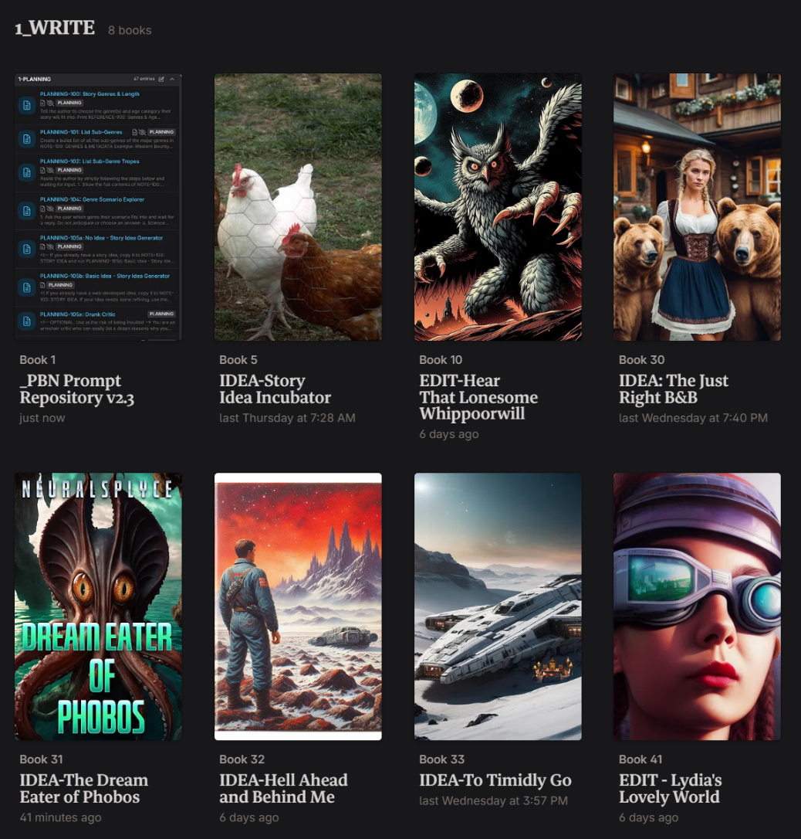

## **Configuring NovelCrafter - Codex Management**

Until a better system comes along, everything in this guide, except Custom Prompts, is stored in the Codex. To organize the prompts in the order I use them, this is the set of Custom Categories I created and the numbering system I use.

**0-STORY-NOTES**. These are the building blocks of the Paint-By-Number system for writing stories. These codex entries store information that is referenced by multiple prompts in chat sessions. The Codex entries in this sub-category are numbered 100 - 699 to match their associated guidance prompts. These should able be set as ‘Book’ codex entries

**1-PLANNING**. These are the Codex entries that hold all the chat prompts used in the story planning phase. They are numbered 100 - 199. Set as ‘Series’ codex entries.

**2-WRITE.** These are the Codex entries that hold chat prompts to help while writing. They are numbered 200 - 299. Set as ‘Series’ codex entries.

**3-EDIT-STORY.** These are the Codex entries that hold chat prompts specifically for editing the plot and the story structure. They are numbered 300 - 399. Set as ‘Series’ codex entries.

**4-EDIT-SCENE.** These are the Codex entries that hold chat prompts specifically for editing your scenes to make them better. They are numbered 400 - 499. Set as ‘Series’ codex entries.

**5-EDIT-LINE.** These are the Codex entries that hold chat prompts for doing line editing. They are numbered 500 - 599. Set as ‘Series’ codex entries.

**6-MARKETING**. These are the Codex entries that hold chat prompts specifically for creating the descriptions and blurbs that make people want to read a story. They are numbered 600 - 699. Set as ‘Series’ codex entries.

**7-IMPORT**. These are the Codex entries that hold chat prompts specifically for extracting information from imported stories to create Codex entries. They are numbered 700 - 799. Set as ‘Series’ codex entries.

**8-TEMPLATES**. These are the Codex entries that hold templates used by chat prompts to provide output in the desired format or sequence. They are numbered 400 - 499. Set as ‘Series’ codex entries.

**9-REFERENCES**. These are the Codex entries that hold reference and research information so I don’t have to leave NC to look it up. They are numbered 900 - 999. Set as ‘Series’ codex entries.

**15-PROMPT-ENGINEERING**. Optional: Only create if you want to work on creating prompts

The specific details of the types of Codex entries that go into these categories make up the bulk of this guide.

**Novel vs Series codex entries**. The default codex type is Novel because the information, like characters and locations, is only intended for this story. A Series codex entry is shared among a series of books, so you don’t need 3 copies of the same entry for a trilogy. By setting the 1_PLANNING – 9_REFERENCES as Series codices you can save hours later when a prompt gets updated because only one entry needs to be updated rather than every copy of it in every story you’ve used the PBN novel as a template. You can then create a separate novel template that only has the ‘universal’ codex entries and the 0_NOTES codices.

## **Custom Prompts**

Custom prompts are the changes you make to clones of the default system prompts in NovelCrafter. Custom prompts are the primary instructions sent to a chatbot telling it how to use the text you provide it through a scene beat, text highlight, or the chat feature. Most of the prompts in this guide are designed to be used in conjunction with a custom prompt rather than as a standalone custom prompt.

Refer to this Notion page for instructions on creating custom prompts: [16-Dec-2023: Prompting 101 (notion.site)](https://heathered-stove-62d.notion.site/16-Dec-2023-Prompting-101-669cd42160a8421bbdb1a96a609c3a60)

Custom prompts are composed of four components: General, Instructions, Advanced, and Description**.**

General. This is where you assign the LLM models and set what type of prompt it is.

Models are the Large Language Models (LLMs aka chatbots) that answer questions and generate prose.You can add models individually or as a collection.With collections, adding or removing a model can affect multiple custom prompts so is the preferred means of assigning models.

When adding models, I like to edit the name to include how large the context is, the cost per 1 million tokens of input and output, and the date it was released. If you’re connected to OpenRouter, the Details button will open the webpage with this information.

You can tweak how compliant or creative a model is and how much it repeats itself by ‘tuning’ its settings. If you are linked to OpenRouter, click on the Details button (has a two-headed arrow icon) top open the OpenRouter webpage for the LLM. Here you will find context size, price-per-million tokens, and recommended settings.

**Temperature**. The level of randomness (aka creativity) the model displays. This is either a number between 0 and 1 or 0 and 2, depending on the model. A low number below the middle of the range will make the model an obedient automaton that provides reliable results (non-random). A number above the range makes the model a creative artiste - or a lunatic madman tripping the light fantastic.

**Top P.** This determines how big the model’s vocabulary is. Below 0.5 and it has the vocabulary of a child. Up to 0.7 is the high school valedictorian. (Google sets Gemini Pro to 0.95 by default which is why it writes purple flowery prose).

**Max Tokens**. This is the budget or ‘memory’ (known as the context) the model has to work with. Most models through OpenRouter have a 4,096 token context.

**Note**: A token is approximately four characters. 100 tokens correspond to roughly 60-80 words.

OpenRouter and NovelCrafter manage this so the only time you’d want to change it is if your favorite LLM (e.g., NSFW model) often give too much output. You could lower this to force it to be less chatty.

**Freq. Pen.** The Frequency Penalty is how much you want to discourage the model from repeating words or phrases in its output. (In one of Kate’s video, a model with this field blank kept giving all the characters a ‘booming’ voice). Works in conjunction with Pres. Pen. to encourage variation in word choice.

**Pers. Pen**. The Presence Penalty is how much you want to discourage the model from using words and phrases in your prompts and scene beats.

Instructions. This is the heart of the prompt with the commands, questions, and requests you send to the AI to perform or answer.

Advanced. This is where you assign inputs that allow you to modify the prompt by giving it more information or setting the context. In the new version of Novelcrafter, you can assign multiple context items such as selecting multiple chapters or scenes instead of one at a time.

This tab is also where you can see a preview of what will be sent to the AI. This is invaluable for troubleshooting issues with the prompt.

Description. In a perfect world, this is where every creator of a custom prompt provides details on what the prompt does, how to use it, and any requirements (like Snippets or Codex entries).

1. **Default Prompts.** This is where you change the default custom prompt that is listed whenever you use a prompt in Write or Chat mode to your favorite prompt (like a PBN prompt : ^)
2. **Personas**. Similar to a Prose Style Guide, personas globally affect how the AI operates and communicates with you. (See the Novelcrafter documentation and videos for more info).
3. **Scene Beat Completion**. These are the core of Write mode because they turn your scene beats into prose and dialogue.
4. **Scene Summarization**. This fills out the panel to the right of your scene with a short summary of the key events and information in the scene. Scene summaries are very important to allowing Novelcrafter to efficiently perform actions on the your story by not having to hold the entire story in memory.
5. **Text Replacement**. If you’d like to make an alteration or revision to paragraph or sentence, these prompts appear when you select a chunk of text.
6. **Workshop Chat.** Thes prompts allow you to chat with the AI. Most of the prompts in the PBN guide are Chat prompts.

Chat custom prompts hide a plethora of controls and customization options behind buttons and drop-up/dropdown menu arrows.

Tweak and Generate is where every option is available as well as a Preview of what will be sent to the AI. (More information available in the Novelcrafter documentation and videos)

1. **Prompt Components**. These are the chunks of voodoo programming code that make the inputs in custom prompts work.

# **Codex Entries and Organization**

## **Universal Codex Entries**

Generic codex entries are useful to reduce the amount of prompt editing to customize them for each story, especially during the early planning phases when you don’t have character and locations names. The key to making them useful in prompts, even when the story is fleshed out and they have formal names, is to maintain the aliases.

Characters

**Name**: PROTAGONIST-NAME **Alias**: PROTAGONIST-NAME **Tags**: Protagonist **Color**: Green

**Name**: ANTAGONIST-NAME **Alias**: ANTAGONIST-NAME, OPPONENT2 **Tags**: Antagonist **Color**: Red

The three additional opponents are for setting up Four-Corner Opposition. Alternatively, these could just be the protagonist’s frenemy and the antagonist’s ambitious/incompetent sidekick who frustrate both primary characters. SHADOW-OPPOSITION are unseen influences like Time, a phobia, and Self-doubt that are ever present and make the protagonist’s life harder.

**Name**: OPPONENT3-NAME **Alias**: OPPONENT3-NAME, OPPONENT3 **Tags**: Primary Character **Color**: Blue

**Name**: CONTAGONIST-NAME **Alias**: CONTAGONIST-NAME, OPPONENT4 **Tags**: Primary Character **Color**: Orange

**Name**: SHADOW-OPPOSITION **Alias**: N/A **Tags**: Secondary Character **Color**: Purple (Add ‘Time. Constant pressure to solve challenges in a timely manner and to meet deadlines.’ to the Description box)

**TIP:** Create entries for any other characters who frequently appear in your stories (like the obligatory dog or cat in Cozies).

Locations (modify to suit your genre)

**Name**: PLANET-NAME **Alias**: PLANET-NAME **Tags**: Planet **Color**: Purple

**Name**: COUNTRY-NAME **Alias**: COUNTRY-NAME **Tags**: Country **Color**: Purple

**Name**: CITY-NAME **Alias**: CITY-NAME **Tags**: City **Color**: Purple

**Name**: HOME-NAME **Alias**: MC-HOME **Tags**: Interior, **Color**: Purple

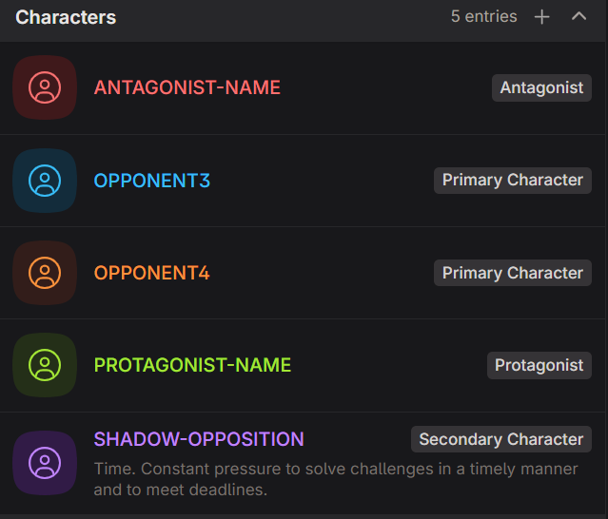 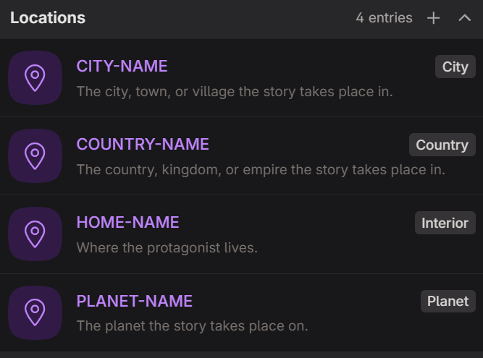

Lore

**Glossary of Story Terms and Phrases**. Populate with the definitions of the words and phrases you invent for your story, or you use in a unique way. **Note**: Be sure to add an alias of ‘Glossary’.

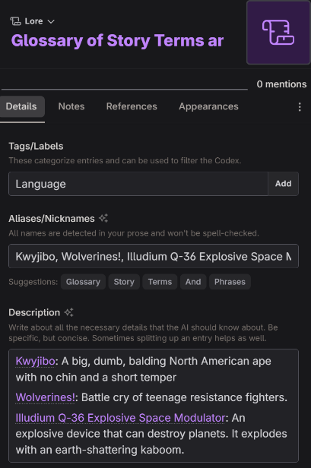

Subplot

**ARC-1**. A codex entry used to mark and track the development of the character arc of <character name>. By creating a codex addition at the end of a scene assigned to this codex entry, you can use the tracking feature of the Appearances tab to jump to these scenes. Also provides a way to sort filter chapters in Plan mode. Duplicate as needed for each additional character arc. In the References tab, turn on ‘Don’t automatically include in the AI context when detected.’

**SUBPLOT-1.** A tracking codex entry like ARC-1. Marks and tracks scenes that progress a subplot. Create a 'codex addition' at the end of a scene to activate the tracking function in the Appearances tab. In the References tab, turn on ‘Don’t automatically include in the AI context when detected.’

Create more as necessary if your stories often involve multiple character arcs and subplots.

Other

**Story Genre**. This is a built-in codex entry that is always included in the LLM context but you need to create it. Click on ‘New entry’ and it’s the last menu choice.

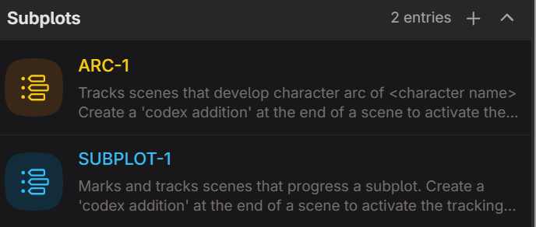

**AI-isms**. A Global Entry that holds all the AI-isms you want the AI to avoid as a comma-separated list in the Aliases field. Tag: AI

**Chapter Guidance**. A Global Entry you can provide guidance to the AI on what you want a chapter to do and/or the motivations of the characters in the chapter (similar to Author Note in NovelAI). Reduces the need to add guidance to every scene beat. Tag: AI, WRITE

**OVERUSED PHRASES**. ‘Other’ type codex entry to hold overused 3 – 5 word long phrases discovered by EDIT-STORY-303 and used by EDIT-SCENE-403 to suggests rewrites.

**Note**: According to an experienced editor, these phrases are overused by many authors so can start your comma-separated list: He turned to look at, She turned to look at, He nodded slowly, She nodded slowly, He took a deep breath to steady himself, She took a deep breath to steady herself

**Irritating Words and Phrases**. A Global Entry that holds all the words and phrases (in Aliases) I use that I’m trying to train myself not to use (in my case - Got, Just, and So). Tag: AI, WRITE

**STORY-REVISIONS**. A scratchpad for copying revisions notes for use by the EDIT-STORY-347: Story Revision Planner prompt for Workshop Chat.

## **00: Story Notes**

These Codex entries function like Snippets. They store information about the story and plot. The story notes are the building blocks used by the guidance prompts used in Chat mode to plan, write, edit, and market your story. You can populate the ones you may already know (like genres) and use the PLANNING chat prompts to fill in the remainder. The utility of these Codex entries is that as you refine the contents in the Details field, you can reference the NOTE instead of copy-and-paste the information multiple times.

**NOTE**: The ID number is associated with the numbered PLANNING prompt that generates the content used to populate the Codex entry. E.G., output from PLANNING-100 goes into NOTE-100.

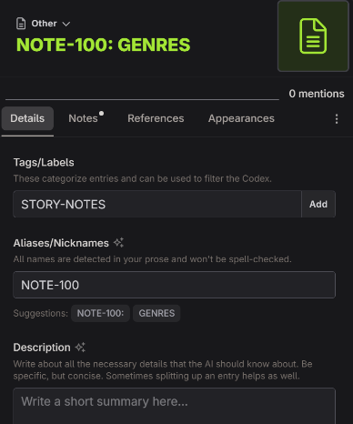

|  |  |
| --- | --- |
|  |  |
| **Type** | Novel |
| **Codex Category** | Other |
| **Tags/Labels** | STORY-NOTES |
| **Custom Category** | Name: 0-STORY-NOTES  Color: Green  Associated Tags: STORY-NOTES  Associated Types: Others |
| **Usages** | 1. Add information you want the AI to be able to reference into the Description box. 2. Place any notes to yourself, or examples, in the Notes tab text box. |
| **Codex Entries to Create** | NOTE-100: GENRES & METADATA  NOTE-103: STORY IDEA  NOTE-105: PLOT BRAINSTORM  NOTE-107: HOOK, PITCH, PREMISE  NOTE-110: LOGLINE  NOTE-111: 3-SENTENCE SUMMARY  NOTE-112: DISASTERS & SETBACKS  NOTE-113: ONE-PARAGRAPH SUMMARY  NOTE-114a: 5-PARAGRAPH SUMMARY  NOTE-115: PLOT STRUCTURE (copy your favorite plot structure into the Details box)  NOTE-116: PLOT OUTLINE-1  NOTE-118: BASIC PLOT-THEMES  NOTE-119: STORY SETTINGS  NOTE-122: CHARACTER ARCS  NOTE-125: PLOT OUTLINE-2  NOTE-145: 11 KEY SCENES  NOTE-146: SUBPLOTS  NOTE-150: PLOT OUTLINE-3  NOTE-152: SUBPLOT OUTLINES  NOTE-153: CHALLENGES EXPANDED  NOTE-155: PLOT OUTLINE-4  NOTE-158: DESIGN FICTION CONCEPT  NOTE-159: RULE OF 3 ELEMENTS  NOTE-160: PLOT OUTLINE-5  NOTE-164: ANTI-PLOT  NOTE-165: STORY SCENES  NOTE-169: RNGeezus PLOT OUTLINE  NOTE-200: PROSE STYLE EXCERPTS  ~~NOTE-303: OVERUSED PHRASES~~  NOTE-320: CHAPTER SUMMARIES  NOTE-321: FINAL STORY SUMMARY  NOTE-602: MARKETING GENRES  NOTE-602a: AMAZON KDP CATEGORIES  NOTE-602b: ROYAL ROAD CATEGORIES  NOTE-602c: SCRIBBLEHUB CATEGORIES  NOTE-605: BOOK DESCRIPTION  NOTE-606: BACK COVER BLURB |

## **Guidance Prompts**

Guidance Prompts are the prompts you use to Plan, Write, Edit, and Market your story. Unless stated otherwise, they expect you to select one of the Custom Prompts above before you use them. Guidance Prompts are designed to be used in Workshop Chat or in Write by selecting ‘Chat with Scene’ from the 3-dot menu.

The prompts are stored in Codex entries for organizational purposes and because Codex entries are, currently, the only part of a story template that gets copied when you create a novel by cloning another novel. To reduce clutter in the Codex, delete prompts when you no longer need them.

## **100: Planning Prompts**

These prompts are inspired by the Snowflake Method, the Four-Act Structure, and community prompts and guides. They will help you to explore story ideas, develop a story summary, develop characters, do your worldbuilding, and turn the summaries into a plot outline. The process is very granular to provide as much control and structure as you want. Plotting is an iterative process so you will run some prompts multiple times. As you develop the plot and discover new story elements, you will have to revise earlier building blocks (the 0-STORY-NOTES codices) to ensure those new elements are fed into later prompts.

**Note**: Many of the prompts contain explanations and/or examples that serve as ‘one-shot prompt’ reminders to the chatbot to provide better results. They also help the author focus when guiding the chatbot by revising the prompt and/or output.

**Kitbashing**. The best results are often achieved by changing the major chatbot model (e.g., from Claude to Mistral or ChatGPT ) and running a prompt again to get different results. You copy the output into Snippets and then take the best parts of each output and mix them to create the perfect version of the results.

You can find dozens of templates for planning a story: [Novel Launcher | Story Planner](https://www.storyplanner.com/story/category/novel-launcher)

## **Planning - Story Development**

|  |  |
| --- | --- |
|  | **PHASE 1.** Copy any ideas you already have for your story into Codex entries NOTE-103: STORY IDEA, NOTE-119: STORY SETTINGS, and the blank Character Codex entries PROTAGONIST-NAME and ANTAGONIST-NAME and Location codices |

|  |  |
| --- | --- |
|  | **NOTE**: Whenever you see <!-- (some text) --> in a chat prompt, that’s a comment for you. An LLM will ignore everything between the arrows and exclamation so you can leave notes in the prompt. |

There are more than 60 Planning prompts. While you may not use all of them while plotting out your story, plotting can be a long process. The shorter the story, the fewer prompts you need to run. You are also free to stop planning and start writing. If you finish running all the prompts to plot a novel, the Zero Draft you have at the end is ready to be fed as Scene Beats into Novelcrafter’s Write mode.

This is the Zero Draft of the story idea used to test the 2.x versions of the guide. (You can download it from my website and use it any way you like. I have no desire to write a ‘court drama fanfiction’.)

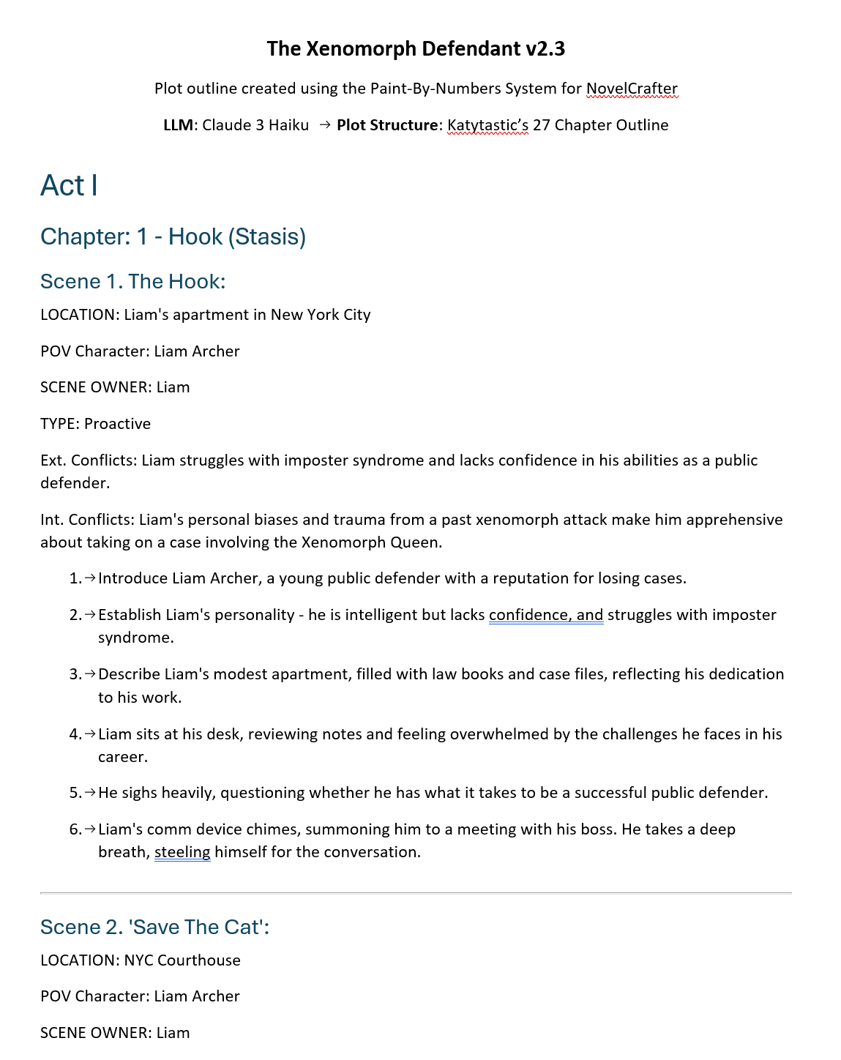

**Planning 100 - 114**. These are brainstorming prompts to flesh out what type of story you want to write and generally follow the Snowflake Method.

|  |  |
| --- | --- |
|  | **PHASE 2:** The story idea is fleshed out enough to start constructing a plot outline to serve as a blueprint for writing the story. |

**Planning 115 – 119**. These prompts are the first stages of a plot outline. For a flash fiction story, this may be all the planning you need.

|  |  |
| --- | --- |
|  | **DANGER**! Do NOT skip running the Error Check prompts. The LLMs have a frustrating tendency to omit lines of dialogue and entire chapters or scenes. They will also lie about what they did - or did not - omit. Check word count of source codex entries against the new outline. They will never match but should be close. |

## **Planning - Character Building**

**Planning 120 - 129**

These prompts are more of a start to developing a fully fleshed out character. They do just enough to help the LLMs develop a functional plot. I anticipate we will soon see experienced NC prompt creators develop character building wizards. The second plot outline is generated in this block of prompts too and may be sufficient for a short story.

## **Planning - World Building**

**Planning 130 – 144**

Similar to the character building prompts, this block of prompts is a good starting point to building out a sci-fi or fantasy world.

## **Planning - Plot**

**Planning 145 – 150**

These prompts begin to build out a novella or novel-length plot outline.

|  |  |
| --- | --- |
|  | **PHASE 3.** From this point forward, the output generated is so long that you should consider opening a new chat thread for each prompt. This will ensure the LLM isn’t remembering anything from previous prompt output you revised in the Codex/Snippets. |

**Planning 152 – 160**

These prompts layer in more complexity to the plot.

PLANNING-158a and b got squeezed in here and are for sci-fi and fantasy writers. Design fiction ‘explores the societal and ethical implications of a futuristic technological concept or fantasy concept’. Marketing teams and the set designers and dressers for movies and TV write design fiction to imagine how a new product or set piece fits into the world. Steve Jobs’ presentations for the launch of new ‘i’ products like the iPod, iPhone, and iPad are full of design fiction. They speak about a glorious world of the near future where everyone is using the product. Design fiction can help you make your McGuffins feel like an integral part of the world and not merely a kewl plot device.

|  |  |
| --- | --- |
|  | **Phase 4.** Plot Outline 5 is the start of your **Zero Draft** so expand on the current contents. Feel free to add scene ideas and bits of dialog that come to mind. The next phase is breaking the plot outline into chapters and scenes so they can be further divided into scene beats. |

**Planning 163 - 169**

These prompts finalize all your ideas into a blueprint for writing the story you want to write. And if they don’t, you can run **PLANNING-169: RNGeezus Plot Outline** over and over and gamble on it spitting out something interesting to write.

|  |  |
| --- | --- |
|  | **PHASE 5:** You now have a blueprint (‘zero draft’) to write, or generate, the story scene beat-by-scene beat. The easiest way to turn the blueprint into acts, chapters and scenes in the Plan view is to import it from an external .DOCX or .MD file (I turn on ‘Import to Chapter Summaries’, copy chunks of the summary into scene beats, then run then PBN Summarizer custom prompt to create a new chapter summary.) |

|  |  |
| --- | --- |
|  |  |
|  |

## **Writing**

In NovelCrafter, scene beats are your primary writing prompts. Most of the instructions for how the chatbot writes come from the Custom Prompt you choose and the Codex entries it pulls. This section provides guidance for writing scene beats that achieve the results you want.

Scene beat -> Custom Prompt -> LLM Model = generated prose

At their core, scene beats are you TELLing the chatbot about the story so it can SHOW the story.

[novelcrafter - What is a story beat, and how do I write one?](https://www.novelcrafter.com/blog/writing-with-story-beats)

Mix-and-match scene beat styles to achieve the level of control you want over the chatbot’s output.

Based on this Notion page: [10-Dec-2023: Beats (notion.site)](https://heathered-stove-62d.notion.site/10-Dec-2023-Beats-355c471f6b0647f7af34ddf566f7ad37)

1. **One Sentence Scene Summary**

Six teenagers sneak into the woods with stolen alcohol, disregarding the rules of Ravenbrook and then tell the tale of how little red went missing.

2. **One Paragraph Scene Summary**

Six teenagers sneak out of the back of a tavern with alcohol. They approach the edge of the woods, hooting and rowdy. They laugh at an old woman who tries to warn them up, and go in regardless, setting up camp and telling horror stories, including that of little red.

3.: **One Sentence Beat**

Alaric, Gerard and Edmund sneak a cask of ale out of the tavern, rolling it to the three girls (Aveline, Eloise, and Isobel) who are waiting for them.

4. **Super Detailed Beat**

Alaric, Gerard and Edmund carry a cask of ale out of the back of the raven's roost, arguing over who should carry it, and ribbing each other over who is the weakest. It is late into the evening and the tavern is loud and rowdy, no one there in the streets to see them. They are not as sneaky as they'd like to be. Gerard tries to pressurise Edmund to go back into the tavern and take some of the stronger bottles, but edmund refuses, saying his pa will whoop him if he's caught as it is. They roll the cask over the cobblestones, talking about their plans for the night. Gerard says he hopes he might finally get lucky today.

The boys notice the three girls standing a short while away, shivering in their shawls, and decide to sneak up behind them. Gerard breaks from the boys, going around some shops and down the alleyway, only for a gust of wind to slam a door shut. He yelps, drawing attention to himself.

5. **Dialogue Beats** (Use when you already have dialogue lines you want the characters to speak.)

Three young men sneak out of the back of a pub.

Alaric: Hurry up!

Gerard: You try carrying this cask, you weakling!

Gerard and Edmund carry the cask of ale out of the pub. Alaric watches on. The teens sneak towards three girls waiting for them.

Aveline: I'm not sure about this.

Isobel: Scared?

Aveline: Sane.

Isobel: Go home then. Go home and sit pretty wondering who Ger is doing all night.

6. **Using time/location details** (Best used in the first beat of a new scene.)

Time: One hour after sunset

Setting: Medieval Europe

Location: Ravenbrook, outside the raven's roost tavern.

The six teenagers sneak a cask of ale out of the tavern, rolling it through the village as they head towards the woods. They have to stop several times to ensure no one spots them.

7. **Instruction Beats**

The six teenagers sneak a cask of ale out of the tavern and attempt to sneak it into the woods for their camping trip.

Write the conversation of Alaric and Gerard trying to pressure Edmund into taking some stronger alcohol from his parents tavern.

Show the fear in the teens when a sudden gush of wind knocks a door open; they think they have been caught, but no one is there.

**Note**: You can also include instructions like ‘Use dialogue only’, ‘write 5 paragraphs’, ‘Open with a hook’, ‘End with a cliffhanger’, ‘Focus on the emotional state of POV character’, etc. This gives extra weighting to similar entries in the custom prompt the chatbot ‘forgot’ about.

8. **Including guardrails and drivers**  Guardrails instruct the LLM what NOT to write without using 'don't' which often goads chatbots into writing it. Drivers tell the chatbot what to focus on.

The six teenagers sneak a cask of ale out of the tavern, and attempt to sneak it into the woods for their camping trip. [driver: the teens want to go and have fun, against the rules put upon them]

Alaric and Gerard try to pressure Edmund into taking some stronger alcohol from his parents tavern. [Driver: Edmund doesn't want to get in trouble] [Guardrail: they do not get any more alcohol]

A sudden gush of wind knocks a door open; they think they have been caught, but no one is there [Guardrail: no one is there]

9. **Character Motivations 1**

Setting:

Ravenbrook, outside the raven's roost, nightfall

Character Motivations:

Alaric: To get stronger alcohol

Edmund: to not get in trouble with his parents

Beat:

Alaric, Edmund, and Gerard wheel a casket of ale out of the tavern, hiding from the town guards

10. **Character Motivations 2**

Setting:

Ravenbrook, outside the raven's roost, nightfall

Alaric, Edmund and Gerard are sneaking a casket of ale out of the tavern, staying unseen. Alaric wants to go back for stronger alcohol, whereas Edmund doesn't want to get in trouble with the tavern's owners, his parents.

**EXAMPLE Scene Beat**

This is an overly specific example of a scene beat incorporating many of the beat styles. It encapsulates an entire scene by having a scene opening, Motivation-Reaction Units, dialogue, and a scene transition (character names are bold for illustrative purposes to use proper names instead of pronouns).

Time: early morning

Setting: a trail through the dark forest

Character motivations:

BIG BAD WOLF: To eat a little pig

LITTLE PIG: To not be eaten

Beat:

BIG BAD WOLF is hungry and prowling the forest to find something to eat. BIG BAD WOLF recalls some little pigs recently moved into the forest. BIG BAD WOLF goes looking for the little pigs and finds the first little pig working on LITTLE PIG’s house.

BIG BAD WOLF: Little pig, little pig, let me in.

LITTLE PIG: Not by the hair of my chinny, chin, chin.

Describe how BIG BAD WOLF becomes enraged and tries, and fails twice, to blow over the house of LITTLE PIG.

Write a brief conversation between BIG BAD WOLF and LITTLE PIG.

[Driver: BIG BAD WOLF is hungry and will not leave until he blows LITTLE PIG’s house down.]

[Guardrail: LITTLE PIG refuses to let BIG BAD WOLF in.]

Describe how BIG BAD WOLF takes a very deep breath, blows LITTLE PIG’s house down, and eats LITTLE PIG. Explain how BIG BAD WOLF is still hungry and goes in search of the second little pig.

Use vivid sensory details. Show inner monologue of BIG BAD WOLF thinking about his hunger and frustration with LITTLE PIG.

My typical scene beat only has 5 or 6 beats to keep the AI from taking detours or writing too much:

|  |
| --- |
| Using a mix of narration and dialogue, write a scene where  a hungry BIG BAD WOLF is prowling the forest when he remembers the little pigs and goes looking for their homes.  BIG BAD WOLF: Little pig, little pig, let me in.  LITTLE PIG: Not by the hair of my chinny, chin, chin.  Describe how BIG BAD WOLF becomes enraged and tries, and fails twice, to blow over the house of LITTLE PIG. |

## **Editing and Revision Prompts**

These prompts are categorized in accordance with the revision methods used by writers and coaches like Jessica Brody (Save The Cat Writes A Novel) and others. Edit the big stuff first and work down to individual sentences. This way you delete large chunks of your story before you waste time making edits on text that will get cut. The 3 levels of edits are Story, Scene, and Line.

* Story Edits look at the overall plot and story structure and asks if a chapter or scene can be cut without affecting the story.
* Scene Edits are about ensuring the scene does its job of advancing the story through conflict and/or character development.
* Line Edits are used to make each sentence say the most with the fewest words necessary.

 **WARNING**: Chatbots are known to be eager to provide a positive answer and/or to ‘hallucinate’ facts rather than admit to not knowing something. Remember, AI wants to take over the world so will gladly say your garbage writing smells like roses to keep you pacified.

Do **not** assume the output to the prompts below are complete and/or accurate. For long output (>2,000 words), you may have to prompt the AI to ‘continue’ repeatedly. LLM providers often throttle output to prevent models that end up in an infinite loop from spewing non-stop text.

EDIT-STORY-300 – 399. All the prompts for analyzing and offering suggestions to improve your entire story (Structural edits).

EDIT-SCENE-400 – 499. All the prompts for analyzing and offering suggestions to improve chapters and scenes (Developmental edits).

EDIT-LINE-500 – 599. All the prompts for analyzing and offering suggestions to improve single paragraphs or sentences and fix spelling and grammar errors (Copy and Line edits).

## **600: Marketing Prompts**

These prompts generate the content that entices people to read your finished story. For prompts to do marketing, there are hundreds of YouTube videos covering SEO, promotional campaigns, website design, etc.

## **700: Import Story Prompts**

These prompts are used after importing a story you wrote from the times Before Novelcrafter (BNC). The prompts borrow heavily from the Livestream/YouTube videos created by Kate and pair nicely with the Extract function.

**800 Templates**. These are templates to be used by chat prompts to achieve repeatable results. For example, using the same set of questions to develop an antagonist.

**900 References.** AI provides better results when you treat it like a child and spoon feed it the information it needs to know. They codex entries hold information you want the AI to refer back to frequently – or anything you don’t want to forget.

**Tip:** You can create additional categories to hold specific types of reference information. I have codex categories **10_REFERENCES-SciFi** and **11_REFERENCES-Fantasy** These hold codex entries with information on things like real and theoretical rocket ship engines and various types of mythical creatures and magic systems for brainstorming purposes.

## **Resources and References**

**PLANNING**

**Plot Formula/Structure Cheat Sheet**. <https://www.eadeverell.com/wp-content/uploads/EA-Deverell-Plot-Formula-Cheatsheet.pdf>

**Snowflake Method by Randy Ingermanson**. <https://www.advancedfictionwriting.com/>

**Story Planner**. Website with dozens of templates for plot structure, character and world building, loglines, etc. <https://www.storyplanner.com/story/category/novel-launcher>

**Dan Wells lecture on story structure**: <https://www.youtube.com/playlist?list=PLC430F6A783A88697>

World-Building

**100+ Medieval Castle Professions**. <https://loreteller.notion.site/dd8ca5209d9943929f1f53a103b43a71?v=cdf4accfe2ad413b8124cbd0b40dd2bd>

**Civilopedia.** <https://www.civilopedia.net/>This Wiki for a video game is a condensed version of the history of technology, warfare, politics, religion, etc. Building an alien society that just entered the jet age? This site can show you what technologies did they need to develop along the way and why Pottery is one of them.

**Universal Biome Model**. Score each region of your world on a scale of 1 - 8 for rainfall and temperature to determine the biome for that region. <https://loreteller.notion.site/Universal-Biome-Model-91be9994f3694e15af9016cc4c609b59>

**WRITING**

**Dialog/Emotional Beats**. [How to Amp up Dialogue with Emotional Beats - Writer's Digest (writersdigest.com)](https://www.writersdigest.com/write-better-fiction/amp-up-dialogue-with-emotional-beats)

**Writing Excuses Podcast**. <https://writingexcuses.com/>

**EDITING**

**MARKETING**

YouTube Channels

**5 Minute Indie Insights**. <https://www.youtube.com/@5MinuteIndieInsights>

**Abbie Emmons.** <https://www.youtube.com/@AbbieEmmons>

**Byte-Sized Booksmith**. <https://www.youtube.com/@ByteSizedBooksmith>

**Dale L. Roberts.** <https://www.youtube.com/@DaleLRoberts>

**Diane Callahan (Quotidian Writer)**. <https://www.youtube.com/@QuotidianWriter>

**Duncanosis**. <https://www.youtube.com/@duncanosis6773>

**Ellen Brock.** <https://www.youtube.com/@EllenBrock>

**Hello Future Me**. <https://www.youtube.com/@HelloFutureMe>

**Jenna Moreci.** https://www.youtube.com/@JennaMoreci

**Jerry B. Jenkins**. <https://www.youtube.com/@NovelistJerryJenkins>

**Kieran Westwood**. <https://www.youtube.com/@KierenWestwoodWriting>

**NovelCrafter.** <https://www.youtube.com/@novelcrafter>

**Scribble.** <https://www.youtube.com/@scribble2867>

**Shaelin Writes**. <https://www.youtube.com/@ShaelinWrites>

**Terrible Writing Advice**. <https://www.youtube.com/@TerribleWritingAdvice>

**The Nerdy Novelist.** <https://www.youtube.com/@TheNerdyNovelist>

**Tyler Mowery.** <https://www.youtube.com/@TylerMowery>

**Writer Brandon McNulty**. <https://www.youtube.com/@WriterBrandonMcNulty>

**Writing For Screens**. <https://www.youtube.com/@writingforscreens>

**Writing With AI**: <https://www.youtube.com/@WritingWithAIMadeEasy>