Valuable Resources

Grief Line



<https://griefline.org.au/>

Grief & Loss Support, Bereavement support groups and 24/7 online forums

What’s Your Grief

<https://whatsyourgrief.com/>

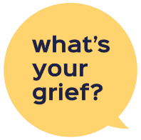

Podcasts, Resources and Courses on Grief



Better Health Channel

<https://www.betterhealth.vic.gov.au/health/servicesandsupport/grief-support-services>

Grief Support Services

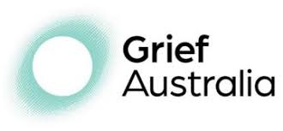

Grief Australia

<https://www.grief.org.au/>

Grief & Bereavement support services



<https://standbysupport.com.au/>

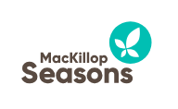

<https://www.mackillopseasons.org.au/>

Seasons for Growth is a small group education program that supports children and young people to develop the knowledge, skills and attitudes to understand and respond well to experiences of change, loss and grief.