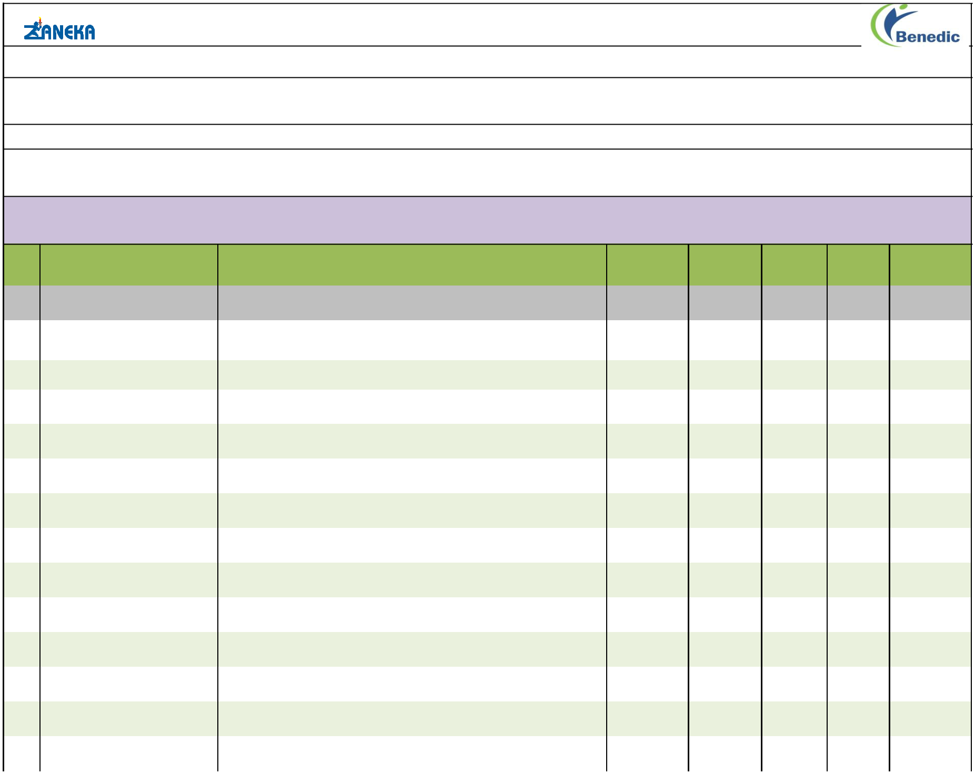
Benedic Pharmaceuticals Pvt. Ltd.

A M INTERNATIONAL
CONTACT : 05122328400,9455899034

EMAIL : aminternational1223@gmail.com

Price list As On Dt. 31.08.2023

Sr. | Product Name | Composition | Packing | Pack Size MRP/strip |  | MRP
No. |  |  |  |  |  | Box
 |  | ANTIBIOTICS
1 | BACIZOL-OZ TAB. | Ofloxacin 200 mg + Ornidazole 500 mg | Blister | 10x10 | 73.00 | 730.00
2 | BENCLAV-625 | Amoxycilline 500mg + Clavulanate Potassium 125 mg | Al. Strips | 10x10 | 195.00 | 1950.00
4 | GLEXIME PLUS TAB | Cefixime 200 mg + Ofloxacin 200 mg | Alu-Alu | 10x10 | 138.00 | 1380.00
5 | GLEXIME 200 TAB | Cefixime 200 mg + Lactic Acid Bacillus 60 million spores | Alu-Alu | 10x10 | 125.00 | 1250.00
6 | FUROZAN-250 TAB. | Cefuroxime Axetil IP eq. to Anhydrous Cefuroxime 250 mg | Alu-Alu | 1X6 | 121.00 | 1210.00
7 | FUROZAN-500 TAB. | Cefuroxime Axetil IP eq. to Anhydrous Cefuroxime 500 mg | Alu-Alu | 10x6 | 180.00 | 1800.00
8 | VB POD DRY SYP | Cefpodoxime Prexetil 50 mg | Pet Bottle with | 1x30ml | 79.00 | 79.00
8 | VB POD DRY SYP | Cefpodoxime Prexetil 50 mg | Carton+WFI | 1x30ml | 79.00 | 79.00
9 | VB POD-CV TAB. | Cefpodoxime Proxetil 200 mg & Potassium Clavulanate 125 mg | Alu-Alu | 10X10 | 300.00 | 3000.00
10 | CEFIZAN-100 DT TAB. | Cefixime 100 mg DT | Alu-Alu | 10X10 | 70.00 | 700.00
11 | VB POD-100 TAB. | Cefpodoxime Prexetil 100 mg | Alu-Alu | 10x10 | 99.00 | 990.00
12 | VB POD-200 TAB. | Cefpodoxime Prexetil 200 mg | Alu-Alu | 10x10 | 180.00 | 1800.00
13 | VB POD-50 TAB. | Cefpodoxime Prexetil 50 mg | Alu-Alu | 10x10 | 65.00 | 650.00
 |  | Page 1 of 11

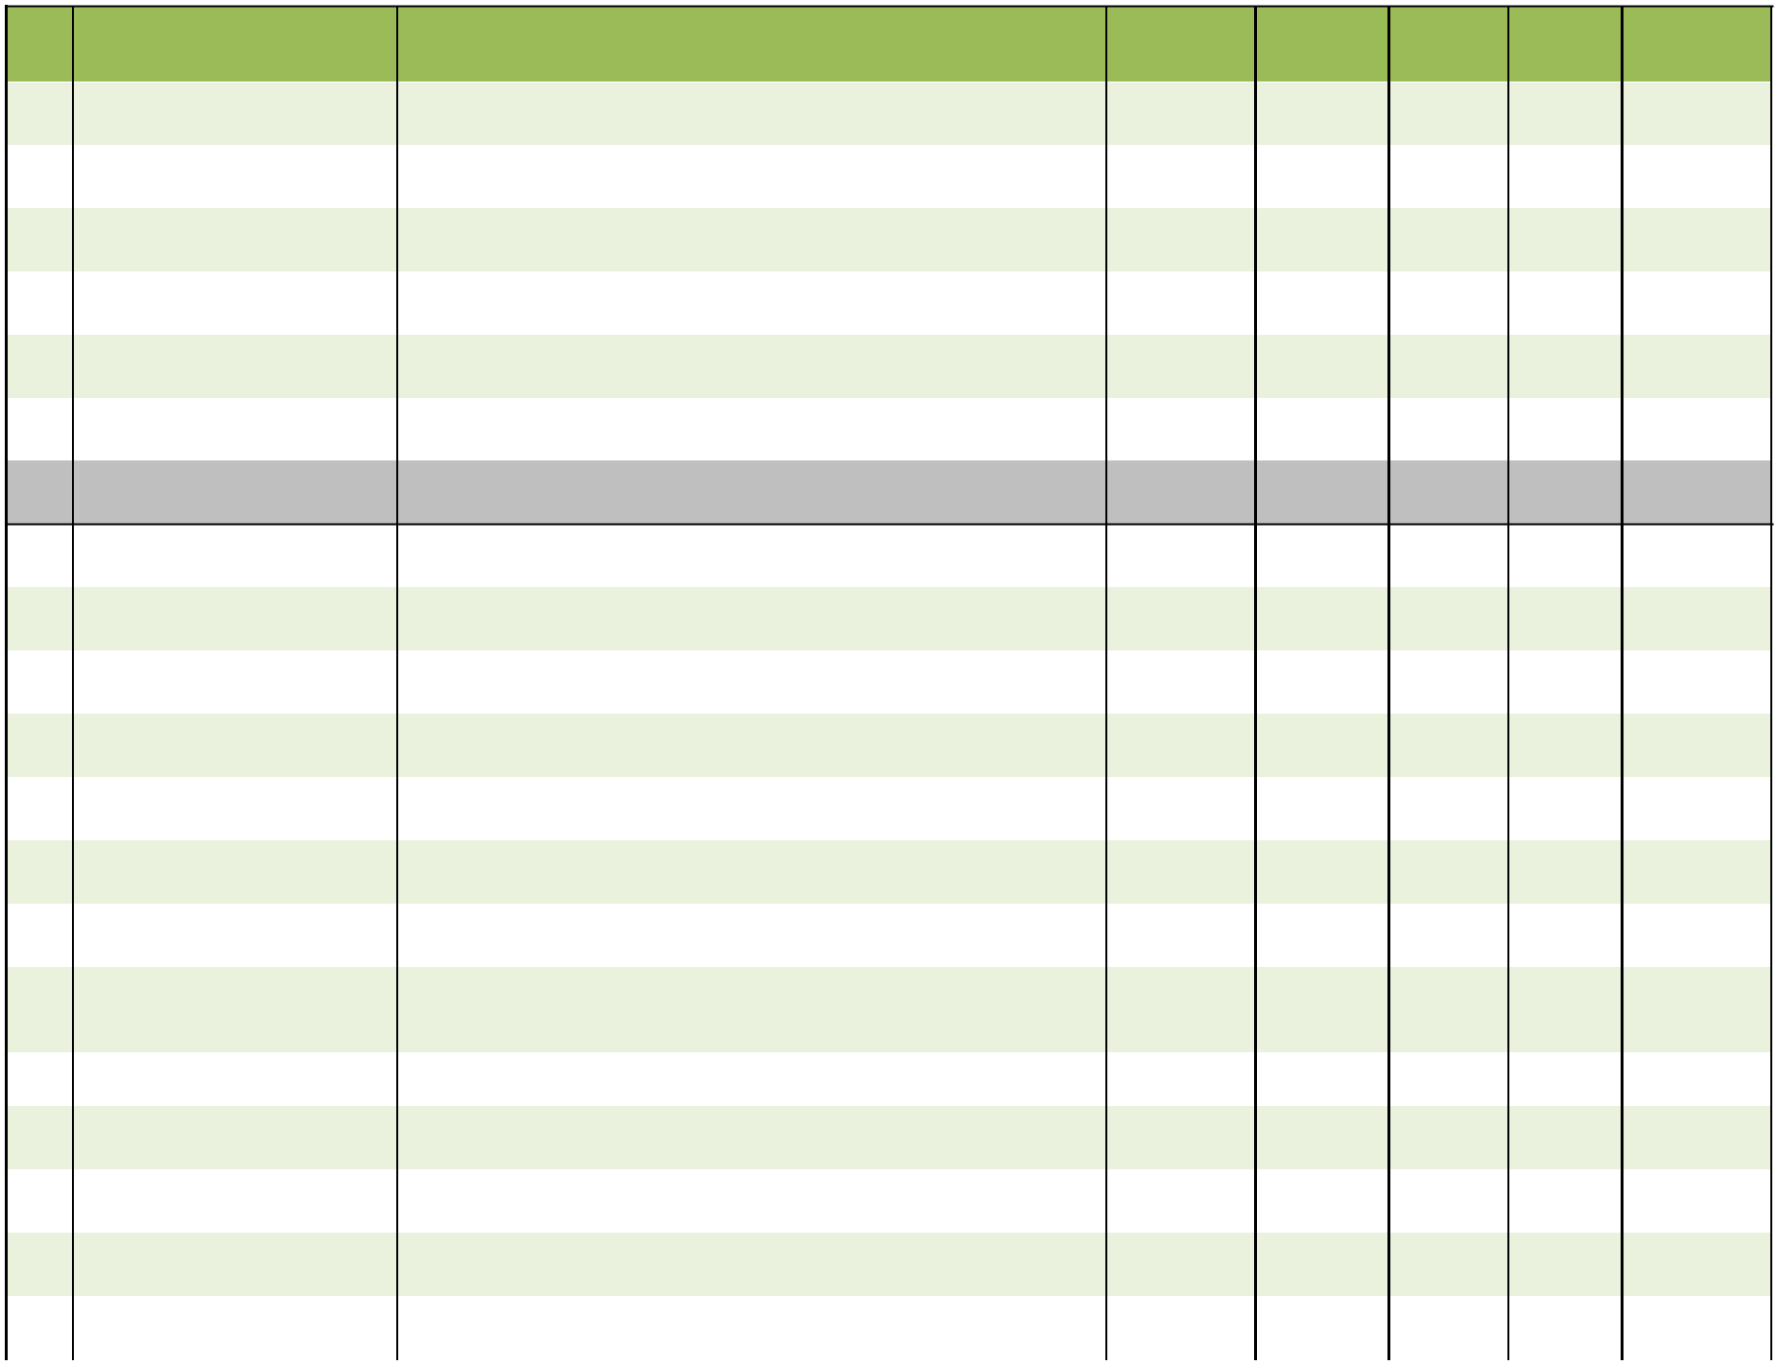
Sr. | Product Name | Composition | Packing | Pack Size MRP/strip |  | MRP
No. |  |  |  |  |  | Box
14 | CEFIZAN-CV 325 TAB. | Cefixime 200 mg + Clavulanic Acid 125 mg | Al. Strip | 10X10 | 320.00 | 3200.00
15 | ZELIN-600 TAB. | Linezolid 600 mg | Al. Strip | 3X4 | 144.00 | 432.00
16 | ZANCLAV-375 TAB. | Amoxycilline 250 mg + Clavulanate Potassium 125 mg | Alu-Alu | 10x10 | 160.00 | 1600.00
17 | ZANCLAV DRY SYP. | Amoxycilline Trihydrare IP eq. to Amoxycillin 200 mg + Clavulanate | HDPE Box | 1X30 ml | 57.10 | 57.10
17 | ZANCLAV DRY SYP. | Potassium eq. to Clavulanic Acid 28.5 mg | with carton | 1X30 ml | 57.10 | 57.10
18 | ZANCLAV FORTE DRY | Amoxycilline Trihydrare IP eq. to Amoxycillin 400mg + Clavulanate | HDPE Box | 1X30 ml | 123.00 | 123.00
18 | SYP.(With WFI.) | Potassium eq. to Clavulanic Acid 57 mg | with carton | 1X30 ml | 123.00 | 123.00
19 | ZANCLAV 1GM TAB. | Amoxycillin 875 mg + Clavulanate Potassium 125 mg | Al. Strip | 1X4 | 154.00 | 154.00

ANTACID/PPI's/GERD

20 | PRAZO L CAP | Pantoprazole 40mg + Levosulpiride 75mg | Alu-Alu | 10x10 | 93.00 | 930.00
21 | ENTRACID-DSR CAP. | Pantoprazole Sod. Sesquihydrate 40 mg + Domperidone 30 mg (As | Al. Strips | 10x10 | 110.00 | 1100.00
21 | ENTRACID-DSR CAP. | Sus. Release Pellets)
22 | RABADIC -DSR CAP. | Rabeprazole 20 mg + Domperidone 30 mg(As Sus. Release ) | Alu-Alu | 10x10 | 85.00 | 850.00
23 | PRAZO TAB. | Pantoprazole Sodium 40 mg | Alu-Alu | 10x10 | 50.00 | 500.00
24 | PRAZO-D TAB. | Pantoprazole 20 mg + Domperidone 10 mg | Alu-Alu | 10x10 | 59.00 | 590.00
25 | RABZAN L CAP | Rabeprazole Sodium 20 mg+ Levosulpiride 75mg | Alu-Alu | 10x10 | 169.00 | 1690.00
26 | RABZAN TAB. | Rabeprazole Sodium 20 mg | Alu-Alu | 1X10 | 39.00 | 390.00
27 | RABUS IT CAP | Each hard gelatin capsule contains: Rabeprazole Sodium IP (as enteric | Alu-Alu | 10x10 | 125.00 | 1250.00
27 | RABUS IT CAP | coated pellets) 20 mg + Itopride (as sustained release pellets) 150 mg
28 | DOMAR–OX SUS. | Oxetacaine 10 mg + Aluminium Hydroxide 0.291 gm + Magnesium | Pet Bott. | 1X200 ml | 110.00 | 110.00
28 | DOMAR–OX SUS. | Hydroxide 98 mg
29 | BENLACT CAP | Lactic Acid Bacillus with Vitamin B-complex Cap | Blister | 10x15 | 54.00 | 540.00
30 | DOMAR-O 4 TAB.(ORALLY | Ondansetron 4 mg | Al. Strips | 10x10 | 49.00 | 490.00
 | DISINTEGRATING)
31 | SUKATE- O SUSP. | Each 10ml contains : Sucralfate1000mg + Oxetacaine 20mg | Pet bott. With | 1x200ml | 160.00 | 160.00
31 | SUKATE- O SUSP. | Each 10ml contains : Sucralfate1000mg + Oxetacaine 20mg | carton | 1x200ml | 160.00 | 160.00
32 | SUKATE- O SUSP. | Each 10ml contains : Sucralfate1000mg + Oxetacaine 20mg | Pet bott. | 1x100ml | 95.00 | 95.00

Page 2 of 11

Sr. | Product Name | Composition | Packing | Pack Size MRP/strip |  | MRP
No. |  |  |  |  |  | Box
 |  | ANTI-ALLERGIC/ANTICOLD/ANTI COUGH
33 | BENCOLD TAB | Levocitrizine 5mg + Ambroxol 75mg | Alu-Alu | 10X10 | 59.00 | 590.00
34 | COBOLD AL SYP (SUGAR | Levosalbutamol Hydrochloride 1mg + Ambroxol Hydrochloride 30mg + | Pet Bottle | 1x100ml | 79.00 | 79.00
 | FREE) | Guaiphenesin 50mg | with Carton
35 | COBOLD-D SYP. (SUGAR | Chlorpheniramine Maleate 2 mg + Dextromethorphan Hydrobromide 10 | Pet Bottle | 1x100ml | 76.00 | 76.00
 | FREE) | mg + Phenylephrine Hydrochloride 5 mg | with Carton
36 | COVENT AGT SYP. | Each 5ml contains: Terbutaline 1.25mg + Acebrophylline 50mg + | Pet Bottle | 1X60ML | 78.00 | 78.00
36 | COVENT AGT SYP. | Guaifenesin 50mg | with Carton | 1X60ML | 78.00 | 78.00
37 | TOXILIN TAB | Montelukast 10 mg + Levocetrizine 5 mg | Alu-Alu | 10x10 | 109.00 | 1090.00
38 | TOXILIN KID SYP | Montelukast 4 mg + Levocetrizine 2.5 mg | Pet Bottle | 1X60ML | 74.00 | 74.00
38 | TOXILIN KID SYP | Montelukast 4 mg + Levocetrizine 2.5 mg | with Carton | 1X60ML | 74.00 | 74.00
39 | ZMONT-FX TAB. | Montelukast sodium eq. to montelukast 10 mg + Fexofenadine | Alu-Alu | 10x10 | 131.00 | 1310.00
39 | ZMONT-FX TAB. | Hydrochloride 120mg
40 | ZANCOD SYP. | Codeine Phosphate 10 mg + Triprolidine HCL 1.25 mg | Pet Bott. | 1X100 ml | 109.00 | 109.00
41 | COVENT EXPECTORANT | Terbutaline Sulphate 1.5 mg + Bromhexine 4 mg + Guaiphenesin 50 | t Bott. with cart | 1X100 ml | 66.00 | 66.00
41 | COVENT EXPECTORANT | mg + Menthol 2.5 mg
 |  | ANTI-INFLAMMATORY/ANALGESIC/PROTEOLYTIC
 |  | ENZYMES
42 | ZANIS FORTE TAB. | Each enteric coated tablet contains : Trypsin B.P 48mg +Bromelain | Blister | 10x10 | 185.00 | 1850.00
42 | ZANIS FORTE TAB. | 90mg +Rutoside Trihydrate BP 100mg + Diclofenac Sodium 50mg
43 | ZANIS TAB. | Each enteric coated tablet contains : Trypsin B.P 48mg +Bromelain | Alu-Alu | 10x1x10 | 180.00 | 1800.00
43 | ZANIS TAB. | 90mg +Rutoside Trihydrate BP 100mg
44 | ZANUPAR-650 TAB. | Paracetamol 650 mg | Blister | 10x10 | 19.30 | 193.00
45 | BENLAR-AS TAB. | Aceclofenac 100 mg + Serratiopeptidase 15 mg | Alu-Alu | 10x10 | 60.00 | 600.00
46 | BENLAR-P TAB. | Aceclofenac 100 mg + Paracetamol 325mg | Blister | 10x10 | 42.00 | 420.00
47 | BENLAR-MF SUSP. | Paracetamol 125mg + Mefenamic Acid 50mg | Pet Bottle | 1x60ml | 46.00 | 46.00
47 | BENLAR-MF SUSP. | Paracetamol 125mg + Mefenamic Acid 50mg | with Carton | 1x60ml | 46.00 | 46.00
48 | BENLAR-DS SUSP. | Paracetamol 250mg + Mefenamic Acid 100mg | Pet Bottle | 1x60ml | 51.00 | 51.00
48 | BENLAR-DS SUSP. | Paracetamol 250mg + Mefenamic Acid 100mg | with Carton
49 | KEPROS TAB (Dispersible) | Ketorolac Tromethamine 10mg | Blister | 10x10 | 49.00 | 490.00
50 | RABEXOL-AC CAP | Acelofenac 200mg (SR) + Rabeparazole 20mg | Alu-Alu | 10x10 | 79.00 | 790.00
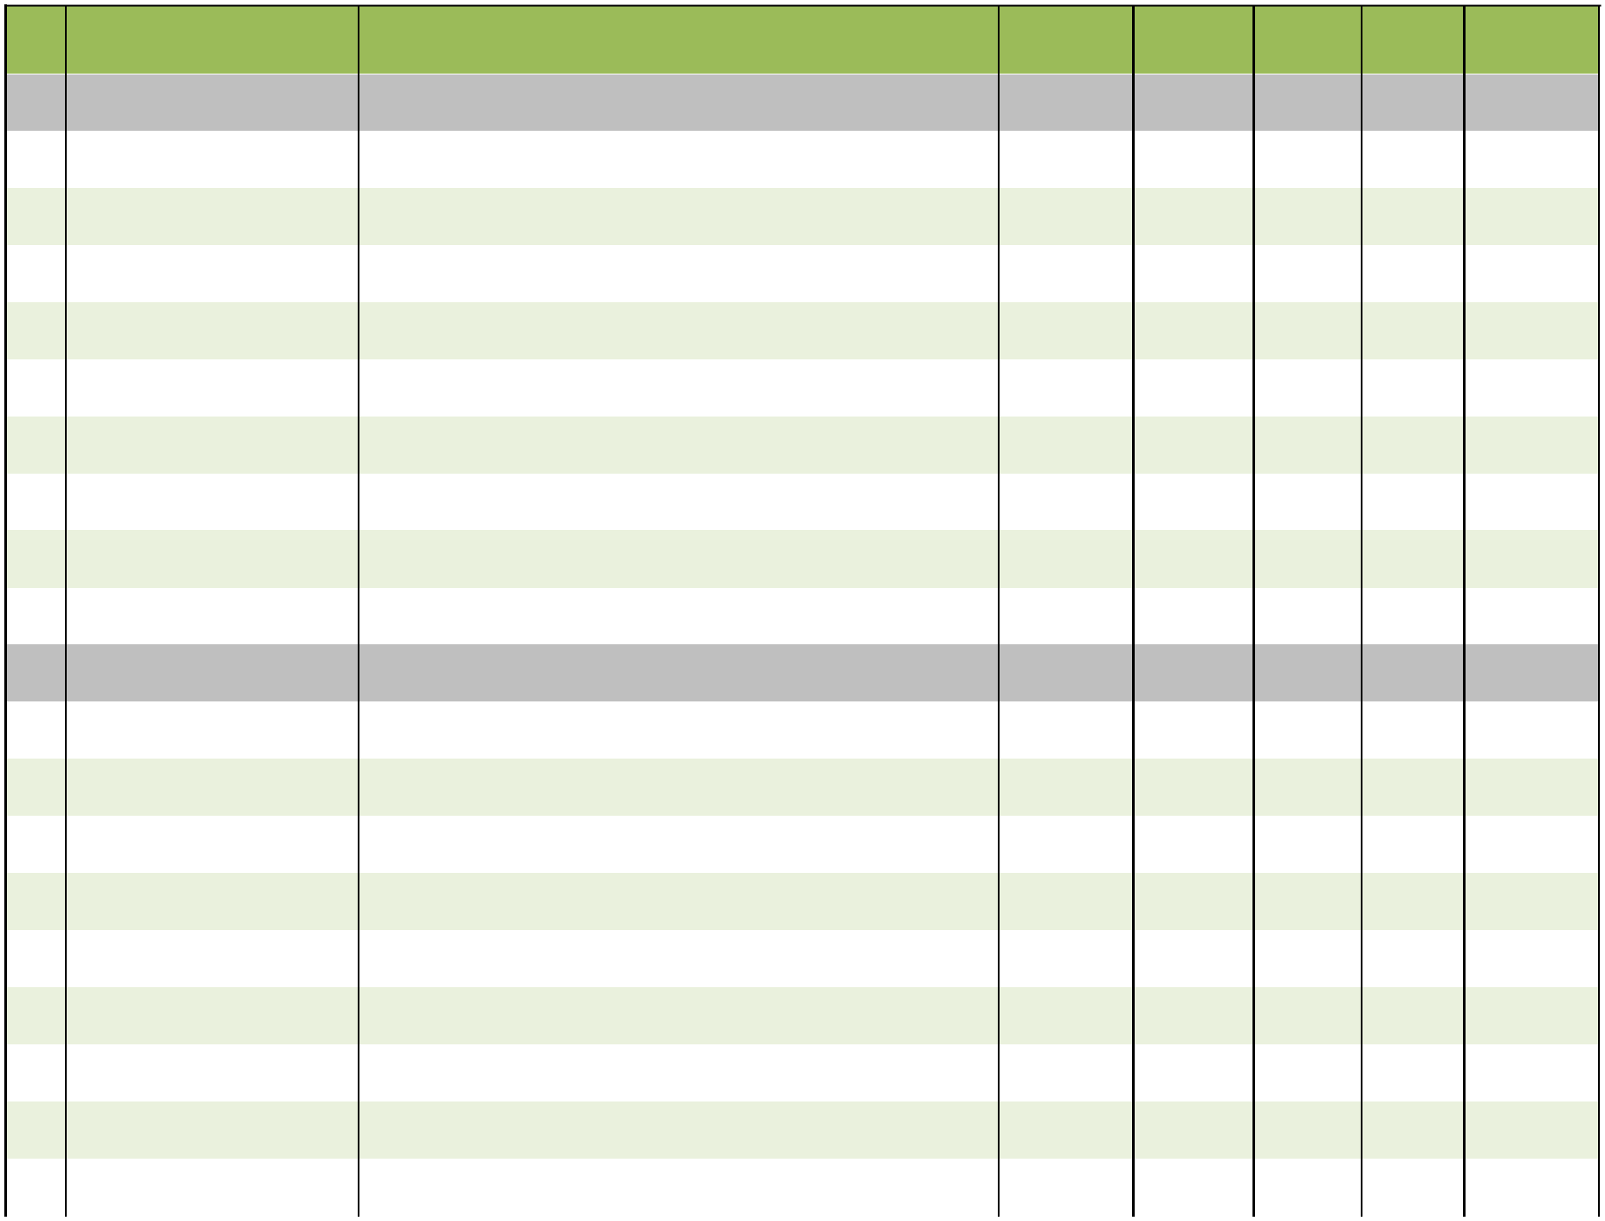

Page 3 of 11

Sr. | Product Name | Composition | Packing | Pack Size MRP/strip |  | MRP
No. |  |  |  |  |  | Box
51 | TRACEMOL TAB. | Tramadol 37.5 + paracetamol 325mg | Blister | 10x1x10 | 71.00 | 710.00
52 | TWINS TAB. | Nimesulide 100 mg + Paracetamol 325 mg | Blister | 10x10 | 33.00 | 330.00
53 | AEUGESIC-MR TAB. | Aceclofenac 100 mg + Paracetamol 325 mg + Chlorzoxazone 250 mg | Blister | 10x10 | 78.00 | 780.00
54 | LORNIZAN TAB. | Lornoxicam 8 mg | Alu-Alu | 10x10 | 70.00 | 700.00
55 | METAZAN-D TAB. | Diclofenac 50mg + Metaxalone 400mg | Alu-Alu | 10x10 | 135.00 | 1350.00
56 | RETICOX TAB | Etoricoxib 90mg | Blister | 10x10 | 95.00 | 950.00
57 | TENDOSET TAB. | Collagen Peptide Type 1 40mg + Sodium hyaluronate 30mg+ | Alu-Alu | 10x10 | 159.00 | 1590.00
57 | TENDOSET TAB. | Chomdrotin Sulphate 200mg+ Vit. C 35mg
58 |  | Linolenic Acid 3.00 % w/w + Diclofenac Diehtyllamine BP 1.16 % w/w |  |  |  | 85.00
58 | JOINT FIT GEL | Eq. to Diclofenac Sodium IP 1.00 % w/w + Methyl Salicylate IP 10.00 % | Lami Tube | 1X30 gm | 85.00 | 85.00
 |  | w/w + Menthol IP 5.00 % w/w + Benzyl Alcohol IP 1.00 % w/w
59 | JOINT FIT-G TAB. | Diacerein 50 mg + Glucosamine Sulfate Potassium Chloride 500 mg | Alu-Alu | 10x10 | 125.00 | 1250.00
60 | ZANUPIROL TAB. | Febuxostat 40mg | Alu-Alu | 10x10 | 65.00 | 650.00
61 | ZANUPIROL-80 TAB. | Febuxostat 80mg | Alu-Alu | 10x10 | 139.00 | 1390.00
 |  | ANTI-PSYCHOTIC/ANTI-DEPRESSANT
62 | PROZAN-AL TAB. | Propranolol 20 mg + Alprazolam 0.25 mg | Blister | 4x5x10 | 38.00 | 760.00
63 | CLONAZAN-0.5 MD TAB. | Clonazepam 0.5 mg (Mouth Dissolving ) | Blister | 10x10 | 33.00 | 330.00
64 | CLONAZAN-ET TAB. | (Clonazepam 0.5 + Escitalopram Oxalate Eq. to Escitalopram 10 mg) | Alu-Alu | 10x10 | 85.00 | 850.00
65 | FLUOZAN-AL TAB. | Fluoxetine 20 mg + Alprazolam 0.25 mg | Blister | 4x5x10 | 41.00 | 820.00
66 | OLANZAN-10 TAB. | Olanzapine 10 mg | Blister | 10x10 | 55.80 | 558.00
67 | OLANZAN-5 TAB. | Olanzapine 5 mg | Blister | 10x10 | 32.00 | 320.00
68 | ZANTOIN TAB. | Phenytoin Sodium 100 mg | Alu-Alu | 10x10 | 17.00 | 170.00
69 | TRIZEN TAB. | Trifluoperazine 1 mg + Chlordiazepoxide 10 mg | Blister | 8x5x10 | 36.00 | 1440.00
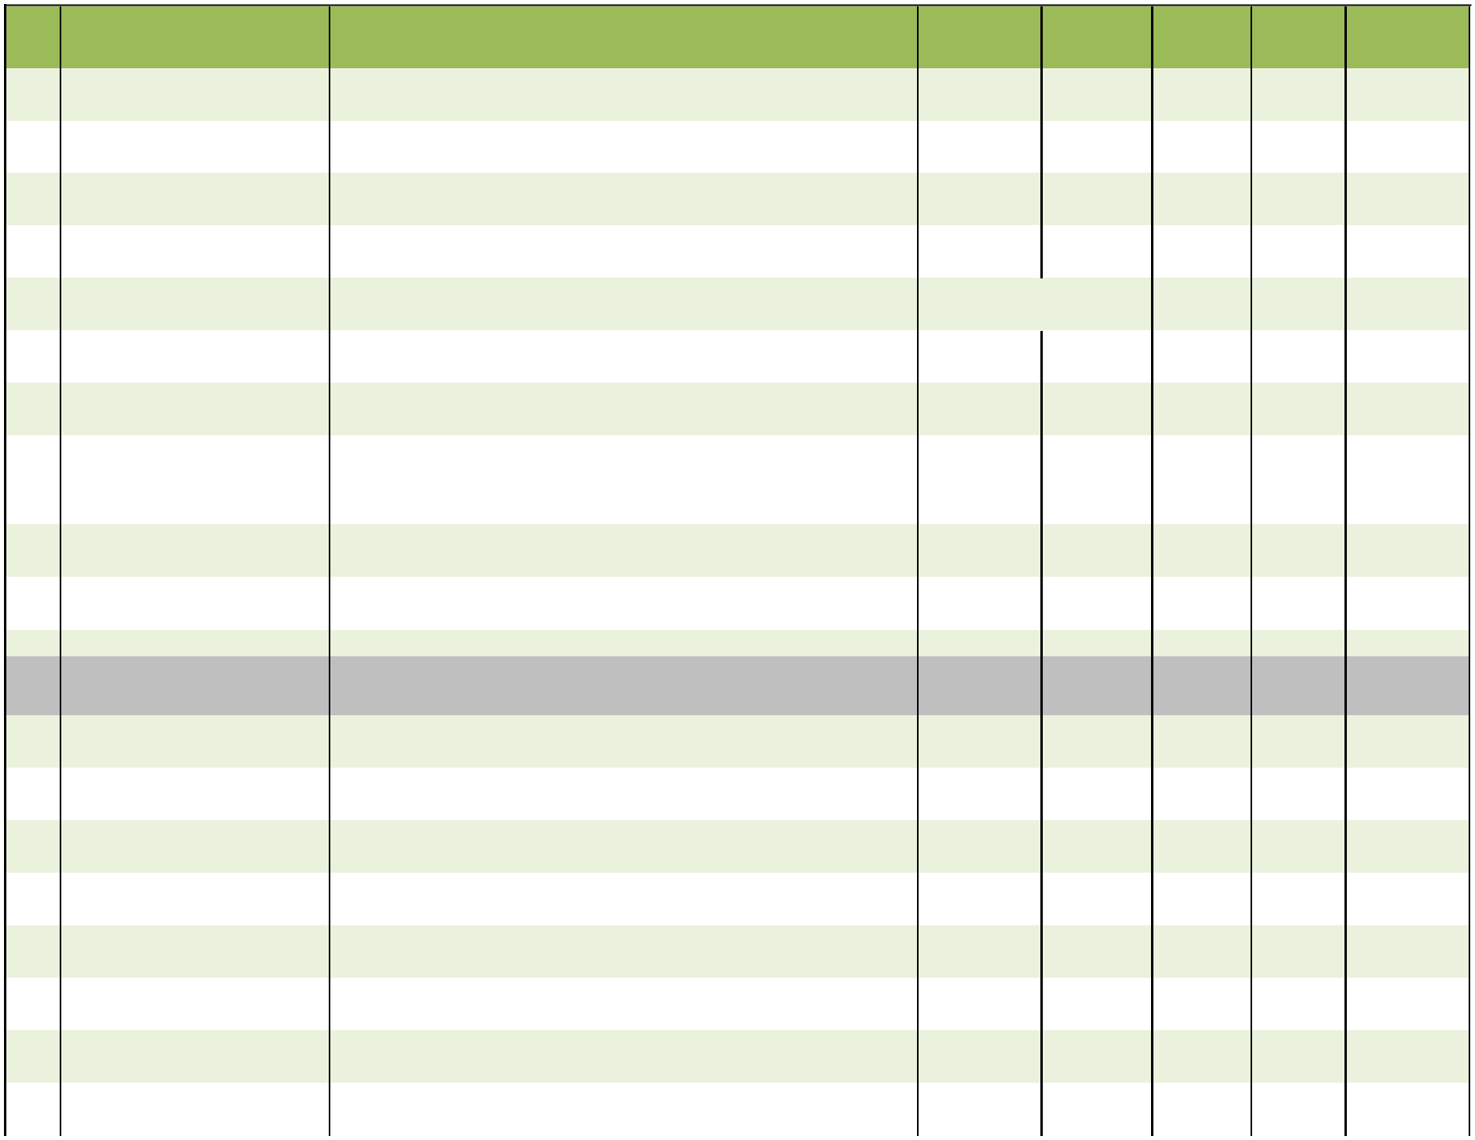

Page 4 of 11

Sr. | Product Name | Composition |  | Packing | Pack Size MRP/strip |  |  | MRP
No. | Product Name | Composition |  | Packing |  |  |  | Box
 |  | ANTI-FUNGAL/DERMA RANGE
70 | FUGANOL OINTMENT | Sertaconazole 2% Ointment |  | Lami Tube | 20gm | 195.00 |  | 195.00
71 | ITROCURE 200 CAP | Itraconazole 200mg |  | Blister | 5x1x4 | 128.00 |  | 640.00
72 | ITROCURE CAP | Itraconazole 100mg |  | Blister | 5x1x4 | 88.00 |  | 440.00
73 | NOVASONE-F CREAM | Mometasone Furoate 0.1% w/w |  | Lami Tube | 10gm | 220.00 |  | 220.00
73 | NOVASONE-F CREAM | Fusidic Acid | 2.0% w/w
74 | DIVINE GLOW GEL | Hydroquinone USP 2 % w/w +Tretinoin USP 0.025% w/w |  | Lami Tube | 15gm | 140.00 |  | 140.00
74 | DIVINE GLOW GEL | +Mometasone Furoate I.P. 0.1% w/w
75 | BACROCIN OINTMENT | Mupirocin Ointment |  | Lami Tube | 5gm | 95.00 |  | 95.00
 |  | Ofloxacin 0.75% + Itraconazole 1 % + Ornidazole 2% + Clobetasole
76 | TERBOCYL CREAM | 0.05% + Methylpereben (As Preservative ) 0.20% + Proprylpereben (As |  | Lami Tube | 15GM | 70.00 |  | 70.00
 |  | Preservative) 0.02%
77 | LUGAZOLE CREAM | Lulicoanzole 1% cream |  | Lami Tube | 20gm | 250.00 |  | 250.00
78 | KIZOL SOAP | Ketoconazole soap 2% w/w |  | Soap | 1X75GM | 95.00 |  | 95.00
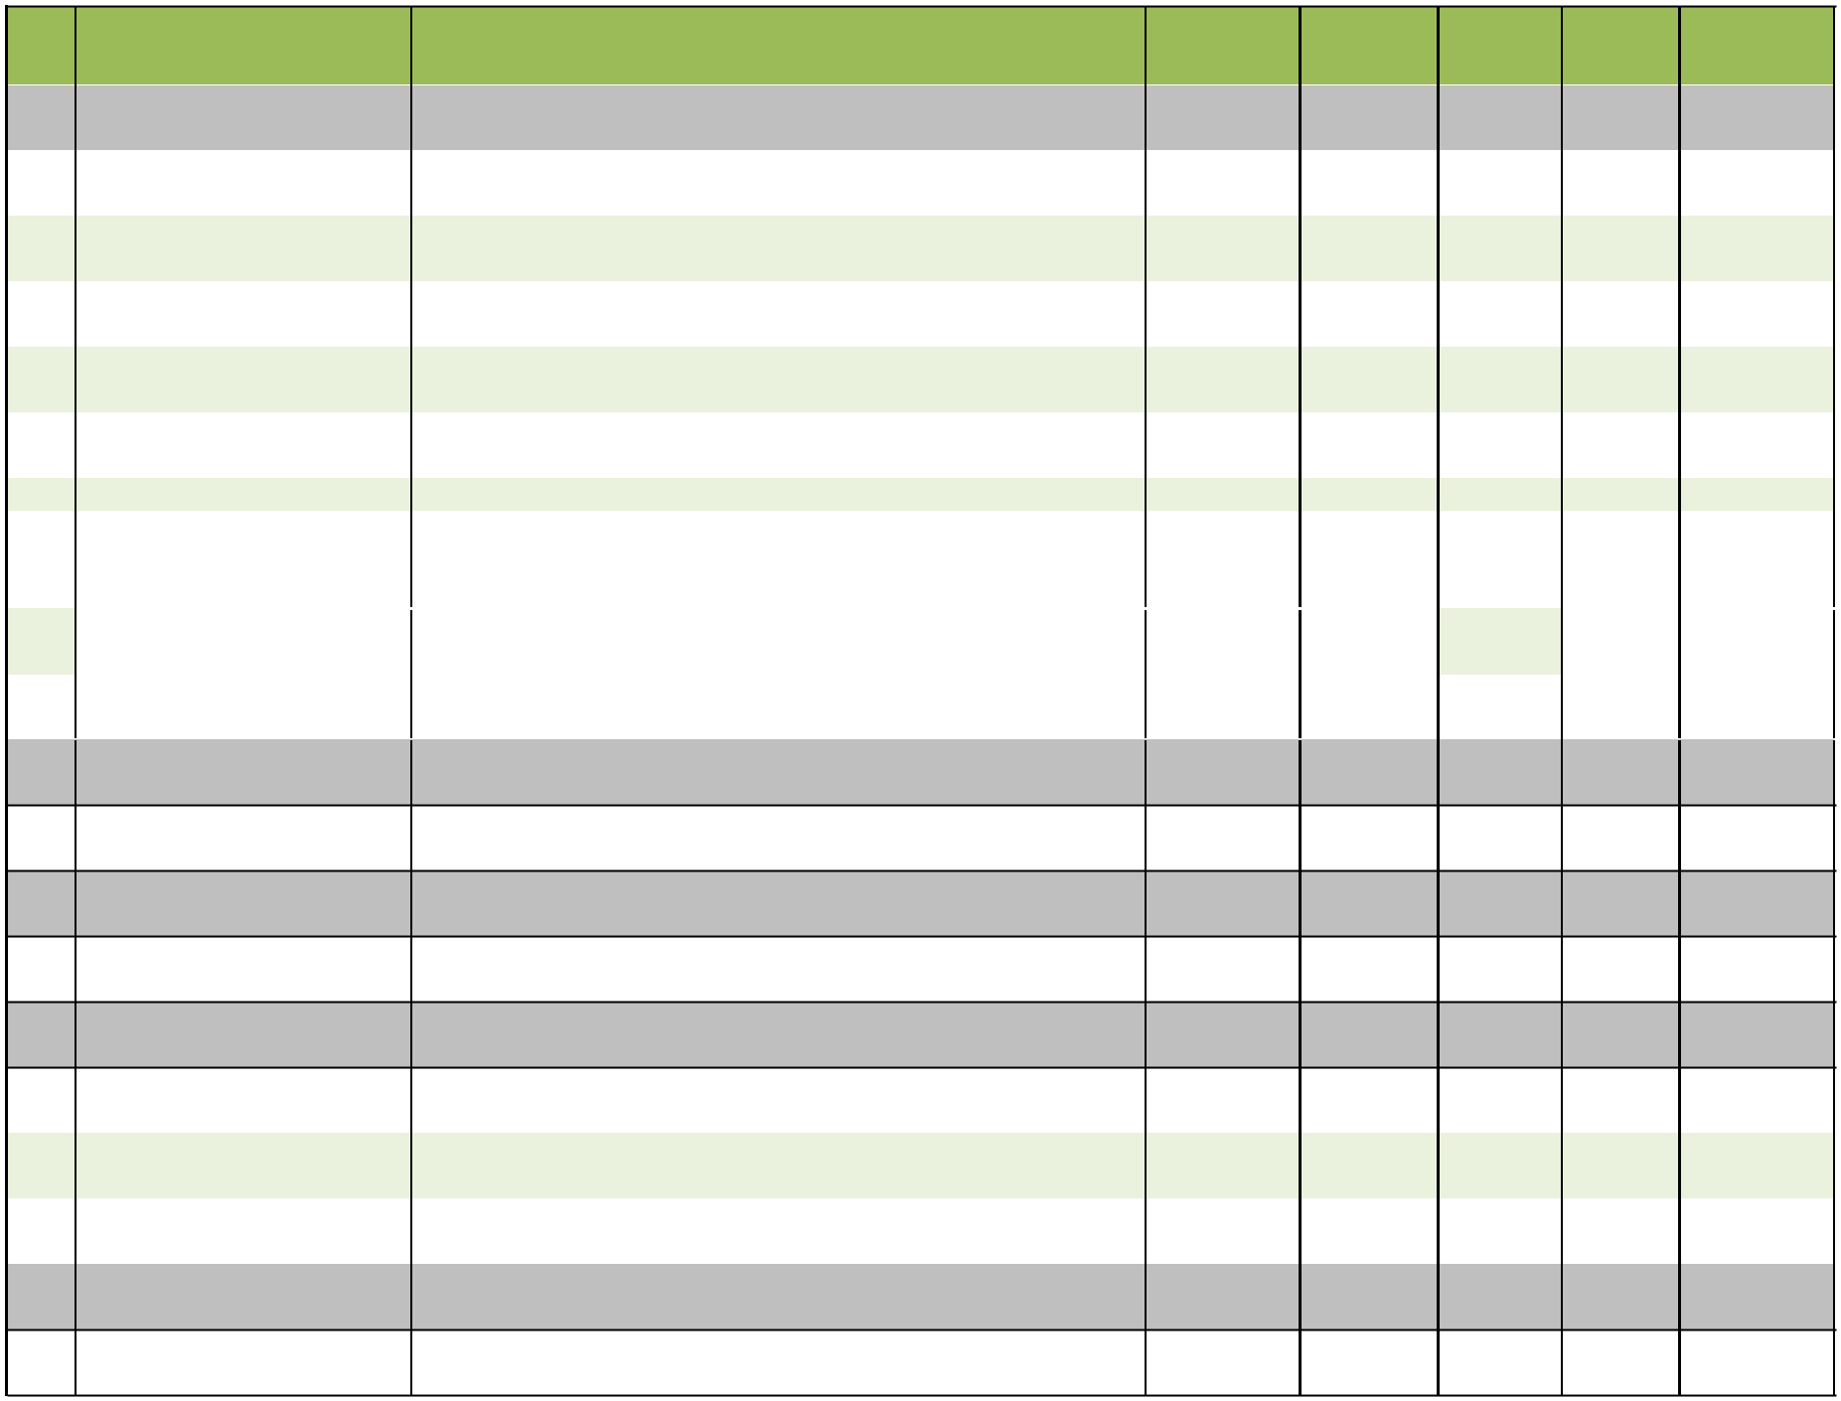
CORTICOSTEROIDS

79 BD-CORT TAB. Deflazacort 6mg Alu-Alu 10x10 75.00 750.00

ANTI-HISTAMINE

80 RAZINE TAB Hydroxyzine 25 mg Blister 10x10 35.00 350.00

ANTI-HYPERTENSIVES

81 | ZANLODI-AT TAB. | Amlodipine 5 mg + Atenolol 50 mg | Blister | 10x10 | 39.00 | 390.00
82 | ZOSARTAN-H TAB. | Telmisartan 40 mg + Hydrochlorothiazide12.5 mg | Alu-Alu | 10x10 | 74.00 | 740.00
83 | IBADINE TAB. | Ivabradine 5gm | Alu-Alu | 10x10 | 160 | 1600.00

INJECTABLES

84 BOLIN-D INJ. Nandrolone Decanoate 50 mg Vial 1 ml 125.00 125.00

Page 5 of 11

Sr. | Product Name | Composition | Packing | Pack Size MRP/strip |  | MRP
No. |  |  |  |  |  | Box
85 | CERABACT INJ. | Cefoperazone Sodium eq. to Anhydrous Cefoerazone 1gm + Sulbactam | Vial | #N/A | #N/A | 189.00
85 | CERABACT INJ. | Sodium eq. to Sulbactam 500mg
86 | DOMAR - O INJ. | Each ml :Ondansetron HCI eq. to Ondansetron 2mg | Ampule | 1X2 ml | 12.80 | 12.80
87 | PIRA TAZ INJ. | Sterile Piperacillin Sodium eq. to Anhydrous Piperacillin 4 gm + Sterile | Vial | 4.5gm | 410.00 | 410.00
87 | PIRA TAZ INJ. | Tazobactam Sodium eq. to Anhydrous Tazobactam 500 mg
88 | PRAZO INJ. | Pantoprazole Sod. (Lyophilized) eq. to Pantoprazole Anhydrous 40 mg | Vial | 1X40 mg | 48.50 | 48.50
89 | RAMODOL INJ. | Tramadol Hydrochloride 50 mg | Ampule | 1X2 ml | 22.00 | 22.00
90 | ZANCEFTRA 1 GM INJ. | Ceftriaxone Sodium Sterile eq. to Anhydrous Ceftriaxone 1000 mg | Vial | 1 gm | 59.00 | 59.00
91 | ZANCEFTRA-T 1.125 INJ. | Sterile Ceftriaxone Sodium eq. to Anhydrous Ceftriaxone 1000 mg + | Vial | 1.125 gm | 149.00 | 149.00
91 | ZANCEFTRA-T 1.125 INJ. | Sterile Tazobactam eq. to Anhydrous Tazobactam 125 mg
92 | ZANCEFTRA SB INJ. | Each Vial contains: Sulbactam Sodium (Sterile) USP eq. to Sulbactam | Vial | 1.5gm | 114.00 | 114.00
92 | ZANCEFTRA SB INJ. | 0.5 g + Ceftriaxone Sodium (Sterile) IP eq. to Anhydrous Ceftriaxone
 |  | 1.0 g
93 | ZANCLAV 1.2 GM INJ. | Amoxycillin Sod. Eq. to Amoxycillin 1000 mg + Potassium Clavulanate | Vial | 1.2 gm | 136.00 | 136.00
93 | ZANCLAV 1.2 GM INJ. | Eq. to Clavulanate Acid 200 mg
94 | ZANIS-AQ INJ. | Diclofenac Sodium 75 mg + Benzyl Alcohol 4% v/v (As Preservative) | Ampule | 1X1 ml | 16.00 | 16.00
95 | ZECOBA INJ. | Each 2ml contains. Methylcobalamin inj 1500mcg+ Nicotinamide | Ampule | 1X2 ml | 50.00 | 50.00
95 | ZECOBA INJ. | 100mg +Vit. B 6 100mg + D-Panthenol 50mg + benzyl Alcohol 2% V/V
96 | ZECOBA INJ.(Dispo Pack) | Each 2ml contains. Methylcobalamin inj 1500mcg+ Nicotinamide | Ampule | 1X2 ml | 89.00 | 89.00
96 | ZECOBA INJ.(Dispo Pack) | 100mg +Vit. B 6 100mg + D-Panthenol 50mg + benzyl Alcohol 2% V/V
97 | MEROBEN INJ | Meropenem 1000mg | Vial | 1x1 gm | 710.00 | 710.00
98 | MEROBEN INJ | Meropenem 1000mg | Vial | 1x1 gm | 2650.00 | 2650.00
 |  | LAXATIVES
99 | PICOZAN SYP. | Sodium Picosulphate 5 mg | Pet Bott. with | 1X100 ml | 66.00 | 66.00
99 | PICOZAN SYP. | Sodium Picosulphate 5 mg | carton
100 | PICOZAN TAB. | Sodium Picosulphate 10 mg | Blister | 10X10 | 39.00 | 390.00
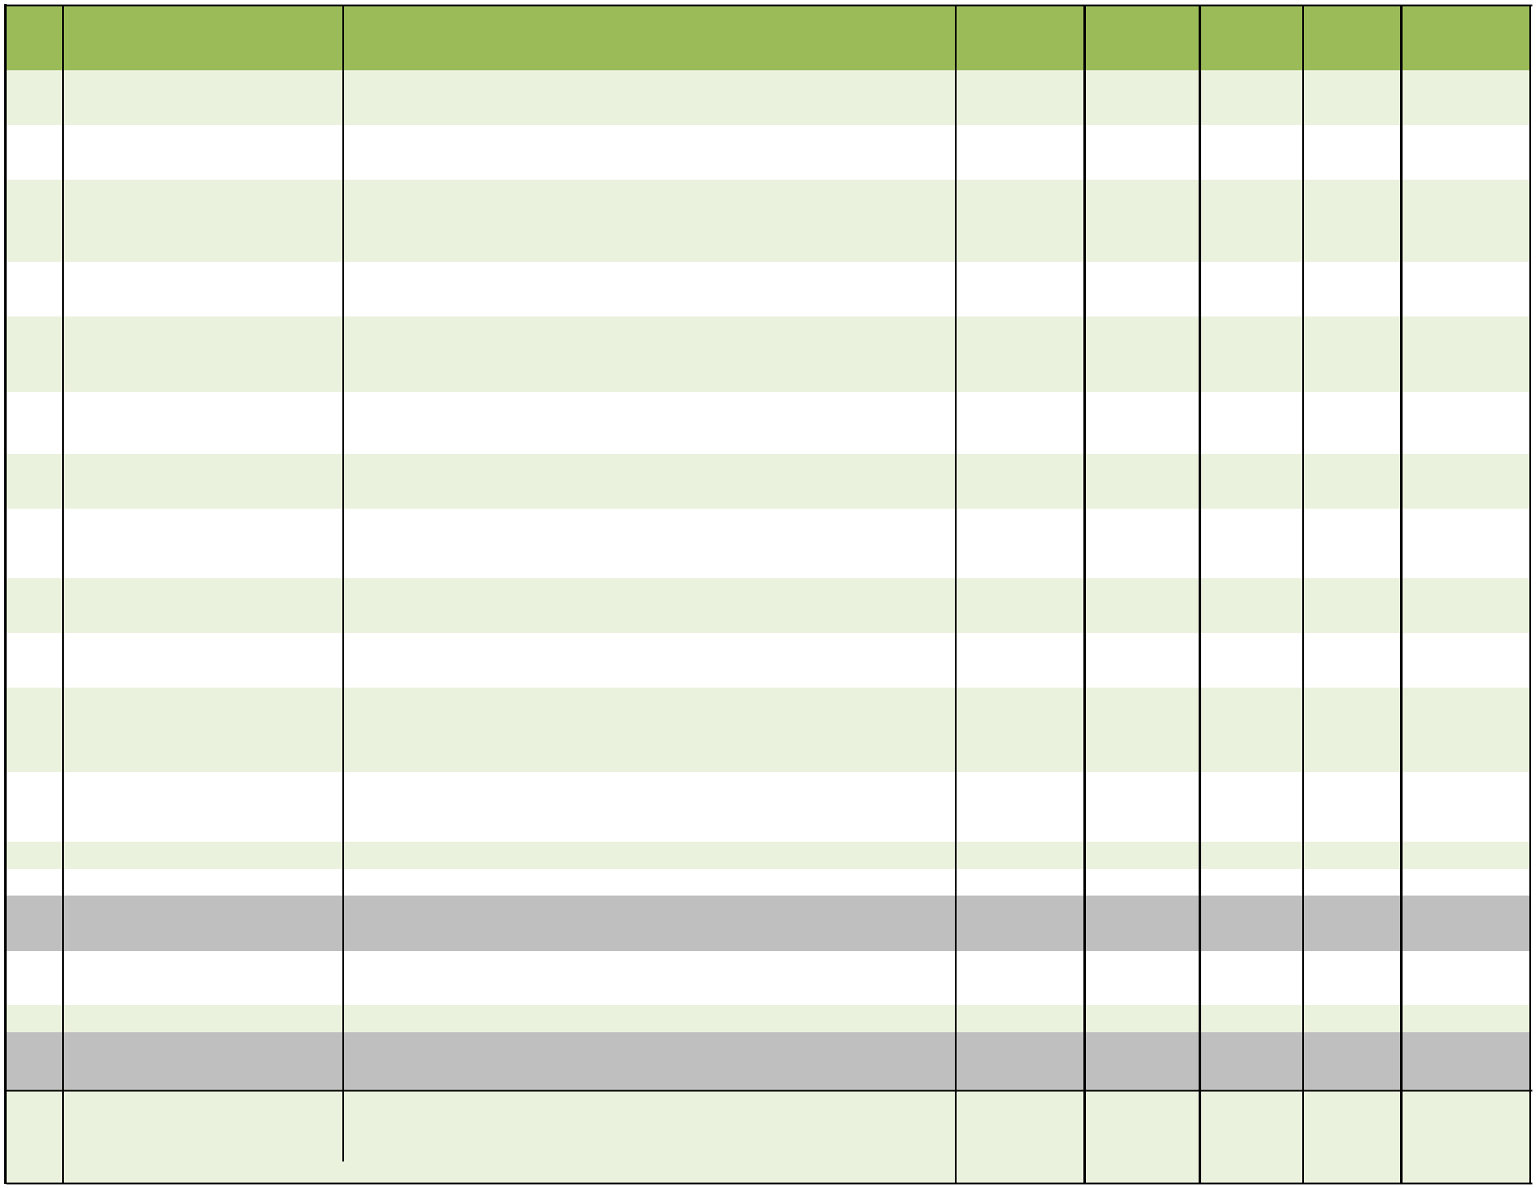
MULTIVITAMINS/ANTIOXIDANTS/NUTRITIONAL

SUPPLEMENT

- FIXET- K2 SOFT GELATIN CAPSULES

Calcium Citrate Maleate 500mg + Calcitrol 0.25mcg + Vitamin K27
45mcg + Omega-3 Fatty Acid ( EPA 90MG + DHA 60MG ) + | Blister | 10x1x10 | 195.00 | 1950.00
Methylcobalamin 750mcg + Zinc sulphate Monohydrate 7.5mg + Boron
(Sodium Tetraborate ) 1.5mg

Page 6 of 11

Sr. | Product Name | Composition | Packing | Pack Size MRP/strip |  |  | MRP
No. |  |  |  |  |  |  | Box
102 | FAXINE SYP ( IRON SYP ) | Each 15ml contains : Ferric Ammoniu Citrate IP 160mg + Zinc Sulphate | Pet Bottle | 1x200ml | 135.00 |  | 135.00
102 | FAXINE SYP ( IRON SYP ) | 30mcg+ Folic Acid 1mg | with Carton | 1x200ml |  |  | 135.00
103 | FEXINE TAB (IRON TAB) | Ferrous Bisglycinate , L Methylfolate, Multivitamins, Multiminerals & | Alu-Alu | 10x10 | 109.00 |  | 1090.00
103 | FEXINE TAB (IRON TAB) | Amino Acids Tablet
104 | ALLOVIT PLUS POWDER | Protein Powder with DHA + Spirulina | HDPE Box | 1x200gm | 198.00 |  | 198.00
105 | ALLOVIT GOLD SACHET | Lycopene , Coenzyme Q10, L Arganine , L Carnitine Fumarate & Foilc | Al. Foil | 10x5gm | 46.00 |  | 460.00
105 | ALLOVIT GOLD SACHET | Acid
106 | ALLOVIT - L SYRUP | Lycopene 1000 mcg + Zinc 7.5 mg + Selenium 35 mcg + Manganese | Pet Bottle | 1x200ml | 160.00 |  | 160.00
106 | ALLOVIT - L SYRUP | 2.75 mg + Iodine 75 mcg + Copper 1.1 mg+Beta-Carotene 10mg | with Carton | 1x200ml |  |  | 160.00
107 | ALLOVIT SYP. | Multi Vitamin Syp. | Pet Bott. With | 1X200 ml | 89.00 |  | 89.00
107 | ALLOVIT SYP. | Multi Vitamin Syp. | Carton | 1X200 ml |  |  | 89.00
108 | ALLOVIT GOLD CAP | Capsules of Omega 3 Fatty Acids, Green Tea Extract, Ginkgo Biloba , | Blister | 3x10 | 150.00 |  | 450.00
108 | ALLOVIT GOLD CAP | Grape Seed Extract , Antioxidants ,Vitamin, Minerals & Trace Elements
109 |  | Coenzyme Q10 100 MG+Folic acid 0.75 MG+L-arginine 50 | Alu-Alu | 10x1x10 | 379.00 |  | 3790.00
109 | ZANRICH-Q10 TAB. | MG+Levocarnitine 500 MG+Lycopene 2500 MCG+Methylcobalamin
 |  | 750 MCG+Selenomethionine 50 MCG+Zinc gluconate 10 MG
110
111 | CIM-60K TAB. (Chewable) | Vitamin D3 Chewable TAB.lets | Blister | 10X1x4 | 105.00 |  | 1050.00
112
112 |  | Ascorbate 450mg eq to Ascorbic Acid 400mg)
113 | CIMZEN TAB. | Calcium Citrate 1000 mg + Magnesium Hydroxide 240 mg + Zinc | HDPE | 1x30 | 240.00 |  | 240.00
113 | CIMZEN TAB. | Sulphate Monohydrate 11 mg + Vit D3 200 IU+Folic Acid 200mcg
114 | CIMZEN-MP TAB. | Calcium Carbonate 1250mg Eq. to Elemental Calcium 500mg + Vit. | Alu-Alu | 10X1X10 | 190.00 |  | 1900.00
114 | CIMZEN-MP TAB. | D3 2000IU + Methylcobalamin 1500mcg + L-Methylfolate Calcium 1mg
 |  | + Pyridoxal 5 Phosphate 0.6mg
115 | ZANEFER-XT SUSP. | Eac 5 ml contains : Ferrous Ascorbate eq. to elemental Iron 30 | Pet Bott. with | 1X200 ml | 134.00 |  | 134.00
115 | ZANEFER-XT SUSP. | mg+Folic Acid 550 mcg | carton | 1X200 ml |  |  | 134.00
116 | ZANEFER-XT TAB. | Each film coated TAB.let contains : Ferrous Ascorbate Eq. to | Alu-Alu | 1X10 | 105.00 |  | 1050.00
116 | ZANEFER-XT TAB. | elemental Iron 100 mg + Folic Acid IP 1.5 mg + Vitamin B12
 |  | 7.5mcg+Pyridoxine Hydrochloride 1.5mg
117 | FERMENTAZ SYP. | Pepsin 10mg + Fungal Diastase 50mg + Vit. B complex | Pet bottle | 1x200ml | 85.00 |  | 85.00
117 | FERMENTAZ SYP. | Pepsin 10mg + Fungal Diastase 50mg + Vit. B complex | with carton | 1x200ml |  |  | 85.00
118 | APPYDINE SYP | Cyproheptadine HCL 2mg +Tricholine Citrate 0.275gm + Sorbitol | t Bott. with cart | 1x200ml | 90.00 |  | 90.00
118 | APPYDINE SYP | Solution (70%) 2gm
 |  | NERVE-REJUVENATORS
119 | ZECOBA-NT TAB | Nortriptyline Hydrochloride IP eq to Nortriptyline 10mg + Pregabalin IP | Alu-Alu | 10x10 | 165.00 |  | 1650.00
119 | ZECOBA-NT TAB | 75mg
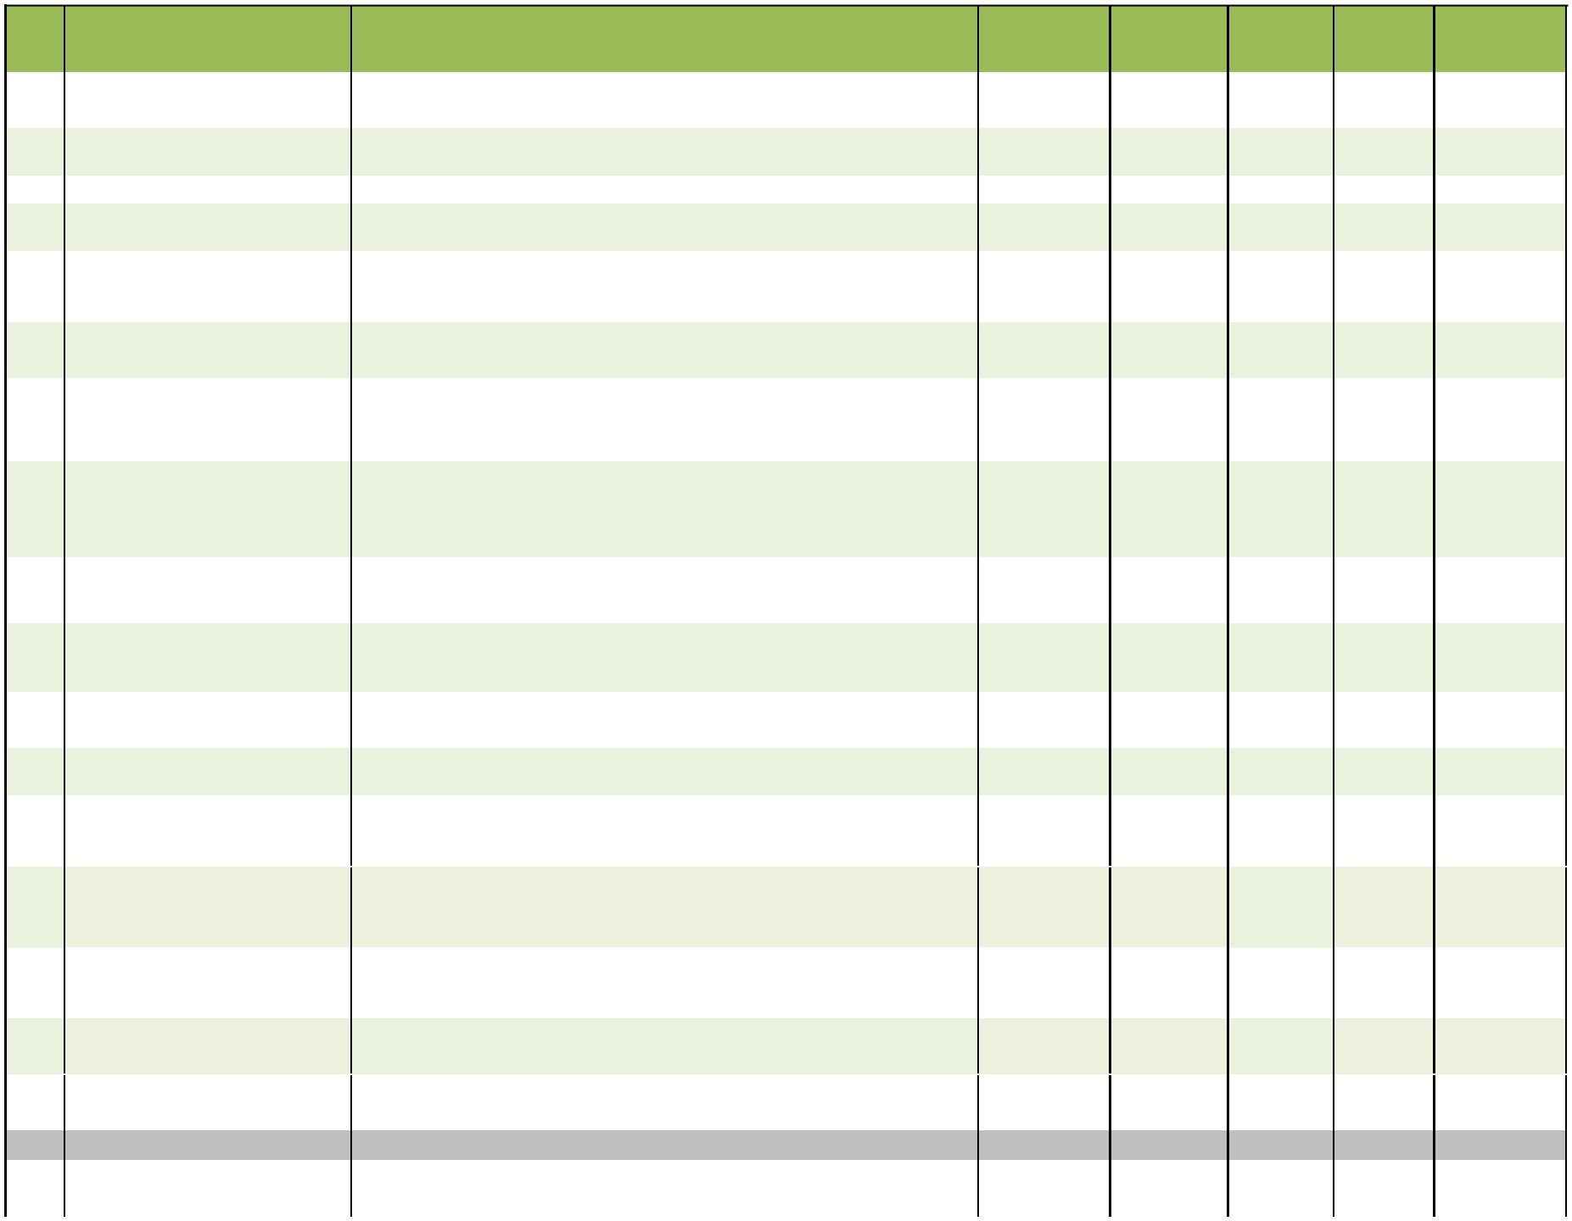
Page 7 of 11
Sr. | Product Name | Composition | Packing | Pack Size MRP/strip |  | MRP
No. |  |  |  |  |  | Box
 |  | Gynecologist
120 | NAUSEFE TAB | Doxylamine 10mg + Pyridoxine 10mg + Folic Acid 5mg | Alu-Alu | 10X10 | 40.00 | 400.00
121 | BENOGEST CAP. (SOFT GEL) Progesterone 200mg |  | Blister | 10X10 | 249.00 | 2490.00
122 | MAXICLAN CAP (SOFT GEL) | Clindamycin Phosphate 100mg + Clotrimazole 20mg + Tinidazole | Blister | 10X1x7 | 160.00 | 1600.00
122 | MAXICLAN CAP (SOFT GEL) | 100mg
123 | NORCEPT TAB. | Norethisterone 5mg | Alu-Alu | 10X10 | 52.00 | 520.00
124 | UP-ARG 9 SACHET | Each sachet (6.5gm) contains:L-Arginine IP 3gm+Proanthocyanidin | Alu. Foil | 10x5gm | 39.00 | 390.00
124 | UP-ARG 9 SACHET | 75mg
 |  | OTHERS
125 | BAXIDIN TAB | Chloridazepoxide 5mg + Clidinium bromide 2.5mg + Dicyclomine 10mg | Alu-Alu | 1X10 | 32.00 | 320.00
126 | DROBEN-M TAB | Drotaverine Hydrochloride 80mg +Mefenamic Acid IP 250mg | Blister | 10x10 | 70.00 | 700.00
127 | ENTHUZAN POWDER (Energy Dextrose, Vitamin C, Sodium Chloride, Potassium Chloride, Citric Acid , |  | Tetra Pack | 100gm | 50.00 | 50.00
 | Drink) | Zinc Sulphate & Sugar
128 | FLAVOZAN-O TAB. | Flavoxate Hydrochloride 200 mg+Ofloxacin 200mg | Alu-Alu | 10x10 | 150.00 | 1500.00
129 | B-PREB CAP | Prebiotic & Probiotic Capsules | Alu-Alu | 10x10 | 89.00 | 890.00
130 | ZACTOGUT ZINC SACHET | Prebiotic & Probiotic Sachet with Zinc | Al. Foil | 25x1 gm | 18.00 | 312.50
131 | DIORITE SYP | Prebiotic & Probiotic Dry Susp. | Pet Bottle | 1X60ml | 125.00 | 125.00
131 | DIORITE SYP | Prebiotic & Probiotic Dry Susp. | with Carton | 1X60ml | 125.00 | 125.00
132 | TAFLOSIN-D TAB. | Tamsulosin 0.4mg + Dutasteride 0.5mg | Alu-Alu | 10x10 | 120.00 | 1200.00
133 | SPARTATE-LPS CAP | L-Ornithine L-Aspartate 150 mg + Pancreatin 100 mg+Silymarin | Blister | 5x15 | 180.00 | 900.00
133 | SPARTATE-LPS CAP | 140MG+ Vitamins
134 | SAVEDENT GEL | Potassium Nitrate BP 5.0% w/w+ Sodium Monofluoro Phosphate USP | Lami Tube | 1x100gm | 99.00 | 99.00
134 | SAVEDENT GEL | 0.7% w/w+ Triclosan USP 0.30 %w/w
135 | SAVEDENT GUM PAINT | Tannic Acid I.P 2% w/v + Zinc Chloride I.P 1% w/v +Cetrimide I.P |  | 1X15 ml | 60.00 | 60.00
135 | SAVEDENT GUM PAINT | 0.1% w/v |  | 1X15 ml | 60.00 | 60.00
136 | CEREVIS SACHET | Each sachet contains:Saccharomyces Boulardii 250 mg | Alu . Foil | 25x1gm | 38.00 | 950.00
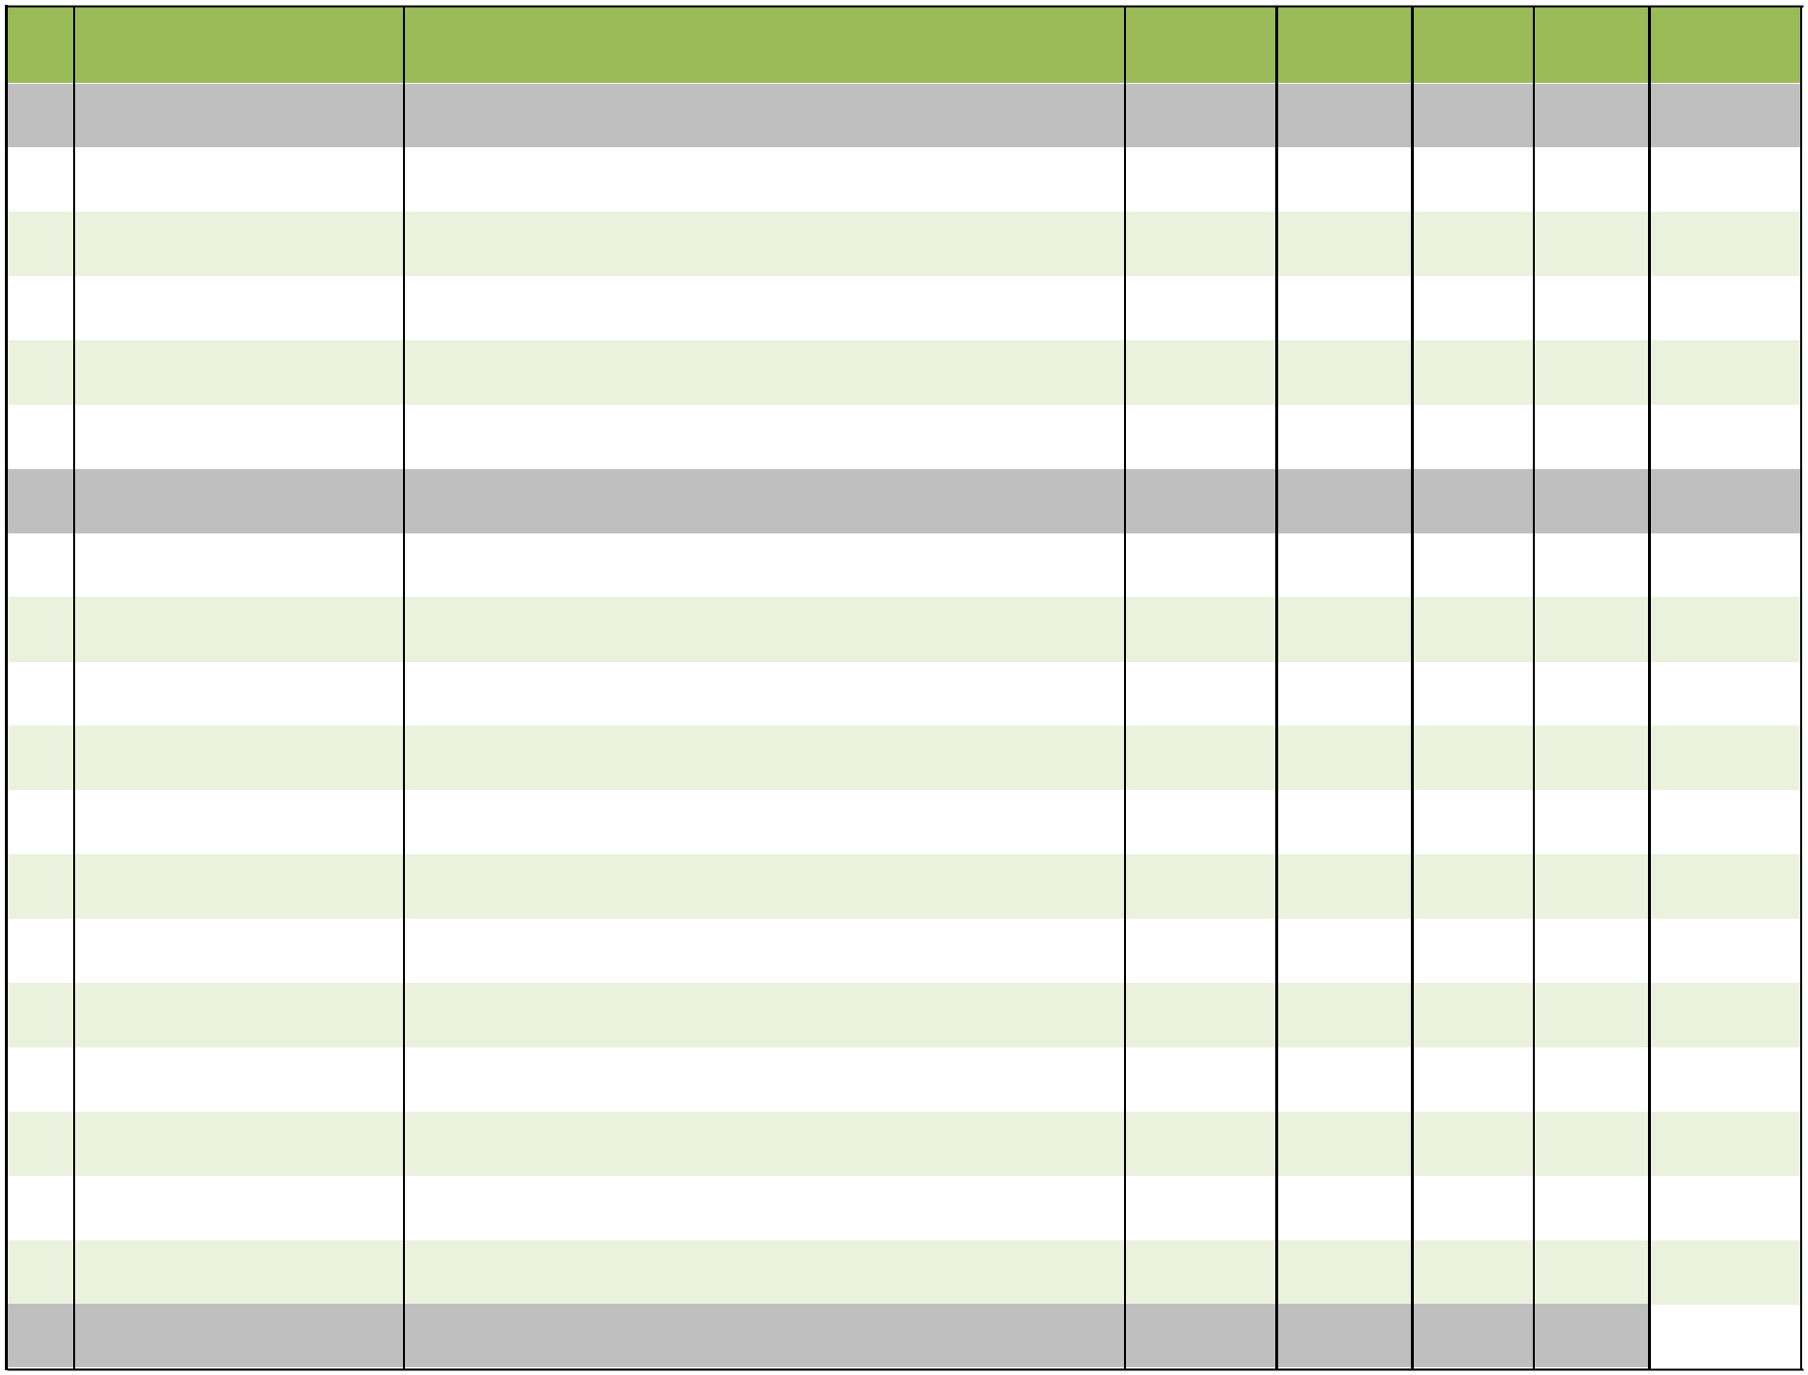
Diabetics

Page 8 of 11

Sr. | Product Name | Composition | Packing | Pack Size MRP/strip |  |  | MRP
No. |  |  |  |  |  |  | Box
137 | TENEGA TAB. | Teneligliptin Hydrobromide Hydrate Eq. to Teneligliptin 20mg | Alu-Alu | 10X10 | 90.00 |  | 900.00
138 | TENEGA - MF TAB. | Teneligliptin Hydrobromide Hydrate Eq. to Teneligliptin 20mg + | Alu-Alu | 10X10 | 115.00 |  | 1150.00
138 | TENEGA - MF TAB. | Metformin Hydrochloride 500mg
 |  | AYURVEDIC
139 | APPETENCE SYP. | Appetizer | Pet Bottle | 1x200ml | 107.00 |  | 107.00
139 | APPETENCE SYP. | Appetizer | with Carton
140 | HEPAZAN SYP | Liver Tonic | Pet Bottle | 1x200ml | 90.00 |  | 90.00
140 | HEPAZAN SYP | Liver Tonic | with Carton
141 | SMASH CAP | For Effective & Safe Management of Kidney Stones | Blister | 10x15 | 105.00 |  | 1050.00
142 | BULKY POWDER | Laxatives Powder sugar free | HDPE Box | 1x100gm | 158.00 |  | 158.00
142 | BULKY POWDER | Laxatives Powder sugar free | with Carton | 1x100gm |  |  | 158.00
143 | MENSOFER SYP | Uterine tonic | Pet Bottle | 1x200ml | 94.00 |  | 94.00
143 | MENSOFER SYP | Uterine tonic | with Carton | 1x200ml |  |  | 94.00
144 | LET UP OIL | Oil for joint pain | Pet Bottle | 1x60ML | 95.00 |  | 95.00
144 | LET UP OIL | Oil for joint pain | with Carton | 1x60ML |  |  | 95.00
145 | LIVERRY FORTE CAP. | For Liver Dysfunctions | HDPE Box | 1X30 | 179.00 |  | 179.00
145 | LIVERRY FORTE CAP. | For Liver Dysfunctions | with Carton | 1X30 |  |  | 179.00
146 | MENSET CAP. | Uterine | Blister | 10X15 | 75.00 |  | 750.00
147 | COHESIVE CAP | HadJod Cap. | Blister | 3x10 | 155.00 |  | 465.00
148 | COHESIVE SYP. | HadJod Syp | Pet Bottle | 1x200ml | 280.00 |  | 280.00
148 | COHESIVE SYP. | HadJod Syp | with Carton | 1x200ml |  |  | 280.00
149 | CLIPTOZAN CAP. | For Hair Fall & Grey Hair | Blister | 3x10 | 229.00 |  | 687.00
150 | CLIPTOZAN HAIR OIL | For Hair Fall & Grey Hair | Pet Bott. With | 1x100ml | 155.00 |  | 155.00
150 | CLIPTOZAN HAIR OIL | For Hair Fall & Grey Hair | Carton | 1x100ml |  |  | 155.00
151 | DIBOZAN CAP | Anti Diabetic Cap. | Blister | 3x10 | 96.00 |  | 288.00
152 | DIBOZAN FORTE CAP | Anti Diabetic Cap. | HDPE Box | 1X30 | 288.00 |  | 288.00
152 | DIBOZAN FORTE CAP | Anti Diabetic Cap. | with Carton | 1X30 |  |  | 288.00
153 | ELEVEN-PM CAP. | Aphrodisiac, stimulant and for youthful vigor and vitality. | Blister | 10X1X1 | 45.00 |  | 450.00
154 | ENZON SYP | Enzyme syrup | Pet Bott. With | 1x200ml | 87.00 |  | 87.00
154 | ENZON SYP | Enzyme syrup | Carton
155 | HONUSS SYP. | For Throat Infection,Bronchitis & Allergic Condition of Respiratory | Pet Bottle | 1X100 ml | 77.00 |  | 77.00
155 | HONUSS SYP. | tract | with Carton
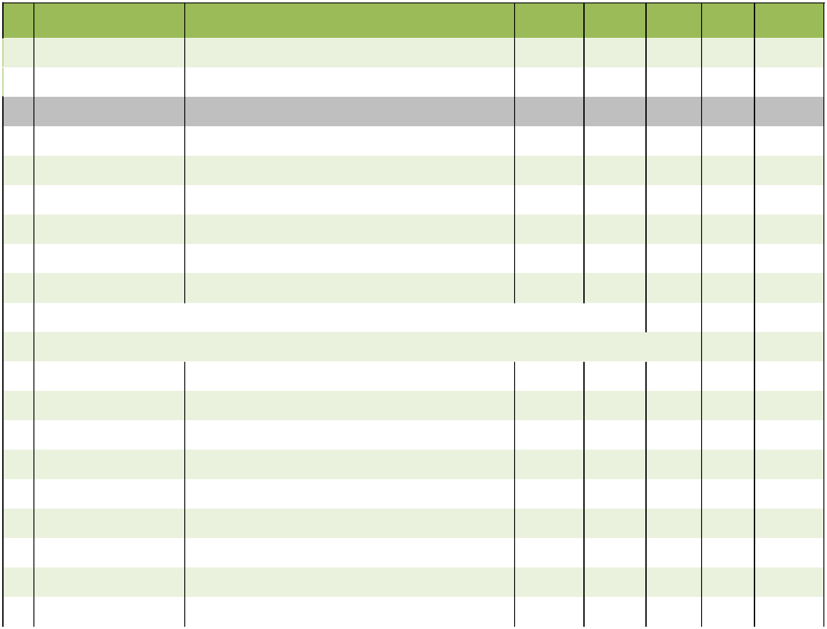

Page 9 of 11

Sr. | Product Name | Composition |  | Packing | Pack Size MRP/strip |  | MRP
No. | Product Name | Composition |  | Packing |  |  | Box
156 | RETENTION PLUS SYP | An Ideal tonic for improve memory & stress relaxation |  | Pet Bottle | 1x200ml | 108.00 | 108.00
156 | RETENTION PLUS SYP |  |  | with Carton
157 | SMASH-AL SYP. | For Effective & Safe Management of Kidney Stones and UTI Disorders. |  | Pet Bottle | 1X100ml | 79.00 | 79.00
157 | SMASH-AL SYP. |  |  | with Carton
158 | SMASH-AL SYP. | For Effective & Safe Management of Kidney Stones and UTI Disorders. |  | Pet Bottle | 1X200ml | 110.00 | 110.00
158 | SMASH-AL SYP. |  |  | with Carton
159 | ZEROPILE CAP | Cap. For Piles,Fisher and Fistula |  | Blister | 3x15 | 120.00 | 360.00
160 | PAPCARI CAP | Useful in Dengue fever, cough and cold,muscular stiffness |  | Blister | 5x1x10 | 175.00 | 875.00
160 | PAPCARI CAP | during fever also increases platelet count
161 | STRESSONIL CAP | Useful In Mental Stress |  | Blister | 10x10 | 60.00 | 600.00
162 | PAPCARI SYP | Useful in Dengue fever and all types of fever during seasonal |  | Pet Bott. | 1X200ml | 148.00 | 148.00
162 | PAPCARI SYP | changes and infections |  | With Carton
163 | IMMTOTAL SYP (Sugar | Boost immunity syp also useful in post operative recovery |  | Pet Bott. | 1X200ml | 139.00 | 139.00
 | Free) |  |  | With Carton
164 | IMMTOTAL CAP. | Boost immunity syp also useful in post operative recovery |  | Blister | 3X10 | 75.00 | 225.00
165 | CHYAWANPRASH (SPECIAL) | Chyawanprash |  | HDEP | 500gm | 209.00 | 209.00
166 | TUMMY OK OIL | Natural Hing & Fennel Oil to Relives Tummy Discomfort , Gas / |  | ROLL ON | 1X50 ML | 198.00 | 68.00
166 | TUMMY OK OIL | Pain and Relives Indigestion |  | BOTT.
 |  | OPTHHALMOLOGIST RANGE
 |  | Chlorpheniramine Maleate IP 0.01% w/v + Naphazoline
 |  | Hydrochloride USP 0.05 % w/v + Phenylephrine Hydrochloride
167 | ICEZOLE GOLD | 0.12% w/v + Menthol 0.005 % w/v + Camphor 0.01% + |  | Eye Drop | 10ML | 75.00 | 75.00
167 | ICEZOLE GOLD | Hydroxypropylmethylcellulose IP 0.2% w/v + Boric Acid 1.25% +
 |  | Benzalkonium Chloride Solution IP 0.02% v/v (As preservative) )
 |  | In sterile aqueous vehicle q.s..
 |  | Moxifloxacin Hydrochloride | IP eq. to Moxifloxacin 0.5% w/v
168 | MOFELOX-LT | Loteprednol Etabonate 0.5% w/v Benzalkonium Chloride |  | Eye Drop | 5ml | 135.00 | 135.00
168 | MOFELOX-LT | Solution IP 0.02% v/v (As preservative) Sterile aqueous buffered
 |  | vehicle q.s.
169 | MOFELOX GOLD | Moxifloxacin Hydrochloride | IP eq. to Moxifloxacin 0.5% w/v | Eye Drop | 5ml with | 125.00 | 125.00
169 | MOFELOX GOLD | Sterile aqueous vehicle q.s. |  | Eye Drop | Tray | 125.00 | 125.00
 |  | Tobramycin Sulfate USP Eq. to Tobramycin 0.3%w/v
170 | T-FlOW GOLD | Fluorometholone IP | 0.1%w/v Benzalkonium | Eye Drop | 5ml | 120.00 | 120.00
170 | T-FlOW GOLD | Chloride Solution IP 0.02%v/v (As preservative) Sterile aqueous
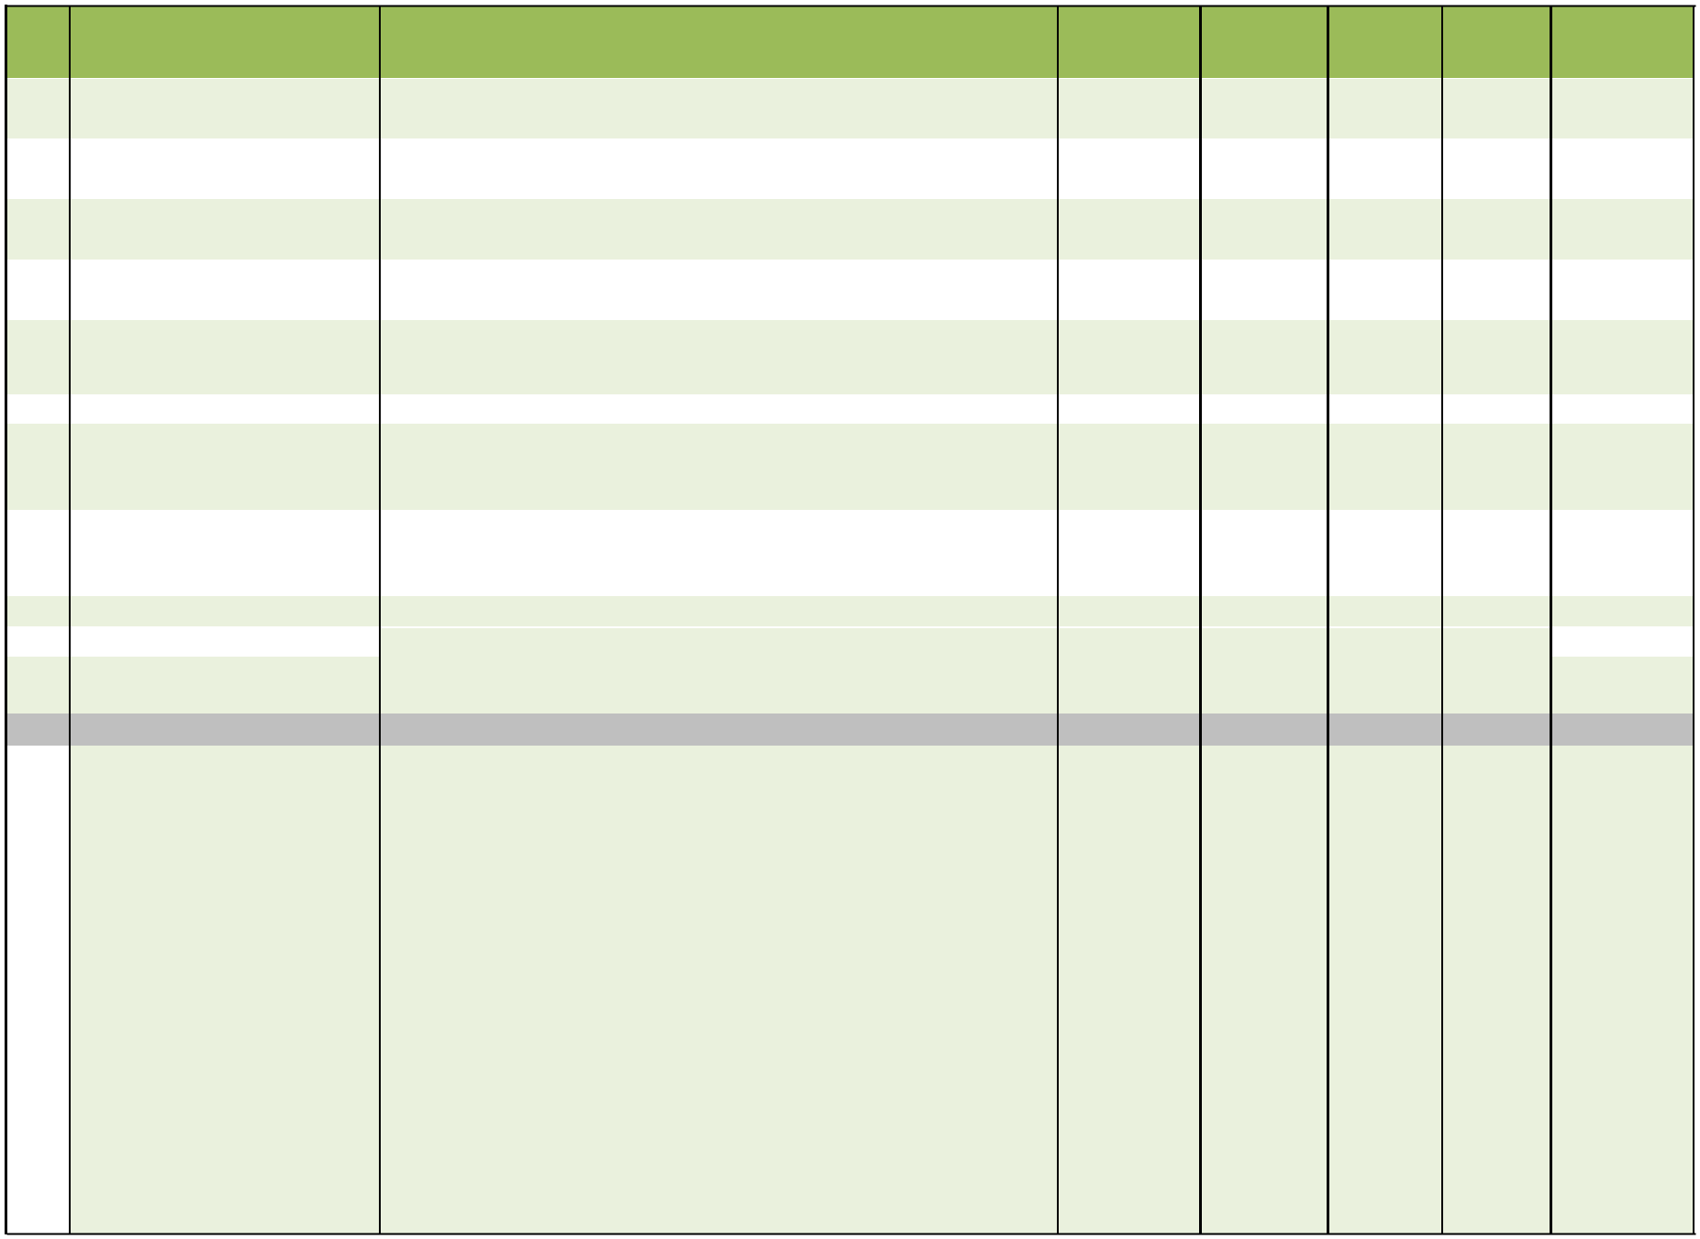
vehicle q.s.

Page 10 of 11

Sr. | Product Name | Composition | Packing | Pack Size MRP/strip |  | MRP
No. |  |  |  |  |  | Box
 |  | Moxifloxicin Hydrochloride BP eq to Moxifloxacine 0.5%w/v
 |  | Dexamethasone Sodium phosphate IP eq to Dexamethasone
171 | MOFELOX-DM | phosphate 0.1%w/v | Eye Drop | 5ml | 70.00 | 70.00
171 | MOFELOX-DM | Benzalconium chloride IP 0.02%w/v
 |  | Sterile Aqueous buffered vehicle qs
172 | DRIPSY GEL | Sodium Carboxymethyl Cellulose IP 1.0%w/v + Stabilized | Eye Drop | 10ml with | 140.00 | 140.00
172 | DRIPSY GEL | Oxychloro Complex 0.0075%w/v (As preservative) Sterile
 |  |  |  | Tray | 140.00 | 140.00
 |  | aqueous vehicle q.s. |  | Tray
173 | DRIPSY GOLD | Sodium Carboxymethyl Cellulose IP 0.5% w/v + Stabilized | Eye Drop | 10ml with | 100.00 | 100.00
173 | DRIPSY GOLD | Oxychloro Complex 0.005% w/v(As preservative) Sterile
 |  |  |  | Tray | 100.00 | 100.00
 |  | Aqueous vehicle q.s |  | Tray
174 | MYTOCIN | Tobramycin sulfate usp equivalent to Tobramycin 0.3 % w/v + | Eye Drop | 5ml | 65.00 | 65.00
174 | MYTOCIN | Benzalconium chloride 0.02% w/v
 |  | Sodium Hyaluronate 0.1% w/v |  | 10ml with
175 | RONATE-H | Stabilized oxychlorocomplex (purite) + 0.005% w/v | Eye Drop | 10ml with | 250.00 | 250.00
175 | RONATE-H | Purified water IP qs | Eye Drop | Tray | 250.00 | 250.00
176 | LUTEIN GOLD | Astaxanthin 4 MG+Elemental copper 2 MG+Elemental zinc 12 | Blister | 10x1x10 | 190.00 | 1900.00
176 | LUTEIN GOLD | MG+Lutein 5 MG+Resveratrol 5 MG+Tocotrienol 12.5
 |  | MG+Zeaxanthin 1 MG
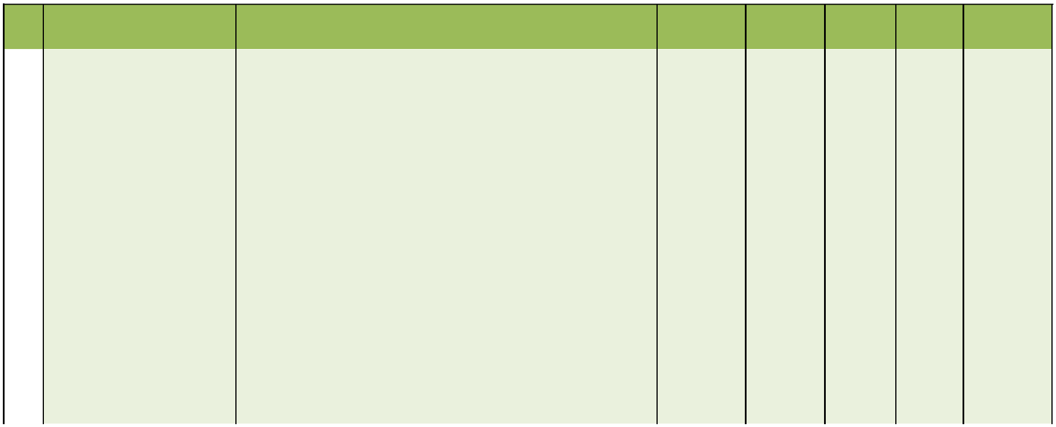

Page 11 of 11

