Laerdal Universal AED trainer

The Laerdal Universal Trainerin a carrying case designed for efficiency in the classroom. The AED trainer can be used by anyone taking a CPR first aid course and can also be used in certain scenarios in the AHLR curriculum. The product is designed for effectiveness in the classroom and is also suitable for training resuscitation teams.

he AED trainer is a very versatile product. It can be used with the electrodes pre-connected or disconnected, it has options for automatic or manual development of scenarios, and you can use your preferred training manikin with the device

The QCPR app gives the instructor control over multiple AED trainers at the same time. It simplifies and improves efficiency in the classroom. The QCPR app extends the device's functionality

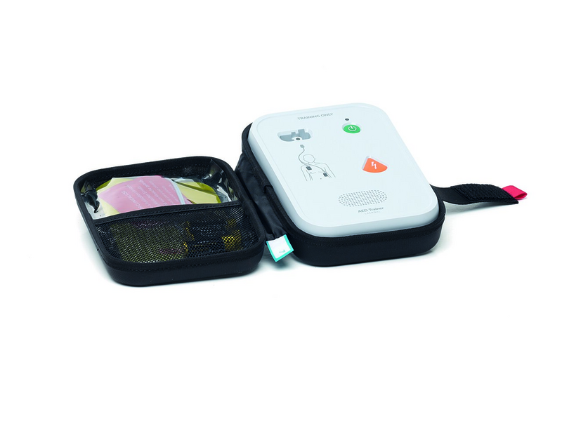

* Child mode on/off
* Fully automatic on/off
* Metronome on/off
* Manual indication of electrode placement
* Volume control
* Stop scenario
* Scenario selection – six scenarios

The AED trainer represents the most common features of all AEDs on the market, allowing users to feel competent and confident enough to use an AED they face in real-world situations.

**Six preset training scenarios (adult/child)**  
Simulate the most common scenarios, such as:

* shocking rhythms
* non-shockable rhythms
* poor electrode connection

**Customize Your AED Trainer**  
The AED Trainer includes several options for customizing the training equipment to resemble AEDs in the local market:

* Pre-connected and non-connected electrodes. We recommend pre-wired, as most clinical AEDs use this setup
* If you use the QCPR app, you can choose metronome off or on and fully automatic or semi-automatic

**Compatible with Laerdal LINK**  
Use LINK electrodes for automatic detection of electrode placement and evolving scenario with LINK-enabled training dummies.

**Ready for any setup**  
The AED trainer can be used standalone using the control panel on the device, with or without the QCPR app for added functionality, and with or without a Laerdal QCPR training manikin.