Digital Estate Plan (Template)

This is a copy of my Digital Estate Plan. It describes what should happen to all my digital assets after my death. It should be administered by the Executors named in my Will. However, if I have chosen a Digital Executor, and if they are not already an Executor in my Will, I would like the Executors to seek their help and counsel in managing the Digital Assets.

Personal Information
Full Name: |  | Email:
Address: |  | Date of Birth:

Digital Executor Details
This person has no legal recognition unless they are also named in the Will as an Executor, but I would like the Executors to seek their advice in managing my Digital Assets.
Full Name: |  | Email:
Address: |  | Relationship to me:

Password Management
If I use a password management tool, this is the name of the tool and the email address associated with this account. If I have set an emergency access email belonging to a third party (loved one, executor), I also state that here and the delay set before the account is released
Tool: |  | Email account linked to the tool:
Emergency email (optional): |  | Emergency email access delay period (optional):

Email Accounts
e.g. Gmail, Outlook, AOL….
Provider | Login Email | Password Stored Where? | Instructions

Social Media Accounts
e.g.. Facebook, LinkedIn, Instagram…
Platform | Login Username/Email | Password Stored Where? | Instructions

Monetary Value Accounts
With possible cash/cash equivalents but NOT banking – executor to be careful about withdrawing e.g. Trading212, eBay, Gambling
Institution | Account Type | Login Username/Email | Password Stored Where? | Instructions

Subscription Services
e.g. Netflix, Disney+, Spotfiy, Sky…
Provider | Login Username/Email | Password Stored Where? | Instructions

Cloud Storage Accounts
e.g. OneDrive, Dropbox, iCloud
Provider | Login Username/Email | Password Stored Where? | Instructions

Digital Devices
e.g. External Hard Drive, USB stick, Digital camera with SD card, Holiday photo DVDs
Device Type | Location | Login Username/Email | Password Stored Where? | Instructions

Utility and other non-Retail accounts
e.g. British Gas, EDF Energy, Thames Water….
Asset Type | Login Username/Email | Password Stored Where? | Instructions

Retailer Accounts
e.g. Tesco, M&S, Argos, Amazon…
Site | Username | Associated Asset | Instructions

Loyalty Accounts
e.g. Tesco Clubcard, British Airways, Nectar…
Service | Username | Instructions

Gaming Accounts
e.g. Unisoft, Steam, Xbox
Domain Provider | Domain Name | Login Username/Email | Password Stored Where? | Instructions

Cryptocurrency and Wallets
e.g. Crypto.com, Coinbase, Kraken…
Wallet Provider | Account Email/Username | Private Key/Password Storage | Access Instructions

Domain Names and Websites
e.g. GoDaddy, Hostinger, 123-Reg…
Domain Provider | Domain Name | Login Username/Email | Password Stored Where? | Instructions

Copyrighted Works & Online Content
e.g. Nielsen, Amazon, Barnes and Noble…
Platform | Details of Content/Work | Instructions

General Instructions for Executors
Anything not covered above or general advice or guidance to support account recovery:
General Notes

Signed
These are my instructions regarding my Digital assets.
Signed: |  | Date:

Update dates
To identify more easily the latest status for my executors:
Update date | Update date | Update date | Update date

Template by Not So Grave. You can find more templates like this covering all aspects of estate planning at www.notsograve.co.uk.
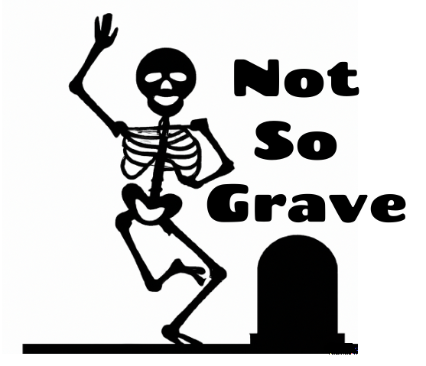
This template is provided free of charge for your personal use. Feel free to adapt it to suit your own needs. However, it must not be sold, shared commercially, or used for any financial gain without written permission. This work is protected by copyright and owned by Alveta Media Ltd. Please note, we can’t accept responsibility for any loss or issues that may arise from its use.

