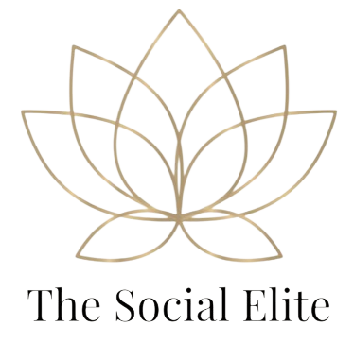

**Social Media Basics Package**

Starter Social Media Management Package - $50/month

**Perfect for small businesses, entrepreneurs, and startups who want to maintain a consistent and professional presence on Facebook and Instagram — without the stress of managing it daily.**

This package is designed for those who **just need to stay active**, keep their brand looking polished, and remind their audience that they are open for business. If you're not ready to post daily but still want **quality content that reflects your brand**, this is the ideal solution!

**Includes:**  
 ✅ 4 custom posts per month (1 post/week) — **Branded to match your business look and feel**  
 ✅ High-quality graphics and engaging captions  
 ✅ A reusable hashtag set (10-15 targeted hashtags to boost reach)  
 ✅ Monthly post scheduling on Facebook & Instagram — **fully automated and done for you**  
 ✅ 1 monthly check-in for updates (promotions, announcements, etc.)

**Why Choose This Package?**

* You want a **professional and consistent presence** without a large investment.
* You don’t have time to manage social media but know **it's important to stay active**.
* You want to **avoid gaps in posting** and make sure your followers see you online.
* Perfect for **small businesses, freelancers, and side hustlers** looking to maintain visibility and stay connected to their audience.