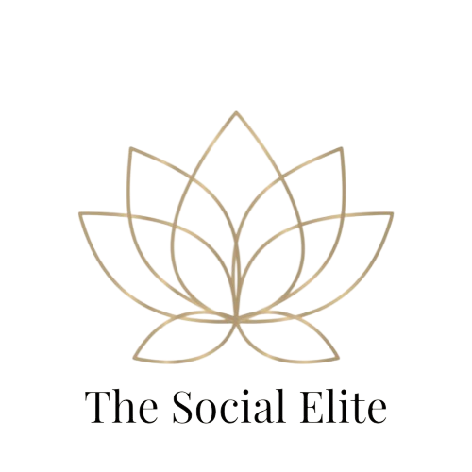

**Pro Package: Engage, Grow & Optimize**

### Pro Social Media Management Package - $150/month

**Designed for businesses that want a strong, consistent online presence with more interaction, ongoing optimization, and monthly performance insights.**

This package is perfect for brands that are **serious about growing their audience, building trust, and engaging regularly** with their community. With a higher posting frequency and light page monitoring, we help you stay visible and connected to your audience — without you having to do the work!

**Includes:**  
 ✅ 12 custom posts per month (3 posts/week) — **professionally branded graphics with strategic captions**  
 ✅ Tailored hashtag research and optimization — **fresh, targeted hashtags to maximize reach and engagement**  
 ✅ Monthly scheduling for Facebook & Instagram — **fully automated and hands-free for you**  
 ✅ Light page monitoring — **responding to comments and DMs twice a week** to maintain engagement and show you're active  
 ✅ Monthly content calendar — **you approve all content before posting**  
 ✅ Basic monthly performance report — **overview of post engagement, reach, and growth insights**

**Why Choose This Package?**

* You want a **professional, high-quality social media presence** that reflects your brand consistently.
* You’re ready to **engage with your audience more regularly** and grow trust and loyalty.
* You want **real insights** on what’s working through monthly performance reports.
* Perfect for **established businesses and growing brands** who want to stay competitive and connected online — **without managing it themselves**.