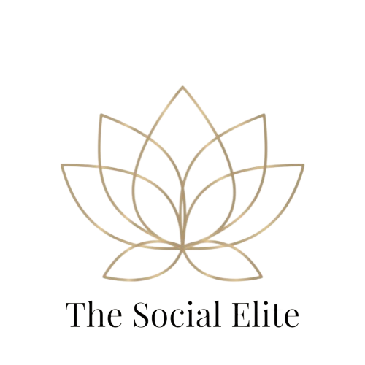

**Growth Package: Build & Engage**

### Growth Social Media Management Package - $100/month

**Ideal for growing businesses that are ready to build a stronger presence on social media with regular posting and light engagement.**

This package is designed for brands that want to **stay consistent, look professional, and interact with their audience**, without spending hours managing their social accounts. It's perfect for businesses looking to **increase brand awareness, attract more followers, and engage with their community** — while focusing on running their business.

**Includes:**  
 ✅ 8 custom posts per month (2 posts/week) — **branded graphics and captivating captions**  
 ✅ Tailored hashtag sets (up to 20 targeted hashtags for better reach and visibility)  
 ✅ Monthly scheduling for Facebook & Instagram — **hands-off for you**  
 ✅ Light engagement — **responding to comments and DMs once a week** to show followers you’re active and listening  
 ✅ Monthly content plan preview — **you approve content before posting**  
 ✅ Professional, consistent content that reflects your brand identity

**Why Choose This Package?**

* You’re ready for a **consistent and polished presence** on social media.
* You want to **engage lightly with your audience** without having to be online all the time.
* Perfect for **businesses looking to grow their reach, increase visibility, and maintain customer relationships**.
* Great balance of quality content and light interaction — **done-for-you** so you can focus on your business.