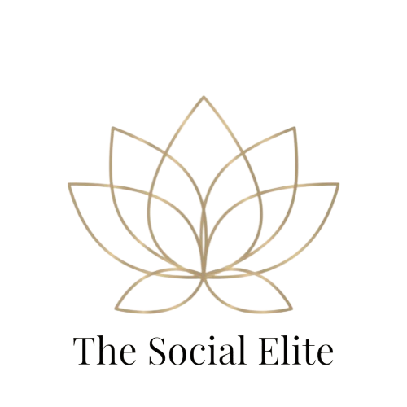

### **Business Pro Package**

## Business Pro Social Media Management Package - $300/month

**Perfect for growing businesses that want consistent, high-quality content, deeper engagement with their audience, and a strong, ongoing presence on Facebook and Instagram.**

This package is ideal for brands looking to **build trust, grow their following, and stay top-of-mind** with customers — without having to manage their social media day-to-day. We handle everything from content creation to engagement, so you can focus on running your business.

### **What’s Included:**

* ✅ **16 custom posts per month (4 posts/week)** — Eye-catching, branded graphics and professionally written captions designed to reflect your brand voice and connect with your audience.
* ✅ **Tailored hashtag research and optimization** — A fresh set of targeted hashtags each month to improve reach, visibility, and attract new followers.
* ✅ **Monthly scheduling and automation** — All posts are scheduled in advance for both Facebook and Instagram, so you never have to worry about what to post or when.
* ✅ **Light engagement and interaction** — Responding to comments and direct messages **3 times per week**, helping to maintain an active and responsive online presence.
* ✅ **Monthly content calendar for approval** — You’ll receive a detailed content plan each month, giving you the opportunity to review and approve posts before they go live.
* ✅ **Basic monthly performance report** — A simple but insightful report summarizing key metrics like reach, engagement, and growth, so you can see what’s working.
* ✅ **1 custom Story set per month (up to 4 slides)** — Designed to promote sales, events, or special announcements in a fun and engaging way.

### **Why Choose This Package?**

* **Consistent and professional content** that keeps your brand active and visible.
* **Light audience engagement** to build trust and maintain customer relationships.
* **Time-saving** — We take social media management off your plate, so you can focus on running your business.
* Great for **small to medium-sized businesses** ready to grow their brand and stay connected to their community.