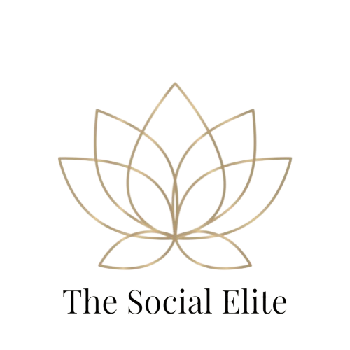

**Brand Growth & Engagement Package**

Brand Growth Social Media Management Package - $600/month

**Designed for brands that are ready to take their content strategy to the next level and grow faster with more consistent content, deeper engagement, and stronger brand presence.**

This package is ideal for businesses looking to **boost visibility, increase engagement, and attract more followers and customers** — without having to worry about daily social media management. Perfect for brands that are scaling up and want **regular content and meaningful interaction with their audience**.

### **What’s Included:**

* ✅ **24 custom posts per month (6 posts/week)** — A mix of beautifully designed feed posts, branded graphics, and lifestyle content that tells your brand story and engages your audience.
* ✅ **Tailored hashtag sets optimized for each post** — Research-backed hashtags specific to each post to maximize visibility and reach the right audience.
* ✅ **Full content scheduling for Facebook & Instagram** — Consistent posting without you lifting a finger — we handle all scheduling and automation.
* ✅ **Engagement and community management** — Responding to comments and direct messages **4 times per week**, helping to foster real connections and maintain an active presence.
* ✅ **Monthly content calendar for approval** — Preview and approve all posts before they go live, ensuring alignment with your brand's voice and promotions.
* ✅ **2 Story sets (up to 4 slides each)** — Engaging Stories designed for promotions, events, or announcements to boost engagement and visibility.
* ✅ **Basic reels (2 per month)** — Short-form video content (created from client-provided materials or stock) to boost reach and capture audience attention.
* ✅ **Detailed monthly performance report** — In-depth insights on content performance, audience engagement, and growth, with **recommendations to improve future results**.

### **Why Choose This Package?**

* **High-volume, professional content** to keep your brand active and engaging daily.
* **Customized strategy** to reflect your unique brand and attract the right audience.
* **Increased interaction and community building**, helping you build trust and relationships with followers.
* Ideal for **growing brands that are ready to scale their online presence** and drive more business through social media.