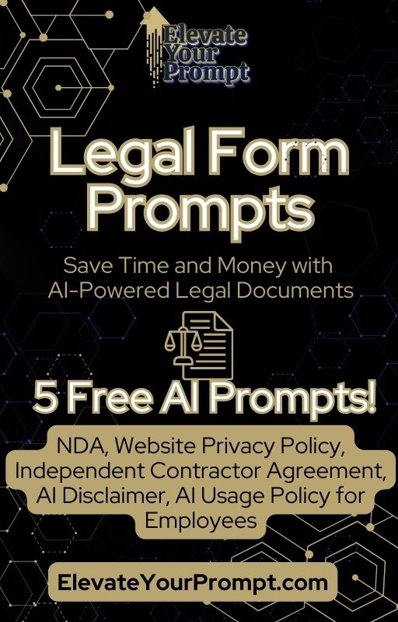

Disclaimer

This is for informational purposes only. For legal advice or assistance, consult a professional.
Disclaimer:
The AI-generated prompts provided on this website and in our digital products are intended for informational and educational purposes only. They are not a substitute for legal advice from a qualified attorney.
While we strive to provide accurate and comprehensive prompts, the legal landscape is constantly evolving, and laws vary by jurisdiction. The AI-generated content may not be suitable for all situations or comply with all applicable laws.
Benefits of Using Our Prompts:
Our prompts are designed to give you a good starting point for creating various legal documents. By using our prompts, you can save time and money on lawyer fees by having them review a draft instead of starting from scratch. This allows you to be more efficient and informed in your legal matters.
No Legal Advice:
The information provided on this website and in our products is not legal advice and should not be relied upon as such. We are not a law firm and do not provide legal services.
Recommendation:
We strongly encourage you to seek the advice of a qualified attorney for any legal matters. An attorney can review your specific situation, provide personalized guidance, and ensure that your legal documents are accurate, complete, and comply with all applicable laws.
Liability Release:
By using this website and our products, you agree to release us from any liability arising from your use of the AI-generated content. We are not responsible for any damages or losses resulting from your reliance on the information provided.
User Responsibility:
You are solely responsible for ensuring that any legal documents you create using our prompts are accurate, complete, and comply with all applicable laws. You should always have legal documents reviewed by an attorney before relying on them.
Contact:
If you have any questions or concerns, please contact us at info@elevateyourprompt.com.
These prompts are provided for your personal use only. You may use them to generate legal documents for yourself or your own business. However, you do not have permission to resell, redistribute, or share these prompts with others, whether for commercial or non-commercial purposes. This includes, but is not limited to, sharing the prompts on online platforms, selling them as part of another product, or distributing them within an organization.

5 Free AI-Powered Legal Prompts
These legal prompts are designed to save you time and money by helping you generate essential business documents quickly.
1. Non-Disclosure Agreement (NDA)
Prompt:
"Generate a legally binding Non-Disclosure Agreement (NDA) that protects confidential business information. It should include standard confidentiality clauses such as definitions, exclusions, duration, and remedies for breaches, while complying with [State] laws. This version should exclude industry-specific variations."
2. AI Disclaimer for AI-Generated Content
Prompt:
"Generate a basic disclaimer for AI-generated content on my website. It should inform users that content is AI-generated, may not be 100% accurate, and should not be relied on for professional, legal, medical, or financial decisions. Ensure compliance with [State] and federal regulations. This version should exclude industry-specific adaptations."
3. Independent Contractor Agreement
Prompt:
"I need a simple Independent Contractor Agreement for hiring a freelancer. It should include essential terms such as payment details, project scope, confidentiality, and work-for-hire clauses. The agreement must comply with [State] laws and clearly define the contractor as an independent entity. This version should exclude specialized clauses such as liability waivers, detailed termination terms, and IP ownership specifics."
4. Website Privacy Policy
Prompt:
"Generate a basic Privacy Policy for my website that complies with [State] laws. It should outline what data is collected, how it is used, and user rights regarding their information. This version should exclude international compliance measures such as GDPR or CCPA regulations."
5. AI Usage Policy for Employees
Prompt:
"Generate a basic AI Usage Policy for employees in my business. It should outline acceptable AI use, data privacy concerns, potential risks, and compliance with company security policies. Ensure compliance with [State] labor laws. This version should exclude detailed enforcement scenarios or industry-specific applications."

