TRAIL BINGO
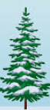  Evergreen Tree | 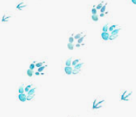  Animal Tracks in Mud | 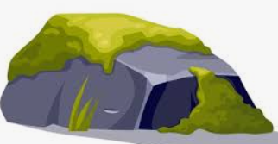  Moss on a Rock | 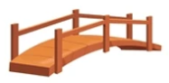  Wooden Footbridge | 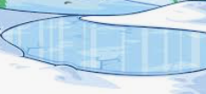  Something Frozen
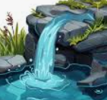  Running Water |   Bird Call | 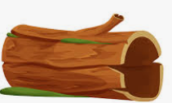  Fallen Log | 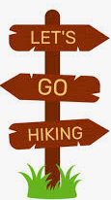  Trail Sign | 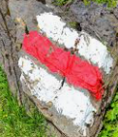  Something Red
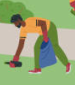  Help keep park Clean  report trash to leader | 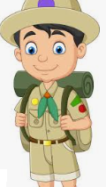  Scout in your Patrol | 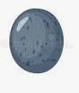  Smooth Pebble | 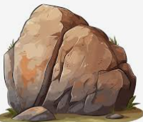  A rock bigger  than your head | 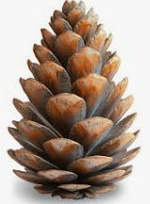  Pinecone
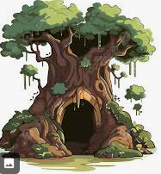  Hollow Tree | 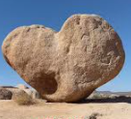  Something heart-shaped | 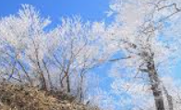  Ice Crystals | 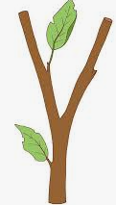  A “Y” shaped Stick | 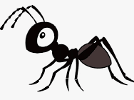  Something Tiny
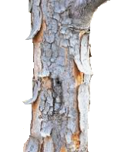  Bark Peeling | 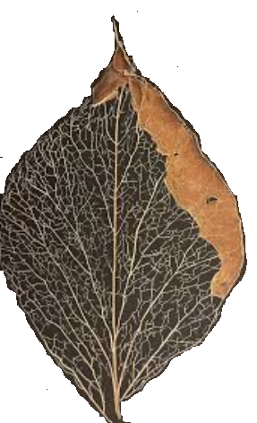  Leaf Skeleton | 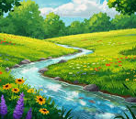  Stream Bend | 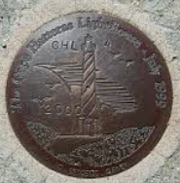  Something Round | 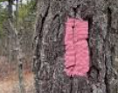  Pink blaze marker

TRAIL BINGO
Evergreen Tree | Animal Tracks in Mud | Moss on a Rock | Wooden Footbridge | Something Frozen
Running Water | Bird Call | Fallen Log | Trail Sign | Something Red
Help keep the park Clean  (report trash to a leader) | Scout in your Patrol | Smooth Pebble | A rock bigger  than your head | Pinecone
Hollow Tree | Something heart-shaped | Ice Crystals | A “Y” shaped Stick | Something Tiny
Bark Peeling | Leaf Skeleton | Stream Bend | Something Round | Pink blaze marker

