PRACTICE BINGO – need a buddy (2 or 3 scout groups)
Something Orange | 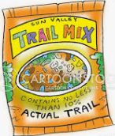  Trail Food | 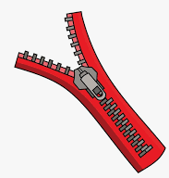  A zipper | 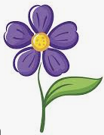  A flower
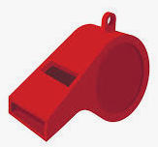  Whistle | 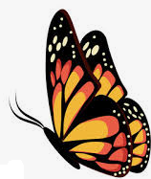  A butterfly | 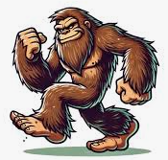  Bigfoot | 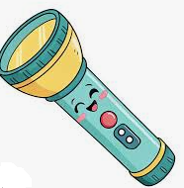  Flashlight
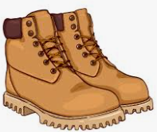  Boots | 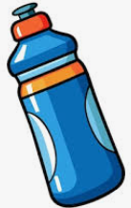  Water Bottle | 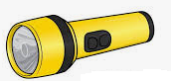  Two different  colored flashlights | 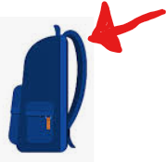  Backpack strap
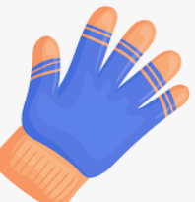  Gloves or Mittens | 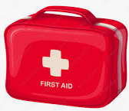  First Aid Kit | 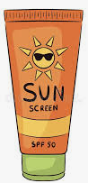  Sun Protection | 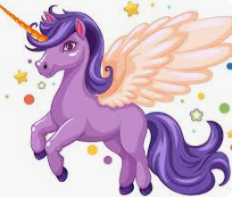  A unicorn

PRACTICE BINGO – need a buddy (2 or 3 scout groups)
Something Orange | Trail Food | A zipper | A flower
Whistle | A butterfly | Bigfoot | Flashlight
Boots | Water Bottle | Two different  colored flashlights | Backpack strap
Gloves or Mittens | First Aid Kit | Sun Protection | A unicorn

