Pack Bike Rides & Rank Advancement
Leader Overview
This document is a high-level reference showing how pack bike rides are often used to support bike-related rank adventures.
You do not need to complete every item in one ride.
Use what fits your group, your time, and the scouts attending.
Pack bike rides are meant to be practical, flexible, and supportive — not formal classes.
How Advancement Fits Into a Pack Bike Ride
Pack bike rides are commonly structured to include both group safety instruction and age-appropriate skill practice.
A typical flow may look like:
- Begin with a short, whole-group review (helmets, hand signals, riding together)
- Younger scouts start the ride with leaders and parents
- Older scouts may stay briefly to demonstrate additional skills
- Groups rejoin and ride together when appropriate
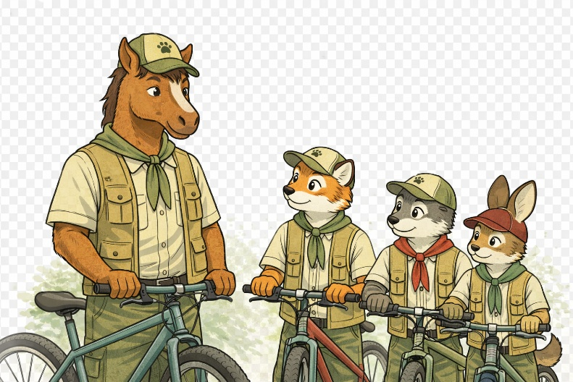
This approach allows scouts to practice skills naturally while keeping the ride moving and enjoyable.

Rank by Rank Advancement Overview
he sections below summarize common bike-related adventure elements that may be supported during a pack bike ride.
For full and current requirements, always refer to official BSA resources.

Tiger — Rolling Tigers (Elective)
Bike-related elements for Tiger scouts often include:
- Wearing a properly fitted helmet
- Learning basic bike safety rules
- Practicing simple hand signals
- Going on a short bike ride with an adult partner
Pack bike rides may help fulfill parts of this elective through group safety review and riding together with family or leaders.

Wolf — Pedal With the Pack (Elective)
Bike-related elements for Wolf scouts often include:
- Helmet use and fit
- Choosing appropriate clothing
- Learning about different types of bikes
- Demonstrating starting and stopping
- Practicing hand signals
- Riding with a buddy
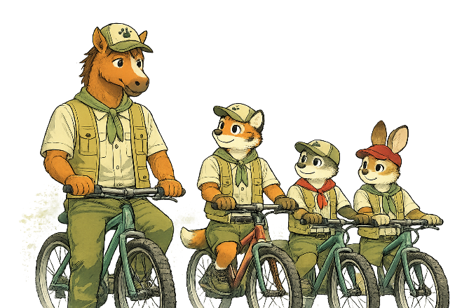
Many of these items are naturally covered during the group safety review and the ride itself.

Bear — Bears on Bikes (Elective)
Bike-related elements for Bear scouts often include:
- Helmet and safety gear review
- Identifying bike parts
- Demonstrating basic bike adjustments
- Using hand signals
- Inflating tires or operating brakes
- Participating in a 30-minute group bike ride
During pack bike rides, older scouts may stay briefly before or after the main ride to demonstrate these skills.

Webelos & Arrow of Light — Cycling (Elective)
Bike-related elements for Webelos and Arrow of Light scouts often include:
- Planning for longer rides
- Understanding bike gears
- Learning basic bike maintenance concepts
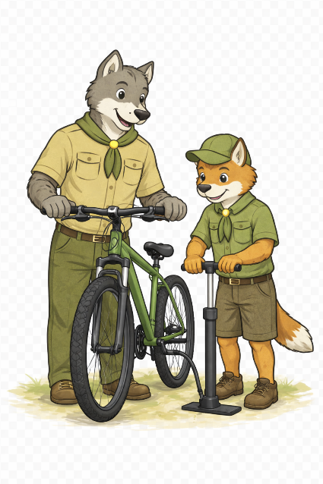
These items are often addressed separately or in small groups, depending on the scouts attending.

Important Notes for Leaders
- Not every scout will complete every adventure item in one ride
- Advancement can be completed across multiple events
- Other leaders or parents can assist with demonstrations
- Use your judgment and adjust based on the group
- Keep the focus on safety, learning, and fun
Pack bike rides support advancement best when they feel practical and low-pressure.

Official Advancement Resources
For full and current requirements, refer to official BSA Cub Scout Adventure resources:
- Tiger — Rolling Tigers
- Wolf — Pedal With the Pack
- Bear — Bears on Bikes
- Webelos / Arrow of Light — Cycling

