Pack Bike Ride Safety
A leader resource
This page is a quick reference to help leaders cover key safety points before a pack bike ride.
You don’t need to cover everything — focus on what fits your group, the route, and the day.
Other leaders are always encouraged to help during the ride.

Rider Safety Equipment
Before the ride begins, it helps to do a quick check to make sure riders are set up safely and comfortably.
At a minimum, riders should have a properly fitted bike helmet and wear closed-toe shoes. Bringing water is important, especially on warmer days or longer rides.
Some families may also choose to use additional protective gear, such as knee or elbow pads. These are optional but can be helpful for newer or less confident riders.
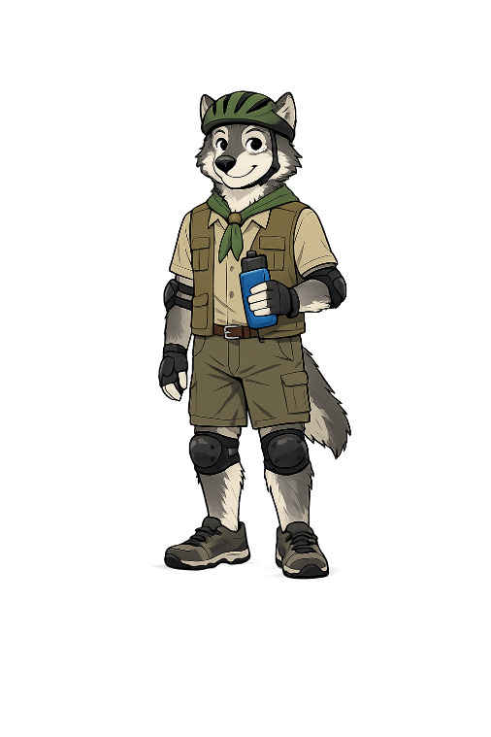
A brief reminder at the start helps everyone feel prepared before heading out.
Bike Helmet

OPTIONAL:
knee and elbow pads
Bring water

Closed Toe Shoes

Bike Types You May See on a Pack Ride
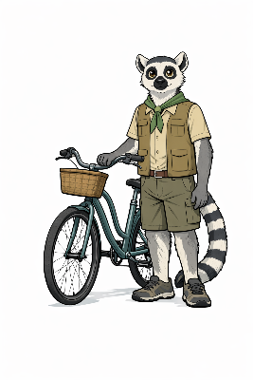
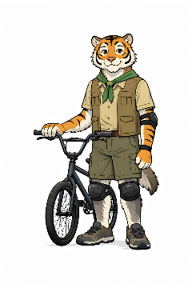
Pack bike rides often include a mix of bike styles. You don’t need to explain every detail — just pointing out that bikes can differ helps set expectations.
You may see:
- BMX bikes, which are common for younger riders
- Road bikes, often ridden by adults
- Hybrid bikes, which work well on many trails
- Cruiser bikes, which are less common but welcome

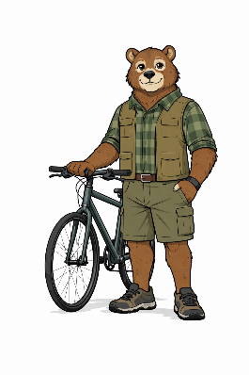
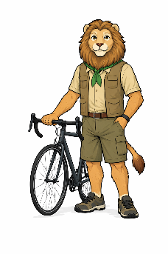
Different bikes may stop in different ways. Some use hand brakes, while others may use pedal brakes. A quick mention helps riders stay aware of how their own bike works.

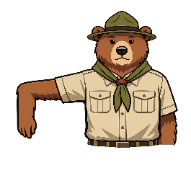
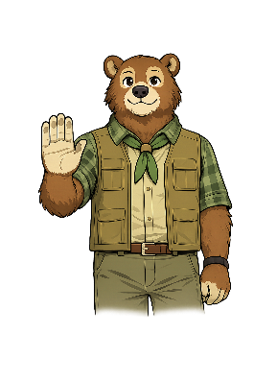

Hand Signals to Review
Before starting the ride, it’s helpful to review a few basic hand signals so riders know what to watch for while moving together.
Be sure to demonstrate both turn signals.
The left turn signal is intuitive (arm straight out), while the right turn signal uses a bent arm and is helpful to show clearly.

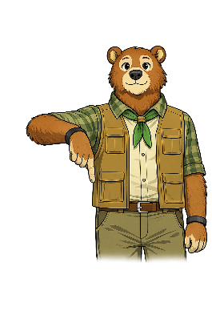
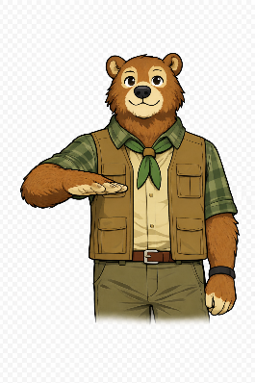

Riding Together & Situational Safety
Pack rides work best when everyone rides together and looks out for one another.
Helpful reminders to share:
- Ride on the right and pass on the left
- Use the buddy system and stay with your buddy
- If you need to stop, stop with your buddy and let a leader know
- Take water breaks as needed
It’s also good to keep the day’s conditions in mind. Weather, trail conditions, and group energy may affect pace or the number of breaks needed.

Still Have Questions?
You don’t need to do this alone. If you’re unsure about anything, reach out to another leader or ask for help during the ride.
Pack bike rides are a shared effort, and everyone is there to support one another.

