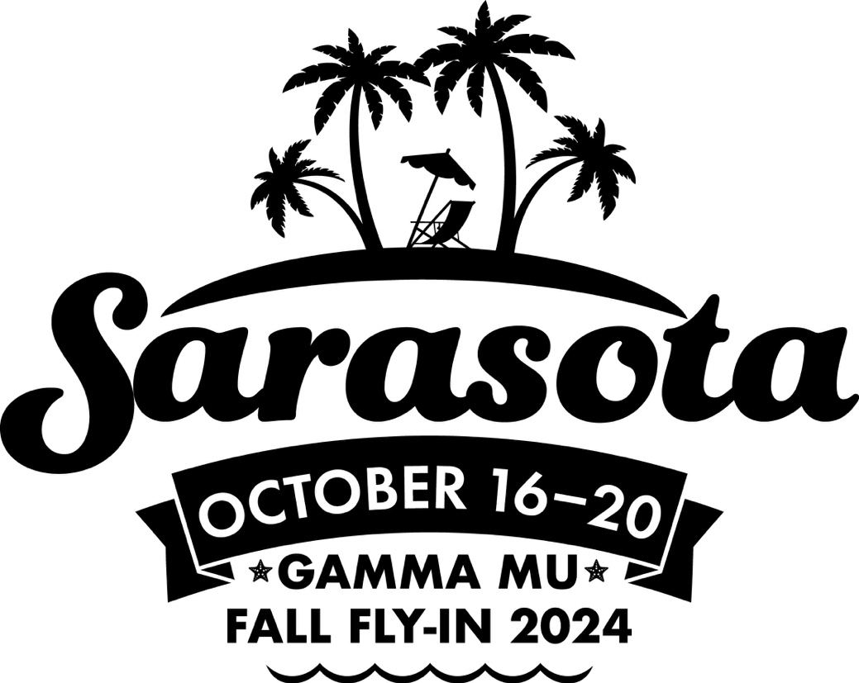

2024 SARASOTA FLY-IN

OCT 16 – OCT 20, 2024

Name ____________________________________________________________________________

Name ____________________________________________________________________________

___ I (we) will be attending Gamma Mu’s fall SARASOTA FLY-IN.
___ Please make my (our) reservation at the Art Ovation Hotel (Gamma Mu’s Headquarters Hotel) beginning on (PLEASE COMPLETE)
(date) _____________________for (number of) _______ nights.
THREE NIGHT MINIMUM
____ Guestroom King occupancy $239 per night – **
____ Guestroom Two Queens $239 per night - **
** plus any applicable state and local taxes, fees
___ will share with __________________________________ (CIRCLE 1 or 2 beds?)

___ will come for Early Birds party on Wednesday night on the rooftop of our hotel.
___ will still be in town for the Sunday Straggler’s party 5-7 PM in a wonderful home.

The registration fee for the Sarasota Fly-In is $665.00 if you are using one of the hotel rooms at the Art Ovation booked by the Gamma Mu office. If not, the fee is $765.00 registration fee is to help pay the tremendous expenses in hosting a major Fly-In. And you will get to visit the world-famous Shelby Gardens and the Ringland Estate and Museum in addition to the Sarasota Yacht Club and two private homes. And Pride is in town over our dates, and we will share one event with them. The registration fee is separate from the hotel deposit required. We would be happy to share a copy of the budget if requested.

All cancellations must be submitted in writing to cliff@gammamu.com. All cancellations after September 5, 2024 will incur a $150 administrative fee. No refunds will be provided if cancelled after September 20, 2024.

Registration fee PER PERSON only $665.00 if you are
staying at the Art Ovation Hotel in the GM block of rooms (or $765) …………..……..…….......$_________

One-night hotel deposit ………… ($239) …………………………………………..................................$_________

Count on me (us) to be out-of-town co-host at $150 per person…………….….…………….......$_________
The co-host fee helps to pay for the bus transportation during Fly-In – Sarasota needs your help!!
CHECK SHOULD BE PAYABLE TO GAMMA MU
(US FUNDS) …………………………...............................................................................TOTAL ... $_________

_____ Please invoice me to pay by credit card even with service charge.

_____ I will pay via Zelle through my bank.

_____ Check payable to Gamma Mu is enclosed with this registration.

Must initial disclaimer below before your reservation will be accepted or this will be returned to you.

Gamma Mu Disclaimer Clause

(This registration form must be initialed by one or both names on the reverse side for your registration to be accepted by the Gamma Mu office)

I (we) acknowledge the Art Ovation Cancellation Fee that states you will forfeit one night’s rate if you cancel or delay your arrival less than 48 hours in advance. Check out prior to your scheduled departure date may result in a penalty unless you notify the front desk at check-in.

Each participate attending any Gamma Mu e. t assumes all risk and danger incidental to the travel to and from such event and incidental to such event, including but not limited to the danger of being injured in a vehicular, boating or aircraft accident and unintentional food or alcohol poisoning and agrees that neither Gamma Mu, any of its agents, the event or Fly-In host committee or any of its members shall be liable for injuries resulting from such causes.
Name one on the reverse please initial here _______________
Name two on the reverse please initial here _______________

Date ________________________________________________________________

BEST EMAIL ADDRESS ___________________________________________________

BEST PHONE NUMBER TO REACH YOU ______________________________________

RETURN TO: GAMMA MU, 1932 Falling Waters Rd, #123, Knoxville, TN 37922

