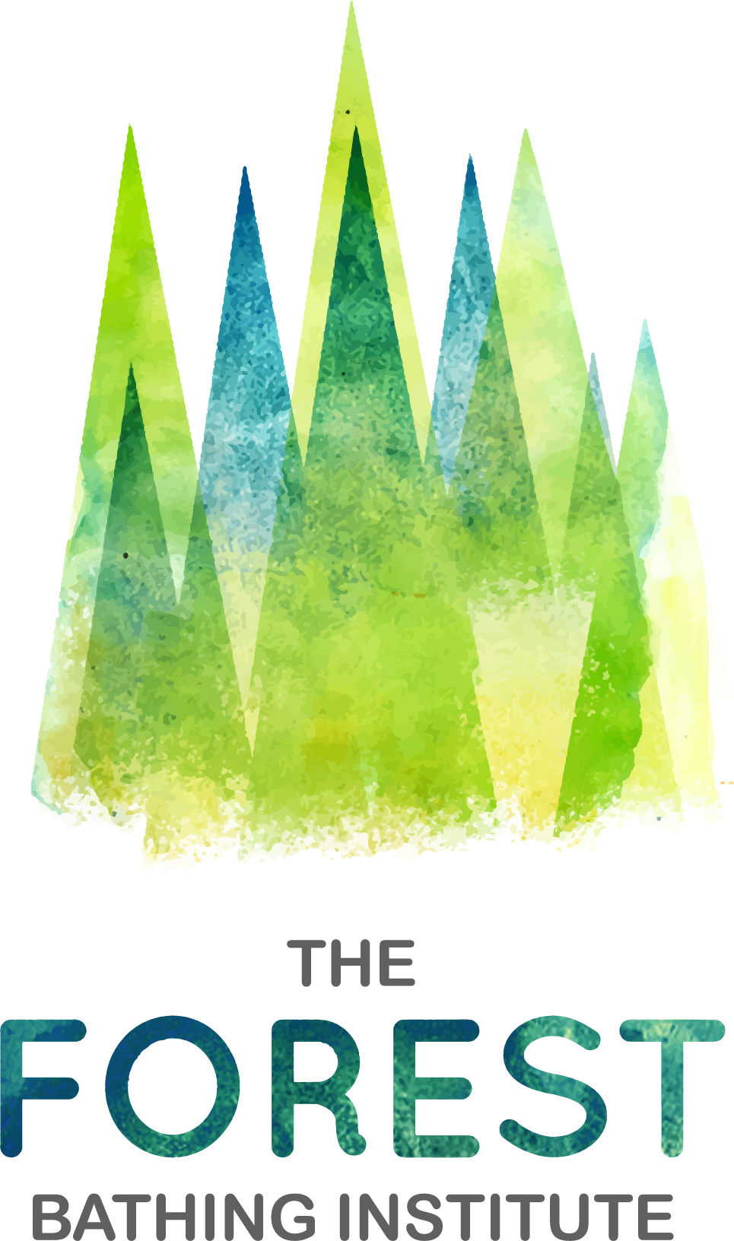
Forest Bathing + Registration
This form must be returned to your guide at least 24 hours before the session.

We ask you to answer the following questions so that TFBI and its guides can provide you with Forest Bathing+ sessions that are safe and appropriate. The information you provide will be treated in the strictest confidence.

Your Contact Information

Name: Address:

Phone number:

Contact email address:

Personal & Health Information

Please confirm you are age 18 or over: Yes/No

Emergency contact: Name: Phone number:

Forest bathing can be an emotional activity; you may find that certain emotions surface during the exercises. In this context, are you currently experiencing any mental health conditions which we should be aware of, e.g. anxiety, PTSD, depression:

Please let us know of any physical issues that might affect your participation in the session (e.g. hearing loss, difficulty walking or standing for long periods):

Do you have any allergies we should be aware of?

Is there anything else you would like to mention e.g. any information to pass to medics in the event of you needing emergency treatment?

Do you consent to photography/filming of yourself during the session for marketing and other purposes (full details contained in our terms and conditions, see below)? Yes/No

IMPORTANT

Please read the terms and conditions on our website: https://tfb.institute/participant-terms-conditions/

Please do not attend a session if you feel unwell and/or have symptoms of COVID-19. We will happily transfer your booking to an alternative date, please let your guide know as early as possible before the session.

By signing below I confirm that:

- I have read and agree to the terms and conditions for this event (https://tfb.institute/participant-terms-conditions/).
- To the best of my knowledge I do not have a medical condition which might hinder my full participation in Forest Bathing+.
- If I have any medical conditions or health-related concerns, or am on a prescribed medication, I am aware that it is advisable to speak to my GP before attending the session. I will seek medical advice prior to the event if appropriate.
- If I am in the first trimester of pregnancy, I am aware TFBI advise I wait to attend. I will provide written confirmation from my medical team that they are happy for me to attend at this time.
- I acknowledge that I am responsible for my own safety (and the safety of my possessions) whilst undertaking Forest Bathing+ activities and that I will only participate in activities appropriate to my level of ability and fitness.
- TFBI shall not be liable for any injury or damage to my person or property arising directly or indirectly from my participation in this event, and I waive and release TFBI from any and all such claims, costs and damages.
- I understand and agree that the information I provide will be stored in accordance with GDPR regulations and give my permission to The Forest Bathing Institute and its members to securely store the information above as detailed in the terms and conditions for this event and our privacy policy: https://tfb.institute/privacy-policy

Signature*: _______________________________________ Date: _____________________

* Your typed name will be taken as a signature if completing digitally.

Thank you, we hope you enjoy your session!

