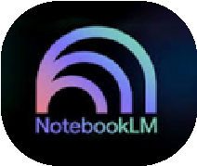 Notebook Setup Planner
Use this planner to design your NotebookLM workspace intentionally before uploading sources or generating content.

- Instructional Outcome What is the specific learning goal this notebook will support?
__________________________________________________________________
__________________________________________________________________
__________________________________________________________________
- Standards & Alignment Which standards (or other frameworks) must be explicitly aligned?

__________________________________________________________________
__________________________________________________________________
__________________________________________________________________
- Core Sources to Upload List 3–5 essential documents that directly support the instructional outcome.

- ________________________________

- ________________________________

- ________________________________

- ________________________________

- ________________________________
- Sources to Exclude What materials should NOT be initially included to avoid noise or misalignment?

__________________________________________________________________
__________________________________________________________________
- Chat Configuration Plan
Define:
Role
Alignment Expectations
Formatting Requirements
Differentiation or other Miscellaneous items

__________________________________________________________________
__________________________________________________________________
__________________________________________________________________
__________________________________________________________________ __________________________________________________________________
- First Generation Prompt Draft Write your initial prompt clearly and concisely.

__________________________________________________________________
__________________________________________________________________
__________________________________________________________________
__________________________________________________________________

