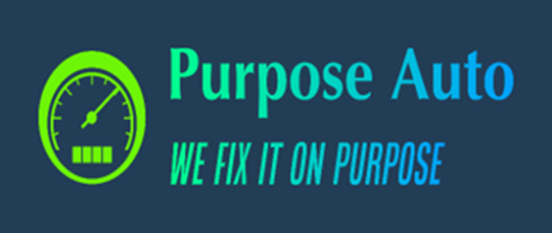
Purpose Auto VR Sim Sequences: Diesel Engine Overhaul
www.fixedonpurpose.com
info@fixedonpurpose.com
Diesel Engine Overhaul
This hands-on VR training course from Purpose Auto is designed to teach the fundamentals of diesel engine overhaul. Learners dive deep into engine teardown, inspection, and reassembly—gaining experience with cylinder heads, top and bottom end components, pistons, camshafts, crankshafts, valve systems, and more. It's ideal preparation for entry-level careers in diesel engine repair and rebuild.
Over 4.9 hours of guided simulation, participants develop skills through repeatable practice and receive real-time feedback. A score of 90% is required to complete the course, with assessments handled through Purpose Auto’s virtual evaluation system.
Program Summary:
- Total Duration: 291 Minutes (4.9 Hours)
- Total Simulations: 18
- Key Modules: Diesel Vehicle Maintenance, Diesel Engine Overhaul

Simulation Modules and Learning Outcomes
Module | Simulation | Learning Outcome | Duration (min)
Diesel Vehicle Maintenance | Lifting Devices | Properly place jack stands and lift a diesel truck. | 16
Diesel Engine Overhaul | Cylinder Head Overhaul | Disassemble the valve cover, camshafts, valve train, injectors, and remove the cylinder head. | 21
Diesel Engine Overhaul | Cylinder Head Analysis | Perform visual and non-destructive tests to inspect for cylinder head damage. | 16
Diesel Engine Overhaul | Cylinder Head Integrity | Measure cylinder head warpage using precision tools. | 17
Diesel Engine Overhaul | Head Disassembly & Reassembly | Take apart and reassemble head valves and fuel injectors. | 15
Diesel Engine Overhaul | Liner & Valve Protrusion Tests | Use a dial indicator to measure liner and valve protrusion. | 19
Diesel Engine Overhaul | Cylinder Head Installation | Install the cylinder head, valve bridge, and fuel injectors. | 16
Diesel Engine Overhaul | Overhead Cam & Valve Train Install | Install a dual overhead camshaft and the valve train system. | 15
Diesel Engine Overhaul | Valve & Injector Adjustment | Adjust valve bridges, clearances, and injector settings. | 18
Diesel Engine Overhaul | Timing Gear Train – Part 1 | Inspect and begin installing the timing gear components. | 6
Diesel Engine Overhaul | Timing Gear Train – Part 2 | Complete installation and adjust backlash in the gear train. | 27
Diesel Engine Overhaul | Crankshaft Removal | Prep the engine and remove the crankshaft. | 16
Diesel Engine Overhaul | Piston & Rod Removal | Remove piston cooling jets and the piston/rod assembly. | 15
Diesel Engine Overhaul | Cylinder Liner Service | Remove and reinstall liners and seals in the engine block. | 13
Diesel Engine Overhaul | Main Bearing Replacement | Replace main bearings and thrust bearings. | 14
Diesel Engine Overhaul | Crankshaft End Play | Measure and correct crankshaft end play using gauges. | 13
Diesel Engine Overhaul | Piston Assembly | Measure piston ring clearances and assemble piston components. | 18
Diesel Engine Overhaul | Piston & Bearing Install | Install piston, connecting rod, and bearing into a cylinder liner. | 16

