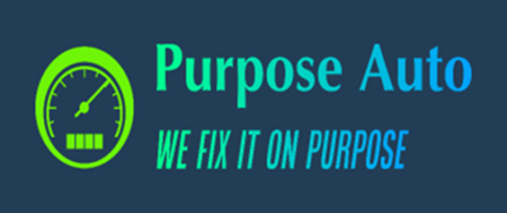
Purpose Auto VR Sim Sequences: Automotive Collision Refinish
www.fixedonpurpose.com
info@fixedonpurpose.com
Automotive Collision Refinish
Purpose Auto’s VR-based Collision Refinish training provides practical, task-oriented simulations designed to develop key skills in automotive refinishing. Learners gain experience in blasting, sanding, masking, priming, painting, and powder coating—essential for entry-level work in auto body and refinish shops.
Throughout the 3.3-hour training program, participants practice and refine their techniques in a virtual environment. Each learner must reach a 90% performance threshold to complete the course, with progress tracked through Purpose Auto’s built-in evaluation system.
Program Summary:
- Total Duration: 196 Minutes (3.3 Hours)
- Total Simulations: 12
- Key Modules: Automotive Fundamentals, Auto Body / Collision

Simulation Modules and Learning Outcomes
Module | Simulation | Learning Outcome | Duration (min)
Automotive Fundamentals | Controls Tutorial | Learn the basic use of VR controls in an automotive training environment. | 3
Auto Body / Collision | Bead Blasting | Safely remove paint and rust using high-pressure blasting tools without damaging surfaces. | 15
Auto Body / Collision | Body Filler: Sanding | Use power and hand tools to sand and shape applied body filler. | 17
Auto Body / Collision | Masking for Priming | Properly tape and cover vehicle areas to prepare for priming and painting. | 15
Auto Body / Collision | Paint Gun: Inspect & Clean | Inspect, clean, and take apart a paint gun for maintenance and proper function. | 14
Auto Body / Collision | Paint Gun: Setup & Spray Patterns | Set up a paint gun and adjust spray patterns for consistent application. | 14
Auto Body / Collision | Priming Panels | Test primer and apply a single-stage topcoat to a vehicle panel. | 20
Auto Body / Collision | Primer Prep for Painting | Prepare a primed panel for painting with block sanding and guide coat techniques. | 16
Auto Body / Collision | Paint Selection & Mixing | Accurately measure and mix different paint colors for application. | 15
Auto Body / Collision | Basic Painting | Learn and apply foundational paint spraying techniques. | 19
Auto Body / Collision | Advanced Painting | Apply basecoat and clearcoat using advanced paint spraying methods. | 20
Auto Body / Collision | Powder Coating | Apply powder coating to metal surfaces using electrostatic techniques. | 28

