Reservation of Jen Hotel: (Due:12/20/2025).
****Please submit the requested form before 12/20/2025
For ease of processing, please fill in the following details
booking requests:
Full Name
Check-in Date
Check-out Date
Room Category
Email Address
ID / Passport Number
Contact Information
Additional Remark

Please email to Danny Yap Soon Lai danny.ysl@hoteljen.com with the above details.
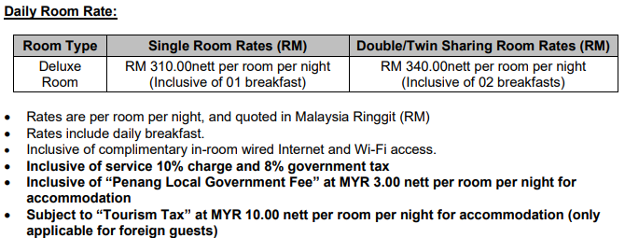
Please check the room rates here for your kind reference.

