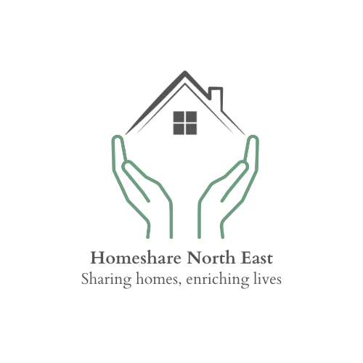

POLICY TITLE: Disclosure and Barring Service Checks

ISSUED: 09/10/2023

REVISED: 28/03/2025

REVIEWED: 28/03/2025

The DBS enables organisations in the public, private and voluntary sectors to make safer recruitment decisions by identifying candidates who may be unsuitable for certain work, including work that involves children or vulnerable adults, and provides wider access to criminal record information for England, Wales and the Isle of Man.

Checks for people living and working in Scotland are managed by the Protecting Vulnerable Groups (PVG) membership scheme which is managed and delivered by Disclosure Scotland in Scotland.

AccessNI criminal record checks provide information for people living or working in Northern Ireland.

Safeguarding Participants

Safeguarding Homeshare participants is of paramount importance. Several steps are required within the process from the point of application to reach a successful, safe, and sustainable match.

This document outlines the rationale and process for checking criminal convictions, including considering individuals who may be barred from certain activities.

Standard and enhanced DBS checks can only be undertaken if the specific role or the specific activities carried out within the role, are included in the Rehabilitation of Offenders Act (ROA) 1974 (Exceptions) Order 1975 (access to standard DBS certificates), and are also covered by the Police Act 1997 or Police Act 1997 (Criminal Records) regulations (access to enhanced DBS certificates).

These laws only provide eligibility for DBS checks, they do not make them a requirement. Decisions on when and whether to undertake a DBS check are for the relevant employer or regulator to make based on what the law allows.

When you request a DBS certificate to assess someone to carry out regulated activity with adults this means that you are a regulated activity provider (RAP). This brings obligations under the Safeguarding Vulnerable Groups Act 2006. As a RAP, you have a legal duty to refer an individual to DBS when you believe a person has caused harm or poses a future risk of harm to vulnerable groups, including children. You must also provide information to DBS when we ask you to and maybe fined unless you have a reasonable excuse for not providing the information. The conditions you must consider before making a referral or providing information to us can be found on the DBS website.

An employer or volunteer manager is breaking the law if they knowingly employ someone in regulated activity with a group from which they are barred from working. A barred person is breaking the law if they seek, offer, or engage in regulated activity with a group from which they are barred from working.

Homesharer DBS Checks

We have been advised by the DBS Service that Homeshare North East should conduct an Enhanced DBS check with Barr on all Homesharers (the person moving into a Homeshare arrangement) These checks contain information on cautions, convictions, reprimands, and warnings as well as any local police information about the applicant that the police believe is relevant, and ought to be disclosed.

The majority of people who are barred have that status because they have committed an automatic barring offense, which will also show on an enhanced DBS check. The barred status of a small group of barred people without criminal convictions or relevant police information will not show up on an enhanced DBS check, without a barred list check.

Although Homeshare is not a regulated service some of the activities carried out by the Homesharer are on the regulated list and therefore, it is Good Practice to carry out DBS checks.

The Homesharer role meets the criteria for this level of check because there is an expectation that they will on some level:
- provide day to day help to Householders with running their homes because their age, illness, or disability means they need this help

That the Homesharer will provide help and or support with:
- paying bills (both online and in-person)
- doing their shopping

Householder DBS Checks.
There is no real justification for us to conduct DBS checks on the Householder unless the Homesharer is classified as a vulnerable adult and the Householder is providing some type of practical learning which could be deemed as support for the Homesharer to live independently.

Other instances where it would be prudent for us to ask the Householder to provide their own DBS check would be where other vetting checks are inconclusive, there are no interactions with third parties such as family members and/or close friends or health and social care professionals.

We have been advised by the DBS Services that in such instances, we could ask the Householder to seek a DBS basic check for themselves (something all members of the public can do) and ask them to share the information with us. (There is an option to share the information with a third party as part of the administration process when applying for a DBS check)

Homeshare North East Colleagues and Volunteers
It is not a legal requirement for Staff working within a Homeshare programme to have the same level of DBS checks as a Homesharer, it would, however, be deemed best practice, especially for those managing a Homeshare programme. Therefore:

- Homeshare colleagues directly engaged in Homeshare activity will be subject to an enhanced DBS, which will be renewed every 3 years or on the commencement of a new match.
- Any volunteer working within Homeshare North East will be subject to an enhanced DBS check.

Who will pay for the DBS Checks?

Homesharers will pay an initial administration charge to Homeshare North East to cover the cost of the DBS check.

Householders will cover the cost of the DBS directly themselves.

Homeshare North East Directors will ensure they have fully up to date DBS checks.

Who will see the information and where will it be stored?

Homeshare participant DBS Checks will be bee conducted and see only by the relevant Homeshare programme lead. We will document the Certificate date and reference number, however, shall not hold a copy of the DBS certificate.

DBS updates and the Update Service

We require all participants in Homeshare, and staff to be signed up to the DBS Update service.

The Update Service is an online subscription that allows you to keep your standard or enhanced certificates up-to-date and allows employers to check a certificate online. You can join the Update Service as soon as you have your application form reference number and the application must be received within 28 days of the DBS being issued

We will ask for updates on the DBS status of all Homeshare participants to be conducted every 3 years. Homesharers entering a new Homeshare match will be asked to provide an updated DBS certificate via the update service before they are introduced to a new potential Householder.

Positive Disclosures

At Homeshare North East, we assess each application individually, where a positive disclosure is made, we will consider the nature of the disclosure and carry out a risk assessment to deem whether the application is suitable or not.

