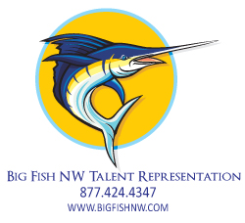
Your Name Here

Ht: 6’1”
Wt: 225
Hair: Red
Eye: Hazel

Television
The Brady Bunch Extra S.S. Minow Productions

Film
The Basket Lead NxNW Entertainment

Commercial
Tidyman’s Meat Sale Principal Hamilton Studios
Northern Quest Casino Principal Hamilton Studios
Toledo Scales Extra Big Wig Productions

Industrial
Albertson’s On-Camera Narrator NxNW Productions
Egghead Computer Principal Millisecond Creative

Voice-Over
Albertson’s Industrial NxNW Productions
Ziggy’s Commercial Lumberland Productions
Premiera Blue Cross Radio House of Sound

Print
Albertson’s Model Bob’s Photography
Silverwood Amusement Park Model Acme Advertising

Theater
Merry Wives of Windsor Mrs. Ford IRT
Camelot Guinevere Coeur D’Alene Summer Theater
Animal Farm Male Horse North Bend High School

Training
MFA in Performance University of Idaho
BA Theater Arts Eastern Oregon University
The Actor’s Gym – On-going workshops Becky Reilly
Improv Workshop The Slow Children at Play
Acting For The Camera Patti Kalles, CSA
Voice Lessons Louder Than Me Studios

Special Skills
Horseback Riding Snow Ski-Downhill Piano
Trumpet Semi-Tractor- CDL-A Farm Tractor
Swimming Juggling Bicycle
Hand Modeling Excessively Long Tongue Huge Feet

