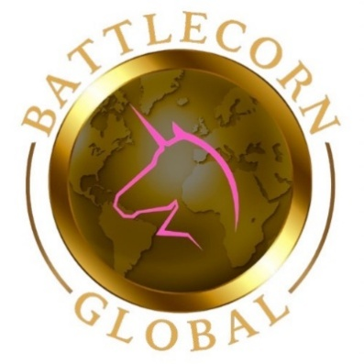

Dear Community Partner,

We would like to invite you to partner with us for The 5th Annual Gold Tie Gala, an inspiring evening dedicated to community, family, and hope in support of children impacted by cancer and the families who walk beside them. This year will be a meaningful gathering of families and community members united by a shared purpose: ensuring that no child or family ever walks this journey alone. We will celebrate resilience, honor courage, and reaffirm our collective commitment to building a stronger, more compassionate community.

Over the past four years, our event has raised nearly $90,000 to fund research and support programs that bring comfort, advocacy, and meaningful impact to families facing childhood cancer. As we prepare for our fifth milestone event, we remain deeply committed to expanding our reach and strengthening our impact — with a special focus on local programs that directly serve childhood cancer survivors and their families.

This year’s event will benefit community-based survivorship and family support initiatives, providing opportunities for healing, connection, and a return to normalcy after treatment. Families navigating childhood cancer often endure long periods of isolation, emotional strain, and financial hardship. Our mission is to help restore moments of togetherness, joy, and stability — empowering families to rebuild, reconnect, and thrive beyond treatment.

We humbly ask for your investment in local impact, helping provide tangible support, vital programming, and life-changing resources for children and families affected by childhood cancer. Your partnership plays a critical role in advancing awareness, strengthening survivorship support, and creating lasting change where it matters most — right here in our community. We would be honored to have your support.

Thank you for your time, consideration, and commitment to making a difference.
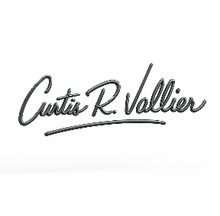
Sincerely,

Curtis Vallier, Chief Operating Officer
Battlecorn Care Packages Co.
501(c)3 #85-2887239

Sponsorship Levels
PLATINUM SPONSOR: $2500_____  VIP TABLE (8 Tickets)  Top Billing on All Event Marketing  Mission Impact Partner Recognition  (recognized as key partners helping deliver direct support to families and advancing childhood cancer initiatives)  Table Recognition at Event (logo, etc)  Recognized on All Social Media + Event Website  Recognized at the Event from the Stage  Dedicated Sponsor Spotlight Social Media Post | GOLD SPONSOR: $1000_____  8 Event Tickets  Logo on Event Marketing Materials  Table Recognized as Gold Sponsor at Event  Recognized on All Social Media + Event Website  Recognized at the Event from the Stage  Included in Group Sponsor Thank You Post
SILVER SPONSOR: $500____  4 Event Tickets  Recognized on All Social Media with Links  Recognized on Event Website  Recognized on Event Day Signage  Social Media Appreciation Post with Links | BRONZE SPONSOR: $250____  2 Event Tickets  Recognized on All Social Media with Links  Recognized on Event Website  Recognized on Event Day Signage
BATTLECORN FRIENDS: $100_____  Recognized on All Social Media with Links  Recognized on Event Website | IN-KIND: __________  Recognized on All Social Media with Links

“The 5th Annual Gold Tie Gala supports childhood cancer survivors and their families through local programs that restore connection, healing, and normalcy after treatment. Together, we build hope, strengthen families, and create lasting impact.”

Please Return Completed Form to:
Curtis Vallier – Chief Operating Officer
Battlecorn Care Packages Co.
501(c)3 #85-2887239
P.O. Box 171
Kimberly, WI 54136
(920) 939-0189

For Questions:
Contact us: cvallier@battlecornglobal.org
Visit us: https://battlecornglobal.org/5th-annual-gold-tie-gala

