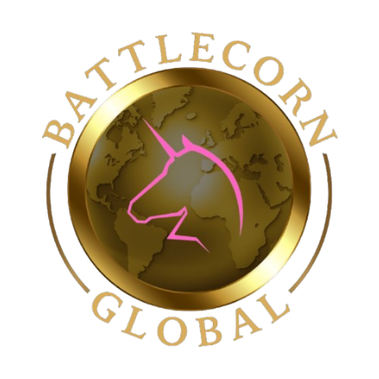

Dear Community Partner,
I am contacting you representing our family’s Non-Profit organization, Battlecorn Care Packages Co. We are a local organization that focuses on enriching the days of children battling cancer through care packages and awareness. We also raise funds for research and work with legislators to create positive changes for the pediatric cancer community, and are currently seeking partners to sponsor our annual trip to Curefest.
Each year in September, we travel to Washington, D.C., This event is an opportunity for hundreds of organizations and thousands of families to come together for a common cause: the future of pediatric cancer treatments, therapy options, and a better overall prognosis for life during and after cancer.
Your support through partnership will contribute directly to our ongoing efforts in spreading joy, championing children fighting cancer, and collaborating on research and infrastructure projects aimed at securing a brighter tomorrow for our children. By partnering with us, you are making a meaningful difference in the lives of those who need it most. Together, we can create a world where every child's future is filled with hope and possibility.

Since creating Battlecorn, we have made it our mission to work within our community, both locally and across the country, to collaborate and network with like-minded organizations to give kids a chance to smile, beat cancer, and to do it without long-lasting side effects. To date, we have sent over 1100 care packages to children all over the U.S., donated $25,000 worth of toys to the Child Life department at HSHS St. Vincent Children’s Hospital, and donated over $70,000 to research through events and fundraising. In total, Battlecorn has made a financial contribution to this community of over $219,000, and it is 100% due to our key partnerships with our community.

Attending Curefest is a vital tool in our ability to reach and connect with the Pediatric Cancer Community, lawmakers, and others that will have a crucial role in the changes we seek. This event has allowed us to form connections, enlighten our elected officials, and strengthen our resolve through a united front, and is also made possible by generous and caring donors. Battlecorn Care Packages Co. would be honored to have your support in our mission to give these kids a voice in their fight by attending Curefest in 2026. Thank you for your time and consideration in assisting us in the completion of our mission through your contributions.

DISCLAIMER: (ALL OTHER EXPENSES OUTSIDE OF THE LISTED ESTIMATE ARE COVERED BY EACH INDIVIDUAL MEMBER PERSONALLY AND NOT COVERED BY ANY DONATED OR CHARITY FUNDS, ANY FUNDS RECEIVED IN OVERAGE OF THE TOTAL COST WILL BE DIRECTED INTO BATTLECORN’S GENERAL FUND AND NOT REFUNDED, 100% OF FUNDS ARE MISSION ORIENTED WITH ZERO DOLLARS FUNDING SALARIES)
Trip Sponsorship Would Cover the Cost of:
Flights, Hotel, and DC Metro Cards for September 16-21, 2026
(Metro Cards $60.75/pp for 7-day Pass) (Flights and Rooms Based on 4/2026 Pricing)

Estimated Cost: (3 Board Members will be attending in 2026)
3 Board Members = 1 Room, 3 Roundtrip Flights, 3 Metro Cards = $2563.45 (Total Cost)
- Flights + Baggage ($1822.20) – Metro ($182.25) – Lodging ($769.00)

Sponsorship Level Recognition:
  - Full Sponsorship ($2500.00) for 3 Board Members Receives:
    - Full 11x11 Logo on 2025 Curefest Shirts worn by all board members during the event week
      - 2-2025 Curefest Shirts
    - Recognition on Social Media (Facebook, Instagram, X, TikTok)
    - Recognition on Website
    - Custom Engraved Plaque
  - Half Sponsorship ($1250.00) for 3 Board Members Receives:
    - Half Shirt 6x6 Logo on 2025 Curefest Shirts worn by all board members during the event week
      - 1-2025 Curefest Shirt
    - Recognition on Social Media (Facebook, Instagram, X, TikTok)
    - Recognition on Website
  - Partial Sponsorship ($500.00) for 3 Board Members Receives:
    - 3x3 Logo on 2025 Curefest Shirts worn by all board members during the event week
    - Recognition on Social Media (Facebook, Instagram, X, TikTok)
    - Recognition on Website

Sincerely,
Curtis Vallier, Chief Operating Officer
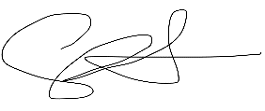
Battlecorn Care Packages Co. 501(c)3 #85-2887239
N132 Kamkes Ave
Appleton, WI 54915
920.931.5268 / 920.939.0189
https://battlecornglobal.org
cvallier@battlecornglobal.org

