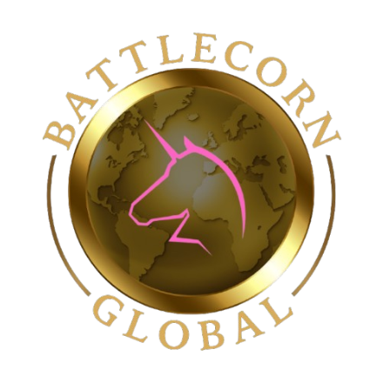

Giving Year 2025

Dear Community Partner,

I am contacting you representing our family’s Non-Profit organization, Battlecorn Care Packages Co. We are a local organization that focuses on enriching the days of children battling cancer, by way of care packages and awareness. In addition, we also raise funds for research and work with legislators to create positive change for the pediatric cancer community.

We are hosting our 4th Annual Gold Tie Gala for Childhood Cancer Awareness on Sunday August 24th, 2025, at Wisconsin Timber Rattlers – The Fox Club and are seeking partnerships in our community to help us reach our goal of positive change for children battling cancer. All proceeds from your support contribute directly to our ongoing efforts in spreading joy, championing children fighting cancer, and collaborating on research and infrastructure projects aimed at securing a brighter tomorrow for our children. By partnering with us, you are making a meaningful difference in the lives of those who need it most. Together, we can create a world where every child's future is filled with hope and possibility.

In the past three years this event has allowed us to raise $67,000 which has been used to fund groundbreaking research, clinical trials and most of all, hope for a better future and hopefully one day a cure. Your partnership will help our organization make a huge impact for children battling cancer.

Battlecorn Care Packages Co. would be honored to have your support in our mission to give these kids a voice in their fight. Thank you for your time and consideration in assisting us in the completion of our mission through your contributions.

Sincerely,

Curtis Vallier, Chief Operating Officer

<https://www.battlecorncarepackages.com> **Sponsorship Levels:**

Battlecorn Care Packages Co. Platinum: $2500 & Up

Registered 501(c)3 #85-2887239 Gold: $1000-$2499

N132 Kamkes Ave Silver: $500-$999

Appleton, WI 54915 Bronze: $249-499

920-939-0189 Friends: $100 to $249

**Sponsorship Levels**

|  |  |
| --- | --- |
| **EVENT SPONSOR: $2500+_____**  **VIP TABLE (8 Tickets)**  Top Billing on All Event Marketing  Table Recognized as Event Sponsor at Event  Recognized on All Social Media + Event Website  Custom Donor Plaque  Recognized at Event from Stage  Speaking Opportunity at the Event (optional) | **TABLE SPONSOR: $1000-$2499_____**  **8 Event Tickets**  Table Recognized as Sponsored at Event  Recognized on All Social Media + Event Website  Custom Donor Plaque  Recognized at Event from Stage |
| **SILVER: $500-$999____**  **4 Event Tickets**  Recognized on All Social Media with Links  Recognized on Event Website  Recognized Event Day Advertisements | **BRONZE: $250-$499____**  **2 Event Tickets**  Recognized on All Social Media with Links  Recognized on Event Website  Recognized Event Day Advertisements |
| **FRIENDS: $100 -$249_____**  Recognized on All Social Media with Links  Recognized on Event Website | **IN-KIND: __________**  Recognized on All Social Media with Links |

***“All proceeds from your support contribute directly to our ongoing efforts in spreading joy, championing children fighting cancer, and collaborating on research and infrastructure projects aimed at securing a brighter tomorrow for our children. By partnering with us, you are making a meaningful difference in the lives of those who need it most. Together, we can create a world where every child's future is filled with hope and possibility.”***

**Please Return Completed Form to**:

Curtis Vallier – Chief Operating Officer

Battlecorn Care Packages Co.

501(c)3 #85-2887239

N132 Kamkes Ave

Appleton, WI 54915

(920) 939-0189

**For Questions:**

Contact us: [cvallier@battlecornglobal.org](mailto:cvallier@battlecornglobal.org)

Visit us: [www.battlecorncarepackages.com](http://www.battlecorncarepackages.com) or [www.battlecornglobal.org](http://www.battlecornglobal.org)