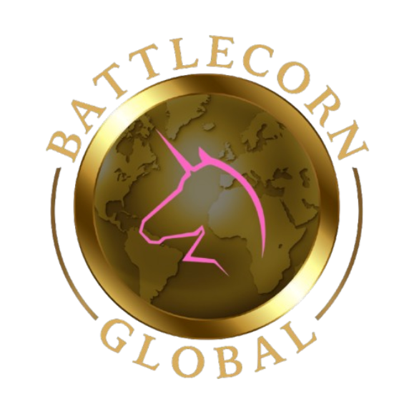

Dear Community Partner,
I am contacting you representing our family’s Non-Profit organization, Battlecorn Care Packages Co. We are a local organization that focuses on enriching the days of children battling cancer, by way of care packages. In addition, we also work to direct funds to research and work with legislators to create positive change for the pediatric cancer community.
Since our inception in 2020 we have sent over 1300 Care Packages around the country and have donated over $90,000 to research to help find better and less toxic treatments. This has all been made possible due to our friends, family, and community partner donations helping us complete the mission our daughter left for us.
Our daughter Jaycee was just 6 years old when she was diagnosed with a rare form of brain cancer which would launch our family into a 520-day battle before she gained her angel wings on 7/3/21. Even during this incredibly enduring fight she always wanted to give back and make others smile, like the way her friends helped her smile during her treatments, with care packages. She always loved to help us pack and send as many as she could and made sure to add her special touches to each one. To this day we continue her mission and rely on our community to help us do so.
Since her passing we have also focused very heavily on advocacy to ensure no other families have to feel the pain that we do, that there will be better and less toxic options for treatment, and that the Pediatric Cancer Community has a much-needed voice. Your contributions will help our organization continue to send smiles across the country and advocate for positive change for children battling cancer. Our combined efforts are aiming to ensure that a population of warriors are given the best chance possible at a long and fulfilling life.
Battlecorn Care Packages Co. would be honored to have your support in our mission to not only spread smiles, but bring awareness to childhood cancer, and give these kids a voice in their fight. Thank you for your time and consideration in assisting us in the completion of our mission through your contributions and partnership.
Sincerely,
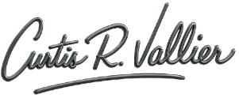
Curtis Vallier, Chief Operating Officer

https://www.battlecornglobal.org
Battlecorn Care Packages Co. / Battlecorn Global
Registered 501(c)3 #85-2887239
920-939-0189
Donation Options

Checks Made Payable To:  Battlecorn Care Packages Co.  And Mailed or Dropped off to Address listed Below | Donations to Community First Credit Union  Any CFCU Location can take donations for our organization, simply mention our name and CFCU will take care of the rest.
Payment Apps:  PayPal: BattlecornCP  Venmo: @BattlecornCP | GiveButter Text to Donate  Text Battlecorn to 53-555
Local in-Kind Donations  Please reach out to cvallier@battlecornglobal.org to arrange donation drop off of toys, blankets, items for events, etc. | Amazon Wish List  Search Amazon for Battlecorn Care Packages

We are so grateful for your donation and support in our efforts to make a positive difference in the Childhood Cancer Community!

Please Return Completed Form to:
Curtis Vallier
Battlecorn Care Packages Co.
501(c)3 #85-2887239
PO Box 171
Kimberly, WI 54136

For Questions, Contact us at:
cvallier@battlecornglobal.org
Or visit us at:
https://battlecornglobal.org
Call us: (920) 939-0189

