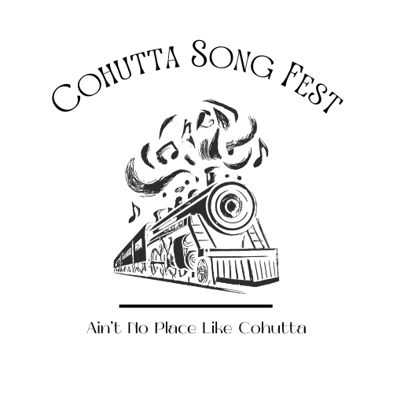
Cohutta Song Fest October 17-18, 2025

Sponsor Information

Name of Business Sponsor: __________________________________________________________

Contact Name: ____________________________Phone No.________________________

Email: _______________________________________

Website:_____________________________

Mailing Address: ___________________________________________________________________

Sponsorship Level (i.e. Gold, Silver,etc):__________________________________

Amount: ___________________________

All Sponsorship Forms must be submitted by August 1st, 2025 to ensure your business benefits from all of our advertising and media promotion.

List items below that you wish to exhibit or distribute to event attendees.

Mail completed form to:

Cohutta Song Fest
℅ Cohutta General Store
317 Wolfe St.
Cohutta, GA 30710
----------------------------------------------------------------------------------------------------------------------------

For Cohutta Song FEST Committee:

Check #___________ Amount ___________ Date Posted ____________ Initials _______
PLEASE INDICATE CONTRIBUTION LEVEL (CASH OR IN-KIND)

Diamond $2500 _____ Double Platinum $1000 _____ Platimum $700 _____

Gold $500 _____ Top Forty $250 _____

Check should be made payable to “Cohutta Song Fest” and mailed to:

Cohutta Song Fest
℅ Cohutta General Store
317 Wolfe St.
Cohutta, GA 30710

Benefits are provided at the following sponsor levels:

 | $250.00 | $500.00 | $750.00 | $1,000.00 | $2,500.00
 | Top 40 | Gold | Platinum | Double Platinum | Diamond
Sponsor Banner on Stages |  |  |  |  | x
Corporate Banner Near Stage (sponsor supplied) |  | x | x | x
LOGO link on website |  |  | x | x | x
LOGO in program |  |  | x | x | x
LOGO on flyers |  |  | x | x | x
Name in program | x | x
Name on website | x | x
Name on flyers | x | x
Recognition from stage | x | x | x | x | x
VIP Package | x | x | x | x | x

