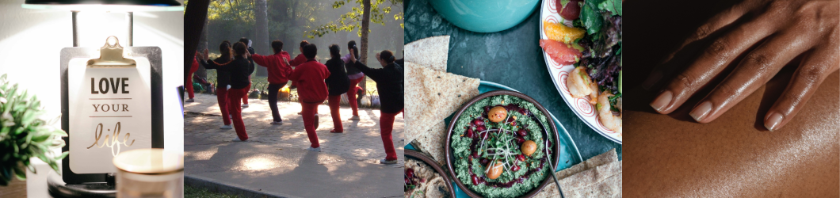

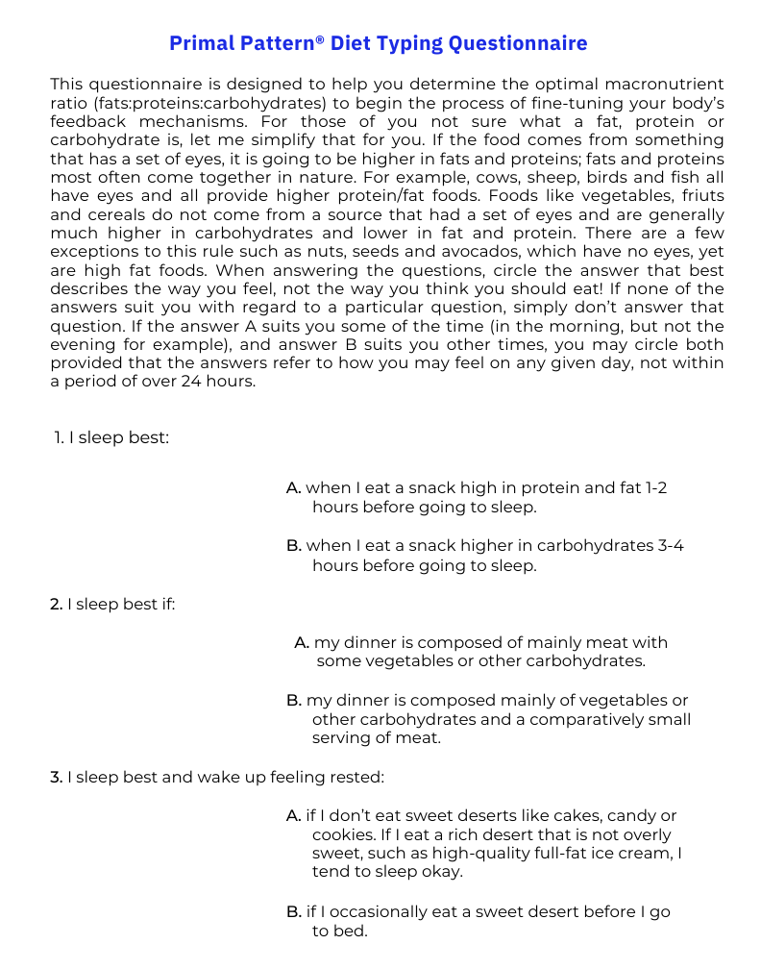

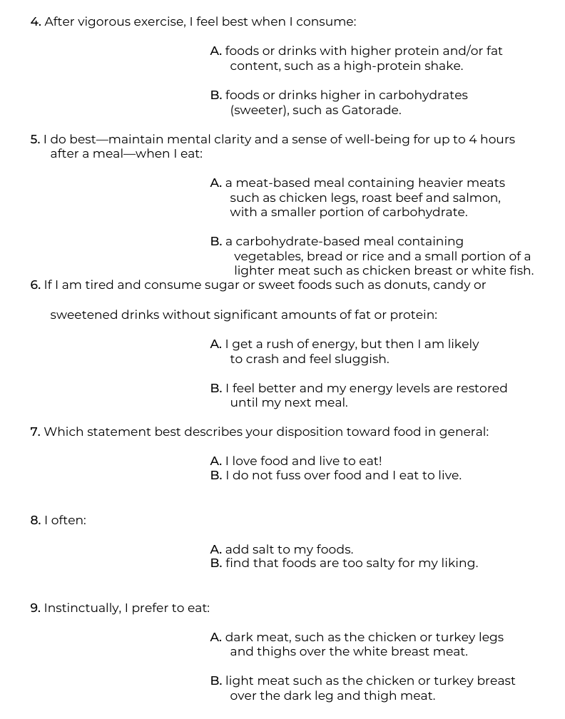

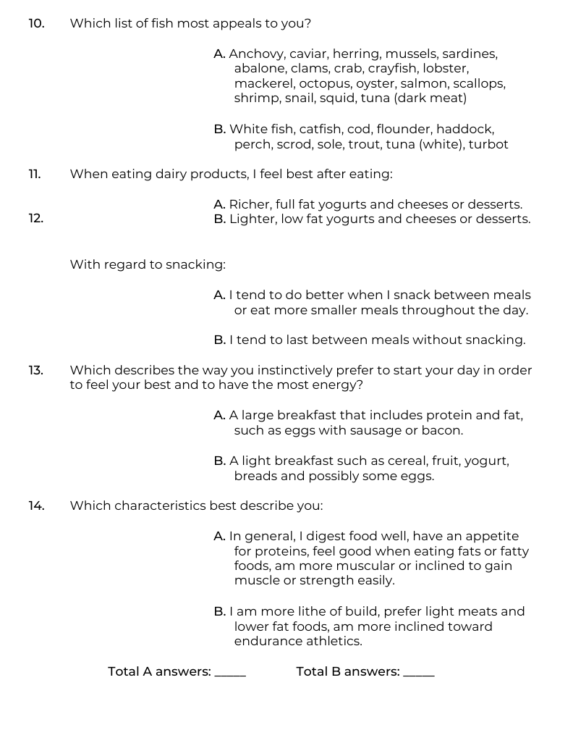

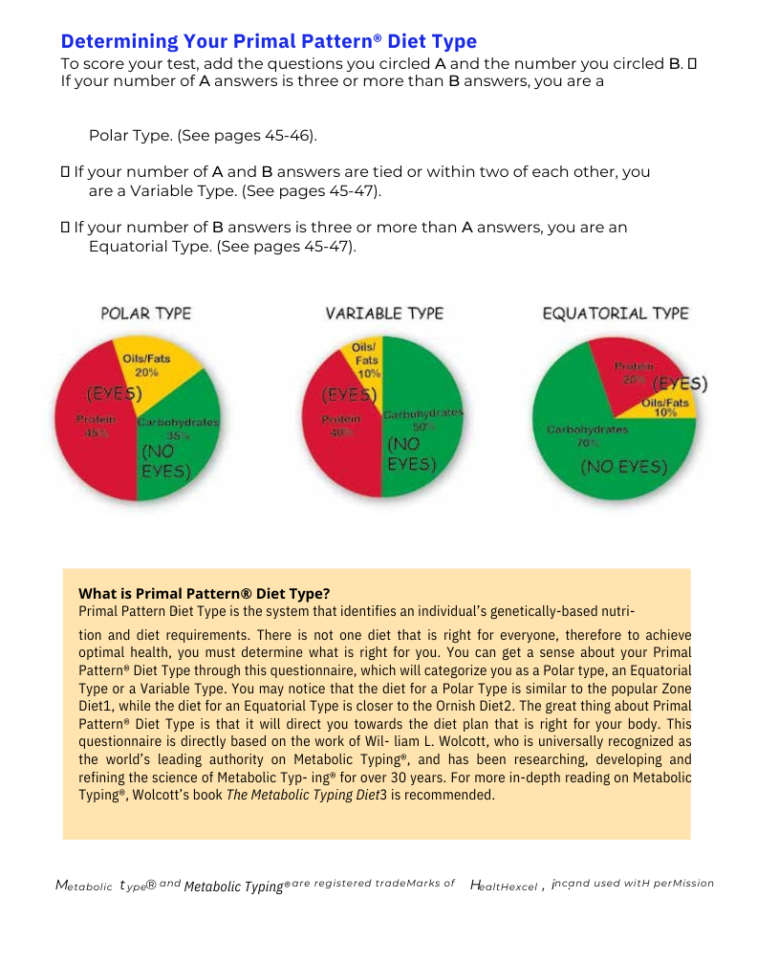

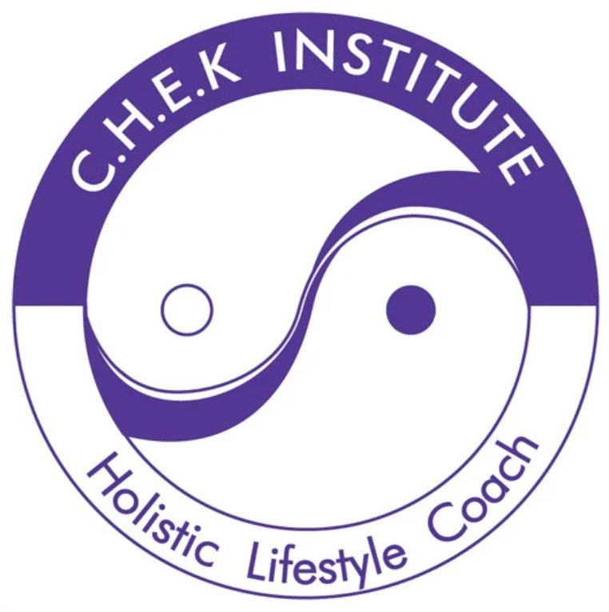

HOLISTIC LIFESTYLE & NUTRITION COACHING

Peter Eves - Chek Holistic Lifestyle Coach

[www.theholisticlifestylecoach.com.au](http://www.theholisticlifestylecoach.com.au)