**NEW OPENING:**

**Chef Balram Yadav Brings Decades of Culinary Mastery to Spice Bazaar in the Heart of Tsim Sha Tsui**

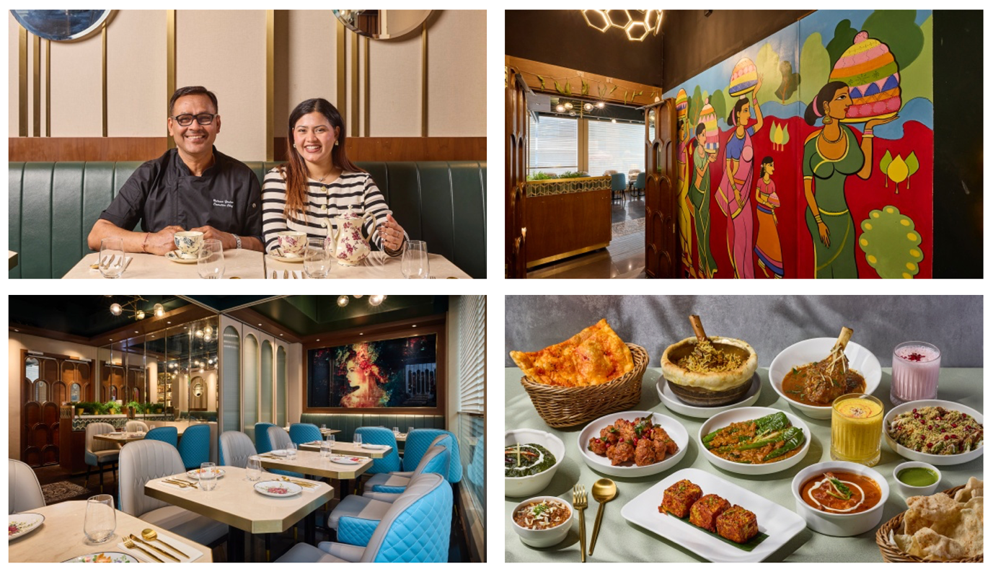

**Download images from Google Drive:**

<https://drive.google.com/drive/folders/1yFHQxcxSvWlhBgcSSG-uSpt2OvN_6bOb?usp=drive_link>

**(Hong Kong, 21 February 2025) -** Indian cuisine, celebrated for its rich flavours, Ayurvedic ingredients, and bold spices, undoubtedly comforts and delights genuine food enthusiasts. As Hong Kong’s admiration for Indian fare continues to grow, [**Spice Bazaar**](https://www.instagram.com/spicebazaar.hk/), a vibrant new addition to the city’s dining scene, is hidden on the fourth floor of Prat Avenue in bustling Tsim Sha Tsui. This chef-driven **modern Indian tandoor barbecue restaurant** opened its doors this mid-February. It is dedicated to quality and authenticity and offers a menu that seamlessly merges traditional recipes with a refreshing modern twist.

**A Partnership Rooted in Culinary Passion**

Spice Bazaar is the brainchild of hospitality veteran Imran Khaleel and Executive Chef Balram Yadav, who first collaborated on various restaurant openings in 2019.

**Imran Khaleel** brings over two decades of global experience in culinary operations, having commenced his career at The Ritz-Carlton in the USA before progressing to leadership roles with the esteemed Hakkasan Group in the UK and UAE, overseeing fine-dining establishments such as Yauatcha and Sake No Hana. In 2012, he relocated to Hong Kong as Deputy General Manager of Zuma Hong Kong, further honing his expertise in managing world-class dining experiences. In 2023, Imran took the bold step of venturing out on his own and successfully opened Rue Du Liban, a popular Lebanese restaurant in Tsim Sha Tsui that is frequently fully booked on weekends. With Spice Bazaar, Imran combines his extensive experience with his passion for Indian cuisine to create a modern, casual dining experience that celebrates bold flavours and refined techniques.

**Meet Chef Balram Yadav: The Visionary Behind Spice Bazaar**

At the culinary helm is co-owner and Executive Chef **Balram Yadav**, a visionary with over 30 years of experience spanning international luxury hotels, Michelin-starred establishments, and fine-dining Indian restaurants. Notably, Chef Yadav served as a royal chef for the Dubai royal family for four years before relocating to Hong Kong 18 years ago. Since then, he has helped shape Hong Kong’s Indian dining scene, contributing to the success of iconic restaurants such as Jashan, New Punjab Club, and Chutney Modern Indian. Most recently, he served as Sous Chef at Leela Hong Kong, solidifying his reputation as a master of refined Indian fare.

Spice Bazaar represents the culmination of Chef Yadav’s lifelong culinary journey, where authentic Indian flavours meet modern techniques. For Chef Yadav, Spice Bazaar marks his first restaurant venture as a deeply personal chapter in his career. This milestone is made even more special with the support of his daughter, Roshni, who co-manages restaurant operations alongside Imran. Roshni draws inspiration from her father’s passion and expertise while learning the intricacies of the business, making Spice Bazaar a true family endeavour.

**A Contemporary Space with an Intimate Setting**

The 30-seat dining room at Spice Bazaar is warm and inviting. The café-inspired interior combines natural light streaming during the day with golden pendant lighting at night, creating an intimate ambiance. Honey-hued timber panels, pastel walls adorned with mirrors, turquoise leather chairs, and marble tabletops lend the space a sense of understated elegance.

Artistic touches, such as a vibrant retro mural at the entrance and an artistic portrait in the dining room, celebrate Indian culture and traditions. The mural pays homage to Sankranti, South India’s harvest festival, expressing gratitude for fresh ingredients and culinary origins.

In April, the restaurant will unveil an alfresco terrace with seating for 20. The terrace, which is currently undergoing renovation, is perfect for enjoying tandoor barbecue dishes and drinks in a relaxed setting.

**A Menu That Celebrates Indian Culinary Heritage**

**At Spice Bazaar, the focus is on simplicity, approachability, and authenticity. The restaurant offers classic Indian dishes reimagined with a modern twist, brought to life through precise cooking techniques and high-quality ingredients. Chef Yadav creates an atmosphere akin to welcoming guests into his family kitchen, highlighting regional specialities and traditional cooking methods that honour India’s culinary heritage with his personal touch. From smoky tandoor barbecue delights to velvety curries and handcrafted specialities, Chef Yadav takes pride in enhancing his creations with carefully selected ingredients, many of which—such as paneer and condiments—are made in-house from scratch.**

The debut menu also features a selection of delicacies from Hyderabad, the hometown of co-founder Imran, which is celebrated for its rich culinary heritage. Hyderabadi cuisine is renowned for its skilled use of herbs and spices and its unique blend of Mughlai, Persian, and South Indian flavours, like the **Hyderabadi Lamb Shank Biryani** (HK$218), the tender lamb shank and aromatic basmati rice are cooked separately with herbs and spices before being layered together. The dish is then sealed with moist dough and steamed to perfection, allowing the flavours to meld beautifully into a hearty, aromatic masterpiece.

**Download images from Google Drive:**

<https://drive.google.com/drive/folders/1yFHQxcxSvWlhBgcSSG-uSpt2OvN_6bOb?usp=drive_link>

**Street Food Inspired Appetisers**

At Spice Bazaar, the starters draw inspiration from India’s renowned street food culture, offering flavourful bites designed for easy, satisfying nibbles, ranging from **Dahi Puri** (HK$88) to **Samosa Chaat** (HK$88), and other unique highlights, including:

**Irani Samosa** (HK$88): Persian traders brought this popular snack to India in the thirteenth century. Made with delicately thin, homemade wheat pastry sheets, it features a spiced onion-based filling instead of the traditional potato stuffing. The onions add a subtle sweetness to the crispy and flaky samosa.

**Chole Bhature** (HK$98): A North Indian street food staple from Punjab. The golden, puffy fried bread is served alongside a spice-packed, tangy chickpea curry, creating a delightful, irresistible pairing.

**Hyderabadi Chicken 65** (HK$108): A classic from Southern India featuring tender, boneless local chicken that is twice-cooked and marinated with a mix of herbs before being perfectly deep-fried. The dish is then glazed with an aromatic blend of chilli, curry leaves, and garlic, delivering an addictive balance of sweet, savoury, and garlicky flavours.

**Keema Anda Pav** (HK$128): Made with New Zealand minced lamb slow-cooked in fragrant spices, topped with freshly grated hard-boiled eggs, and served with buttery, toasted soft buns on the side.

**Tandoor Barbecue Delights**

The restaurant’s Tandoor barbecue selection is a standout, showcasing the finest cuts of meat, fresh seafood, and homemade paneer, all expertly cooked in traditional tandoor ovens. For Chef Yadav, patience and precision in temperature control are critical to ensure perfectly seared meats and tender vegetables, all infused with an irresistible smokiness. Highlights include:

**Chutney Paneer Tikka** (HK$148): Homemade paneer (Indian-style cottage cheese) is prepared on-site using fresh cow’s milk. The fresh paneer is marinated in spices and baked to perfection, adding a hint of smokiness.

**Murgh Kali Mirch Tikka** (HK$158): This dish features a flavourful combination of local fresh chicken brined and marinated overnight in Greek yogurt, crushed organic black pepper, mixed spices, green cardamom, and Indian lemon. It is then grilled over medium heat until lightly charred.

**Gilafi Sheekh Kebab** (HK$168): Triple-minced New Zealand lamb is blended with aromatic spices to create a refined and smooth texture; it is then mixed with chopped bell peppers for an added crunch and sweetness before being grilled to perfection.

**Masala Lamb Chop** (HK$218): These New Zealand lamb chops are marinated overnight in honey, brown onion, garlic, and mustard oil, before being slow-cooked in the tandoor to achieve tender, flavourful perfection.

**Signature Curries**

The curry selection at Spice Bazaar offers over ten options, each crafted with authentic flavours and care. Highlights include:

**Palak Paneer** (HK$108): The homemade paneer is simmered in a vibrant spinach purée with onion and spices, creating a hearty dish that’s impossible to resist.

**Dal Bukhara** (HK$98): A rich and creamy black lentil dish slow-cooked for 14 hours, made with black garam masala, tomatoes, ginger, and garlic.

**Mirchi Ka Salan** (HK$128): This flavourful curry is a signature dish from the royal kitchens of Hyderabad. Green chilies are simmered in a rich, velvety gravy made with roasted peanuts, sesame seeds, coconut, and aromatic spices, creating a perfect balance of heat, nuttiness, and tanginess.

**Old Delhi-Style Butter Chicken** (HK$158): This dish originated in Delhi in the 1950s. It combines smoky, tandoori-roasted chicken with a creamy tomato sauce infused with spices, cream, and butter, delivering an irresistible tangy and smoky essence that’s simply finger-licking good.

These curries are best enjoyed with Spice Bazaar’s selection of soft, crusty naan breads, which are equally a treat on their own. Options include the indulgent **Truffled Cheese Naan** (HK$58), a decadent choice for cheese lovers; the fiery **Laal Naan** (HK$38), a soft bread infused with chili oil and sesame; and Chef Yadav’s signature **Kashmiri Naan** (HK$48) delightful combination of sweet, savoury, and nutty flavours. Made with a filling of almonds, raisins, melon seeds, cashews, honey, and homemade masala spice, the Peshwari Naan is soft, chewy, and pairs beautifully with curries, offering a sweetness that balances the heat and spice.

**Sweet Finishes**

Dessert lovers will enjoy the **Indian French Toast** (HK$118), a variation of Hong Kong-style French toast garnished with ice cream and berries using buttery Brioche bread. Another standout is the **Gulab Jamun Bomb** (HK$108), a deep-fried dough ball crafted from condensed milk, covered in rose and cardamom syrup, and filled with ice cream for a delightful contrast of warm and cold textures.

**A Weekday Lunch That Delivers Value and Flavour**

Spice Bazaar’s weekday lunch menu offers exceptional value, priced at HK$98 for the vegetarian option and HK$108 for the meat option. Available Monday to Friday, from 12 pm to 3 pm, the set includes a starter, one main dish, slow-cooked creamy Dal, naan bread or basmati rice, dessert of the day, and one Iced Lemon Tea.

Starter options include Soup of the Day, homemade Samosa, crispy Pakoras, and tandoor grilled Chicken Tikka, followed by choice of mains like creamy Butter Chicken, Chicken Tikka Masala, Railway Mutton Curry, Aloo Gobi, Mutter Paneer, and Channa Masala.

Spice Bazaar is open daily for lunch (12 pm to 3 pm) and dinner (6 pm to 11:30 pm), located at 4/F, 10 Prat Avenue, Tsim Sha Tsui. For reservations, visit [**book.bistrochat.com/spicebazaar-hk**](https://book.bistrochat.com/spicebazaar-hk), call +852 3422 8588, or follow them on Instagram at @[**spicebazaar.hk**.](https://www.instagram.com/spicebazaar.hk/)

**About Chef Balram Yadav**

Spice Bazaar’s Co-owner and Executive Chef Balram Yadav is a culinary visionary with over three decades of experience honed across international luxury hotels, Michelin-starred establishments, and fine dining Indian restaurants. Chef Yadav’s illustrious career is a testament to his mastery of the culinary arts. Among his many achievements, he served as a royal chef for the Dubai royal family for over four years before bringing his wealth of experience to Hong Kong 18 years ago.

In the past 18 years, Chef Yadav has been a driving force behind the evolution of Indian cuisine in Hong Kong, helping to establish some of the city’s most iconic and award-winning Indian restaurants. His remarkable journey began at Jashan Indian Restaurant and The American Club Hong Kong, before playing key roles in opening celebrated establishments such as New Punjab Club and Chutney Modern Indian. Most recently, he served as the Sous Chef at Leela Hong Kong, further solidifying his reputation as a pioneer of refined Indian fare.

Born in Bihar, Eastern India, and raised in Rajasthan and Udaipur, Chef Yadav’s culinary passion was sparked at a young age, deeply inspired by the vibrant flavours and aromas of his mother’s cooking. Growing up in diverse parts of India allowed him to immerse himself in the country’s rich cultural tapestry, exploring unique regional ingredients and traditions that would later form the backbone of his culinary philosophy.

Chef Yadav’s expertise lies in bringing India’s vast culinary heritage to life, weaving together the intricate nuances of its regional flavours with a modern touch. Spice Bazaar represents the culmination of his lifelong culinary journey—an expression of his deep knowledge, signature precision, and invigorating interpretation of Indian cuisine. Each dish tells a story, celebrating the heart and soul of India while offering comfort and familiarity to diners.

For Chef Yadav, culinary precision is not just a craft but a philosophy. His attention to detail ensures a consistent and exceptional dining experience, meeting the high expectations of Hong Kong’s discerning food lovers. At Spice Bazaar, he delivers more than just a meal—he shares his passion, heritage, and a fresh perspective on one of the world’s oldest and most celebrated cuisines.

**About Spice Bazaar**

Located in the vibrant heart of Tsim Sha Tsui, Spice Bazaar is a modern Indian tandoor barbecue restaurant founded by hospitality veteran Imran Khaleel and Executive Chef Balram Yadav. Combining over five decades of culinary expertise, Spice Bazaar offers a refined yet approachable dining experience that celebrates the rich flavours and heritage of Indian cuisine. The menu showcases a creative mix of classic dishes reimagined with a modern twist, from smoky tandoor barbecue delights and velvety curries to handcrafted specialties, all made with top-quality ingredients and precise cooking techniques. With its intimate, café-inspired setting and a focus on authenticity and innovation, Spice Bazaar delivers a warm, inviting space where bold flavours and exceptional dining meet.

**Address**  
4/F, 10 Prat Avenue, Tsim Sha Tsui, Hong Kong

**How to Get There**

A short walk from Tsim Sha Tsui MTR Exit D2 or East Tsim Sha Tsui MTR Exit N2

**Reservations**   
**Phone:**    +852 3422 8588  
**Online:**   [book.bistrochat.com/spicebazaar-hk](https://book.bistrochat.com/spicebazaar-hk)

**Instagram**@[spicebazaar.hk](https://www.instagram.com/spicebazaar.hk/)  
   
**Seating**   
Indoor dining room to cater to 30 seated guests; semi-covered alfresco terrace to cater to 20 seated guests  
   
**Opening Hours**                      
Open daily for lunch from 12 pm to 3 pm; dinner from 6 pm to 11:30 pm  
 **Corkage**                                                      
HK$150 per wine bottle  
HK$350 per spirit bottle  
   
**Cake Charge**                          
HK$25 per person

**-ENDS-**

**Download high-resolution images:**

<https://drive.google.com/drive/folders/1yFHQxcxSvWlhBgcSSG-uSpt2OvN_6bOb?usp=drive_link>

**Issued by Spice Marketing on behalf of Spice Bazaar**