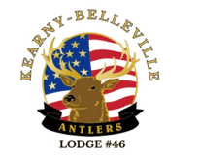
KEARNY-BELLEVILLE ANTLERS LODGE#46
THE NEXT GENERATION OF LEADERSHIP
MAKING A DIFFERENCE

PLEASE ANSWER QUESTIONS SO WE CAN GET IN TOUCH WHEN NECESSARY.

Mother's Name: Fathers Name:

Home Address:

City: State: Zip:

Mom's Home Phone: Mom's Cell Phone:

Mom's E-mail: Mom's Work Phone:

Father's Home Phone: Father's Cell Phone:

Father's E-Mail: Father's Work Phone:

Are either Parent members of the Elks: Mom: Father: _

If No, would they like to join? Yes: No: _

Would you like to be a Chaperone if needed? ? Yes:_____ No:_____ not always needed _____

