Tab 1
Notes:
- Use Simple Language: Avoid complex financial jargon; relate topics to daily life.
- Be Energetic: Keep an upbeat tone to maintain engagement.
- Encourage Participation: Call on different people to answer.
- Adapt as Needed: If participants struggle, slow down or provide more examples.

Section 1: Introduction to SoFi Personal Loans
Welcome | Welcome participants and introduce yourself. | Slide 1  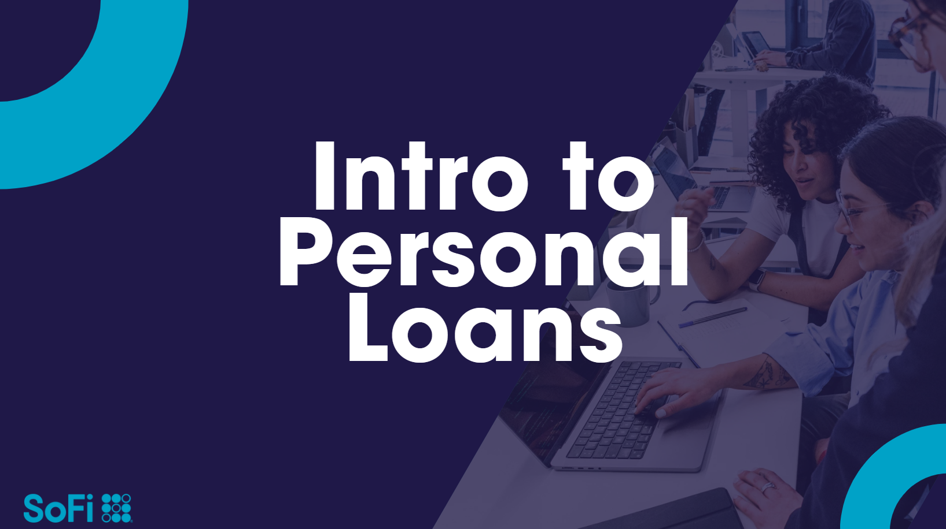
Training Overview (1-2 mins) | Introduce the training objectives:  - Understand the SoFi Personal Loan product.  - Learn how to address customer inquiries confidently.  - Practice handling real-life customer scenarios. | Slide 2  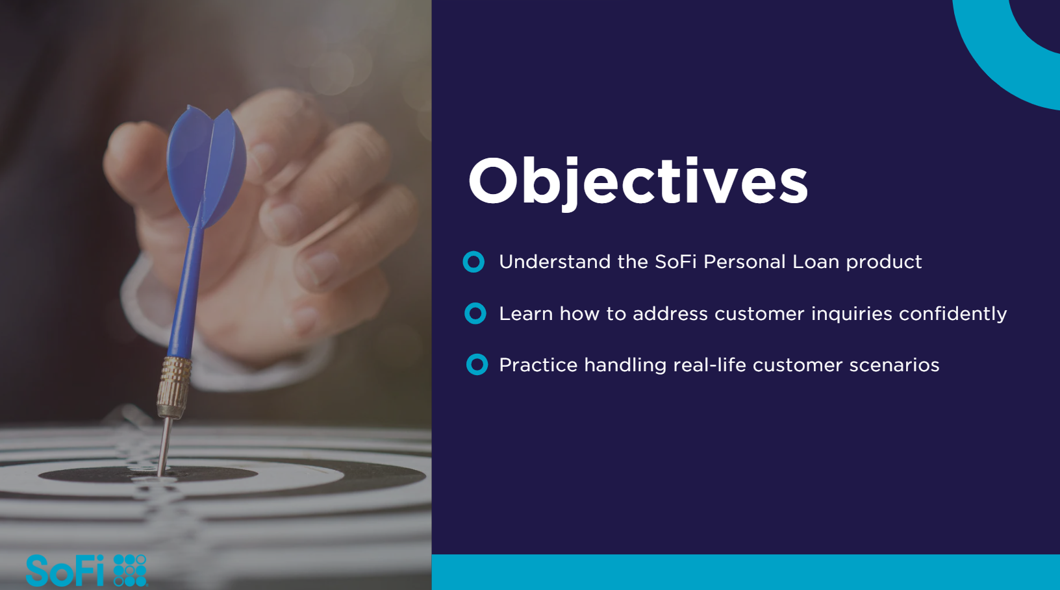
What is a Personal Loan?  (3-5 mins) | Define how personal loans are lump-sum amounts borrowed and repaid over time.  Emphasize that SoFi loans are unsecured (no collateral required).  Compare personal loans vs. credit cards (lower interest rates, fixed payments).  Is a personal loan secured or unsecured?  Can a SoFi personal loan be used for home improvement?  How long can you take to repay a SoFi loan?  Engagement Tip: Ask, “How many of you have ever applied for a personal loan? | Slide 3  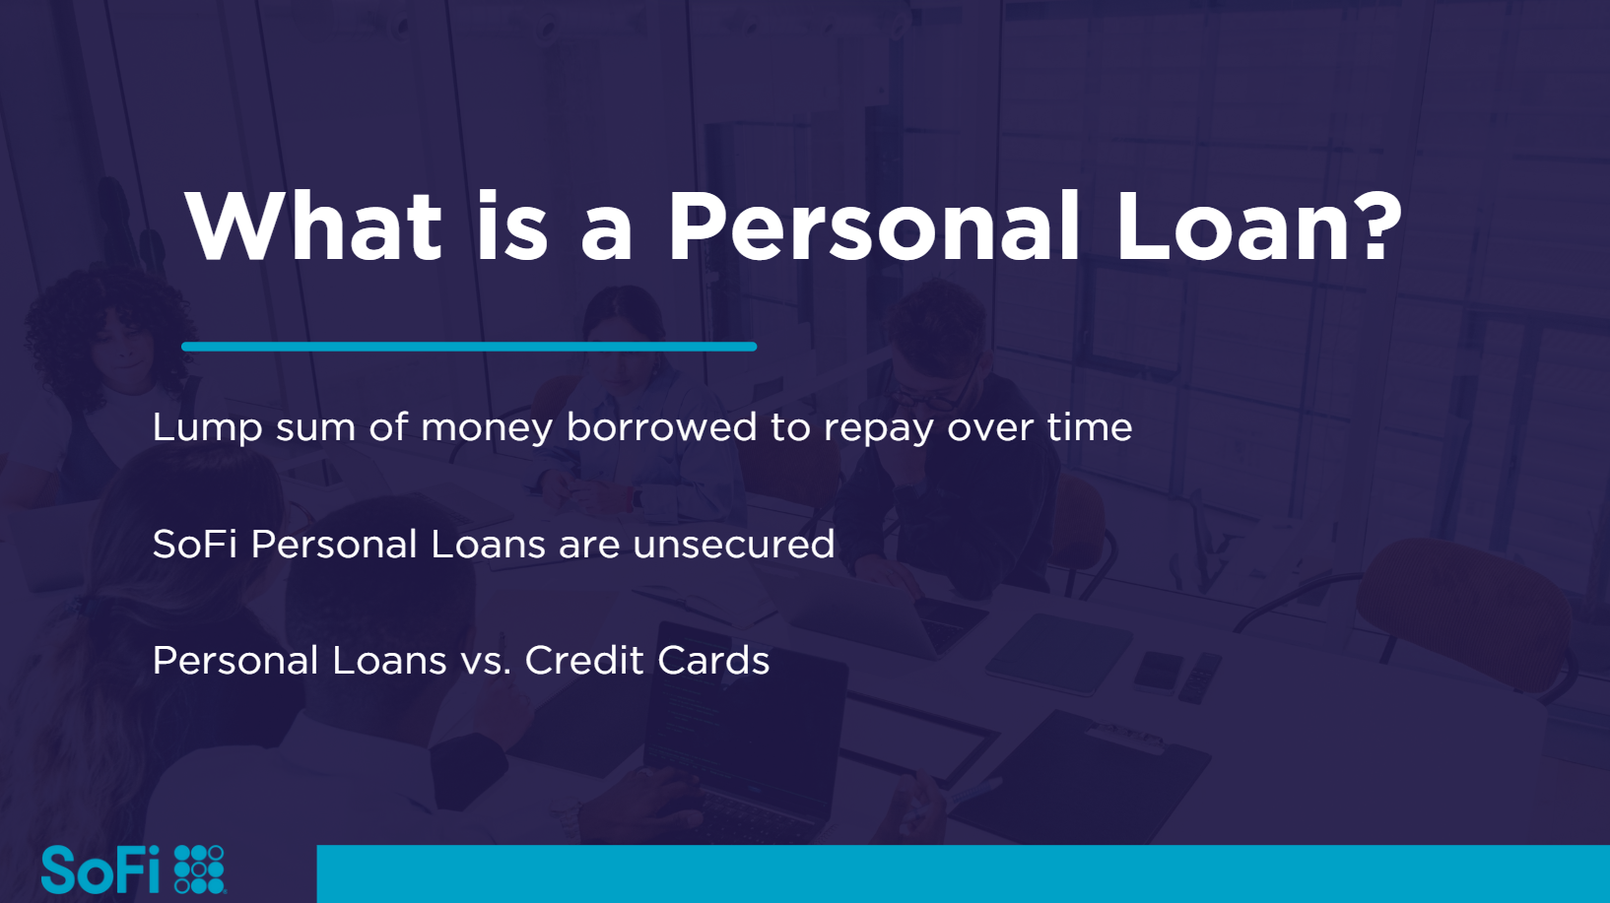
Why would someone need a Personal Loan? | Explain the options people use a personal loan for. (Examples on the slide) | Slide 4  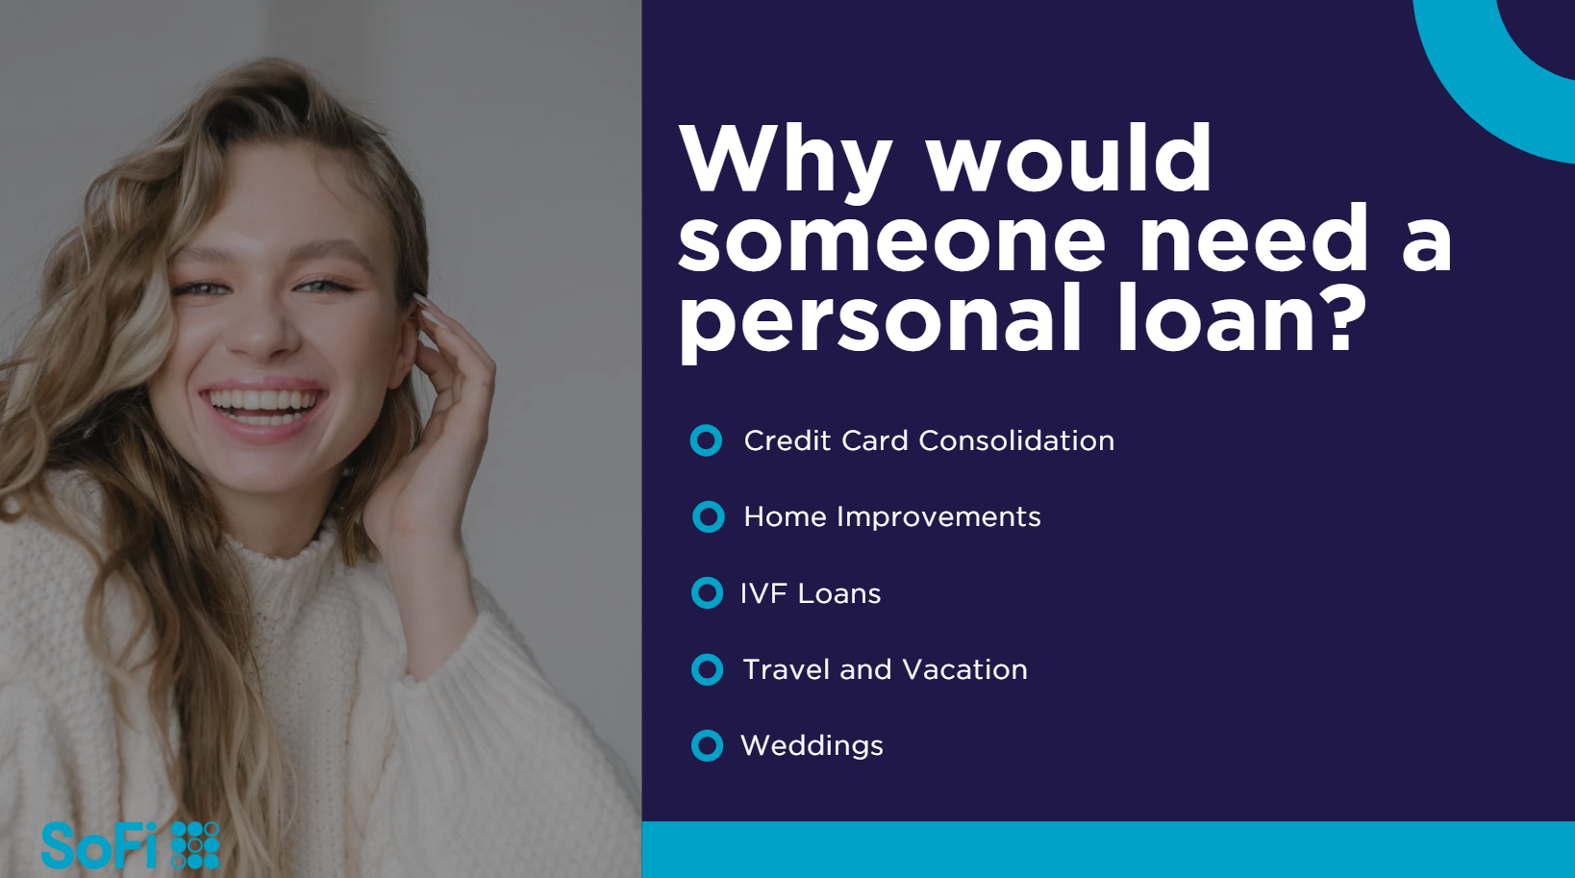
Section 2: Product Features & Eligibility (15 minutes)
Key Features of SoFi Personal Loans (5 mins) | Loan amounts: $5,000 - $100,000  Repayment terms: 2-7 years  No fees: No origination, late, or prepayment fees  Fixed rates: Predictable monthly payments  Same-day funding possible | Slide 5  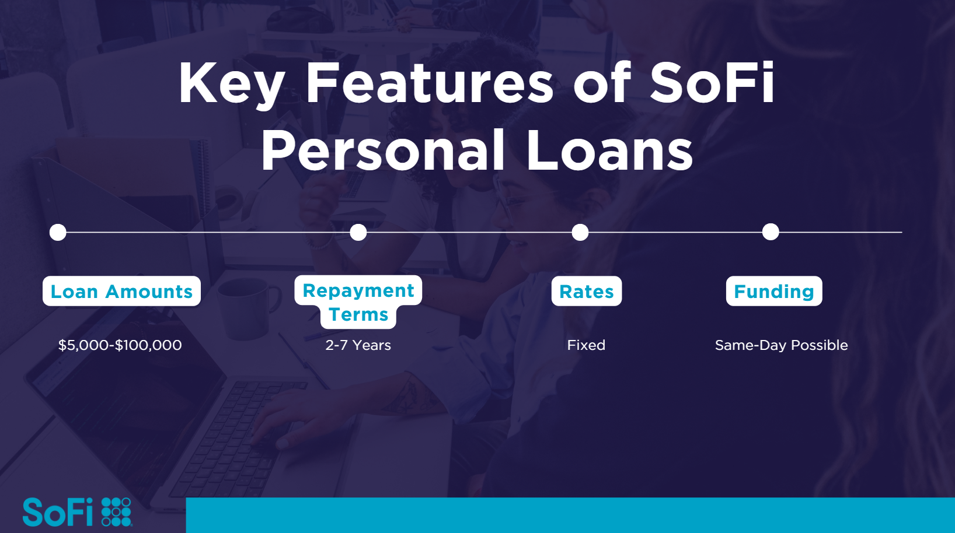
Eligibility Criteria (5 mins) | Minimum credit score: 680+  Must have steady income and U.S. residency  Debt-to-income ratio considerations | Slide 6  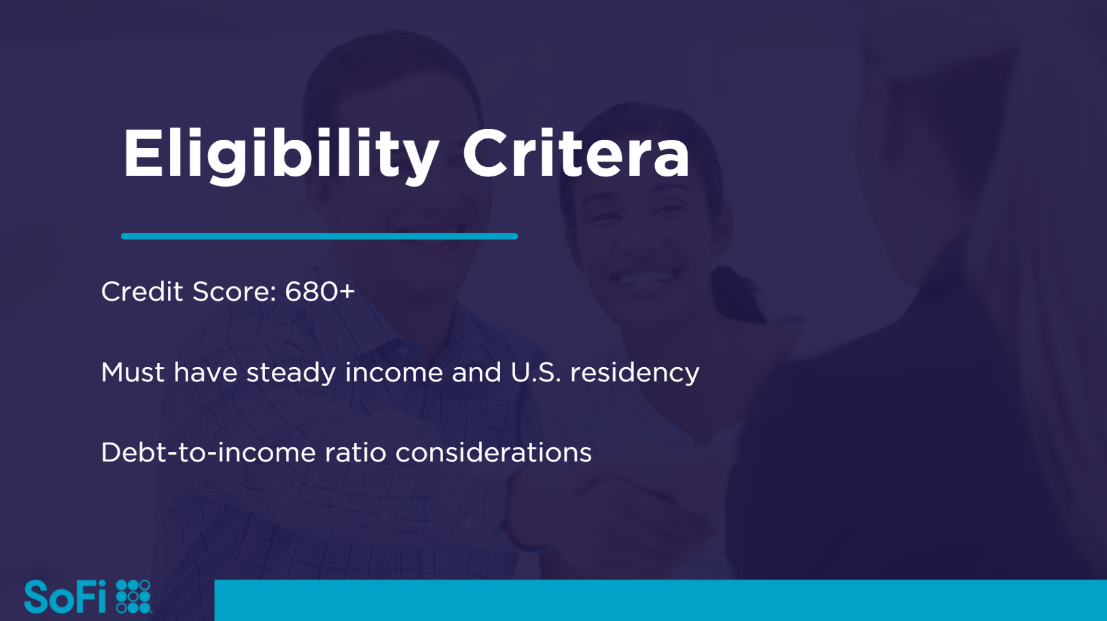
Activity: Who Qualifies? (5 mins) | There will be three customer profiles on the screen. Have the class read all three.  Ask:  - Which of these customers are eligible? Why?  - Discuss responses. | Slide 7  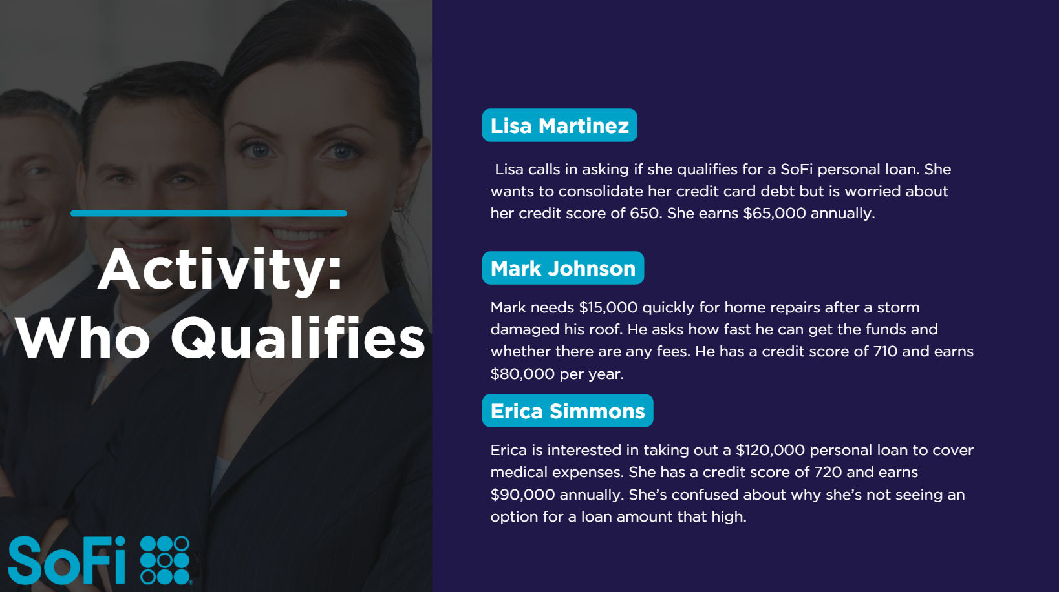
Section 3: Handling Customer Inquiries (10 minutes)
Common Customer Questions & Answers (3 mins) | Ask:  “How does a SoFi loan affect my credit score?” (Soft pull for pre-approval, hard pull upon application)  “How fast can I get my loan?” (Same-day funding possible for approved applicants)  “What happens if I miss a payment?” (Report to credit bureaus, late fees do not apply but credit score impact varies.) | Slide 8  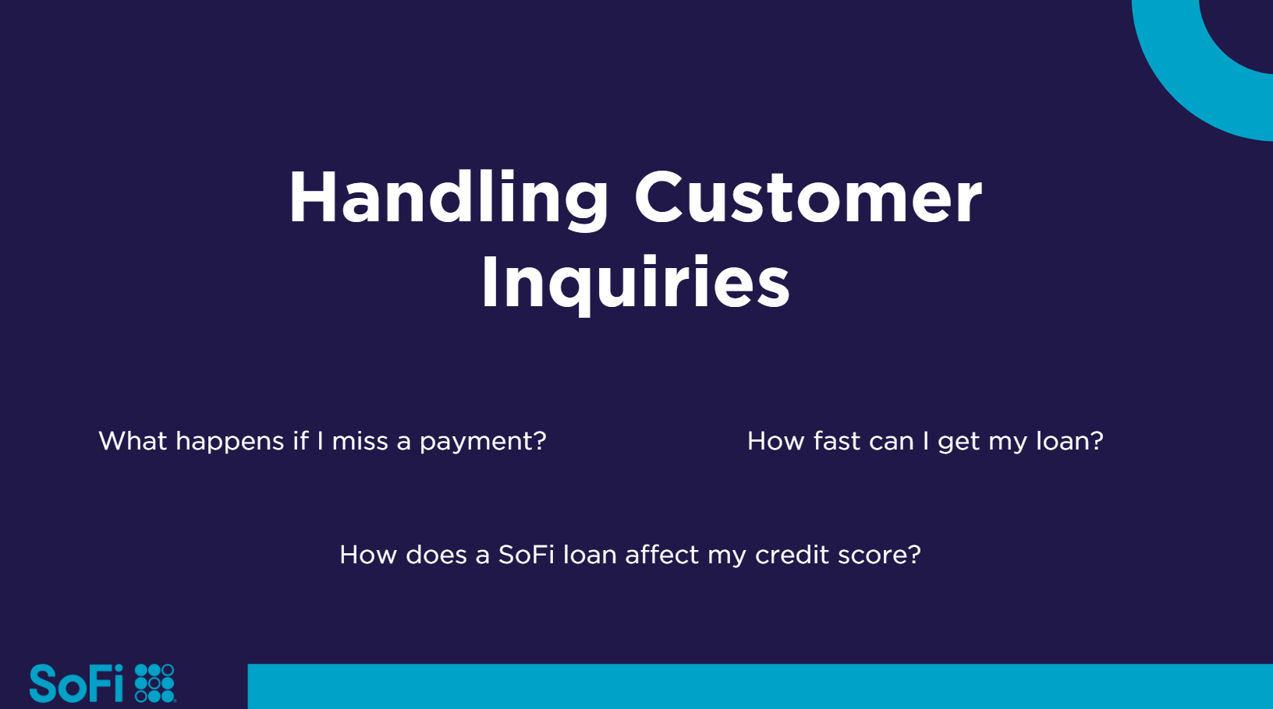
Activity: Role-Playing (7 mins) | Ask for three volunteers. Instruct the volunteers to select one person to ask a question as a customer, one to answer the question and one to provide feedback.  Ask for new volunteers as time permits. | Slide 9  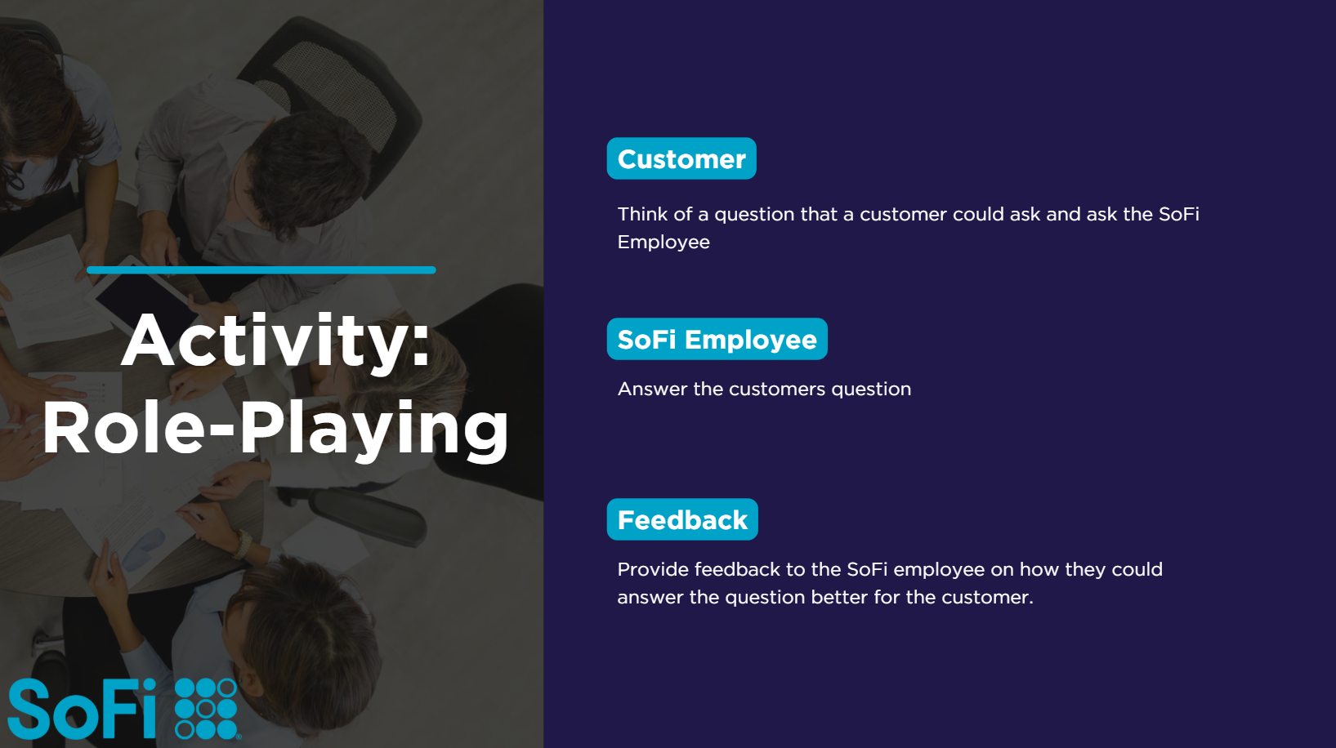
Recap & Knowledge Check (5 minutes)
Key Takeaways & Q&A (2 mins) | Summarize main points:  - SoFi offers unsecured loans with no fees.  - Eligibility includes a 680+ credit score & steady income.  - Agents should use job aids to handle customer inquiries.  Ask:if anyone has any questions or needs clarifying of the concepts covered. | Slide 10  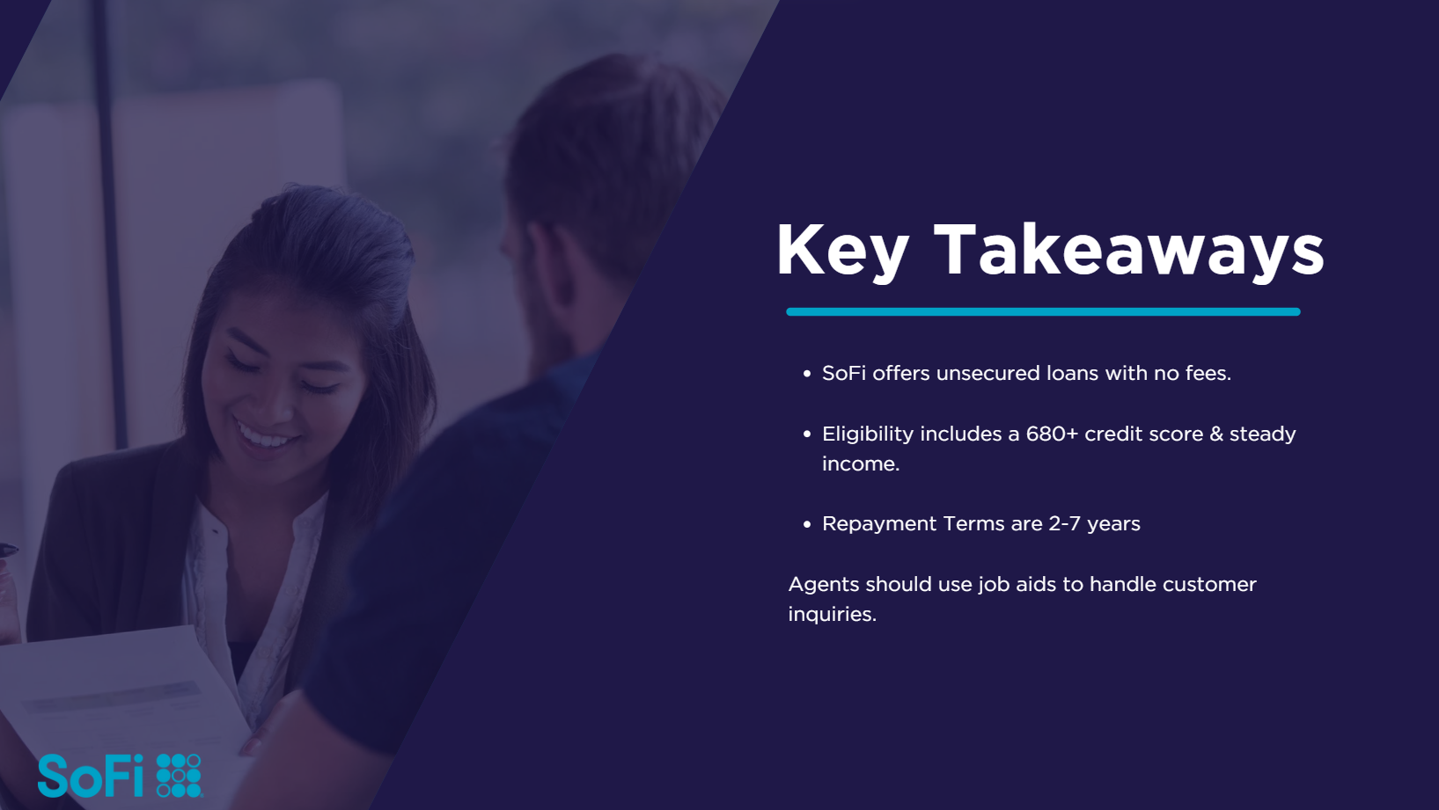
Activity: Rapid Fire Quiz (3 mins) | Ask questions, and participants raise hands to answer.  - What's the minimum credit score for a SoFi loan? (680)  - Can a SoFi personal loan be used for home improvement? (Yes)  - True or False. SoFi loans are secured loans (False)  - How fast can a customer receive their money? (Same-day is possible)  - What are the Repayment Terms? ( 2-7 years) | Slide 11  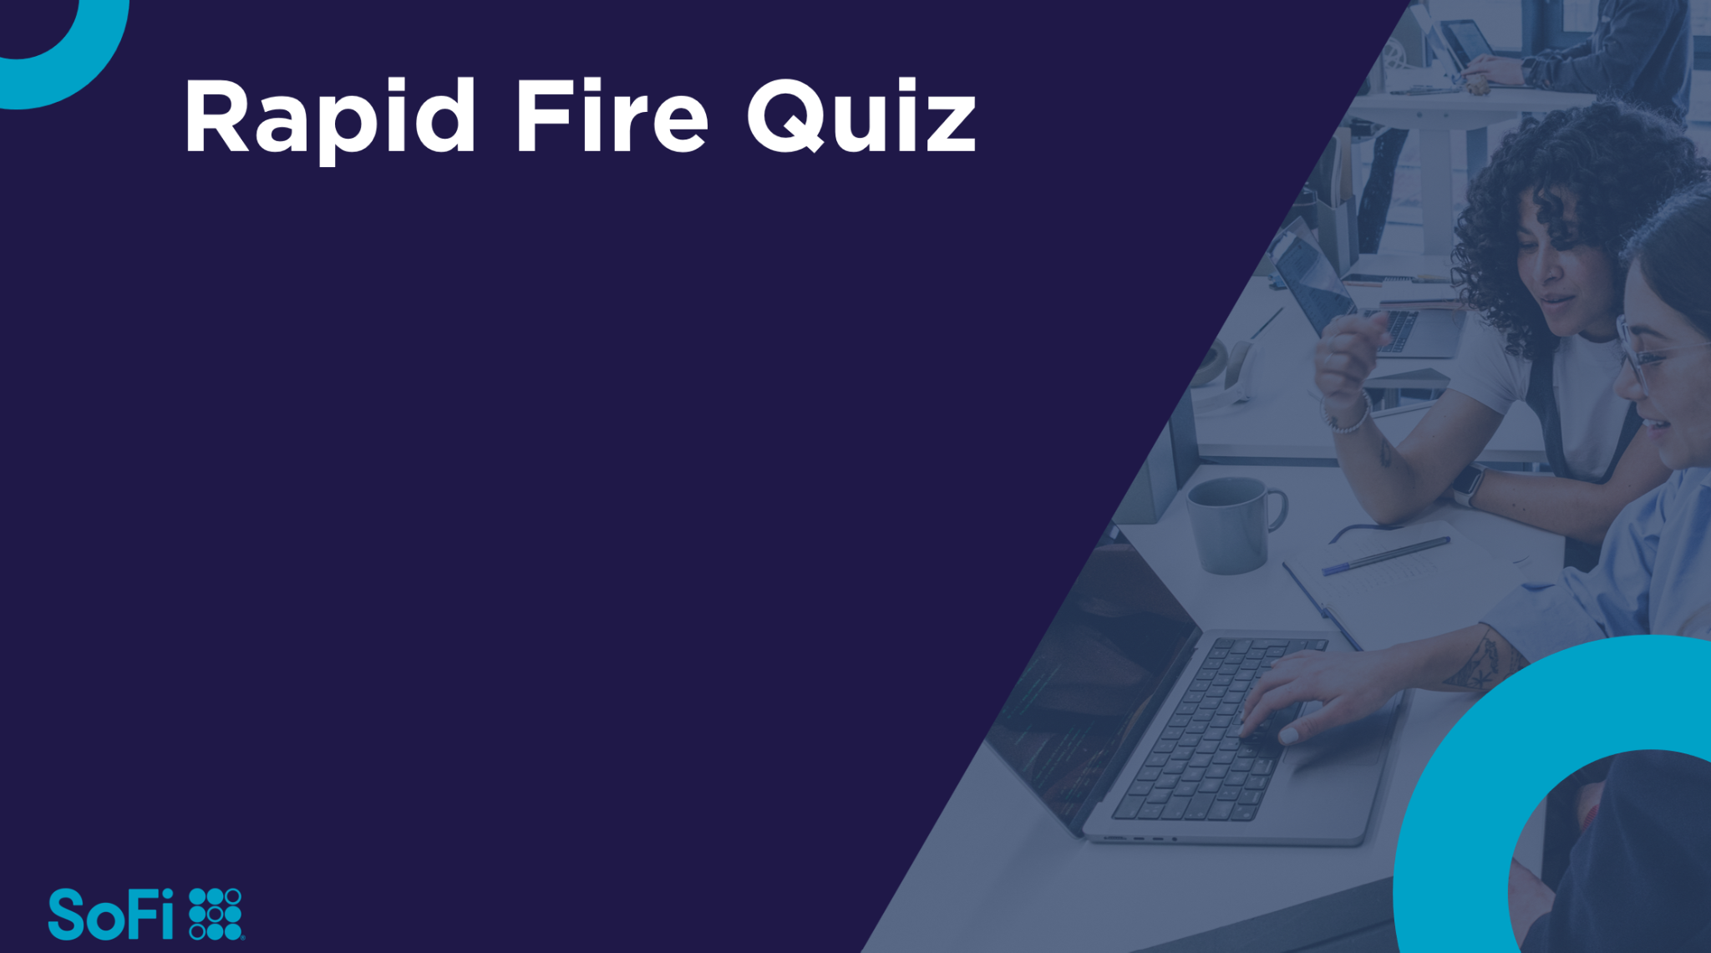
Thank You | Say:  Thank participants & encourage them to access intranet materials for reinforcement. | Slide 12  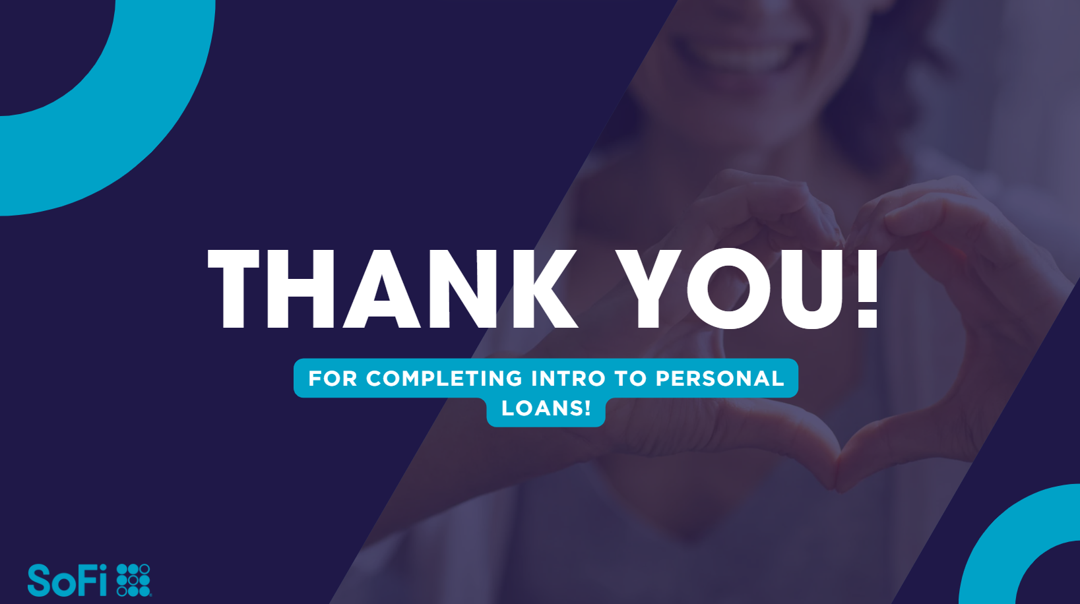

Tab 2

