
First State Mini Club Newsletter July 16, 2026
New Castle Senior Center, 400 South Street, New Castle, DE 19720

President’s Comments
I hope everyone reading this is enjoying their summer. I am not a fan of summer heat, summer clothing or summer yard work. I would be ecstatic if Fall was here all year round!
I’ve decided that in this writing I would give you some insight into the Summit that we formed a couple of years ago. It has always interested me to learn how other miniature clubs operate and what their meetings and activities are. A bit of background – there are ten club presidents in our Summit representing 12 clubs, as two have two clubs. These clubs are on the East coast and vary in size and structure. We’ve met twice via Zoom, but mostly we communicate by email. With their permission, here are some excerpts of the messages describing their clubs.

[
Marj Parker
Another World Miniature Club
Maple Shade, New Jersey:
“Another World Miniature Club has been busy on-boarding eight (8!!!) new members since April. So, how did we get eight new Club members?!?
I honestly have no idea. Three sets of them are family members of each other and others found us through the NAME website. We are now up to 19.
We’re very relaxed on what we work on and so, we include model train and model-making miniaturists.
It helps that I am really into model trains myself and really enjoy the miniature scenes at train shows.
We meet twice a month, on second Thursdays and fourth Saturdays, (generally). We don’t take a summer or winter break.
The short business meetings are held on Thursdays while on Saturdays the model train enthusiasts will run a train on a corner table.
At each meeting we work on our own projects, some of which are aligned to our Club project along a theme for our annual Philadelphia Miniaturia Show display.
We vote each year on what the Club display theme will be. For 2026 it is “Americana” and for 2027 it is “Dutch Scene with Canal Boats”.
One of the very popular things we do at each meeting, besides a “Display Table” for showing our work, is a newer thing called a “Freebie Table”. We bring in miniatures and craft supplies to give away for free. Sometimes “just the thing” we need for our projects is there.
We also have a Snack Table where members bring in much-appreciated snacks, because our meetings go from 10 am to 2 pm. We are lax about the hours, too. Members may arrive late and leave early.
Our only dues are the NAME membership, verified with the NAME roster.
Our current charities are the Maple Shade Food Bank and Providence House (women’s and children’s shelter). We collect separately for these donations.
Our ages range from 4 to 84. (Of those who will confess their age.)
We are planning an article in the Miniature Gazette to celebrate our 50th anniversary as a Club. We even have one surviving original member!
We do have a Facebook page and Instagram.
We also have a “Director of Displays and Entertainment”.
Other fancy Club titles are “Director of Charities”; “Club Historian”, “Club Scrapbooker”, “Club Editor”, and “Club Photographer”.
And we also have two “Kitchen Fairies” who set up the hot water and beverage fixings and put it all away again. Yes, our meeting area comes with a kitchen and restrooms. All we have to do is take out our trash and sweep up the floor after each meeting. I am usually the “Club Janitor”. LOL.

[
Michelle Faleshock
White Haven, PA:
“The Minis of NEPA always do projects at our meetings. We occasionally have play dates in-between meetings.

[
Sue Ostheimer
Fitch House Miniature Club, CT:
We did a fun and well attended presentation and exhibit at a local senior center this past week and plan to do a mini workshop there since the feedback was so good.
Our club is pretty much bursting at the seams, as we have always,s (in my 15 years as president), held our number at 16 since we meet at members’ homes, and of course not everyone can attend usually. We have talked about finding a free or rental place but we like it this way. We are now 17 and have one more that would like to join. We shall see if we can squeeze them in. Although it is not required, we are presently all NAME members, which is a first for our club.
We work on a 6-month basis and have a June picnic and a December holiday party with everyone bringing a delicious food dish, and we plan our next 6 months of activities, where we meet and what we will be making. We are lucky to have many very talented people in our club and we all look forward to our minis but also to socializing every month!

[
Cindy Hopper
Wee Warwick, NY:
“We are a new group of 4 so far and in the past two months, we made mini plants at one meeting and in the next we played with shrinks sink plastic to make stained glass wall hangings. Our next meeting, (July), we are bringing in stuff from our junk drawers to brainstorm mini things to make. We are currently ordering our NAME Day kits. We usually do a show and tell at our meetings.
We are going to make a trip to a local Miniature shop over the summer to bring fliers to try to grow our group. In August, we will be working on miniature clothing. In September, we plan on making some rugs by printing on different materials such as velvet paper and canvas. October will be our NAME project, November we will be “baking” some polymer clay goodies. We have the best time just creating together.

* I hope you enjoyed reading about some of the clubs in our Summit. I always get some great ideas for activities that our club can do.
Enjoy your summer! Jane Bailey, President

[ [
Zoom Meeting
This will be a social meeting only.
Here is the Zoom link for the July 16 social club meeting. This link is also found in our newsletter that is posted on our website, www.firststateminiclub.org after the 10th of the month.
Topic: First State Mini Club-Jane Bailey
Time: Jul 16, 2026 07:00 PM Eastern Time (US and Canada)
Join Zoom Meeting
https://us06web.zoom.us/j/81170288230?pwd=soVW5gJbLZahfNEtHdYvc9a6pZYT6l.1
Meeting chat link
https://us06web.zoom.us/launch/jc/81170288230
Meeting ID: 811 7028 8230
Passcode: 219131
---
One tap mobile
+13092053325,,81170288230# US
+13126266799,,81170288230# US (Chicago)
Join by SIP
• 81170288230@zoomcrc.com
Join instructions
https://us06web.zoom.us/meetings/81170288230/invitations?signature=SSQBUIe858WOaVbHiVG8GHYjWi8wD4h0ZDS06J8qBVY

[ [
Birthdays
Happy July Birthday to Joann Conaway, and Angela Hunt.
Angie Phillips, Membership

[ [
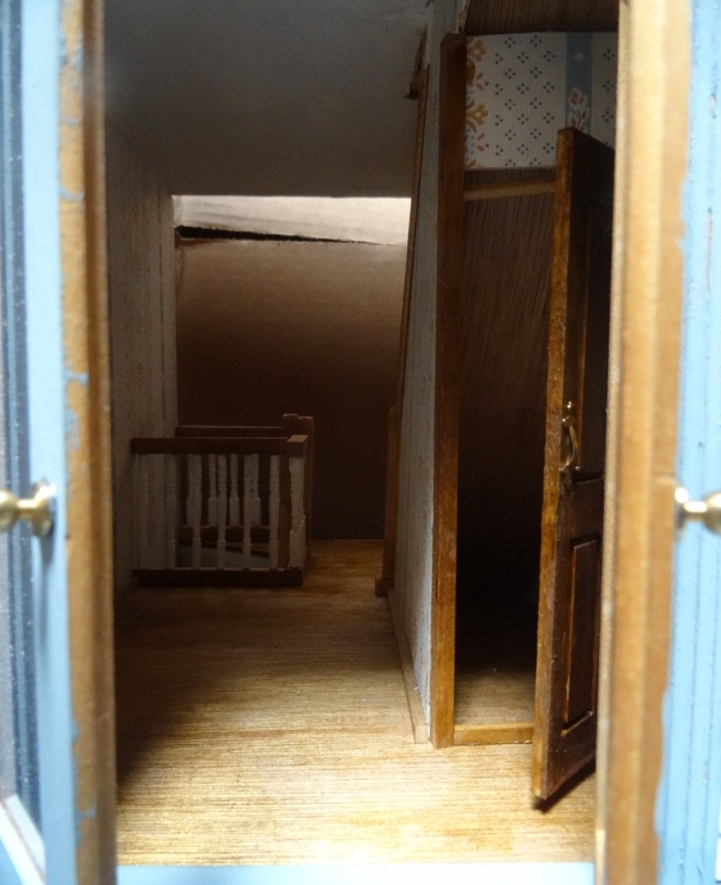
Our Activities
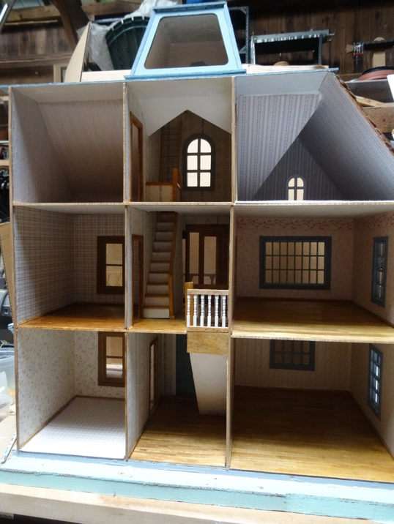
As a sequel to last month's house renovation report, I'd like to share one way to place a "secret" room under a staircase. This Artply Rutherford came to us with no stairs at all. After removing many globs of hot glue, putting down new flooring and wallpaper, adding the staircases, I wanted to include a special "room" under one of the staircases. This required the purchase of a 1:12 scale "narrow" wooden door, as the staircase I had to use was only 2.5 inches wide. I could not find an operational narrow door but did find a non-operating one in Ann Pennypacker's Etsy shop.
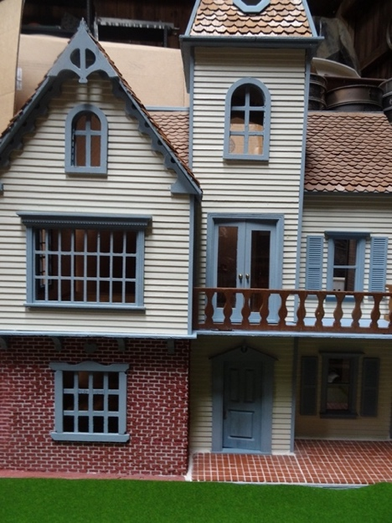
I subsequently cut away its framing and installed pins in new frames, resulting in the door you can see in the picture, on the right. You can see the second-floor double doors in an overview of the front of the house. The house, by the way, is 98% complete, and I will be putting it up for sale soon. Here is the renovated inside view too. You can see how moving the first-floor staircase to the hall has opened up the living and bedroom spaces quite a bit.
Lois Weyer

[
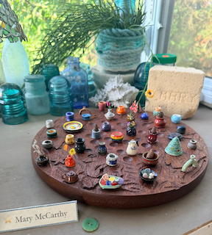
Making the World Smaller was the 2026 theme of the International Guild of Miniature Artisans (IGMA) guild school in Castine, Maine this year. I took a 36-hour pottery class. Classes were Sunday-Friday from 8-3 each day; it was intensive and at times a bit exhausting or frustrating as a newbie but I learned a ton and feel very grateful for the experience. I made a few dozen pieces that got better as the week went on.
I learned that I liked working with stoneware over porcelain (terracotta too), that making necks, spouts and lids are the tougher parts, so I probably won’t become a teapot miniaturist. My goal was to learn to make simple vessels for the candles and live plant arrangements I enjoy making, and I can say I accomplished that goal. I also loved learning about underglazing/glazing because to me that’s the artistic decorative part, so I do enjoy it.
I also enjoyed the beachcombing, beautiful landscapes, bioluminescent kayaking, blueberry ice cream and lobster in Maine while visiting.
My favorite pieces created were ones that had meaning versus the technical achievement of the teapot: a Corningware pot made to resemble the percolator pot my mom always used growing up, a fun Ms. Pac Man plate using discarded clay, a miniature ceramic tree complete with lights and electricity that I had to quickly learn from an Italian teacher in another building on exhibition night. It was fun to make new friends from the 34 U.S. states and 16 countries from around the world represented at guild school; I can’t wait to return and learn more next year!
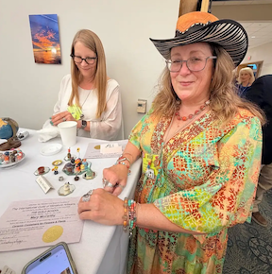
Mary McCarthy

Here’s a link to a longer piece
(https://www.splicetoday.com/writing/learning-to-center) I wrote about my experience, and I have an article in the next issue of the new World of Miniatures magazine about the trip as well. Mary

[
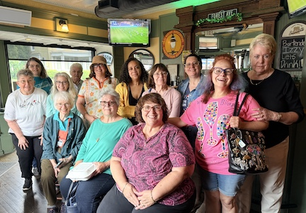
Here are some photos taken of the members who went to lunch at Sheridan’s Irish Pub and then on to a shopping trip to Fingertip Fantasies in Clayton last week.
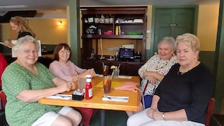

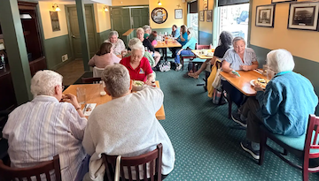

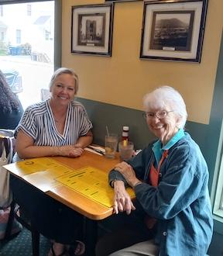
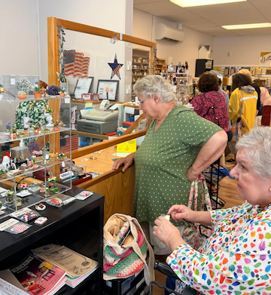
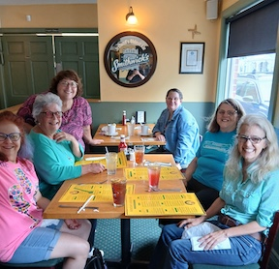
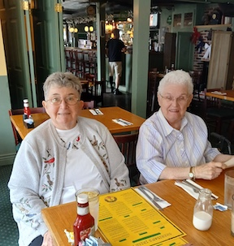

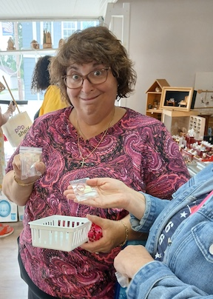
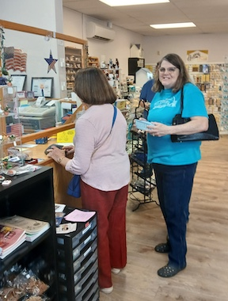
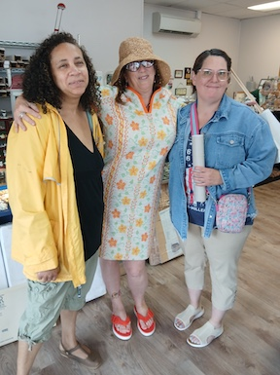
[ [
News
NAME has a new website - miniatures.org. Take a look when you can and report any issues.

[
About a year ago I came across a picture of the 25th anniversary cake. Needless to say, I cannot locate it now. I thought it could be used in the article for our 50th anniversary article. If any present member was in the club waaay back then and saves frivolous items, like I do, you might come across it in your stash. Meanwhile, I’ll keep looking. I know I didn’t toss it.
This carpal tunnel operation is not healing fast enough for me.
DianeAlice Scheuer

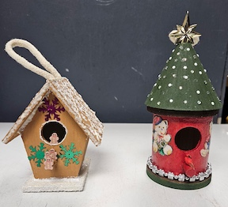
[
These are Paula's birdhouse ornaments for our club's Festival of Trees donation. The tall one resembles a Christmas tree.

[
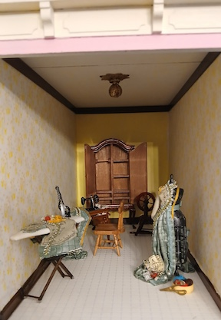
Marie Kennel’s step Mom gave her a roombox of a sewing room. She is adding some extra touches. Love the little red tomato pincushion!
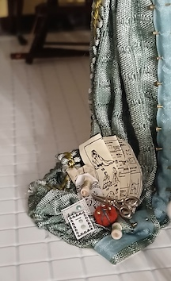

[
I am always collecting for club grab bags.
Whenever sorting tiny things is calling to you, put some unwanted items aside for our club sale of grab bags at the yard sale and show and I will collect them throughout the year at physical meetings.
Thank you!!
Carol Tillson

[
Our club newsletter is posted on the 10th of each month by our newsletter editor, Angie Phillips.
Please send her (aephllps@atlanticbb.net) any notes, articles, photos, etc. prior to the 10th. It can be a photo of a project you're working on or a mini technique you recently learned or even a cute mini you found on social media. All are welcome and appreciated. Sharing is what our club is all about!

[ [
Calendar of Events
JULY 16 - Zoom meeting 7pm - 9pm
SEPTEMBER 12 - Yard Sale, Claymont Community Center, 11am - 2:30pm
SEPTEMBER 26 - Discover Winterthur, 10am - 4pm
OCTOBER 10 - Retreat, McGlynn’s Pub in Glasgow People’s Plaza, 11:30am - 5pm
MARCH 7, 2027 - FSMC SHOW & SALE, Newark Senior Center, 10am - 4pm

[ [
FSMC Officers
President & Show Chair - Jane Bailey
Vice President, Membership & Newsletter Editor - Angie Phillips
Secretary - Bonnie Patrick
Treasurer & Webmaster - Lois Weyer
State NAME Rep TBD
Program Chair & Exhibit Chair - Angela Hunt
Family News & Titbits Chair & Estates Chair - DianeAlice Scheuer
Scholarship Program Chair & Handbook Committee Chair - Jane Bailey
Show-Yard Sale Chair - Debbie Kostyk
Outreach Chair - Marie Kennel

Publicity Committee Chair - Mary McCarthy

