
First State Mini Club Newsletter June 18, 2026
New Castle Senior Center, 400 South Street, New Castle, DE 19720

President’s Comments
It’s hard to believe it’s June already! Graduations, weddings, proms, parties, barbeques abound! The First State Mini Club is taking the summer off from monthly meetings. Instead, we’ll be meeting socially via Zoom to stay in touch and discuss important topics…like miniatures!
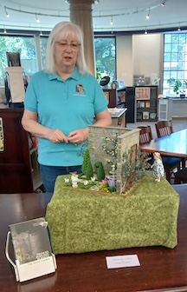
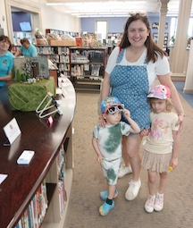
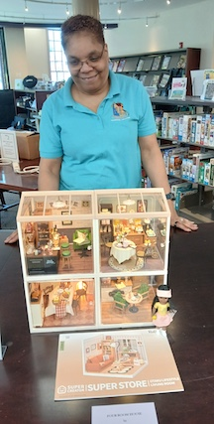
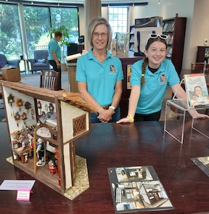
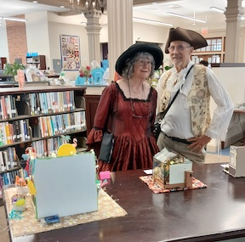
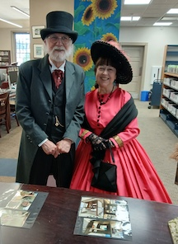
Our “A Day in Old New Castle” event went well. Although our exhibits were located a bit out of the way, we did have some visitors who enjoyed our displays. Our members who participated had a good time exploring the activities, house tours, vendors, etc., of the event.
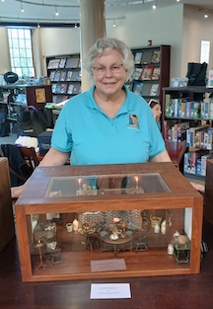
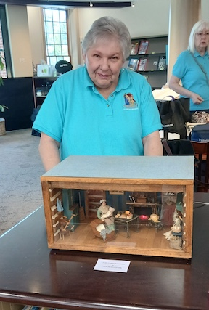
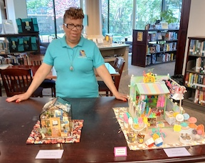

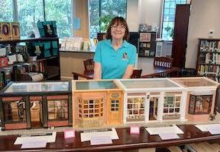
We will be gathering at Fingertip Fantasies miniature shop in Clayton on June 27 to see what miniature goodies shop owner Alice DeVore has to offer because one can never have enough minis! A group lunch at Sheridan’s Irish Pub in Smyrna is always a great time with good food.
Our Fall Yard Sale on September 12 in Claymont will be an opportunity to sell your unwanted/unused/unneeded minis and make room for more. This popular event offers amazingly low prices for those looking to expand their miniature collections.
We will be participating in Winterthur’s “Discover Winterthur” event on September 26. Our Outreach Chair, Marie Kennel, has the wonderful idea of displaying how kitchens have evolved over the years. If you have a kitchen that may suit this theme, please let Marie know.
Our Fall Retreat will again be during the NAME month of October. We will be ordering the NAME Day kits. Anyone is welcome to work on the kits or whatever else they want. A delicious buffet lunch, door prizes, giveaways and mini projects will make this a great time to enjoy our hobby and each other.
Enjoy the summer and stay cool!
Jane Bailey, President

[ [
Zoom Meeting
This will be a social meeting only.
Time: Jun 18, 2026 07:00 PM Eastern Time (US and Canada)
Join Zoom Meeting
https://us06web.zoom.us/j/87921816271?pwd=M1Uc0gC9dyRKqzCALgCPyLRyCjspxF.1
Meeting chat link
https://us06web.zoom.us/launch/jc/87921816271

[ [
Sunshine
News Flash!
Deb Kostyk had to quit her ballet lessons due to a toe operation. Rest assured, the healing is right on target.
Lynne Poindexter is doing ok also. Next time you see her, just ask..."can you hear me now?"  CHEERS!!!!
DianeAlice Schuer, Sunshine
[ [
Birthdays
Happy June Birthday to Joan Hoyt and Mary Ellen Raun.
Angie Phillips, Membership

[ [
Our Activities
Lois:
Here is an update on the Artply Rutherford I'm currently renovating. It came to me with no stairs at all, and poorly-done and somewhat-wrecked inside walls. I had asked the club members for advice on how to handle the second-floor staircase, and I received some great suggestions, thank you. I combined the ideas to develop a second- floor staircase that is simpler than the first floor one, with wallboards instead of spindles.
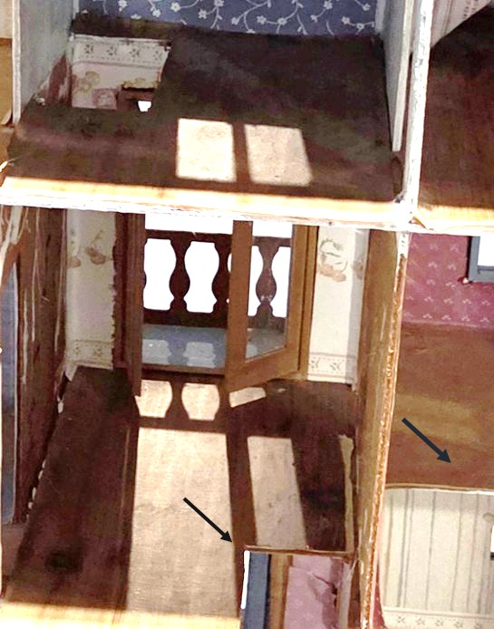
These pictures show how the space looked originally, when there were only holes in the floor of the second-floor hallway (arrow on the left) and the right-hand bedroom (arrow on the right), and no stairs. The original builder had cut out the extra hole in the hallway, and lost the stairs, and didn't finish whatever had been planned. I incorporated two sets of wood stairs from my junk bins. One had holes for spindles, so I used that one for the more formal first floor, adding spindles and a railing and a 45-degree tread. The other was straight, narrow, and with no spindle holes, so that became the second-floor staircase.
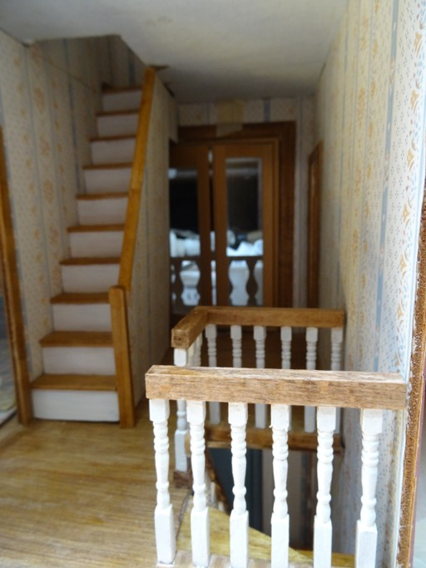
I inserted a piece of board in the right-hand second floor room floor. As planned by the manufacturer, that staircase, although graceful and curved, took up a good part of the room unnecessarily. I read in Greenleaf/Artply blogs that other builders also took that staircase out.
As an added feature, I bought a narrow door to create a secret room under the second-floor stairs. I love secret rooms and bookcase doors and have put them into houses I work on whenever possible. You will only be able to see that from the front. I can't take a picture of that yet because I haven't turned the house around yet to work on the front. The house is in my barn, on a long table with stuff all around it.
Lois Weyer
[
Angie:
I didn’t get more than the one article from Lois, so, as I warned everyone last month, I am going to have to make another contribution of my current and/or anticipated projects. (My bride bunny is mostly finished; the groom is half dressed.)
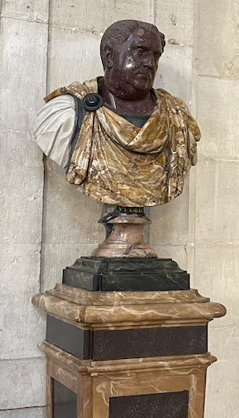
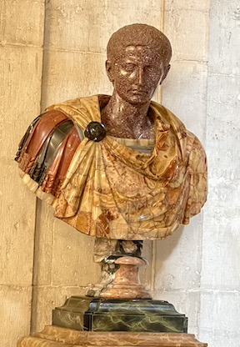
I bought this enormous foyer project from our trip to Karen Aird’s shop last August. The only work I have been able to do on it was to figure out how the staircase fits inside the alcove, since it was in pieces when I got it. I have a few ideas of what I want to do with it. So far, I have only managed to start casting heads from one of the porcelain dolls in my stash, along with a head I sculpted many years ago for a different project. These guys are intended to end up looking like the Renaissance portrait heads made of many different colored stones, like the ones I photographed in the Royal Palace of Madrid, from our 50th anniversary trip a couple of years ago. That’s going to be a paint job and then some….
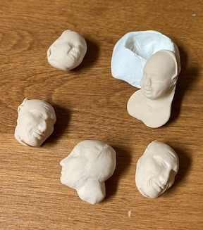
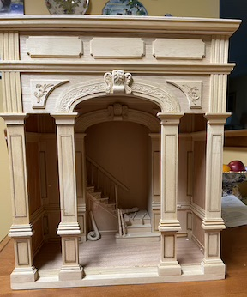
It’s going to take a lot of wiggle and manipulation to get stuff done on this interior, so it will take quite a while to finish. Meanwhile, there are bunnies needing assembly, clothes and a place to play chess. There’s also Christmas donations to the Festival of Trees. Has anyone started working on those birdhouses yet? We would love to see some of them, finished or works in progress. Please send pictures for our next issue.
Thanks,
Angie

[ [
News
NAME has a new website - miniatures.org. Take a look when you can and report any issues.

[ [
Calendar of Events
JUNE 18 - Zoom meeting 7pm - 9pm
JUNE 27 - A visit to Fingertip Fantasies miniature shop in Clayton
SEPTEMBER 12 - Yard Sale, Claymont Community Center, 11am - 2:30pm
SEPTEMBER 26 - Discover Winterthur, 10am - 4pm
OCTOBER 10 - Retreat, McGlynn’s Pub in Glasgow People’s Plaza, 11:30am - 5pm
MARCH 7, 2027 - FSMC SHOW & SALE, Newark Senior Center, 10am - 4pm

[ [
FSMC Officers
President & Show Chair - Jane Bailey
Vice President, Membership & Newsletter Editor - Angie Phillips
Secretary - Bonnie Patrick
Treasurer & Webmaster - Lois Weyer
State NAME Rep TBD
Program Chair & Exhibit Chair - Angela Hunt
Family News & Titbits Chair & Estates Chair - DianeAlice Scheuer
Scholarship Program Chair & Handbook Committee Chair - Jane Bailey

Show-Yard Sale Chair - Debbie Kostyk
Outreach Chair - Marie Kennel
Publicity Committee Chair - Mary McCarthy

