
First State Mini Club Newsletter May 1x, 2026
New Castle Senior Center, 400 South Street, New Castle, DE 19720

President’s Comments
Well, Spring is right around the corner and we’re looking forward to warmer temps, blooming flowers and lazier days. Our club’s next adventure is our exhibition at the New Castle Library in Old New Castle on Saturday, May 16. We were asked by their council members to take part in their “A Day in Old New Castle” event. This event will feature many colonial-themed activities, such as a civil war reenactment, a band, artists, tours, and more. We will be displaying our period-related room boxes in the library to be enjoyed by the attending visitors. There will be an activity scheduled for children in the library as well.
During our April club meeting, we went over our recent Show and Sale. It was the first time at a new venue and my first time as Show Chair. With the help of Lois Weyer, previous Show Chair, we managed to successfully produce a great Show. With discussion and suggestions from our members and vendors, we will be tweaking next year’s Show to make it even better. Speaking of next year’s Show, it’ll be our 50th anniversary of the birth of The First State Mini Club and we will be celebrating in style! Stay tuned for more details on that.
We’ll be promoting miniatures at the “Discover Winterthur” event on September 26 at the museum. “This admission-free community day is designed as a welcoming, feel-good celebration—an opportunity for guests and partners to connect, share, learn, and engage with one another. Last year, we welcomed more than 1,800 guests throughout the day. Partners will be featured across the estate in “hubs,” encouraging guests to explore, mingle, and engage with each organization as they move through the grounds.” Per Abigail Miller, Manager of Audience Engagement and Discover Winterthur Coordinator.
Our club’s Miniature Retreat is set for October 10 at McGlynn’s Pub in Glasgow, Delaware. We will be participating in the NAME Day/Month activity by working on the NAME Day annual project as well as some of own projects. This event brings us together for fun, food and friendship.
Program Chair Angela Hunt presented a drink in a glass project for us at last month’s meeting. Mary McCarthy made one for me and it looks great in “Bailey’s Pub”.
We have another new member, Mindy Kelly. Mindy is moving to Delaware from Tennessee in June. We are looking forward to meeting her and sharing our love of miniatures with her. Welcome Mindy!
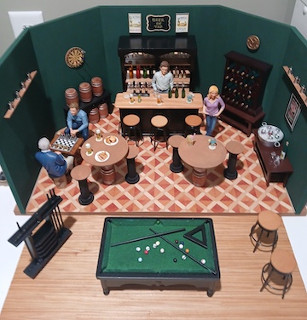
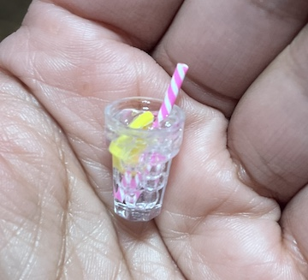
A group of us will be attending the Lancaster Miniature Show on May 17. I always enjoy this Show, seeing familiar vendors, and shopping their amazing array of minis!
Cheers! Jane Bailey, President

[ [
Sunshine
We send our prayers and condolences to Cyndi Charney, whose brother has passed away.
We are awaiting the arrival of a new member ... Mindy Kelley, who will be arriving from Tennessee soon.
Speaking of arrivals - I have a brand new great grand-son, Parker!
DianeAlice Schuer, Sunshine

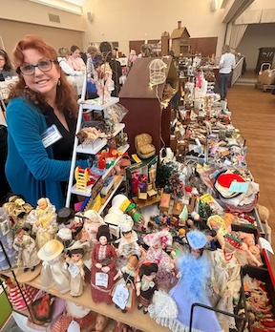
[ [
Birthdays
Happy May Birthday to Mary McCarthy.
Angie Phillips, Membership

[ [
Our Activities
Mary McCarthy sent some photos from the show that I didn’t have room for in last month’s newsletter. Here they are, including the especially terrific one we have used for the next year’s postcard.
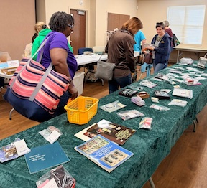
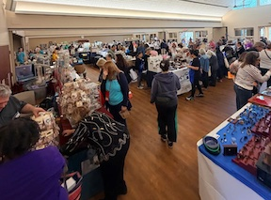
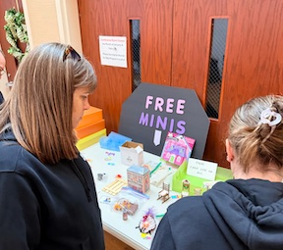
[
Well, I have not gotten many submissions for the newsletter this month, my fault for not sending out a nagging email request for content.
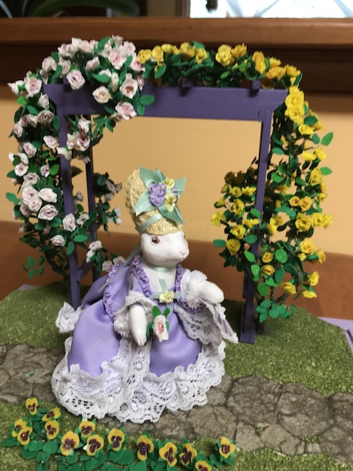
Anyway, that means I get to talk about my plans for next year’s Project’s theme, “A Celebration”. I had few ideas, until I decided to make it a part of my ongoing, though long in abeyance, series of “Bunnies at Versailles”.
My first bunny was “Marie Lapinette at Versailles”. I made the arbor and all the roses and pansies are of Fimo.
The second vignette, of Beatrix Potter’s Benjamin and Flopsy, has the park bench as the main challenge. It was aluminum roof flashing cut, quilled and painted. Again, all flowers are homemade, the irises from sheets of plastic and the daises are paper punched.
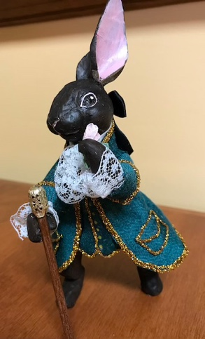
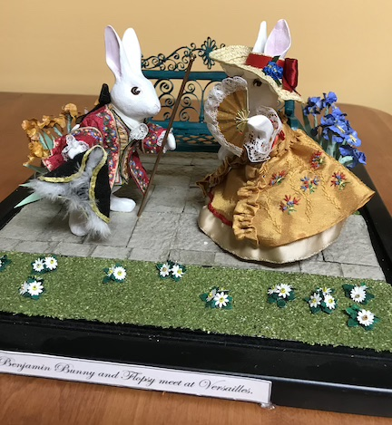

The third project, a Tea Party in the gardens, was inspired by the tea set that I received as a gift for a two-year subscription to Dollhouse Miniatures magazine. It was in no standard scale but was perfect for the bunnies. Carrot cake is the featured sweet, of course. Uncle Hare was fashionably late.
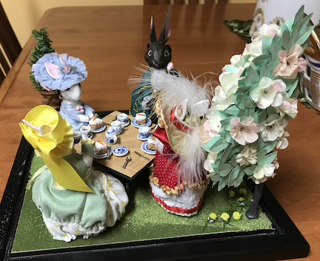
I have also received an out-of-scale chess set from the same magazine, that I have long intended to use for a pair of gentlemen bunny players. I just have had other projects to do, and we all know what that is like.
I thought, for the Celebration project, I would like to do a bunny wedding, just because I have an urge to embroider something in white satin and silver. I also have some broken opal jewelry that would be fun to include in the bridal ensemble.
I was looking through the Miniature Gazette today and saw the Bridal Shop that was an article in the magazine. I just want to say that it had no influence on my decision to do a wedding. I had already begun work on the bunnies before it came out.
We’ll see how my bunny bride and groom turn out next year.
Angie
[
News from Portugal
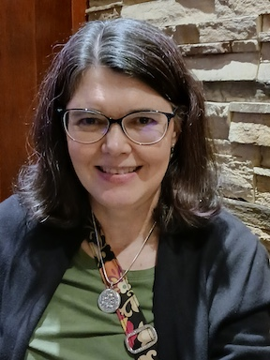
"Every day is an adventure here! We're (Mom & fur baby) settling in pretty well. I just found out there is a small miniature show here in Lisbon this weekend. I'm not going to make it, but there will be another one in Porto later this year. We (Angela's friend, Lainie and I), are planning a trip to go. We're also talking about sharing a table at next year's show. I better get creating!"
Gabrielle

[ [
Calendar of Events
MAY 16 - A Day in Old Newcastle, New Castle Public Library
MAY MEETING IN PERSON 21st, at 7pm at the New Castle Senior Center
SEPTEMBER 12 - Yard Sale, Claymont Community Center, 11am - 2:30pm
SEPTEMBER 26 - Discover Winterthur, 10am - 4pm
OCTOBER 10 - Retreat, McGlynn’s Pub in Glasgow People’s Plaza, 11:30am - 5pm
MARCH 7, 2027 - FSMC SHOW & SALE, Newark Senior Center, 10am - 4pm

[ [
FSMC Officers
President & Show Chair - Jane Bailey
Vice President, Membership & Newsletter Editor - Angie Phillips
Secretary - Bonnie Patrick
Treasurer & Webmaster - Lois Weyer
State NAME Rep TBD
Program Chair & Exhibit Chair - Angela Hunt
Family News & Titbits Chair & Estates Chair - DianeAlice Scheuer
Scholarship Program Chair & Handbook Committee Chair - Jane Bailey

Show-Yard Sale Chair - Debbie Kostyk
Outreach Chair - Marie Kennel
Publicity Committee Chair - Mary McCarthy

