
First State Mini Club Newsletter March 19, 2026
New Castle Senior Center, 400 South Street, New Castle, DE 19720

President’s Comments
Welcome March! Spring is just around the corner and let’s hope Mother Nature stays on her meds and conforms to the season…
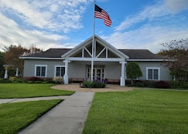
March is also the month of our 49th Annual Show & Sale and we’re now in the final stretch of preparations. We have 23 vendors with 40 tables. We’ve been advertising it heavily on social media as well as through emails and through the US mail and more. We’re hoping for a good crowd of shoppers, but we’ll have to wait and see. The new venue has presented some challenges, but the space is great. There’s plenty of parking and at an easy to find location.
We’ve been asked to participate in “A Day in Old New Castle” on May 16 by exhibiting our period miniature room boxes. This event mimics the colonial era with presentations such as a civil war reenactment, a colonial-style band, artists and tours of historic buildings. The town council members are excited for our club to display our mini scenes and I’m working with them to select the perfect venue to do that.
I’m currently seeking locations for our Fall Retreat. As you know, October is NAME month, so I’m meeting with a Newark-based hotel to secure a room for us to work on our projects together.
We’ve also been asked to collaborate with Winterthur on some of their projects. We’ll need to see if there is interest in presenting the history of our club or in participating in Winterthur’s community day, “Discover Winterthur”, with a Mini Club booth. Cyndi Charney is the contact for this.
Remember when a freelance journalist came to our November meeting to interview a few of our members for an article on our club? The publication, Cecil County Life, is due out at the end of this month. I’m excited to see it!
See you all at the Show!
Jane Bailey, President
[ [
Sunshine
Holy cow, gee whiz and Wow!!! We have another new member. Welcome to JANAINAH WINGATE.
DianeAlice Scheuer, Sunshine Chair
[ [
Birthdays
Happy March Birthday to Connie Gorman, Joshua Loper, and Angie Phillips.
Angie Phillips, Membership
[ [
Our Activities
MaryEllen Raun
Last year two room-boxes were donated to the club. They were in poor condition; in multiple pieces, faded and torn wallpaper, missing doors, falling-apart windows. I have been restoring them over the winter. They have been repainted; new wallpaper added, windows fixed or replaced, and missing doors and hardware added. Flooring will be added to the drawing room. They are not lighted but easily could be. The room-boxes; a colonial keeping room and a drawing/dining room, will be for sale or will be a part of the raffle at the club show on March 22. Proceeds will go to the club.
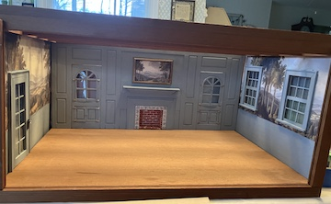

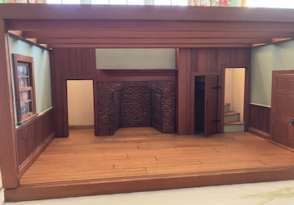

[
Angie Phillips
I spent so much time all last year working on the Christmas Shoppe, I can’t seem to shake the impulse to find and work on holiday goodies. So, of course, when Jane provided teacup sets for minis projects, what else could I do with them?
I had taken my visiting niece and nephew antiquing while they were here in January. They didn’t buy anything, but I found a Royal Winton “Christmas Chintz” teacup and saucer and just had to have it. I added some holiday pins and glitter and here it is:
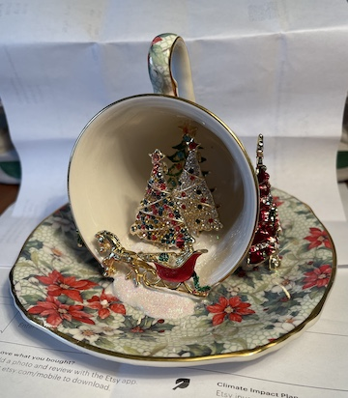

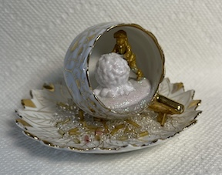
It’s funny how much gold paint and glitter can make things look good. I had a couple of those, let’s be honest, ugly little Christmas figures from Michael’s and gold paint sure did improve their appearance. I found a little demitasse cup set that was not holiday themed, but white and gold are pretty generic. So, here I am, still doing Christmas.

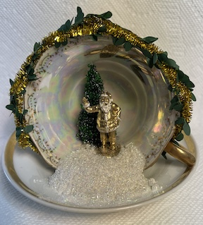

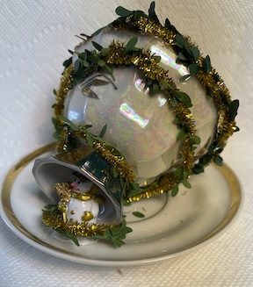

[
Angie Phillips
I forgot last month to put in an article about a book I had been recommended by my sister. It was the second of two by an author named Katie Tietjen. They are called “Death in the Details” and “Murder in Miniature”, about a woman in Vermont, post WW2, who makes dollhouses and uses her eye for detail to recreate murder scenes to help local police solve crimes. Maple Bishop is based on Frances Glessner Lee, whose crime scene miniatures helped solve real-life murders and are still used today in teaching forensic science. We in the club have talked about going to Baltimore to see them but now they are located at the Office of the Chief Medical Examiner in Baltimore, where they are still used today for forensic training and are not open to the public. Too bad.
These two books are good, but today, while checking their titles, etc., I discovered another series of three books so far, by Frances McNamara, along the same lines. Her stories instead are:

“a series of fictional stories roughly based on the Nutshell Studies of Unexplained Death…
Set in the 1920s, these stories imagine Frances Glessner Lee working with Dr. George Magrath to learn about "legal medicine", as forensic science was known at the time. Working with Magrath provided the foundation for the miniatures for which Frances Glessner Lee has become known as “The Mother of Forensic Science.” (Over twenty miniature crime scenes were used from the 1940s to the present to train police detectives.)

The three other books are entitled:
“Molasses Murder in a Nutshell: A Nutshell Murder Mystery”
“Three-Decker Murder in a Nutshell”
“Joy Street Jail Murder in a Nutshell”

Looks like some fun reading and I am going to see if my library has any of them.

[ [
Calendar of Activities
MARCH MEETING IN PERSON 19th, at 7pm at the New Castle Senior Center
ANNUAL SHOW AND SALE - March 22, 2026 at the Newark Senior Center
[ [
FSMC Officers
President & Show Chair - Jane Bailey
Vice President, Membership & Newsletter Editor - Angie Phillips
Secretary - Bonnie Patrick
Treasurer & Webmaster - Lois Weyer
State NAME Rep - Mary McCarthy
Program Chair & Exhibit Chair - Angela Hunt
Family News & Titbits Chair & Estates Chair - DianeAlice Scheuer
Scholarship Program Chair & Handbook Committee Chair - Jane Bailey
Show-Yard Sale Chair – Debbie Kostyk
Outreach Chair - Marie Kennel

Publicity Committee Chair - Mary McCarthy

