
First State Mini Club Newsletter February 19, 2026
New Castle Senior Center, 400 South Street, New Castle, DE 19720

President’s Comments
I hope everyone has managed to navigate the snow that was dumped on us. We are still digging out and are praying for warmer weather soon, at least for temperatures above freezing!
The BIG NEWS is that The Brandywine Plaza Hotel, where we had a contract for our Show & Sale in March, informed me on January 8 that due to maintenance issues that are still incomplete, they would not be able to host our event as planned. They recommended another hotel at the Philadelphia Airport which had our dates available.
Leslie and I took a ride up to The Delta Hotel and toured the facility. I’ll spare you the details; it did not meet our needs. So, as the Show Chair, I set Plan B into action. I surveyed the northern Delaware firehalls. Then, after a sleepless night, I thought of The Newark Senior Center. I had been there previously for a BINGO event and, more recently, for a flea market event. I remembered all the space they had. I contacted them the next day and fortunately, they had March 22 available, although not March 21 for our set-up day. Good enough!! The NSC has space for our vendors, exhibits, People’s Choice contest, yard sale and basically all the pieces of our Show that make it so appealing to our loyal fan base, aka, shoppers. I think, fingers crossed, it will work out fine. We have 23 vendors filling 45 tables of miniature treasures. A current list of our registered vendors may be found on our website, www.firststateminiclub.org. We are also promoting our Show on Instagram, Facebook and postcards.
Stay safe and warm!
Jane Bailey, President
[ [
Zoom
Zoom link:
Topic: First State Mini Club-Jane Bailey
Time: Feb 19, 2026 07:00 PM Eastern Time (US and Canada)
Join Zoom Meeting
https://us06web.zoom.us/j/89290005533?pwd=k6GGyDbHiIdYMjqAyG1DzMPVeTb183.1
Meeting ID: 892 9000 5533
Passcode: 799071

[ [
Birthdays
Happy February Birthday to Sara Chrisanthon, Lisa DuZant, Paula Williams and Connie Gorman. Yes, I still send her a newsletter.
Angie Phillips, Membership

[ [
Our Activities
I would just like to comment on the change of venue for our show. I accompanied Jane and Angela to have a look at the Senior Center and I think it is an excellent place for our show. The building is really nice, modern, spacious and well lit, (much superior to the Waterfall in that respect), and easier to load and unload. The main entry doors are Automatic!!! It’s not far from several places to eat and hotels for the vendors are not too far away. I think Jane has done an outstanding job and we owe her a big THANK YOU! Angie Phillips

[
*Now, About the Yard Sale:
If you plan on selling items at the Yard Sale at our Show, you need to register with Jane by February 15. Then, follow these parameters:
First, we need to make sure we have enough members that want to sell. We should have at least 6. This does not include club items. We need 2 cashiers at all times. Each seller will need to spend time at the table as a cashier. The more sellers we have the less time they will need to spend at the table. Sign-up sheet for cashier times will be at the show. Before items go on the table they will sign up for their time.
Cash or checks for payment. Cashiers will add prices, take the cash, make change, & bag items. I would prefer to use an adding machine (me). I will bring one. It would be helpful if the club would acquire a Square for CC payments. People tend to spend more with a CC.
Sellers will need to put each item in a clear plastic bag, well-sealed with tap & or staples. Please tape to the bag half an index card 1.5" X 2.5". Top half print your initials, on bottom put price. No change even amounts only. The tags are important; they are being used to calculate the amount you will receive. Please note payment will be at a later date. If you are donating the item to the club no initial is required. Sellers will be responsible for placing their items on the table. They will need to return to the table at 4:45 to collect any leftover items.
We will not need a cash box. We will use the same set up that Diane has used for many years. It works.
It would also be helpful if we could have some spotters walking around to help with theft. This can be anyone that we know. They could wear the same color shirt & a tag. One way in & out would be helpful.
Debbie Kostyk, Yard Sale Chair
[
Fair Warning. If you members don’t send me your stories, I am going to have to bore you all by posting about my projects; so, get typing, folks.
Thanks, Angie
That said, here goes:
Before and after Christmas and all the family visits, I have been working on my Courtyard project and am not nearly done. I went through several changes of concept and still lack a base to set it on.
At the same time, I have been working on a long-deferred Conservatory project. I did create the base for the terrarium, some MDF, wood veneer, inlay, and Fimo tiles.
Lots of plants, some bought, some made at home. I’d been accumulating items for this project for such a long time that I don’t remember where I got some of them.
The 3D printed cats are from a website called Scale Grail. I plan to paint them to look like cats I have loved and lost over the years.

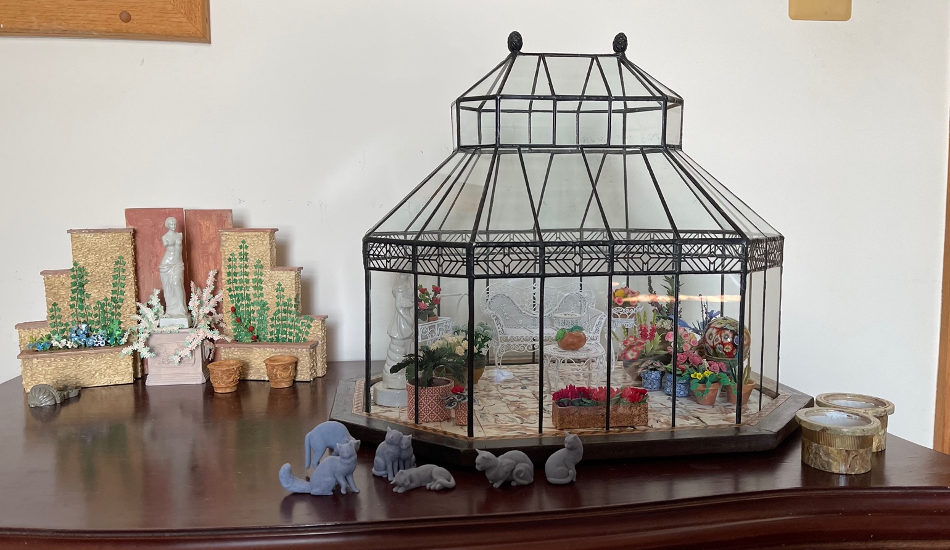

I want to put Angel Trumpet trees in the large pots but haven’t figured out how to make the flowers yet. Any recommendations will be appreciated.

 Waiting for members’ stories – Angie

[ [
Calendar of Activities
FEBRUARY MEETING BY ZOOM 19th at 7pm.
MARCH MEETING IN PERSON 19th, at 7pm at the New Castle Senior Center
ANNUAL SHOW AND SALE - March 22, 2026 at the Newark Senior Center
[ [

FSMC Officers
President & Show Chair - Jane Bailey
Vice President, Membership & Newsletter Editor - Angie Phillips
Secretary - Bonnie Patrick
Treasurer & Webmaster - Lois Weyer
State NAME Rep - Mary McCarthy
Program Chair & Exhibit Chair - Angela Hunt
Family News & Titbits Chair & Estates Chair - DianeAlice Scheuer
Scholarship Program Chair & Handbook Committee Chair - Jane Bailey
Show-Yard Sale Chair – Debbie Kostyk
Outreach Chair - Marie Kennel
Publicity Committee Chair - Mary McCarthy

