
First State Mini Club Newsletter January 15, 2026
New Castle Senior Center, 400 South Street, New Castle, DE 19720

President’s Comments
Happy New Year everyone! I hope you all had a wonderful holiday. Now it’s time to jump into another year of miniature activities and events.
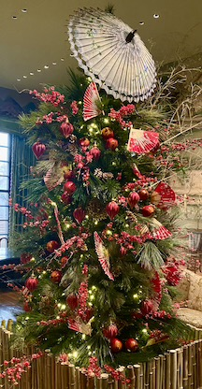
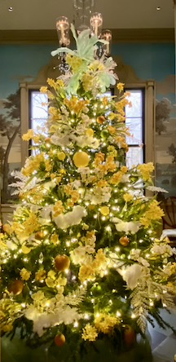
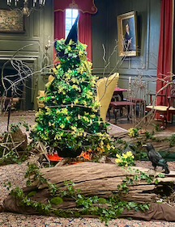
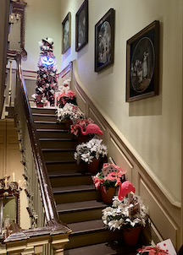
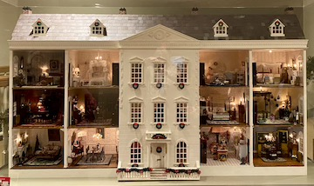
We started off the year with a fun-filled field trip. Eighteen of our members experienced “Yuletide at Winterthur” on the afternoon of the 3rd. Four members from the “Startin’ Small Club” also joined us and we were delighted to have them. (Three of FSMC’s members also belong to Startin’ Small.) It was a great day of viewing amazing miniature houses, stunning Christmas trees and artifacts in the beautiful setting of Henry F. DuPont’s former estate. A shoutout and thank you goes to Cyndi Charney who organized this event and was able to secure complimentary tickets for our attendees. Thanks so much Cyndi!!
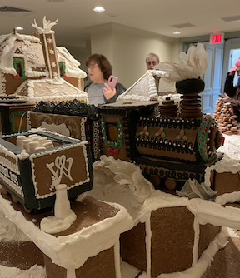
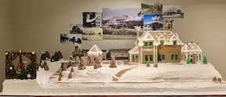
We have another new member join our club! Her name is Lisa DuZant. Lisa just moved down from New York and has settled in Seaford, Delaware. She is a member of a NAME club in NY called "Big Apple Miniaturists". She attended our show earlier this year (found the information online) and loved it. She spoke to "some ladies" at the show about our club and decided to join. This makes four new members since October! We now have 39 members, although not all are active.
As we plow ahead into the spring, we will be focusing on completing the details of our Show & Sale to be held on March 22. We’re updating a few promotional items, adding an auction and a free table. The ballroom is almost all filled with miniature dealers, some returning ones and a few new ones.
DianeAlice Scheuer is stepping back as Yard Sale Chair for our Show & Sale. DianeAlice has been running the Yard Sale portion of our Show for many years. She now asked for someone to take over this position and Debbie Kostyk has answered her call. Debbie has always been a big help with the Yard Sale and is the perfect person to coordinate this popular part of our Show. While DianeAlice will still be assisting Debbie, she will be getting a much deserved and needed rest. We thank DianeAlice for all her years of hard work and dedication to our club.
Our club meetings for January and February will be held via Zoom on the third Thursday of these months. Our next in-person meeting will be on Thursday, March 19 at the New Castle Senior Center.
Let’s make this our best year yet. Happy miniaturing!
Jane Bailey, President
[ [
Zoom
Time: Jan 15, 2026 07:00 PM Eastern Time (US and Canada)
Join Zoom Meeting
https://us06web.zoom.us/j/82058800393?pwd=Rk0dMk43EeF0vz4IQwvTL5hE2EYSBH.1
Meeting ID: 820 5880 0393
Passcode: 392039

[ [
Birthdays
Happy January Birthday to Marion, Debbie and DianeAlice.
Angie Phillips, Membership

[ [
Our Activities
Jill:
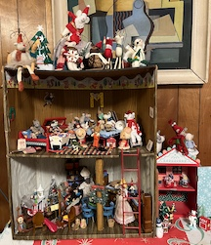
This was built by my dad for my brother Roger in 1965. I added a few more mice- okay lots more mice! Merry Mousemas!

[
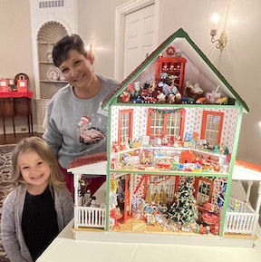
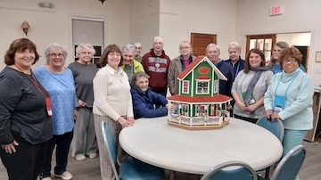
Angie: I wanted to share some photos from the Festival of Trees that I somehow mentally blanked out of adding to the December newsletter. I admit I was pretty much done with Christmas after spending a year on the Shoppe. Thank you everyone who contributed to its creation. It was raffled off for nearly $1,000 for the Delaware Hospice and our own new member Marie won it.

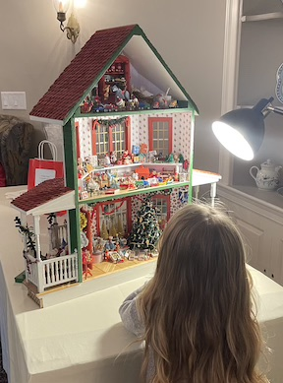
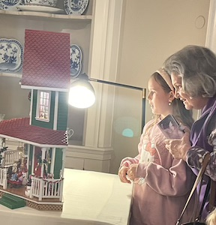
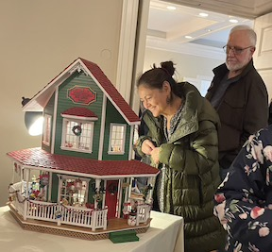
[
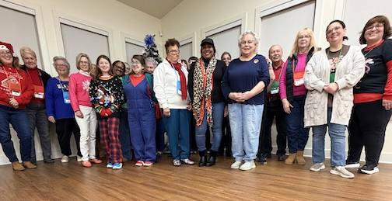
Christmas Party Pictures:
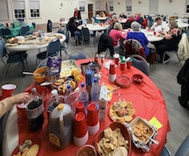
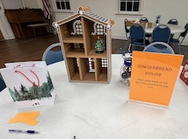
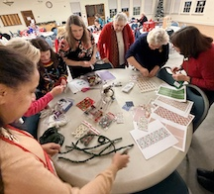

[ [
Sunshine
Welcome our newest member, Lisa DuZant.
DianeAlice Scheuer, Chair

[ [
Calendar of Activities
JANUARY AND FEBRUARY MEETINGS BY ZOOM
ANNUAL SHOW AND SALE - March 22, 2026, We’re not sure yet!!! Maybe at the Delta Hotel by the Philadelphia Airport…Stand by for updates.
[ [

FSMC Officers
President & Show Chair - Jane Bailey
Vice President, Membership & Newsletter Editor - Angie Phillips
Secretary - Bonnie Patrick
Treasurer & Webmaster - Lois Weyer
State NAME Rep - Mary McCarthy
Program Chair & Exhibit Chair - Angela Hunt
Family News & Titbits Chair & Estates Chair - DianeAlice Scheuer
Scholarship Program Chair & Handbook Committee Chair - Jane Bailey
Show-Yard Sale Chair – Debbie Kostyk, (so far, I think)
Outreach Chair - Marie Kennel
Publicity Committee Chair - Mary McCarthy

