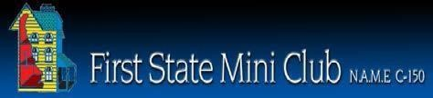

**First State Mini Club Newsletter September 18, 2025**

***New Castle Senior Center, 400 South Street, New Castle, DE 19720***

**PRESIDENT’S COMMENTS**

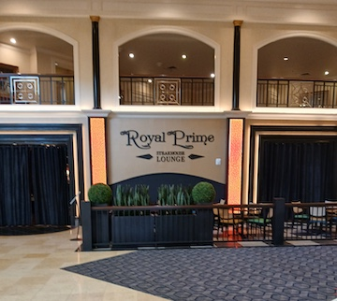 Well, here we are entering Fall with lots of activities to look forward to. Our Mini Retreat is scheduled for October 5 at Bally’s Hotel in Dover, Delaware. Eighteen club members have registered to spend the day constructing a project of their choice. Many will be assembling the NAME Day courtyard kits while others will be working on various other items. This active setting offers numerous eateries, exciting casino games and plenty of people watching. Our reserved room is a Lounge just off the main hotel lobby. We’ll have plenty of photos to share in next month’s newsletter.

September 18 is our in-person meeting at the New Castle Senior Center. It’s been a long summer of no official meetings and we’re anxious to hear what you’ve been working on. I, myself, have been trying to complete an outdoor scene for our club project. I’m not sure if it’ll be good enough to enter the People’s Choice Contest, but we’ll see.

I’m going to cut this short since we have several more submissions this month.

**Jane Bailey, President**

•••

**ZOOM ACCESS TO IN-PERSON SEPTEMBER MEETING**

Topic: First State Mini Club-Jane Bailey

Time: Sep 18, 2025 07:00 PM Eastern Time (US and Canada)

Join Zoom Meeting

<https://us06web.zoom.us/j/89163215653?pwd=ufGhpYnraazB3Nzri4xB8TbJ7nVTf5.1>

Meeting ID: 891 6321 5653

Passcode: 357382

•••

**STATE REP RAMBLINGS**

It was a joy to attend the “It’s a Small World” NAME convention in Cincinnati last month. I experienced so many amazing things - from Sue Ketchum’s storefront workshop to visiting two incredible dollhouse museums in Kentucky. One of the most amazing things I saw wasn’t on the

agenda - the 5,000 sq foot temperature-controlled, vaulted private collection of a new friend I made; can’t wait to tell you all about it!

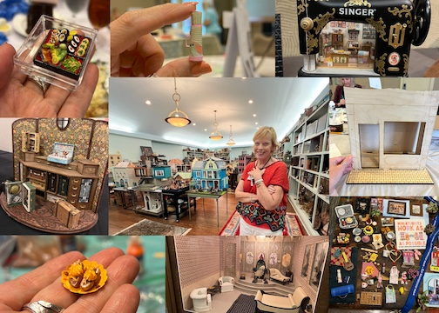 I have to admit it was a little bit overwhelming - there are many things going on at the same time and since I had volunteered to do social media for NAME, I was running in a lot of directions. However, my favorite parts were seeing the exhibit room and definitely the “hospitality room”, which had tons of fun make-and-take activities, raffles, freebies, even puzzles and games to do - it was just a relaxed, fun atmosphere and I thought it was the best place to hang out and meet people.

I would like to thank FSMC for the scholarship to attend Sue Ketchum’s workshop. I’m building a Christmas bakery for the miniature gingerbread houses I love to make. I will exhibit the completed project at our spring show. I loved visiting Cincinnati! It was an honor to attend as the Delaware State Rep on behalf of our dear Wanda and the club, and I brought Wanda some goodies!

Thanks everyone,

**Mary McCarthy, State Representative**

•••

**BIRTHDAYS**

Happy September Birthday to Deborah and Wanda.

**Angie Phillips, Membership**

•••

**OUR ACTIVITIES**

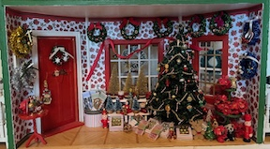 I’ve been plugging away at the Christmas Shoppe for the Festival of Trees in November and believe me, I am “Christmas-ed Out” for the time being. A problem I have run into is that our kitten is now big enough to jump up onto the desk with the Shoppe, and it’s chock full of goodies just perfect for kitty toys. The Shoppe is now resting peacefully, shrouded in towels and weighed down with dollhouse books until time to call it finished and get it safely boxed up.

**Angie Phillips**

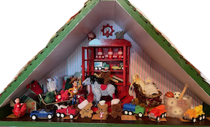

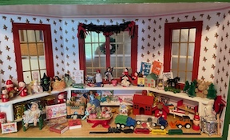

**•••**

**ANNOUNCEMENTS**

**Cyndi** has taken over the Grab Bags for Connie, so please bring anything you want to donate to every meeting until the Show in the spring.

**---**

**People’s Choice: The Buzz about this Mini Honey Themed Market Stall**

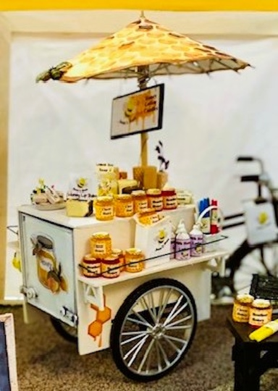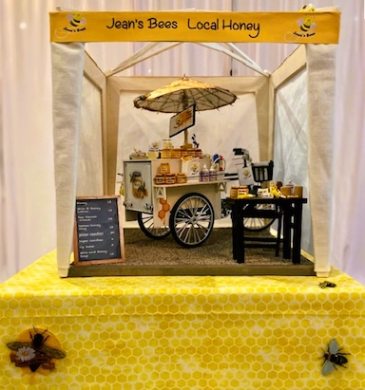 It’s hard to choose a favorite from all the People’s Choice entries, but “Jean’s Bees – Local Honey” is especially charming. Jean Kaufman, the maker, combined handmade items, enhanced bought items, and loads of custom graphics to create the epitome of an urban market stall.

Jean came up with the idea after much thought and consideration. Wanting a unique theme, she researched ideas until she remembered seeing bicycles that vendors use to ride around and sell 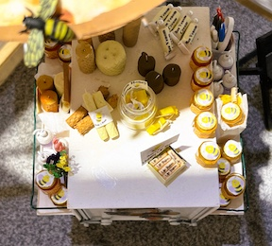things. As a librarian, she also recalled bike bookmobiles that libraries use to connect with children in the community. These recollections inspired her theme.

The market stall replicates a pop-up canvas canopy set up on an asphalt paved surface. The centerpiece is a tricycle-drawn vending cart loaded with items like honey lip balm, lemon honey soap, and of course, lots of honey! The handmade umbrella on top of the cart was a challenge for Jean. Despite two unsuccessful tries, she kept going, and the third time's the charm—it's as sweet as honey.

Jean also made the pillar candles herself using polymer clay. She colored and shaped the clay. While it was still soft (before baking), she rolled each candle in gauze to achieve the embossed honeycomb pattern. They are absolutely the bees-knees in mini candle crafting.

Working with her artist husband, Jean added depth and realism to the display with the custom name banner, labels, signs, and decals that complete the honey market theme.

No doubt Jean was a busy bee creating her market stall, and it turned out bee-utifully!

**Cyndi Charney**

---

**Paula and Gwen Share Their Experiences at the 2025 Convention in Cincinnati**

Paula:

The Presidents' meeting was held Wednesday morning.  It was presided over by Lynne Hoffman, who said she had 3 more days as the club liaison, then Kathy Burke would take over the job. Lynne said she did not regret doing it. "It was a great way to volunteer and the more volunteers the merrier."  
 She said that during her four years on the committee, paper work has been updated. Now the forms are down to eighteen (digital) pages, including a check list, (2 or 3 pages), with dates and whom to send them to. She said, literally, there were three pages that needed to be done. "Charters must be renewed by April 1 each year, IRS stuff needs to be done, and "the president's main job is to be a contact person for NAME, when information comes to you, your job is to pass it on."

There are 4 new clubs, including 1 from Canada. That makes 163 clubs as of July 22. Presidents have to keep memberships current.  There are 12,049 members, including on-line clubs.

Share resources from both the website and “Create”.

There has been, since 2021, a project available only to clubs. This year's project, a 1-inch scale book nook, was designed by Carol Mittlesteadt of True2Scale Miniatures Shop. Carol has moved to Italy but says the postage is about the same as sending it to California. There are 3 different designs available: bakery, bookshop, or florist. The kits are $10 each and $2 dollars from each kit goes back to NAME.

NAME has zoom accounts and liability insurance that clubs can use. If you want to use them, call Kim at the NAME office.

Please send copies of your newsletters to NAME at [clubliaison@miniatures.org](mailto:clubliaison@miniatures.org).

The Gazette has a new editor. Write articles about things you are up to and send stories and pictures. You will get points toward the Blue-Ribbon Award. " It is a great way to share."

The Blue-Ribbon Awards turn 39 this year.

Club presidents meet twice yearly, once in person at the convention and the other one via zoom.

**FYI**

There are 6 past presidents attending this year.

The 2027 Convention will be in Louisville, Kentucky.  The theme will be Glamping.

Next year’s Convention is “California Dreaming” in La Quito.

Academy of Honor awards were given to: Ginger Anderson, Pat Boldt, and Ruth Stewart.

Our First Vice President Leslie Swaggert died suddenly so Second Vice President Nancye Claypool is now 1st and Terry Unnold has agreed to be 2nd.

The bylaws passed and everyone on that committee was given a special pin claiming they had survived being on the committee.

“Create” will be 5 years old in October and there will be a party.

M1 is talking about a retreat in Danberry, Connecticut.

See you at the next meeting.  **Paula Williams**

**---**

Gwen:

  I had a wonderful time attending the NAME Convention this year. I joined a few sessions and explored several exhibits, with the Yard Sale exhibit and the auction being among my favorites. Beyond the events, I truly enjoyed meeting so many like-minded people who share the same passion for miniatures. The highlight of my experience, however, was getting the chance to meet one of my favorite YouTube influencers in person. It was both inspiring and unforgettable, making this convention a truly special experience.

**Gwen Denby**

•••

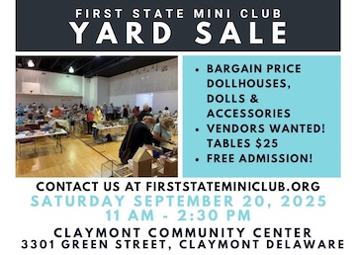**CALENDAR OF EVENTS**

SEPTEMBER 18 – FSMC MEMBER IN-PERSON

MEETING, NEW CASTLE SENIOR CENTER

SEPTEMBER 20 – OUR INDOOR YARD SALE,

CLAYMONT COMMUNITY CENTER

OCTOBER 4 – FREDERICK SHOW

OCTOBER 5 – FSMC RETREAT, DOVER

NOVEMBER 7-9 – MINIATURIA, CHERRY

HILL, NJ

NOVEMBER 15 - DELAWARE HOSPICE

FESTIVAL OF TREES, WILMINGTON

NOVEMBER 20 - FSMC MEMBER IN-PERSON

MEETING, NEW CASTLE SENIOR CENTER

DECEMBER 18 - FSMC MEMBER IN-PERSON MEETING, NEW CASTLE SENIOR CENTER

•••

**FSMC Officers**

*President & Show Chair - Jane Bailey*

*Vice President, Membership & Newsletter Editor - Angie Phillips*

*Secretary - Sharon Nonn*

*Treasurer, Webmaster - Lois Weyer*

*State NAME Rep - – Mary McCarthy*

*Program Chair & Exhibit Chair - Angela Hunt*

*Family News/Titbits Chair - DianeAlice Scheuer*

*Scholarship Program Chair & Handbook Committee Chair - Jane Bailey*

*New Show/Yard Sale Chair - Lynne Poindexter*

*Outreach Chair - Debbie Contravo*

*Publicity Committee Chair – Mary McCarthy*