

**First State Mini Club Newsletter August 21, 2025**

***New Castle Senior Center, 400 South Street, New Castle, DE 19720***

**PRESIDENT’S COMMENTS**

Greetings from the sauna…at least it feels like it. Between the heat, rain and humidity, it’s unpleasant to be outside. Hopefully, cooler weather will be coming soon.

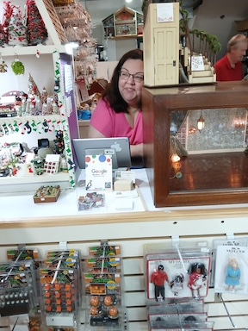 Our trip to **Karen’s Dollhouse Shop** was a lot of fun. Eight club members were in awe of the many miniature items, houses and room boxes that were neatly arranged and organized by category in her store. It’s a place that needs to be visited often to view everything more closely. I wish it was located closer to my house, but then, my bank account would take a serious hit if it were! Thank you, Karen Aird for being such a gracious host. She even offered us lemonade and cupcakes! Karen has also been a longtime loyal supporter of FSMC. Check her out at [Karen's Dollhouse Shop](https://www.bing.com/alink/link?url=https%3a%2f%2fkarens-dollhouse-shop.myshopify.com%2f&source=serp-local&h=FI3dbUoF6VxFzU6GwHOvHgF1V3hhUftgV3wF1uIeQOk%3d&p=lw_magsml&ig=0A9964570B4C4E479F0F2C70D80971CB&ypid=YN873x4972148098330571115). After our shopping frenzy, we had a nice and yummy lunch across the street at Dora’s Restaurant.

The FSMC board met on the 7th and approved a Reserve Fund Policy presented by Lois Weyer, club treasurer and Cyndi Charney, alternate treasurer. The policy states that the treasurer will place the amount of funds equivalent to one year’s operating expenses into a separate account. The funds in this reserve account may be invested as the board determines appropriate.

Wanda Simons has resigned her position as NAME State Representative due to family health issues. Mary McCarthy is her backup and, with approval by NAME’s board, will take over Wanda’s responsibilities for this position. Mary has been meeting with Wanda over the past year and has been learning the ropes regarding NAME. She will be attending the NAME Convention next week and has an active role in this event. We appreciate Wanda’s dedication to her NAME role and we wish Mary the best of success as she takes the reins in her place.

Fall cannot come fast enough for me! There are lots of big events planned in the coming months! September 20 is our annual indoor Yard Sale at the Claymont Community Center. Many mini bargains are offered at this popular event. Then, October 5 is our first Mini Retreat at Bally’s Hotel and Casino. We’ll be celebrating National NAME Day by making the NAME courtyard kits. Members may also bring items of their choice to complete. November 7-9 is Philadelphia Miniaturia in Cherry Hill, New Jersey. FSMC is well represented at this grand show.

Preparations continue for our 2026 Show & Sale on March 22. The Brandywine Plaza is still undergoing restorations after their water main break. They anticipate reopening by early October. We currently have 21 dealers committed to attend and we’ll be soliciting more as we move through the fall.

From our handbook:

***The FIRST STATE MINI CLUB was chartered on June 20, 1977****. Its origin was from a newspaper article about the Patterson’s miniature house. In the articl,e the Pattersons asked for anyone interested in forming a miniature club to get in touch with them. “We had about twenty (20) people at our first meeting, held in our living room on December 27, 1976.”*

Therefore, 2027 will be our 50th Anniversary. We’ll begin tossing around ideas on how to make it a very special one.

Enjoy the rest of the summer!

**Jane Bailey, President**

•••

**AUGUST ZOOM LINK**

This Zoom link is for social purposes only. There is no formal meeting until September.

Time: Aug 21, 2025 07:00 PM Eastern Time (US and Canada)

Join Zoom Meeting

<https://us06web.zoom.us/j/85665327036?pwd=rwFDGBdVZbdB5iGW6e0DybpziGfoXa.1>

 Meeting ID: 856 6532 7036

Passcode: 665505

One tap mobile

+13017158592,,85665327036# US (Washington DC)

+13052241968,,85665327036# US

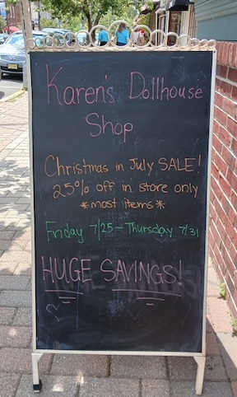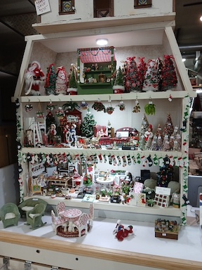

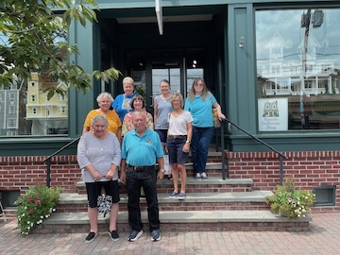

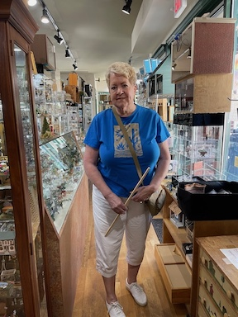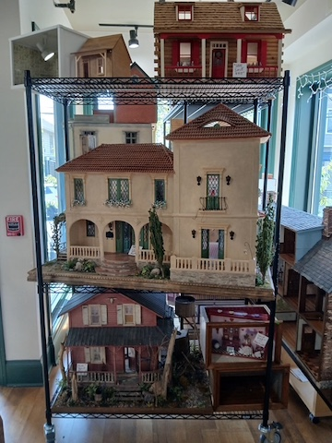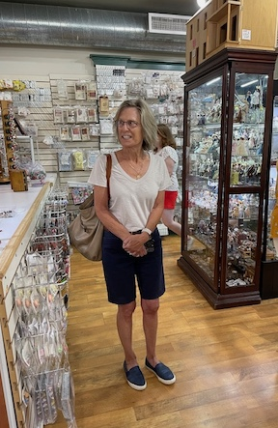•••

**BIRTHDAYS**

Happy August Birthday to Jane and Lois.

**Angie Phillips, Membership**

•••

**OUR ACTIVITIES**

**Angie**

**I just finished a book entitled “The Library of Lost Dollhouses” by Elise Hooper, about a woman who goes from portraiture before the first World War, to creating on-demand dollhouses for women whose lives have been overlooked, with secrets sometimes hidden in plain sight. References to Queen Mary’s Dollhouse and the Thorne Rooms. Worth a look.**

**---**

We visited the Small on Scale Lehigh Valley dollhouse show!

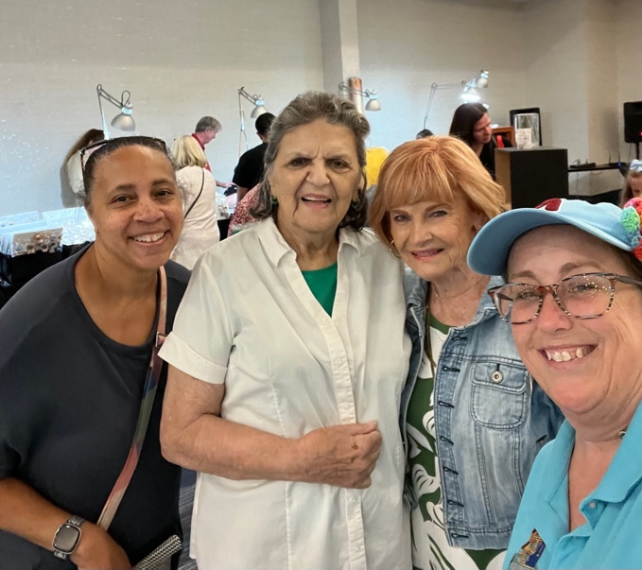

•••

**FAMILY NEWS**

Wanda's husband, Nick had a nasty fall and is now recuperating in a rehab facility.  He could use a few prayers.  For that matter, so could Wanda.

A nephew of Lois's passed away suddenly.

My brother "Texas Tom" also passed away.

Now for some glad/sad news.  Connie is leaving for her new home in South Carolina on Wednesday. Good Luck, Connie

**DianeAlice Scheuer, Family News Chair**

•••

**THE EXCHANGE**

**Does anyone have anything they want to ask about, where to find something, trade something, just give away something to another member? If you have something to post, we’ll put it in the newsletter but for privacy, all contact info is in our phone list that is sent out regularly.**

**Angie Phillips, Newsletter Editor**

•••

**ANNOUNCEMENTS**

**Cyndi** has taken over the Grab Bags for Connie, who is now on her way to South Carolina, so Cyndi will need minis for the mystery bags.

“My thought was maybe to open the “collection” for craft items too. Glue, doors, tools, etc. I’d make a separate color of bag or something for them. I know I have gathered MANY jeweler-size screwdrivers, tweezers, etc. Jewelry baubles, beads, and ribbons can inspire the imagination on what one can do with findings. I’m sure we all have “can’t throw out” collection of that stuff.”

Angela suggests that we tell members to bring grab bag items at EVERY meeting.

**---**

**Lois**

I have completed and sold the Duracraft Bayberry house that I described last month, and now have also finished a quarter-scale Laser Dollhouse Designs "Southern Cottage" kit.  I bought the kit about 4-5 years ago from Cathy Miller's Bauder Pine table and just set it aside for when I had free time. It was quite enjoyable to put it together from a kit that had all of its pieces and instructions. I was going to sell it at the yard sale, but my husband has suggested that I keep it for a while, so maybe I will.

I can bring it to a meeting if anyone thinks there is an interest in seeing how a laser-cut quarter-scale house build looks like.

PS:  The flooring was not part of the kit.  It came from my stash of surplus parts.  The shingling is cut-paper from "David's Dollhouse".  Asphalt shingles would have cost $56, while the paper was less than $20.  The kit cost $95.

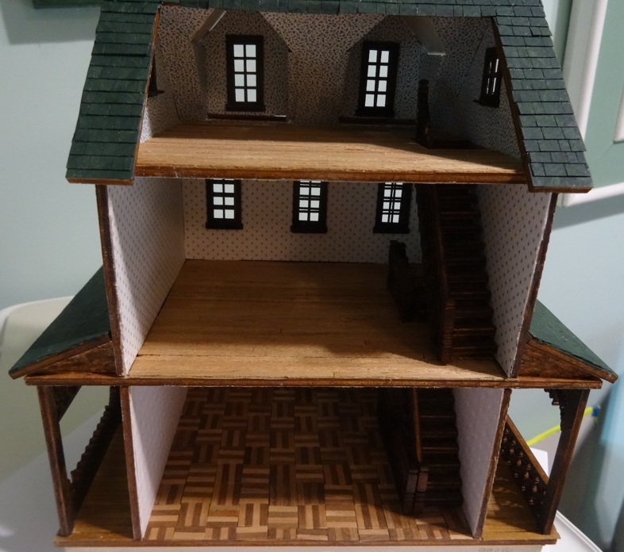

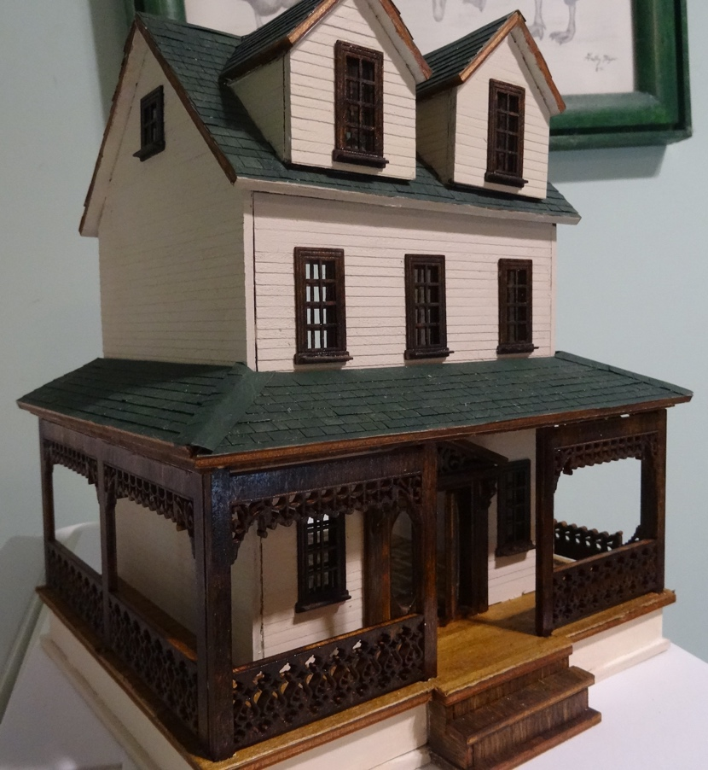

On another note:  The yard sale reservations have been filling up, with several new people wanting to sell off their collections.  We are up to 19 tables reserved now, counting only two reserved for our club and NAME.  I have collected $300 so far, which will help pay for the $500 venue rental cost.  There is a maximum of 30 tables available.

•••

**People’s Choice: The Gen X Stall that Won it All!**

Even before I joined the club, I loved going to the annual show and sale, especially checking out the People's Choicedisplay. When Jane and Angie put out the call for more newsletter content, I figured others might be just as interested as I am by the backstories behind the entries.

  While there are basic ground rules, there is still tons of room for creativity. Coming up with ideas can be hard for me, so I'm always curious: What inspires your themes and sparks your ideas? That's why I've offered to write a regular article for the newsletter, highlighting one submission from the most recent People's Choice display and exploring it in more detail.

This year the People’s Choice theme was “Market Stall.”  Our first-place winner, Angela Hunt, graciously offered to be our first presentation. Her miniature music store “Generation X,” clearly struck a chord with voters, (pun intended)!  Angela’s inspiration was weeks of listening to the satellite radio station 80’s on 8 and remembering (and researching) life in the mid-eighties.

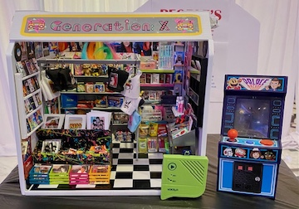 Front and center are crates from the kit displaying 33s (LPs) by music industry superstars Madonna, Boy George, and Michael Jackson’s iconic album “Thriller”. The stall is jam-packed with music posters, teen magazines, CDs, and clothing. All the things every teenager in the 1980s had in their bedrooms.

But Angela didn’t stop with the typical music store inventory. She included timeless classics like Trolls, Pez, themed lunchboxes, and board games. And then there are the true vintage staples of the era like splatter paint, L’eggs hosiery, Aqua Net, and Rubik’s Cube that are all very 1980s. Thinking outside the box – literally – Angela added a portable recorder playing period music along with a miniature arcade.

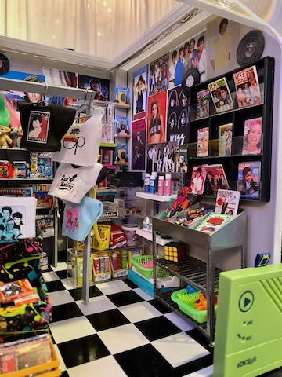 In the words of the 1980s Pepsi tagline, Angela’s Generation X entry is "The choice of a new generation". It’s totally tubular!

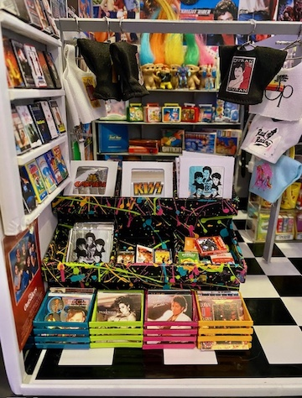**Cyndi Charney**

•••

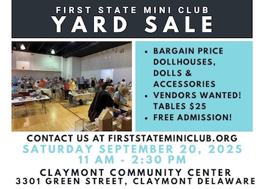**CALENDAR OF EVENTS**

AUGUST 21 – FSMC MEMBER

ZOOM MEETING

SEPTEMBER 18 – FSMC MEMBER IN-PERSON

MEETING, NEW CASTLE SENIOR CENTER

SEPTEMBER 20 – OUR INDOOR YARD SALE,

CLAYMONT COMMUNITY CENTER

OCTOBER 4 – FREDERICK SHOW

OCTOBER 5 – FSMC RETREAT, DOVER

NOVEMBER 7-9 – MINIATURIA, CHERRY

HILL, NJ

NOVEMBER 15 - DELAWARE HOSPICE

FESTIVAL OF TREES, WILMINGTON

NOVEMBER 20 - FSMC MEMBER IN-PERSON

MEETING, NEW CASTLE SENIOR CENTER

DECEMBER 18 - FSMC MEMBER IN-PERSON MEETING, NEW CASTLE SENIOR CENTER

•••

**FSMC Officers**

*President & Show Chair - Jane Bailey*

*Vice President, Membership & Newsletter Editor - Angie Phillips*

*Secretary - Sharon Nonn*

*Treasurer, Webmaster - Lois Weyer*

*State NAME Rep - Wanda Simons*

*Program Chair & Exhibit Chair - Angela Hunt*

*Family News/Titbits Chair - DianeAlice Scheuer*

*Scholarship Program Chair & Handbook Committee Chair - Jane Bailey*

*New Show/Yard Sale Chair - Lynne Poindexter*

*Outreach Chair - Debbie Contravo*

*Publicity Committee Chair – Mary McCarthy*

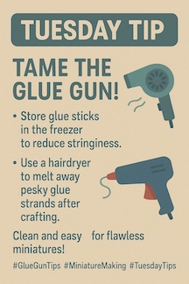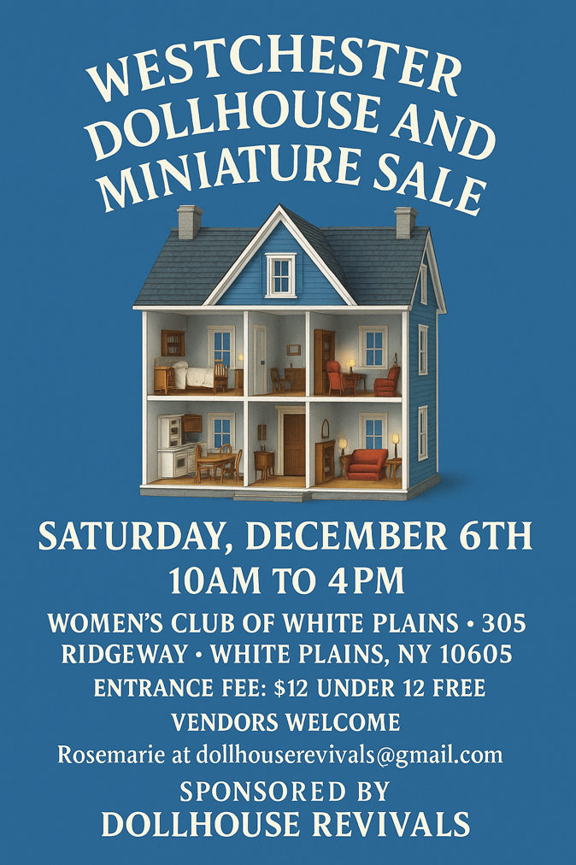

Tame the Glue Gun is a class offered on NAME’s Facebook page, for anyone who missed it. Looks like it could be useful…