

**First State Mini Club Newsletter June 19, 2025**

***New Castle Senior Center, 400 South Street, New Castle, DE 19720***

**PRESIDENT’S COMMENTS**

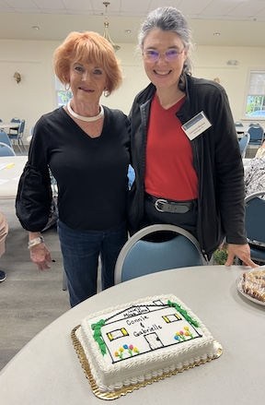 Our last in-person meeting on May 15 was bittersweet since we had to say goodbye to two dear members, Gabrielle Marlow and Connie Gorman. Their contributions to our club cannot be overstated. They will be greatly missed, and we will endeavor to keep in touch with them.

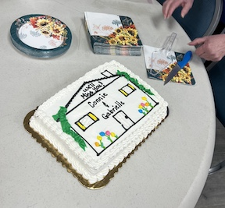My Mini Summit meeting went very well. I am so impressed with the club presidents who agreed to participate in this little scheme of mine. Each one had much to say about their clubs and I learned a great deal. Of course, a common thread was everyone’s love of miniatures! We decided to meet quarterly to discuss joint ventures, joint marketing avenues and just to catch up with each other. Now, we need a name and a logo!

Vendors for our 2026 Show & Sale are beginning to commit to attending in March. These are our loyal vendors who have participated in our show for many years and we are so grateful. Lois is updating our website, firststateminiclub.org, weekly as they register.

FSMC will be taking the summer off from meetings. There will still be a newsletter produced, social media and website updates and many casual luncheons with our mini friends.

I hope everyone has a wonderful summer.

**Jane Bailey, President**

**JUNE ZOOM LINK**

This Zoom link is for social purposes only. There is no formal meeting until September.

Time: Jun 19, 2025 07:00 PM Eastern Time (US and Canada)

Join Zoom Meeting

<https://us06web.zoom.us/j/89835630437?pwd=0yuBHTtkaTPKpD6Ynd9b71Qu07e6GB.1>

 Meeting ID: 898 3563 0437

Passcode: 593852

---

One tap mobile

+13052241968,,89835630437# US

+13092053325,,89835630437# US

•••

**STATE REP RAMBLINGS**

Don't miss out on the chance to send a photo of something you've made using a new medium to this month's Create Challenge. You can even sign up for a lesson on June 21st by Terry Unnold about using Paper Clay.

So much is going on in our little miniatures’ world these days; yet I have little to say except that I know there is much inspiration and fun being planned and I hope everyone there has a grand time.

I do feel for members attending the national business meeting in Cincinnati and if there are any question(s) about issues to be voted on, let’s talk about what’s at stake.  I’d like for our members to go “informed, not instructed to vote a certain way”.  So far, I believe our club members who’ll be there in person are Gwen Demby, Mary McCarthy, and Paula Williams. I admit that I still haven’t sat down to focus on the main issues, but do plan to do that for each of the 9 pages of by-laws before noon on Saturday, June 14th.  ANYONE, whether going to Cincinnati or not, WITH CONCERNS or INTEREST in these specifics, please get in touch with me: [ [wmsimons@udel.edu](mailto:wmsimons@udel.edu),  or (302) 420-3325].  Don't be alarmed when “my Google Assistant” screens if I don't answer immediately.  Just leave your name, when you called, and how best to reach you and I’ll get back to you.

Many, mini regards and good wishes to all to have a wonderful summer!

**Wanda Simons, DE State Rep for NAME**

•••

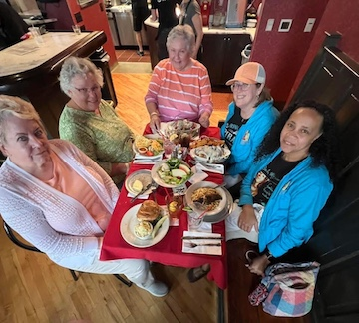

Jane, Mary Ellen, Leslie, Mary and Angela enjoy lunch after the Lancaster Miniature Show.

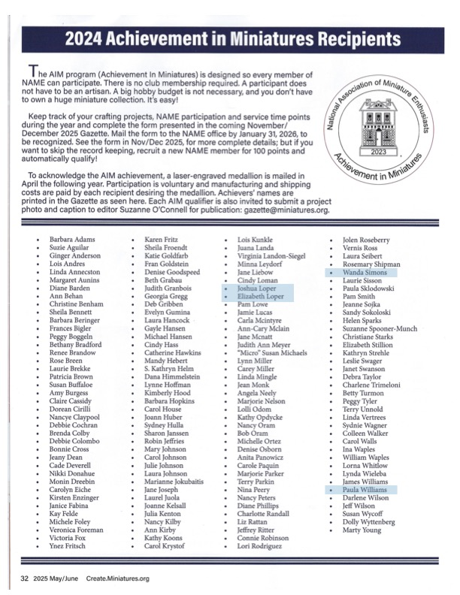**Congratulations to our members who have been recognized in the Miniatures Gazette.**

•••

**BIRTHDAYS**

Happy June Birthday to Joan, Mary Ellen and Carolyn.

**Angie Phillips, Membership**

•••

**OUR ACTIVITIES**

**The Kensington Dolls House Show Festival in London, UK**

**By Jill Kyle-Keith**

Greetings and Salutations! This year’s foray to the Kensington Dolls’ House Festival in London turned out to be (with apologies to Shakespeare) a Comedy of Errors - the comedy being traveling with my husband Bill, son Toby and his girlfriend Savannah - being with these three fun people for two weeks was a blast. But this year, the Errors part was entirely caused by - me!

As is so often the case with us mini people, more is always better, yes? Um, no - not when you go to Home Depot and come back with two enormous toolchests to travel with. Our mini trunks have never really been mini - large, yes, oversized, yes, but still admissible by the airlines with just a small overage fee. I thought these would be too. I did make sure the measurements were correct - and yay, they had wheels and handles, which our old trunks didn’t have! But they were SO large, and SO heavy, that they immediately passed the 50-pound weight cutoff when only half full - which I did not realize because our studio postage scale only goes up to 30 lbs. Well, they FELT ok!

You guessed it- once we hit check-in, they were ‘not allowed’ due to weight. Mucho thanks to my friends Deb and Dennis (who drove us to the airport) while I rummaged around for the heaviest items to ditch. We had packed 4 antique German houses with antique furniture, though, and these stayed, but some antique china, most of our displays, some of my handmade stuff, and a large box of antique furniture had to go back to D&D’s car. Sigh.

Things got better when we got to our Airbnb - we usually try to stay near Kensington, but found a good deal with lots of amenities farther out. Toby, Sav and I have gone to the London show before, and as seasoned AirBnB-ers, we are all agreed on three things: a microwave, a bathtub, and decent WiFi! (I also like ambiance and decent art on the walls, but you can’t have everything). Sav is a great cook, so we save a bit of travelling cash by having a place we can cook in (and also how much fun is it to go grocery shopping overseas? Lotsa fun!)

Setups for the booth went smoothly - usually it’s a frenzied rush, but all of us have done mini shows before, so four people make it go fast (and with setup time just 6-9pm the night before, this is important).

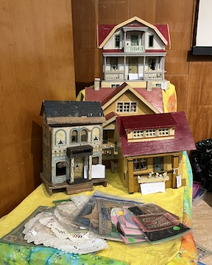 We had a GREAT show - the best yet - and all four antique 1890s Gottschalk houses sold to another dealer before the show even opened! We noticed that people on Friday seemed to buy our antique items, while the Saturday crowd was more interested in our wizardly and historical handmade pieces. And good news, there were a lot of younger patrons this year - twentysomethings interested in the odd and unusual, right up our alley. After four shows in London, we might just have figured out a good balance between antique/vintage and handmade. And honestly, I can’t build fast enough to keep up with our handmade stuff anyway!

The KDF festival is juried, and one of the best in the world, with many international vendors and some insanely fine miniatures. I’m honored to be accepted there, and to be honest, I try my best not to go whackadoodle and buy everything I see. This year I did come away with a few minis for me, but I also bought something new - six bags of cutoff pieces from a vendor’s laser cutting machine. These are tiny pieces from his 144 scale houses - leftovers from windows, doors, side pieces, and the more I look at them, the more mini accessory ideas I have!

One new thing I’ve started to do is to re-costume antique bisque dollhouse dolls in antique fabrics - most of the time, when I am able to source them, they are naked, so not to worry, I’m not destroying the history of these beauties. These nearly sold out, and they are fun to re-costume (at last, putting my theater costuming skills to work), so I will continue that.

Over two days, we sold a lot of stuff - a lot! But we still had a lot left over - and KDF coordinator Charlotte Stokoe was kind enough to let us leave our two trunks in her storage unit so we could take a side trip to Scotland. Bill and I honeymooned there, thirty-five (!) years ago, and I performed at the Edinburgh Fringe festival twice, so there were a lot of memories. We took a picture in the old theater I was in, which made me both happy and sad at the same time.

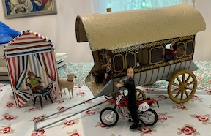 Our AirBnB in Scotland (shoutout to Avril and Alan, proprietors!) was a wonderful stone cabin with a really-truly gypsy caravan named Ruby in the garden - everyone took turns sleeping in it! And, as luck would have it, I went to an auction when we got back to the States - and snagged a vintage (1920s?) gypsy caravan for my dollhousers! I’ve named it Ruby in honor of Scotland Ruby!

All in all, a wonderful trip, until Error #2 happened - yup, overweight trunks again, and this time, because they were too large for Heathrow’s X-Ray machine, we were directed to a low-ceilinged basement room in the bowels of the terminal, where a very slow employee took out everything from the trunks and proceeded to wand Every-Tiny-Thing. But here’s another shoutout - to Virgin Air, which miraculously (and with the help of a sympathetic supervisor in the basement room, I suspect), held the gate for us so that both we and the trunks made it.

And the gem remark goes to Toby, who waited until we were in the air to mention quietly to us all that we had been, you guessed it, in the Bomb Room of Heathrow. Kinda explains the low sealings and mysterious foamy coverings on the walls.

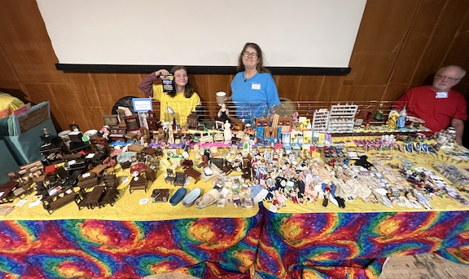 And that’s our trip in a nutshell - Dollhouses and a visit to the Bomb Room. What more can a gal ask for?

---

**Lois Weyer:**

This is a Duracraft Bayberry cottage that I got from a neighbor in a partially completed condition. Whoever started it had built the main structure and the staircase (not the railing), but did not do any priming, no windows or the door, no roof or porch.  Unfortunately, the person didn't match the center and one wing very well, and so it will take some creative trimming to fill gaps in the internal wall corners.

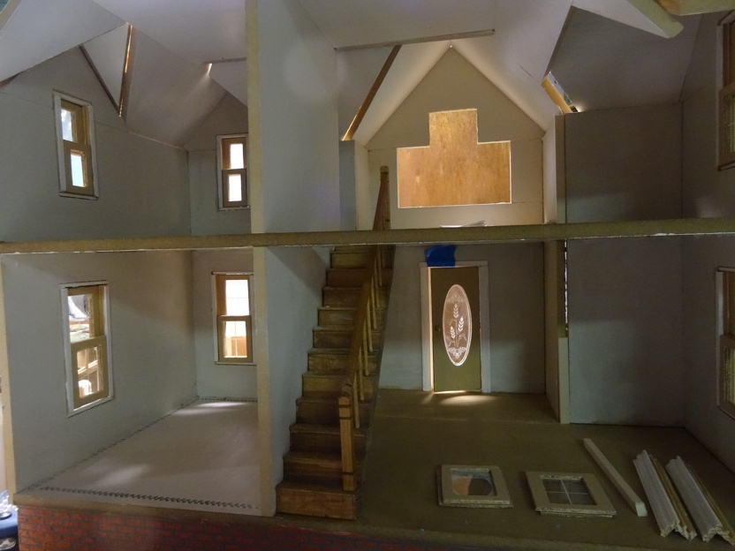

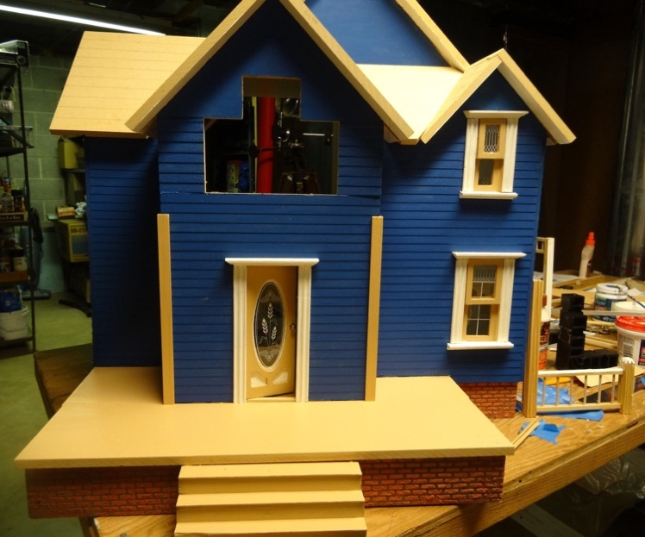---

**Wanda Simons:**

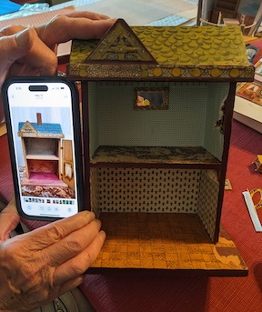I never expected to become immediately engrossed by a friend’s latest bargain from a random sale, but her simple 2-room dollhouse with a missing front has become a fun challenge for us both.  Not exactly “restoring,” but replicating some features, uncovering others, and finding that 20th century wallpaper patterns installed by previous owner(s) can be difficult to remove.  So, it may end up being “shabby chic”.

Half inch-scale furniture fits well in my friend's house.

She would like the dollhouse to have a hinged front wall and so is deciding whether to use wood or something like Mighty Core, a strong version of foam core. The original front would have had wood.  We found that reproduction papers are sold online, so photos are difficult to determine as which is original and which is more recent, if they're not labeled.

  My friend had noticed the R Bliss logo over the front door on her little house, so we found similar photos online. We worked from several of those.  References gave the company’s origin as R. Bliss Mfg. Co. of Pawtucket, Rhode Island.  Both internet and book resources provided info for background on the brand.  While I have a huge collection of reference books about historic dollhouses, I hadn’t focused on Victorian era “children's playthings” with lithographed paper inside and outside, which is what she bought, with the side exterior walls’ printed papers intact.  We found a bit about its maker, who sold doll houses for up to $25! I’m guessing that, due to its small size, her house likely sold for under $10, possibly even under $5. Flora Gill Jacobs’ 1965 *History of Dolls' Houses*, p. 190, shows my friend’s house in the middle and is the smallest of six in a row that Jacobs titled "Bliss Street" in her now-closed museum in D.C.. They are all dated as “turn of the (20th) century”.  A large one in the group is identified as ca. 1895 and probably cost $25 when new.

In the meantime, a professional photographer worked to stretch the photo of the second floor a bit to cover the expected front wall, using one of the internet photos as our “original”.   We hope that it will work.  Stay tuned for the finished project.

If any of our members own Bliss dollhouses, I hope they'll contact me so we can learn from each other about these amazing relics!

**Wanda Simons**

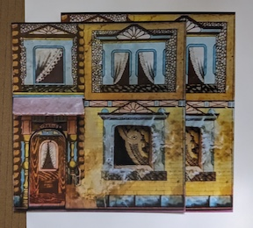 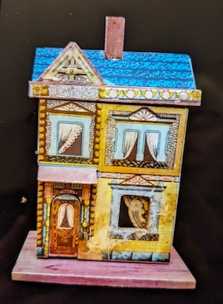

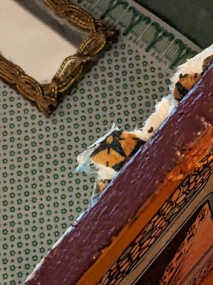 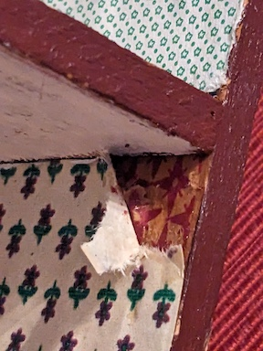 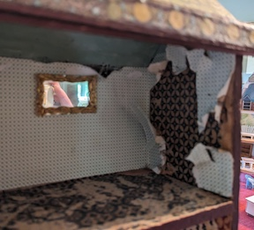

•••

**FAMILY NEWS**

I was recently made aware that Joan Hoyt was to have back surgery on June 25th.  Let’s all say a prayer and wish her well.

I was recently in California to meet my Great-grandsons.  Pictures are available upon request.

Connie is still residing in Delaware and will probably be joining us as a guest sometimes.

**DianeAlice Scheuer, Family News Chair**

•••

**THIS IS NEW – THE EXCHANGE**

Cyndi Charney asked if it is possible to include a section listing items that some of us are looking for, or things we need help with?  Jane and I are agreed that this is a very good idea, so we will make this a regular feature in the newsletter in future. If you have or want something along this line, tell us. Contact info for these exchanges is in our phone list which I try to keep updated and send out with the newsletter.

Cyndi is currently searching - unsuccessfully - for 1:12 scale shiplap wallpaper.  So far, all she has found are digital downloads and wood siding. Any ideas, anyone?

**Angie Phillips, Newsletter Editor**

**---**

Also from Cyndi:

“Another idea I have is a monthly article about one (or more) of the People's Choice submissions from the prior year's show with photos and a brief description of the project, similar to a social media post.  I would be happy to help with the writing, if you choose to do this.”

•••

**ANNOUNCEMENTS**

There will be no Minutes published in the newsletter in future. My remarks are a recap of the meeting, so we don’t need to publish them on our website. We will hand them out at meetings and get them approved and the secretary can get them for our records. We will discuss this at our next in-person meeting in September.  **Jane**

**---**

**The date for our visit to Karen's shop is JULY 26!!!!**

**---**

I read on CNN’s website a couple of days ago that Michael’s Arts & Crafts has decided to enlarge their fabric and sewing notions department in light of the loss of JoAnn’s Fabrics.

<https://www.cnn.com/2025/06/05/business/michaels-acquires-joann-ip-private-labels>

**Angie**

**---**

I am appointing Mary McCarthy as Publicity Chair. Lois will continue to do the website and Facebook. Angie will still do the newsletter. They will be the Public Relations Committee. Mary will coordinate these functions as the Chair. This way we'll have a cohesive streamlined message, format and look/brand.

Here is the charge for the committee.

**Public Relations Committee**

• Develops/maintains newsletter

• Develops/maintains website

• Develops/maintains social media

• Generates news releases, promotional materials for events

• Assists other committees with any public relations/outreach when needed/as able

• Provides budget/financial reporting to board

• Reports as needed to board and membership

**\***Writes articles and takes photos for the club as needed.

**Jane Bailey, Club President**

•••

**CALENDAR OF EVENTS**

JUNE 19 - FSMC MEMBER ZOOM MEETING

JULY 17 - FSMC MEMBER ZOOM MEETING

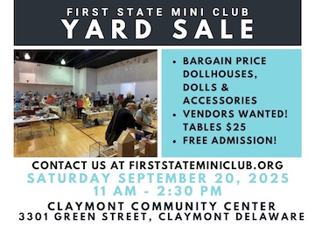AUGUST 21 – FSMC MEMBER ZOOM MEETING

SEPTEMBER 18 - FSMC MEMBER IN-PERSON MEETING, NEW CASTLE SENIOR CENTER

SEPTEMBER 20 – OUR INDOOR YARD SALE, CLAYMONT COMMUNITY CENTER

OCTOBER 4 – FREDERICK SHOW

OCTOBER 5 – FSMC RETREAT, DOVER

NOVEMBER 7-9 – MINIATURIA, CHERRY HILL, NJ

NOVEMBER 15 - DELAWARE HOSPICE FESTIVAL OF TREES, WILMINGTON

NOVEMBER 20 - FSMC MEMBER IN-PERSON MEETING, NEW CASTLE SENIOR CENTER

DECEMBER 18 - FSMC MEMBER IN-PERSON MEETING, NEW CASTLE SENIOR CENTER

•••

**FSMC Officers**

*President & Show Chair - Jane Bailey*

*Vice President, Membership & Newsletter Editor - Angie Phillips*

*Secretary - Sharon Nonn*

*Treasurer, Webmaster - Lois Weyer*

*State NAME Rep - Wanda Simons*

*Program Chair & Exhibit Chair - Angela Hunt*

*Family News/Titbits Chair - DianeAlice Scheuer*

*Scholarship Program Chair & Handbook Committee Chair - Jane Bailey*

*New Show/Yard Sale Chair - Lynne Poindexter*

*Outreach Chair - Debbie Contravo*

*Publicity Committee Chair – Mary McCarthy*