

**First State Mini Club Newsletter May 15, 2025**

***New Castle Senior Center, 400 South Street, New Castle, DE 19720***

**PRESIDENT’S COMMENTS**

We’ve been busy collecting orders for the NAME Club mini book nook project. To date, we have 26 orders for these tiny bakeries, libraries, and flower markets.

We’re also planning a field trip for late summer to Karen’s Dollhouse Shop and to Propagate Studio, both in New Jersey.

Our upcoming May meeting will be a party as it is our last in-person meeting before the summer months begin. It’s also a good-bye tribute to two cherished members, Connie Gorman and Gabrielle Marlow, both of whom are moving away. It was decided that we would still offer the opportunity to Zoom during June, July and August, but no formal agenda will be provided. Instead, it will be a social chat session. Members may log on and discuss whatever they wish.

I will be meeting with my peers in our surrounding states on the 14th to discuss club events and issues. There will be seven club presidents from NJ, MD, PA and, of course, DE, representing nine miniature clubs in this “mini summit”. I’m anxious to hear what they do in their clubs and what challenges they experience as president. I really think we can help each other and enhance the club experience for our members.

I hope you all have a wonderful summer, and I look forward to catching up with everyone soon.

Mini best wishes!

**Jane Bailey, President**

•••

**MAY ZOOM LINK**

Topic: First State-Jane Bailey

Time: May 15, 2025 07:00 PM Eastern Time (US and Canada)

Join Zoom Meeting

<https://us06web.zoom.us/j/82108649695?pwd=4SHGoFnGYraeio64Dq9bBBAdhKG1HR.1>

Meeting ID: 821 0864 9695

Passcode: 197594

•••

**STATE REP RAMBLINGS**

Surprise!!  When my May/June *Gazette*from NAME arrived, I was under-impressed at first.  The black-bordered, white/gray/black cover didn’t stimulate my interest, and I didn’t open it right away.  BUT WHEN I DID, the interior of the magazine was a surprise with lots of colorful photos promoting a very personal connection with many members, creations and events.

The new editor, Suzanne O'Connell, surely worked hard, but had fun, creating this issue!  The magazine showed that Florida had snow and lots of it as the members of DIME (Daytona Ideal Miniature Enthusiasts) “played in the snow” while they created their “In the Woods: Winter Resort”

projects.  And 60-some members’ 2024 creations from the yearly challenge were also featured, as well as Cincinnati convention info and the major changes to the current bylaws and more.

Come on now, let’s put on our thinking caps and come up with ideas for how we can share some of our club’s creativity and accomplishments.   What can we WOW editor Suzanne and her readers with?  There will be a suggestion box at the club’s May meeting for your thoughts.  I’m looking forward to seeing many!

**Wanda Simons, DE State Rep for NAME**

•••

**MEETING MINUTES**

April 17, 2025

Attendance: Angie Phillip, Jane Bailey, Sharon Nonn, Angela Hunt, Cyndi Charney, Gabrielle Marlow, Lois Weyer, Sara Chrisanthon, Diana DeWalt, Diane Alice Scheuer, Bonni Patrick, Marion Hogan, Leslie Shaffner, Mary Ellen Raun, Paula Williams

ZOOM:

Caroline Schwartz, Wanda Simons, Joann Conaway, Mary McCarthy

GABRIELLE: Thanked everyone for the exhibits at the show and announced that she will be leaving the club because she is moving to Portugal by the end of the year. We wished Gabrielle all the best!

SHOW UPDATE: LOIS presented the show update: lots of volunteers with 30 members helping. $2702 was collected at the door. The Make-and-Take was successful. Lois provided a printed copy of the expenses/income for the show. The club lost money, but we knew that, mostly due to the cost of the facility, that 2 sets of postcards had to be sent out, tables rental and set up. We must start advertising for next year’s show. Lois also gave members a copy of the flyer for the Yard Sale in September (September 20, 2025) and next year’s Show (April 12, 2026). Four shadow boxes were donated and some members took them home to create something so they can be sold at the Yard Sale in September.

SHOW REVIEW: JANE asked for any feedback. Sara, as a vendor, thought there were fewer people attending. In other feedback: the lighting wasn’t that good; one person didn’t like the venue; the vendors enjoyed it and are coming back.

We are looking for a new Yard Sale Chairperson. Diane is stepping down.

Jane talked with Rolife at Christiana Mall about possibly doing our Show (maybe next year’s now). Sara said we should reach out again next year to TV.

PROGRAM: ANGELA made Bird Feeder kits that we were given to take home. E7000 is Angela’s new favorite glue.

BOARD MEETING ACTIONS: JANE announced that the board will meet quarterly and then on an “As-Needed” basis. Lois provided the financials and the board decided to donate $500 to NAME. The $130 made by the Garage Sale Raffle at the show will go towards to NAME Day kits for the members. The kits will be ordered in June.

Jane met with NAME via zoom and talked about NAME kit exclusive to clubs, “Mini Book Nooks”. The sell for $10 each, that the club will pay: 1 per member for whoever wants one. Three different Courtyard scenes are available. Two dollars of each ten-dollar purchase goes back to NAME.

Jane came from the Credit Union field: “People Helping People”. They reached out regionally. Jane reached out to club presidents in the surrounding state and asked if they wanted to form an alliance and share ideas, successes, failures. Celeste Wiley is President of MD Club and wants to grow her club membership. Celeste attended our Show. Others reached out and they will have a Zoom Meeting on May 14th. Jane will give us feedback. Everyone seemed excited.

MAY PARTY: It may be a farewell party for Connie and Gabrielle. A Food Sign-Up sheet was passed around.

WANDA SIMONS: She visited Joann Conaway today to see her miniature collection, supremely categorized and organized. Wanda was impressed. Joann has a Thornhill Kit from RGT still in the box and containers of wood.

Wanda also talked with Joshua and some of the old members at the show. The Show provides a social outlet for a lot of people. A lot of people took the new member form.

POTENTIAL VISIT TO KAREN’S DOLLHOUSE STORE in Clinton NJ. Sunday seems best for members to visit. Members pay and carpool, shop and lunch. Check out her website. August seems to be her most open time, (Karen does lots of shows).

If anyone knows of any other possible field trips, contact Jane.

JUNE, JULY, AUGUST in-person meetings will take off for the summer, but we will have a zoom link for socializing without a specific agenda. We may organize a few lunches just to get together.

SEPTEMBER STARTS IN PERSON MEETINGS; OCTOBER OFFERS THE MINI RETREAT; NOVEMBER IS MINIATURIA; DECEMBER IS OUR CHRISTMAS PARTY.

Paula, Mary and Gwen will be attending NAME Convention this summer

It will be our 50TH year celebration for Club next year. We will talk about making our show special in future meetings. Maybe Mary can write something up for the Gazette.

**Sharon Nonn, Secretary**

•••

**BIRTHDAYS**

Happy Birthday to Mary McCarthy. I am still lacking birth month info on several members.

**Angie Phillips, Membership**

•••

**OUR ACTIVITIES**

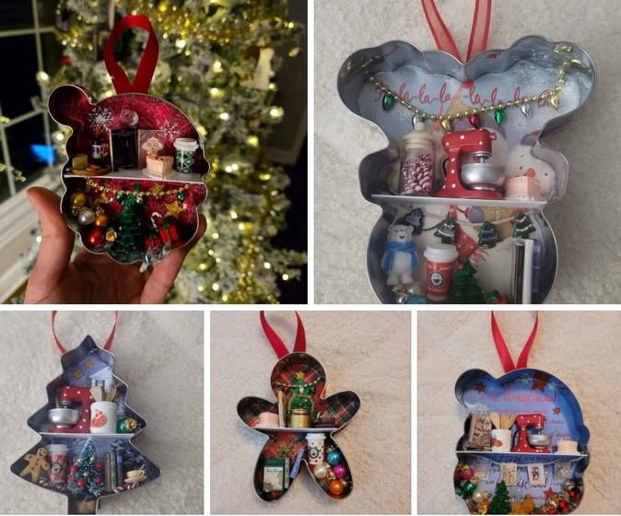 I will be bringing some cookie cutters to the meeting if anyone wants to take one home and make it into a Christmas Ornament for the Delaware Hospice Festival of Trees next November. I am also still taking contributions to the Christmas Shoppe for the Festival.

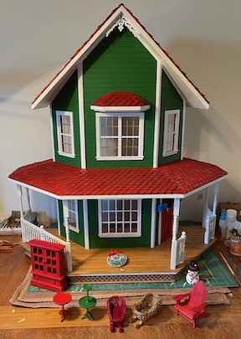 I will also be bringing some Rx bottles with some of the green and red paint I used on the Shoppe for anyone who might want to use them.

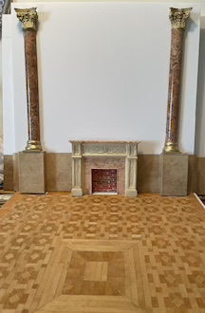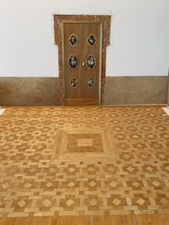 I have set the Shoppe aside for the time being and am working on a new project based on photos from my Italian travel magazines, a Gold Room with an intricate inlaid floor, engaged marble columns, paintings, frescos and I am trying once again to print on fabric to reproduce the silk damask wall coverings of the original. Wish me luck.

**Angie**

•••

**ANNOUNCEMENTS**

**Something new for us miniaturists:**

My siste, Denice Smith, is reading a Non-Fiction book about manuscripts that illuminated the Renaissance, *The Bookseller of Florence*, by Ross King.  It focuses on the real person, Vespasiano da Bisticci, a prominent bookseller of 15th century Florence, who set up the Laurentian Library in Florence, (designed by Michelangelo), for the Médicis, and the Vatican Library for the Pope.

In the chapter focusing on illumination there is a paragraph that she thought might interest us…

"Another lead-based pigment, likewise poisonous, was minium, or red lead, used by scribes and illuminators for lettering important words or phrases. The task of "rubricating" was often performed by a specialized scribe known as the "rubricator" or, in Italian, as the 'miniatore' (from the Latin 'miniare', to color red). The process of painting these letters in minium was called 'miniatura'. Since Latin words such as 'minuo, minimus, minor and minus" all denote something diminished in size, the terms 'miniatore' and 'miniatura' eventually lost their association with the color red and came to mean painting anything small in scale. By Vespasiano's time, contracts with illuminators referred to them as 'miniatori' and the work they performed as 'miniatura'. They became miniaturists, painters of small scenes, rather than simply painters in red ink."

How wonderful to learn that our chosen art form comes from a word originally meaning to color something red.

To learn more about Vespasiano da Bisticci, here’s a link:

<https://en.wikipedia.org/wiki/Vespasiano_da_Bisticci>

**Angie Phillips, Editor**

---

**FAREWELL MY MINI FRIEND, GABRIELLE MARLOW**

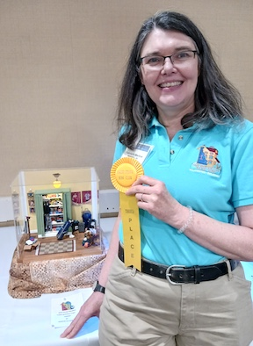 Gabrielle joined the First State Mini club the same year as I did. Those first few meetings were over Zoom and it wasn’t until months later that I met her in-person. As we chatted, we found we had many of the same interests outside of miniatures. We are both fans of Cape May, NJ and dogs, among other things. We often met for dinner and discussed club issues as well as personal ones.

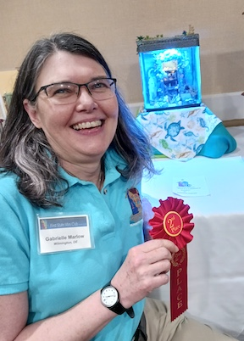 Gabrielle’s dedication and support of FSMC was evident from the start. She was a member of the program committee and board secretary. She was my co-chair for the show exhibits for three years. She was a tremendous help measuring spaces, setting them up, and making sure every exhibitor had the items they needed for their displays. She was so helpful, in fact, that I asked her to be the Exhibit Chair going forward and she agreed. She did a wonderful job coordinating and facilitating our 2025 Show exhibits this year.

Gabrielle’s miniature talents are amazing. Her creative displays have won her awards in several of our People’s Choice contests.

So, it is bittersweet that we must say good-bye to her as she begins a new chapter of her life. She will be missed dearly, especially by me.

**Jane Bailey**

---

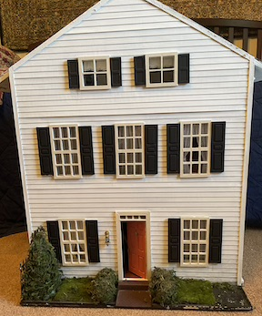

On Tuesday the 6th, Lois and I met at the Elkton Library with a lady from Annapolis, who sold the club her dollhouse. It’s interesting because it opens from the front and the back. We will be doing some little repairs and prepping it for sale at the yard sale in September. I will be bringing some of the furnishings to the club meeting on the 15th, to give to Diane for appraisal and pricing. I spent at least 2 hours scraping museum wax off most of them. There are some nice items for us to look forward to at the sale.

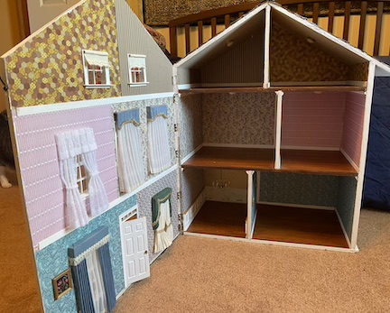**Angie**

•••

**CALENDAR OF EVENTS**

MAY 15 - FSMC MEMBER IN-PERSON MEETING, NEW CASTLE SENIOR CENTER

MAY 18 – LANCASTER SHOW

JUNE 19 - FSMC MEMBER ZOOM MEETING

JULY 17 - FSMC MEMBER ZOOM MEETING

AUGUST 21 – FSMC MEMBER ZOOM MEETING

SEPTEMBER 18 - FSMC MEMBER IN-PERSON MEETING, NEW CASTLE SENIOR CENTER

SEPTEMBER 20 – OUR INDOOR YARD SALE, CLAYMONT COMMUNITY CENTER

OCTOBER 4 – FREDERICK SHOW

OCTOBER 5 – FSMC RETREAT, DOVER

NOVEMBER 7-9 – MINIATURIA, CHERRY HILL, NJ

NOVEMBER 15 - DELAWARE HOSPICE FESTIVAL OF TREES, WILMINGTON

NOVEMBER 20 - FSMC MEMBER IN-PERSON MEETING, NEW CASTLE SENIOR CENTER

DECEMBER 18 - FSMC MEMBER IN-PERSON MEETING, NEW CASTLE SENIOR CENTER

•••

**FSMC Officers**

*President, - Jane Bailey*

*Vice President, Membership & Newsletter Editor - Angie Phillips*

*Secretary - Sharon Nonn*

*Treasurer, Webmaster & Show Chair - Lois Weyer*

*State NAME Rep - Wanda Simons*

*Program Chair - Angela Hunt*

*Exhibit Chair - Pending*

*Family News/Titbits Chair - DianeAlice Scheuer*

*Scholarship Program Chair & Handbook Committee Chair - Jane Bailey*