

**First State Mini Club Newsletter April 17, 2025**

***New Castle Senior Center, 400 South Street, New Castle, DE 19720***

**PRESIDENT’S COMMENTS**

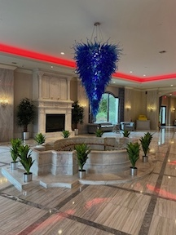 Well, we just wrapped up another successful show! The new venue presented a few challenges as we were unfamiliar with the facility, but under Lois’ direction, we managed to get everything coordinated. The crowds came and were very complimentary. The vendors seemed happy, and I heard no complaints. I’m excited to take over the planning of the 2026 Show and hope I can measure up to the standard set by Lois. Wish me luck!

We have a new youth member, Courtney Nonn! Courtney is the granddaughter of Sharon Nonn, who is one of our long-time club members. Courtney has been helping with show events for several years and this year she was “official”!

Once we’ve all recovered and wrapped the details of the show, we’ll be on to our next adventure. Watch this space for more information!

**Jane Bailey, President**

•••

**APRIL ZOOM LINK**

Topic: First State Mini Club-Jane Bailey

Time: Apr 17, 2025 07:00 PM Eastern Time (US and Canada)

Join Zoom Meeting

<https://us06web.zoom.us/j/81501586974?pwd=ZUjvgw6mxBSB7iWBJFASr9yvDgovQQ.1>

Meeting ID: 815 0158 6974

Passcode: 777603

•••

**STATE REP RAMBLINGS**  
 It takes a team for a successful event.  So many good outcomes happened on April 6th after a lot of unexpected planning and effort by our members after a water main break flooded our previous venue. Thank you, everyone, especially chair Lois Weyer!  Our 48th show and sale at "The Waterfall" was definitely a team effort.

The joint FSMC-NAME display attracted old-timers who came by to say hi as well as curious newcomers who took information.  Amazingly, a number of visitors said they were already members of NAME, but many for various reasons could not join our club.  I do expect to add several already-NAME members to our roster and will be in touch with all who left contact information.  It was fun to share a table with Connie and the grab bags.

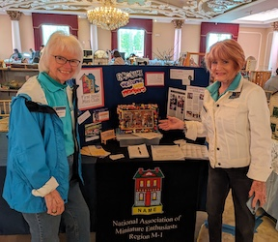 Participation by our newer members was inspiring...their enthusiasm was infectious. Our newest, Courtney, was energetic and helpful with door prizes that Mary had collected from our generous dealers.  Angela, Mary and Bonnie won all three People's Choice ribbons for their intricate market stall displays. Also, the club has a new dealer-member, Debbie C.

This old- timer is happy that new generation(s) are stepping into all the mini fun!

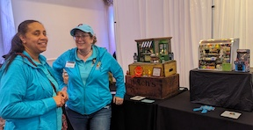**Wanda Simons, DE State Rep for NAME**

•••

**MEETING MINUTES MARCH 20th**

**Attending members**: Angie Phillips, Wanda Simons, Jane Bailey, Sharon Nonn, Angela Hunt, Cyndi Charney, Gabrielle Marlow, Lois Weyer, Sara Chrisanthon, Mary McCarthy, Lynne Poindexter, Jean Kaufman, Gwen Demby, Debbie Contravo, Joan Hoyt, Connie Gorman, Diana DeWalt, Diane Alice Scheuer, Bonnie Patrick, Marion Hogan, Leslie Shaffner, Mary Ellen Raun, Paula Williams, Lee LeFranc and Al LaFranc

By ZOOM: Jill Kyle-Keith, Caroline Schwartz, Holly Kolodczak, Carol Tillson, Courtney Nonn

**SHOW UPDATE – LOIS**

1. Members are to take postcards home to distribute.
2. A Floor Schematic was handed out.
3. Friday: The rented tables will arrive between 9 am and 5pm.
4. The Grand Ballroom is for Vendors and the Cascade Ballroom is for Exhibits and Club Sales.
5. Saturday: We are allowed in at 10am. Vendors are allowed between noon and 5pm. We will help the vendors as needed and directed.
6. Sunday: The door will be open at 6am. The show opens at 10am. The building must be vacated by 6pm.
7. All club members should wear club shirts and name tags.
8. Vendor tables - 38 Vendor tables (22 Vendors) plus extra tables – to be moved in on Friday between noon and 5. We must set all our electrical cords. The Table rental people will set up tables.
9. Members signed up for jobs, to assist vendors, show bathrooms, offer help - remind them they have to be out by 6pm
10. We will be raffling off the Garage Sale Project at the show ($5 or 3 for $10).

**2026 PEOPLE’S CHOICE PROJECT VOTE – JANE**

Choices:

Backyard Scene

Attic

Breakaway Box

Workshop/hobby shop

Trailer

Café/Pub

**WINNER: Backyard**

**NAME DAY PROJECT – JANE**

RETREAT - Jane: Sunday, October 5th, coordinating with NAME Day. A Courtyard is the theme for the NAME project. Sign up if you want to do it. It will be at each member’s cost. $25 for 1”, $18 for ½”, and $12 for ¼” scale.

**NAME – WANDA/MARY**

Mary met with Wanda - they are working on a welcome packet for new members. Three members are going to Cincinnati - Gwen, Paula, and Mary.

**OUTREACH – DEBBIE CONTRAVO**

College, libraries, …. A connection has been made with the library and they welcome displays. They should be coordinated with displayed books – they are changed out about every 2 weeks. Members are encouraged to show our projects. Debbie will help or coordinate.

**Sharon Nonn, Secretary**

•••

**BIRTHDAYS**

Happy April Birthday from all of us to Gwen Demby, Jill Kyle-Keith, Sharon Nonn, and Lynne Poindexter. I apologize to DianeAlice Scheuer for missing her birthday in January. Happy Birthday all.

Please, I still lack birth months from several members and would like to include everyone. Please check the phone list that I try to keep updated, and help me fill in the blanks.

**Angie Phillips, Membership**

•••

**TIDBITS**

  " I blamed the washing machine for shrinking my clothes, found out it was the refrigerator"

**DianeAlice Scheuer, Family News Chair**

•••

**OUR ACTIVITIES**

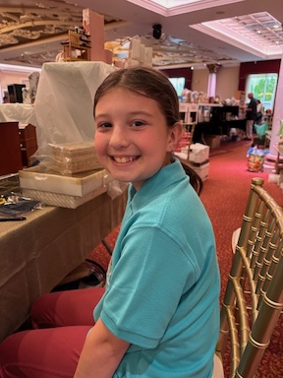 Courtney did an amazing job assisting me at my vendor table.  She was a true natural setting up my layout & even upselling to the customers. I was so impressed as her “Grammie” aka Sharon Nonn, & I watched on.

Courtney wore her FSMC shirt proudly and is an added plus to our club.

Thank you, Courtney! **Sara**

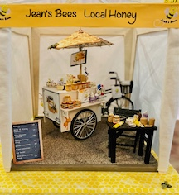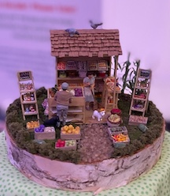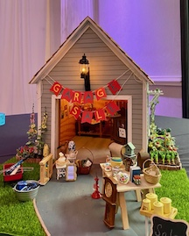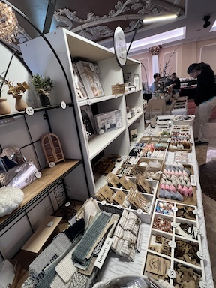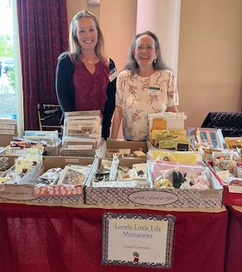**Some views of our show:**

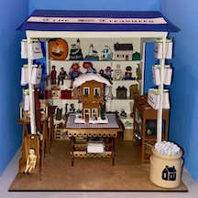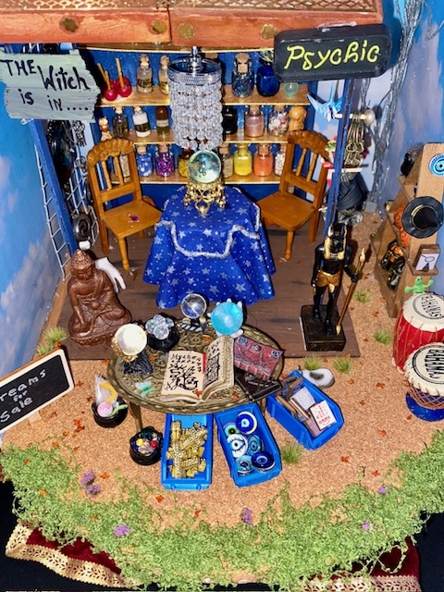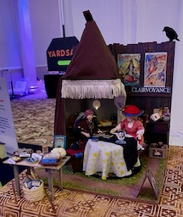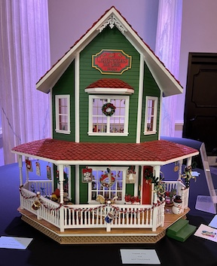

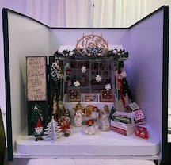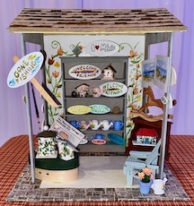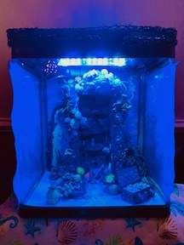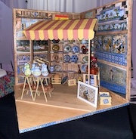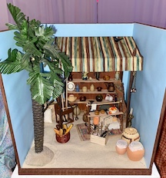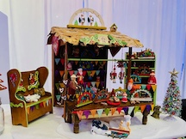

•••

**ANNOUNCEMENTS**

Leslie Shaffner’s email has changed. Connie Gorman has also changed hers. Check them both on the updated phone list.

---

**The winners of the People’s Choice Annual Project are as follows:**

1st Place - Angela Hunt

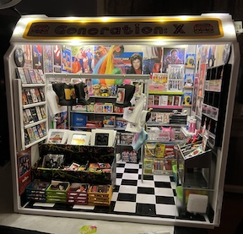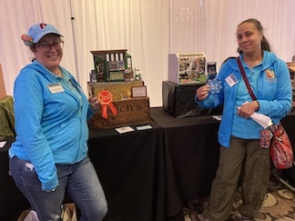

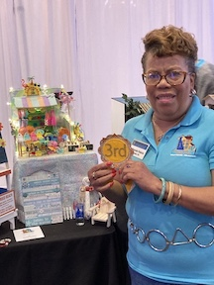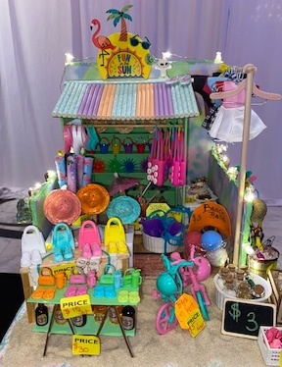2nd Place - Mary McCarthy  3rd Place - Bonnie Patrick

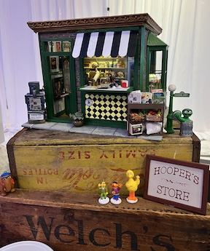

Honorable Mention - Cyndi Charney

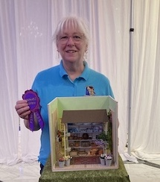**Gabrielle, Exhibit Chair**

Cyndi sent me so many wonderful photos of our entries and displays but she actually overlooked getting a nice closeup of her own Honorable Mention entry!

I truly hope I didn’t miss anyone’s entry. Thanks to everyone who sent pictures in. I limited this newsletter edition mostly to the People’s Choice to keep the file size down for email.

**Angie, Newsletter Editor**

•••

**CALENDAR OF EVENTS**

APRIL 17 - FSMC MEMBER IN-PERSON MEETING, NEW CASTLE SENIOR CENTER

MAY 15 - FSMC MEMBER IN-PERSON MEETING, NEW CASTLE SENIOR CENTER

MAY 18 – LANCASTER SHOW

JUNE 19 - FSMC MEMBER ZOOM MEETING

JULY 17 - FSMC MEMBER ZOOM MEETING

AUGUST 21 – FSMC MEMBER ZOOM MEETING

SEPTEMBER 18 - FSMC MEMBER IN-PERSON MEETING, NEW CASTLE SENIOR CENTER

SEPTEMBER 20 – OUR INDOOR YARD SALE, CLAYMONT COMMUNITY CENTER

OCTOBER 4 – FREDERICK SHOW

OCTOBER 5 – FSMC RETREAT, DOVER

NOVEMBER 7-9 – MINIATURIA, CHERRY HILL, NJ

NOVEMBER 15 - DELAWARE HOSPICE FESTIVAL OF TREES, WILMINGTON

NOVEMBER 20 - FSMC MEMBER IN-PERSON MEETING, NEW CASTLE SENIOR CENTER

DECEMBER 18 - FSMC MEMBER IN-PERSON MEETING, NEW CASTLE SENIOR CENTER

•••

**FSMC Officers**

*President, - Jane Bailey*

*Vice President, Membership & Newsletter Editor - Angie Phillips*

*Secretary - Sharon Nonn*

*Treasurer, Webmaster & Show Chair - Lois Weyer*

*State NAME Rep - Wanda Simons*

*Program Chair - Angela Hunt*

*Exhibit Chair - Gabrielle Marlowe*

*Family News/Titbits Chair - DianeAlice Scheuer*

*Scholarship Program Chair & Handbook Committee Chair - Jane Bailey*