

**First State Mini Club Newsletter March 20, 2025**

***New Castle Senior Center, 400 South Street, New Castle, DE 19720***

**PRESIDENT’S COMMENTS**

Our March meeting will be an in-person meeting. The last two months’ meetings were via Zoom only. We will continue to offer the Zoom option for our in-person meetings for those who are unable to physically attend. Zoom is a benefit we get from our NAME membership.

Our March 10th meeting will be filled with several agenda items. We’ll be settling the final details for our April 6th Show and Sale at The Waterfall event facility under Lois’ guidance. We’ll be voting on next year’s People’s Choice club project. Our members will select their favorite theme from: a backyard scene, an attic, a breakaway box, a café/pub, a work/hobby shop, or a trailer. We’ll also discuss some outreach activities. We’ll be putting the final touches on our progressive garage sale project. Then, it will be exhibited at our show and raffled off.

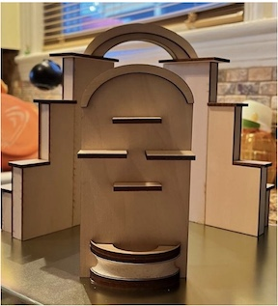 Our Fall retreat has been finalized! We have booked the Prime Steakhouse Lounge located in Bally’s Hotel in Dover for this special event. Seventeen club members will spend October 5th making minis and enjoying other mini activities. Alice DeVore, owner of Fingertip Fantasies, will provide a demonstration on a yet to be determined project. Since October 4th is NAME Day, we may be assembling the NAME Day courtyard project.

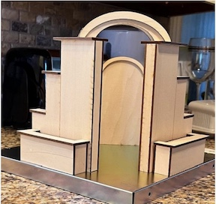 We’re looking forward to the Spring and warmer weather and many more mini adventures!

**Jane Bailey, President**

•••

**MARCH ZOOM LINK**

Topic: First State Mini Club-Jane Bailey

Time: Mar 20, 2025 07:00 PM Eastern Time (US and Canada)

Join Zoom Meeting

<https://us06web.zoom.us/j/88650491894?pwd=hvHHoBTsVF2DwNvQJdkm9RQL9NmlPq.1>

Meeting ID: 886 5049 1894

Passcode: 474816

One tap mobile

+16469313860,,88650491894# US

•••

**STATE REP RAMBLINGS**

My mind is boggled by the many, mini opportunities for expressing or expanding one’s own creativity that are available through NAME, our parent organization. If you haven’t taken advantage of what’s being offered on the create.miniatures.org website, you might miss a life-changing opportunity. Well, I am known to exaggerate, but I’m enthusiastic anyway.

There’s a yearly challenge project with check-ins periodically with Debbie Colombo (our M-1 Regional Coordinator) who wears many hats for NAME. Every month there’s been a fun, themed challenge requesting photos for the on-line gallery. For February, it was coffee and donuts, while for March it’s laundry rooms. Any scale. Then there’s the NAME online, monthly auction that will run from March 10 to 15, 11p.m. EDT, if you are interested in the thrill of bidding and maybe getting a really good deal.

The Create website is always launching new ways to educate and entertain us. A series of “Let’s Chat with ___” will begin March 30 at 2 p.m. with Andi Vinciquerra, “a mixed media artist” who does amazing miniatures. It’s easy to find the link on the Create calendar. (I don’t think one has to be a member to log on, but will check on that and put out the word.)

To explain other learning opportunities there are three options for a fee for each, there are

(1) Create Workshops, with kits to assemble, or techniques to learn with teachers live on ZOOM.

(2) Second Chance Workshops are the same, but with recorded previous instruction and

(3) Gift and Gabs will include artisan-made items plus ZOOMing with the artisan. If you sign up for any of these options, please share your experience with me and our club.

There are FREE tutorials online about probably hundreds of topics dating back many years, and they’re categorized well for easy searching.

Finally, I don’t know for sure, but there still may be a limited number of spaces for Convention Registration as I haven’t seen anything saying otherwise. And if you need your member ID for any reason, it’s just above your name in the address block on the back cover of your *Miniature Gazette* magazine. Other ways are explained online. It’s worth using as members get a significant discount for programs/events open to the public.

Now I need to get back to working on my Market Stall for the Club Show. I look forward to seeing and enjoying many of the club projects! Be sure to stop by the table promoting both NAME and FSMC and say “hi” at Show Day on April 6.

**Wanda Simons, DE State Rep for NAME**

•••

**MEETING MINUTES FEBRUARY 20th**

**Attending members**: Cyndi Charney, Jane Bailey, Angie Phillips, Debbie Contravo, Gabrielle Marlow, Bonita Patrick, Wanda Simons, Carol Tillson, Joan Hoyt, Jean Kaufman, Angela Hunt, Mary McCarthy, Lynne Poindexter, Lois Weyer, Jill Kyle-Keith, Angie Phillips, Paula Williams

SHOW UPDATE: LOIS

Lois provided an update on the show. So far, 37 Tables have been sold for $4,800. Lois thinks this is okay and expects that we will continue to get more vendors. The show has been advertised locally and on social media. Postcards will be mailed within the next week. They must be mailed from the Oxford post office due to nonprofit restrictions. Lois also mentioned her preference for not sending postcards for the yard sale and finding a commercial firm to mail the show postcards next year.

Get in touch with Lois if you need a table. The cost to members is $100. Half tables are available.

Jill volunteered to bring her speaker system.

EXHIBIT UPDATE: GABRIELLE

Gabrielle thanked everyone for responding to her messages about the People’s Choice and Project exhibits. She has received about 15 to 16 responses for the People’s Choice. She also mentioned that there are plenty of outlets in the display room for everyone who might need access to electricity.

IDEAS FOR 2026 CLUB PROJECT FOR PEOPLE’S CHOICE: JANE

There were several suggestions for next year’s People’s Choice project. Carol suggested that the club buy bulk outdoor items and members could make a backyard scene, park, etc. Wanda showed a couple of prototypes, including an attic. Jane reviewed the list of past projects, and we did attics in 1988/1989. Wanda’s other suggestion is a break-away box made from a kit (looks like a gift box). The lid comes off and one side lays down to display the interior. Debbie suggested a picnic scene but also thinks that it could fall under the backyard scene. Bonnie also asked if the backyard scene could be any season, or only summer. Everyone agreed it could be any season. Jill sought clarification and asked if it could be outdoors, or specifically a backyard. Jill suggested a Trailer and a Café/Pub.

Jane listed some other past projects, including Decades on the Farm, Cigar Box Vignette, Loft, Attic, Porches, Store, Potting Shed, Stage, Gypsy Wagon, Shadowbox Garden, Scenes in Books.

Wanda also suggested that we consider using ranked voting to choose the project.

There was discussion around the deadline for choosing a project. The deadline was tonight’s meeting, but some who normally participate in the project couldn’t attend.

The final list will be voted on next month. The options are: Backyard Scene, Attic, Break-away Box, Workshop, Trailer, Café/Pub Scene.

2026 SHOW: JANE

Lois will be stepping down from show chair in 2026. Jane is her back-up. Jane confirmed that Brandywine Plaza has said that they will be open next year. By the time of our show, Marriott will be the owner. Jane booked the ballroom for April 11 & 12,2026.

RETREAT UPDATE: JANE

Jane provided an update regarding the retreat. It will be held on October 5th at Bally’s Hotel/Dover Downs from 9:00 to 5:00. Sixteen people said they are interested. Jane needs the $50 from all participants by the end of the month so that she can sign the contract.

Everyone should bring a project to work on. Alice DeVore, owner of Fingertip Fantasies, will provide a demonstration. There may also be door prizes.

NAME DAY: MARY

NAME Day is October 4th this year. NAME Day is also International Dollhouse Day. This year’s kit is a courtyard, and Mary thinks it could be incorporated into the retreat. NAME hasn’t shared any prices yet, but Wanda expects that information to be available shortly. Mary suggested that the club might consider paying for the kit since it’s educational in nature.

PROGRAM: ANGELA

Angela fielded questions about the market stall project. She mentioned that she envisioned them all the same size to look like a market when they are set up side by side. That’s why they are all the same size. You can bash the kit, build it as-is, or use a different kit. The box must be 10’ X 10”. A question was raised about the box and what to do with it. It can be decorated or not. The tiny holes on either side of the stall are for pegs (included with the kit) to hang things on.

Diane Alice previously suggested to Angela that we display the basic kit design and an explanation of the project so that people understand what they are voting for.

NAME REPORT: WANDA

Wanda reported that space is limited for the NAME National Convention in Cincinnati. Several people from the club are going, but Wanda is unable to attend this year. Mary, Gwen, and Paula are planning to attend. Registration is online.

The NAME monthly theme is donuts and coffee. Photos can be sent to NAME to be displayed online.

OUTREACH: LOIS

Lois reminded the group that one of the club’s missions is to introduce the public to miniatures. Although some members are working with groups independently, aside from the ornament project and the Read House, not much else has been done since the pandemic. Lois would like to see it brought back and form an Outreach Committee to do that. Jane suggested that we discuss this at the March meeting and asked for a leader (committee chair) and volunteers. Debbie expressed interest in helping with that and Jane asked her to prepare something for next month’s meeting.

SHOW & TELL

Angie showed the Christmas House. It will be raffled off by Delaware Hospice during the Festival of Trees. She still needs stuffed animals and dolls.

Jane mentioned that the Garage Sale project is coming along. Maryann did a beautiful job with the landscaping.

Jill recently got a 3-D printer and showed us her first project – a cat, and her son’s – a Pikachu. She also shared some of her auction buys including dollhouse dolls and vintage food items.

OTHER BUSINESS

Wanda brought up an issue with email distribution. NAME is getting pushback from people in its email distribution group. Members’ email addresses are visible to everyone receiving the messages. The concern is that the email addresses are being used for spam purposes.

Next Meeting is March 20th, in person.

**Cyndi Charney for Secretary Sharon Nonn**

•••

**BIRTHDAYS**

Happy March Birthday from all of us to Janette Henry and AngiePhillips.

•••

**FAMILY NEWS**

On March 3rd 2025, Debbie Kostyk's son Michael had a triple bypass.  I am pleased to let you all know that he came home on the 7th.  He is doing remarkably well, and in six weeks will be as good as new and looking forward to a new baby in October.  Prayers are always welcome.

**DianeAlice Scheuer, Family News Chair**

•••

**OUR ACTIVITIES**

A young woman came today, (February 23), to buy the dollhouse that Jill gave the club, and Lee brought to me in December.  It was not a high-quality house, but nice enough for her first house.  I repainted it, put in some wallpaper, fixed 5 windows, and stained the floors.  I only charged her $40 because that is what I thought it was worth.  It still has imperfections that I couldn't do much with.  See the before/after pictures.

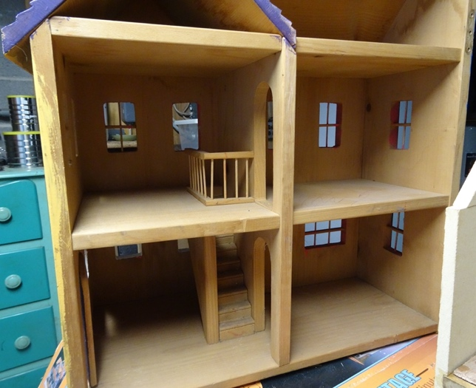 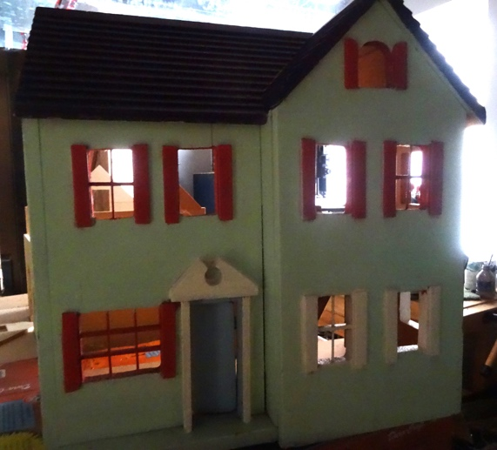

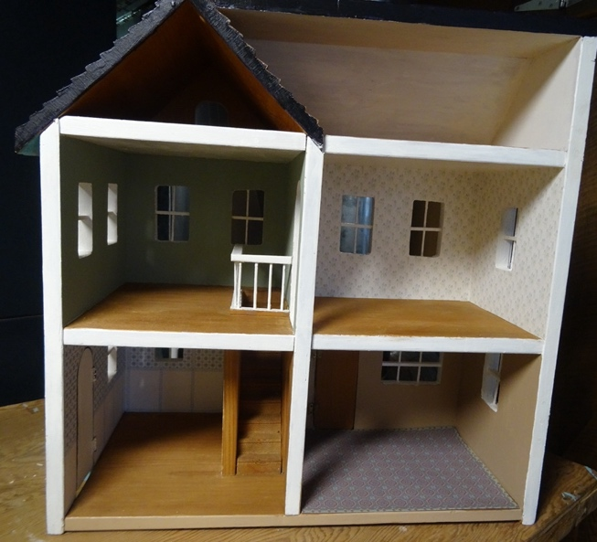 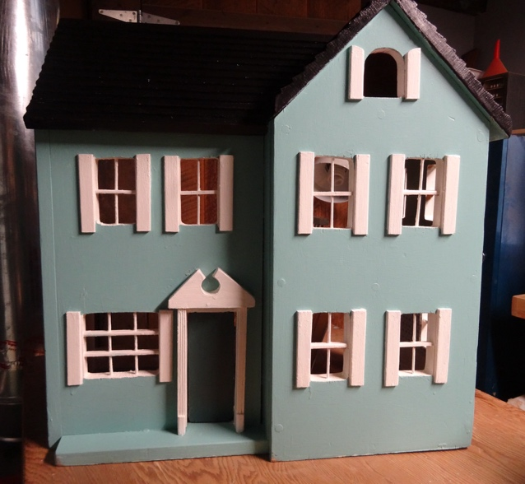

The before picture doesn't really do justice to how poorly it had been painted, with a light blue front, reddish shutters, a purple roof, one mustard-colored side, and one navy blue side, all sloppily painted.  I enjoyed redoing it.

**Lois**

•••

**ANNOUNCEMENTS**

**FSMC Bids a Fond Farewell to a Dear and Valued Member, Connie Gorman**

Connie Gorman has been a devoted member of the First State Mini Club since 1994. Over the past 31 years, she has earned the respect and admiration of our club members. She was always welcoming to new members and enjoyed club meetings and activities. Her miniature projects on display at our Shows were favorites of the Show attendees, often earning her awards for her talents. We cannot adequately express how much we’re going to miss her. We wish her all the best as she moves south to be closer to her family.

Here is her bio she wrote for the club handbook many years ago:

“*I'm in a Homemaker's Club. Our group took a trip to one of our members’ daughter's dollhouse shop in Elkton. I got hooked on minis and had my father put a Victorian House together. I painted, wallpapered and electrified it. Been crazy with decorating ever since then. I enjoy 1" scale. I’m just starting into 1/2". Working with miniatures gets addictive. I enjoy decorating, planning what you want to do in your house, going to shows to see what is available, changing for the seasons, conversation pieces for anyone visiting my home. I really love it!! I enjoy collecting--waiting to find just the right thing for all the rooms. Also, I have made counted cross-stitch rugs and bed coverings.*

*Other hobbies include needlepoint, sewing, counted cross-stitch, quilting for myself, stenciling and "shopping for clothes"! I'm a volunteer at Hagley Museum in the needlework group, needlework and different crafts. A few years ag, I made handcrafted jointed Teddy Bears and sold them. I also had several craft shows in my home involving other people also.*

*I was born in Maryland but have only lived in Delaware. Some memorable places I have traveled are: Italy, Egypt, Poland, Vienna, Greece, Singapore, England and Scotland, to mention a few”.*

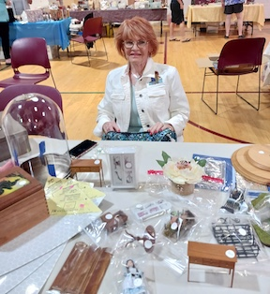

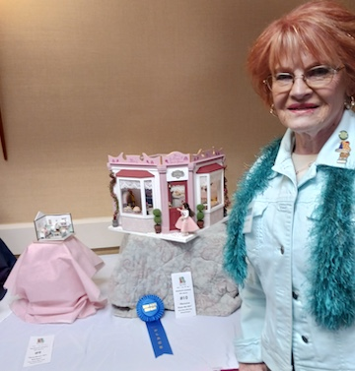

Connie was co-chair of the Holiday Dinner, Hospitality and Publicity for the FSMC show for 1998- 1999, and Librarian for 1999-2010, Hospitality co-chair 2006-10. She has been facilitating our grab bag sales at our Shows.

**Jane**

---

**ALSO:**

I have finished making up the Show & Sale Grab Bags with 87 bags, using all the minis that were given to me. I could use more minis. If anyone can contribute, I would like to get a total of 100 if I could.

**Connie**

**PLEASE NOTE**

Leslie Shaffner’s email has changed. Check her entry on the updated phone list.

•••

**CALENDAR OF EVENTS**

MARCH 20 - FSMC IN-PERSON MEMBER MEETING, NEW CASTLE SENIOR CENTER

APRIL 6 – FSMC SHOW & SALE, THE WATERFALL, CLAYMONT

APRIL 17 - FSMC MEMBER IN-PERSON MEETING, NEW CASTLE SENIOR CENTER

MAY 15 - FSMC MEMBER IN-PERSON MEETING, NEW CASTLE SENIOR CENTER

MAY 18 – LANCASTER SHOW

JUNE 19 - FSMC MEMBER ZOOM MEETING

JULY 17 - FSMC MEMBER ZOOM MEETING

AUGUST 21 – FSMC MEMBER ZOOM MEETING

SEPTEMBER 18 - FSMC MEMBER IN-PERSON MEETING, NEW CASTLE SENIOR CENTER

OCTOBER 4 – FREDERICK SHOW

OCTOBER 5 – FSMC RETREAT, DOVER

NOVEMBER 7-9 – MINIATURIA, CHERRY HILL, NJ

NOVEMBER 15 - DELAWARE HOSPICE FESTIVAL OF TREES, WILMINGTON

NOVEMBER 20 - FSMC MEMBER IN-PERSON MEETING, NEW CASTLE SENIOR CENTER

DECEMBER 18 - FSMC MEMBER IN-PERSON MEETING, NEW CASTLE SENIOR CENTER

•••

**FSMC Officers**

*President, - Jane Bailey*

*Vice President, Membership & Newsletter Editor - Angie Phillips*

*Secretary – Sharon Nonn*

*Treasurer, Webmaster & Show Chair - Lois Weyer*

*State NAME Rep - Wanda Simons*

*Program Chair - Angela Hunt*

*Exhibit Chair - Gabrielle Marlowe*

*Family News/Titbits Chair - DianeAlice Scheuer*

*Scholarship Program Chair & Handbook Committee Chair - Jane Bailey*