

**First State Mini Club Newsletter February 20, 2025**

***New Castle Senior Center, 400 South Street, New Castle, DE 19720***

**PRESIDENT’S COMMENTS**

In our January Zoom meeting we assigned backups for key club positions. This was to ensure that a position would be covered in the event that the current position holder was unable to perform their duties or desired to be relieved of their role. Many club members have assumed different roles over the years, which facilitates cross-training, allows for diversity in members’ tasks, and ensures the continuity of club operations.

We’re looking into the feasibility of a miniature retreat. This would be a one-day event where members would bring their projects to work on in a group setting, in a private room. More on this later, so stay tuned.

Joan has completed electrifying the garage, so she passed it onto Mary Ellen who will landscape the base. Then, Leslie will arrange the items to sell at the “Garage Sale”. This is the second progressive project the club has done since I was a member. Last year several members worked on the “She Shed” and when completed, it was raffled off for free to the members. The garage project will be exhibited at our Show in April.

NAME now has an email group to ask questions, relay information, etc., to everyone on the list. To sign up for this email group, go to the NAME website at [www.miniatures.org](http://www.miniatures.org).

At our upcoming February 20 Zoom meeting, I’ll be soliciting suggestions for next year’s club project. The club project is a contest at the Show for the public to select their favorite entry. We call it “The People’s Choice.” This year’s project is a “market stall”. Each participant will complete a market stall using their own creative skills. The winners will receive award ribbons and bragging rights.

Speaking of the Show, Gabrielle and I toured The Waterfall and it is gorgeous! Kudos to Lois for grabbing it so quickly after she heard that The Brandywine Plaza could not honor our reservation due to a water main breakage.

Stay warm Ya’ll! **Jane Bailey, President**

•••

**FEBRUARY ZOOM LINK**

Time: Feb 20, 2025 07:00 PM Eastern Time (US and Canada)

Join Zoom Meeting

<https://us06web.zoom.us/j/84832248592?pwd=8lAZP5bKuy1ahvabbUNJsgOrJk0WIt.1>

Meeting ID: 848 3224 8592

Passcode: 082682

One tap mobile

+13092053325,,84832248592# US

+13126266799,,84832248592# US (Chicago)

•••

**STATE REP REPORT**

While it seems that much of the world is unsettled these days, it’s wonderful to have our club president Jane Bailey be forward-thinking and planful. Thank you, Jane, for recruiting a “back-up, apprentice, assistant, helper” (or whatever they will be called) for me and the various (mostly appointed) positions within FSMC. I was thrilled to have an eager, newer member, Mary McCarthy, want to learn “the job” of Delaware State Rep even though she lives on Maryland’s Eastern Shore. We are a very geographically-diverse club. Our January FSMC membership list shows 16 members living in DE, 6 in MD, 9 in PA and 1 in NJ! And we have welcomed some new members for the club since January!

I met with Mary recently and note that it was indeed wonderful to have her volunteer, without so much as a job description in place, to step in any time I might need reinforcement or replacement! Soon, we’ll discuss ideas for how she can be helpful using her talents and background in writing, editing, and public relations. We expect to talk with the Program Committee and Board about which might be implementable. I learned that Mary drives about two hours each way to attend in-person meetings, but doesn’t mind driving!

With general NAME news focusing on August’s upcoming national convention in Cincinnati, there’s little new to report except to say that I hope that some club members will be able to attend one way or another. Participation is possible through many new options this year – for example, day passes or virtual attendance for the three-scale, Thursday night project. Do remember that general registration opens mid-February and It’s done online only (See miniatures.org/25Cincy.) I’m doing some soul-searching about my own attendance as the dates are very inconvenient for me and my family.

**Wanda Morris Simons, DE State Rep**

---

**STATE REP RAMBLING**

If you’ve ever thought about how good it is to keep in touch with our mini friends via both this print newsletter as well as, for many of us, through our wintertime ZOOM monthly meetings, good communication within the club comes to my mind as something to be thankful for. So, here are the “thanksgivings” collected back at our November in person meeting, and I’m finally communicating them back to you. (I wish I wasn’t so very slow in getting this back to you, but in the last two months there was other information to share!)

**2024 THANKSGIVING REFLECTIONS – “In this past year and/or in my life, miniatures and FSMC are or have been:”**

“New friends and expanded horizons from FSMC!! Miniatures continue to provide calm in uncertain times.”

“I am grateful to have joined FSMC, made new friends and developed the wonderful hobby of miniatures!”

“A financial boon and a way to travel! And a wonderful way to meet folks!”

(edited) “Unexpected move to (another state to retirement village to be near family). Giving up my home of 63 years … taking a lot of my minis to work on there and maybe meeting others in miniatures. Bittersweet leaving my dear miniature friends in our club and no longer be in the club. I give thanks and love to everyone to have a blessed holiday and celebrate the New Year.”

“Finding like-minded people—inspiring me to dust off my collection and discovering my past and future projects. Thank you everyone.”

“FSMC has reopened the road to my heart and love of miniatures, not only in miniatures but also for wonderful friendships with such talented people.”

“I am thankful for minis because not only do they give me something I enjoy doing, but thru the hobby I have met many fine people and many of them I now call friends. Also, thru the hobby, I have opportunities to travel.”

“This has been a very difficult year for me because I lost (my husband). The club has been a source of fun, diversion and friendship for which I am so thankful.”

“FSMC introduced me to Miniaturia, NAME, IGMA and the broader world of minis and was a source of pride to see our members’ work in reference to others at exhibits and shows. During COVID, miniatures provided focus on positive fun, relaxing and creative projects.

“Opportunities for meaningful mini-related service to others doing demos, sharing techniques, giving encouragement to newcomers, school children and Girl Scouts.

**Wanda Simons, DE State Rep for NAME**

•••

**MEETING MINUTES JANUARY 16th**

**Attending members**: Angie Phillips, Wanda Simons, Jane Bailey, Sharon Nonn, Angela Hunt, Cyndi Charney, Gabrielle Marlow, Joshua Loper, Carol Tillson, Lois Weyer, Sara Chrisanthon, Mary McCarthy, Lynn Poindexter, Jean Kaufman, Gwen Demby.

Jane welcomed our new member, Joshua Loper.

FIELD TRIP RECAP:

Everyone enjoyed themselves at the Brandywine Art Museum to see the Wyeth Dollhouses and trains, followed by lunch in the dining room.

SHOW UPDATE:

Lois - 26 tables are sold out of 50 budgeted from vendors. We will be at the Waterfalls Event Center this year. The cost is up. Lois sent out an email with update; the following is a small recap. Please refer to the email. Our representative at the Waterfalls is Diandra at [diandra@waterfalls.com](mailto:diandra@waterfalls.com). Her phone number is the general number for the facility. There are two big ballrooms. The Grand Ballroom is the same size as we have had at the hotel before. We will need to add our electrical connections ourselves. We have the electrical equipment. One wall has no outlets. Members/vendors setting up will need to access the rooms thru the main entrance between noon and 5 on Saturday (there are stairs at the other entrance in the back). The smaller space will not be available till Sunday. Table rentals lined up; and the rental company will set up and take down these tables. Possibly, the tables will come in on Friday night if no one else rents the big ballroom. We need to find out about chair availability. There is no audio system. We will need to find one or possibly just write door prize winners on a board. We will need more signs to direct people. There is no ATM on site, we will have list of where customers can find some. We will encourage vendors to bring their lunches. The entry fee is going up to $10/person. Lois will meet with Diandra again before the event. Diane, Angie, and Lois visited the facility earlier this month. If Club members want to rent a table at the show, it will be $100/table. If there are 50 paying vendors, then Club Members will be relocated to the hallway or smaller room.

Wanda will be in the smaller room representing NAME and our Club.

We will be getting a donation next month from a previous vendor who has passed away.

EXHIBITS:

Gabrielle will be taking over as the Exhibit Chair. Jane will assist. We are not sure about outlets/electricity. The suggestion is, if there is a choice between needing an electric outlet or using a battery, the battery may be the better option for the stall market displays.

BACKUP POSITIONS:

Gabrielle is Exhibit Chair / Jane back up

Lois is Show Chair/ Jane back up

Wanda is NAME rep/ Mary is back up

Lois is Media Chair/ Mary is back up

Connie does Grab Bags/ Carol is back up

Diane does Member News/ Lynn Poindexter is back up

Angie does the Newsletter/ no back up

Angie does membership list/ Wanda is back up

Lois is Treasurer/Cyndi will be back up

Sharon is Secretary/ Jane will make arrangements

NAME: Wanda is Delaware representative. There is supposed to be a state newsletter and a welcome committee is recommended. Wanda will discuss creating a welcome committee with Mary. There is a new member handbook on-line. February 15th general registration begins (on line) for the NAME Convention this year in Cincinnati OH. At that time, you can see the classes that are available. The Convention runs August 14-17th, 2025. This year the theme is: “It’s a Small World”.

PROGRAM: ANGELA /WALLPAPER

At our meetings, we can now write our questions on a card and it goes to Angela as Program Chair. Put your name on the card to make sure that the person asking is at the next meeting or zoom.

Carol had asked a question about wallpaper.

There are wallpapers made for dollhouses. Angela uses scrap book paper. It’s cheaper, and more readily available. Wallpaper can be printed on your computer (but it can fade if you print from a computer, so you can spray with clear sealer to seal the color, e.g., “Mr. Super Clear” or Rustoleum). Angela has been using New Creations Wallpaper Paste. She recommends painting the wall first to seal it for ease in removing any paper in the future. Use Seam Repair if your paper is peeling. Tools for working with wallpaper can be any flat plastic, such as a credit card. Use a sponge for cleaning up.

SHOW & TELL

Courtney showed her Dachshunds Pulling Santa’s Sleigh. Angie showed the club’s Christmas Shoppe that is going to Delaware Hospice Festival of Trees that she is working on. Donations such as toys and decorations are still needed.

Josh showed a miniature sailor and ship rooms that he has been working on for his daughter. He built everything on his own with a very limited budget.

Gwen showed a Christmas Book Nook she assembled from a kit she bought at the mall.

Sara showed pillows made by Scottish artist Emma Truscott.

Next meeting Zoom, February 20th.

**Secretary Sharon Nonn**

•••

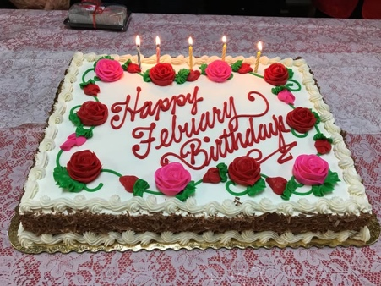**BIRTHDAYS**

Happy February Birthday from all of us to Sara, Connie and Paula.

I am lacking birth month info from Dale and Kimberley, Lee and Albert, Wendy, Bonita, Carol and Cynthia. I hate to leave any of you out of birthday greetings, so please contact Angie at [aephllps@atlanticbb.net](mailto:aephllps@atlanticbb.net) so I can get you included. Thanks.

•••

**CLUB NEWS**

Our heartful condolences are extended to Carol Tillson upon the death of her father.

Joan Hoyt is now home after spending a week in the hospital with pneumonia.

Also home now is Ernie Phillips, Angie’s husband.  He was also in the hospital with pneumonia.  While he was away, Angie came down with the flu and now has pneumonia also.  Who is caring for whom? (Diane, we’re doing synchronized coughing here at the Phillips’ house. - Angie).

Lois's husband, Gordon was in the hospital also ... heart surgery.  He, too, is now recovering at home and doing very well.

Let’s hope the rest of 2025 treats our members better, and also that we all stay safe in the coming snow storms.

*  Shawn Betterley has passed away.  He and Robin were familiar dealers at the Philadelphia Show (Cherry Hill, NJ). They sold the smaller scale kits with a 'story line'.

**DianeAlice Scheuer, Family News Chair**

•••

**OUR ACTIVITIES**

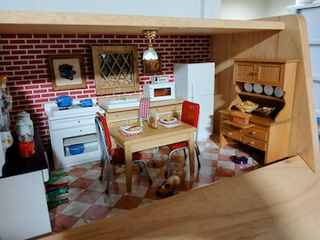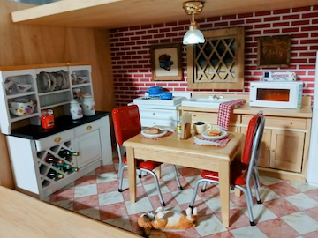 This was such a fun easy project to put together. Angie had given me the breadbox which sat in my basement for months. Then, after Christmas I went to Hobby Lobby to spend a gift card my niece had given me. I selected random items with no plan in mind. One item was a kitchen set. When I got home, I remembered the breadbox!  **Jane**

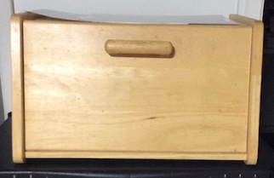

•••

**ANNOUNCEMENTS**

I have finished making up the Show & Sale Grab Bags with 87 bags, using all the minis that were given to me. I could use more minis. If anyone can contribute, I would like to get a total of 100 if I could.

**Thanks, Connie**

---

Also from Connie, who is leaving us for a move closer to her family, here are some of her minis that she is selling as she clears her house. If you are interested, please contact her at 302-994-0004 or [conniegorman6@comcast.net](mailto:conniegorman6@comcast.net)

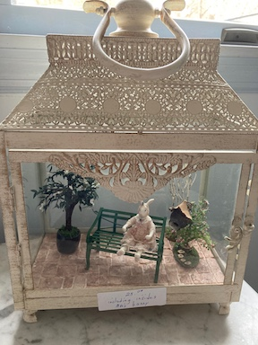 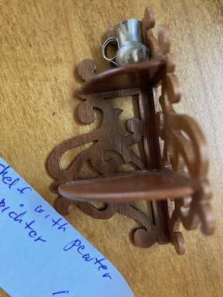 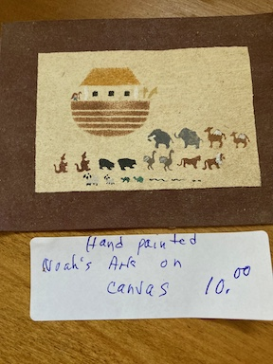 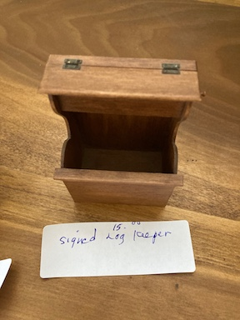

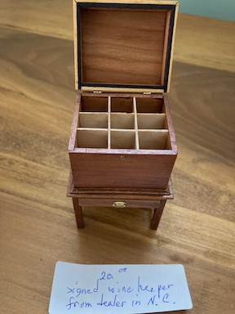 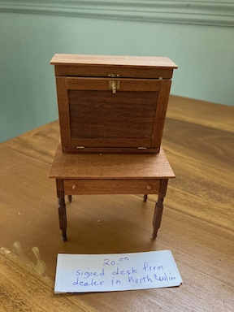 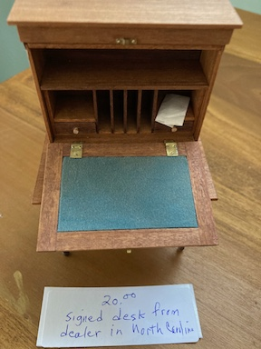

---

**FYI**

Sara has found a lovely British craftsperson called Emma Truscott, who makes, among many other things, 12th scale cushions:

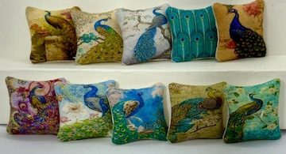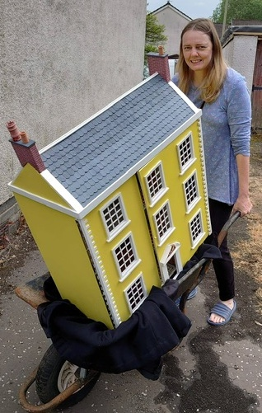

If you would like to know more about herand her work, contact Sara Chrisanthon at [sec0209@verizon.net](mailto:sec0209@verizon.net).

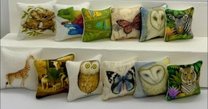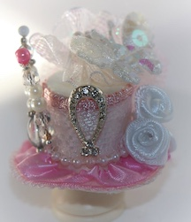

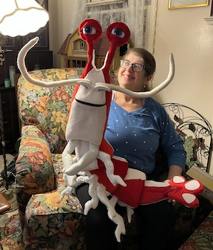---

**FYI**

Jill sent everyone some shots of her Finding Nemo puppets, just to lighten the mood. They are terrific!!

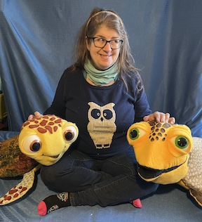 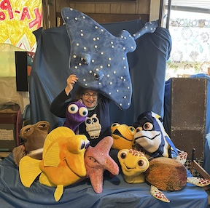

•••

**The Christmas Shoppe Project**

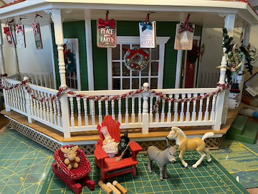 I have diverted my attention from the Shoppe to my Market Stall for the time being, but I really need toys for the porch and upper floors. The donkey and pony are going to become rocking horses eventually. I am looking for dolls, dolls, dolls, and lots of stuffed animals. Glinda and Elphaba need company. A bicycle would be nice to have, and/or a tricycle. Does anyone have roller skates, ice skates, mini trains, sporting goods to donate? Remember, this is a club donation to the Delaware Hospice for their annual Festival of Trees fundraiser next November. They always love what we contribute and are looking forward to this.

**Thanks,**

**Angie**

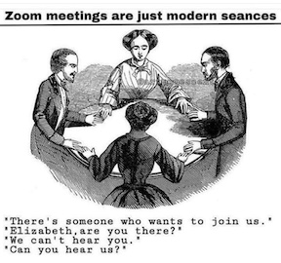

**DON’T FORGET**

Zoom meeting ONLY for February

•••

**FSMC Officers**

*President, - Jane Bailey*

*Vice President, Membership & Newsletter Editor - Angie Phillips*

*Secretary – Sharon Nonn*

*Treasurer, Webmaster & Show Chair - Lois Weyer*

*State NAME Rep - Wanda Simons*

*Program Chair - Angela Hunt*

*Exhibit Chair - Gabrielle Marlowe*

*Family News/Titbits Chair - DianeAlice Scheuer*

*Scholarship Program Chair & Handbook Committee Chair - Jane Bailey*