

First State Mini Club Newsletter October 23, 2025
New Castle Senior Center, 400 South Street, New Castle, DE 19720

PRESIDENT’S COMMENTS
Please make a note, everyone, that our October meeting will be on Thursday, October 23rd, instead of the 16th. This is due to a scheduling conflict at the New Castle Senior Center.
Also, please bring your items for the Festival of Trees and for the Grab Bags, if you have them, at this meeting.
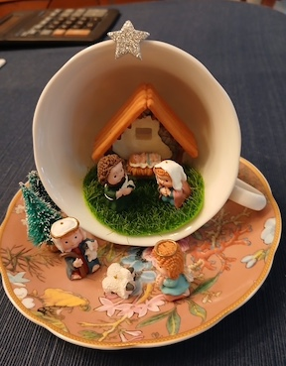
The Mini Retreat, by all accounts, was a big success. I’m so glad the attendees enjoyed it. I certainly loved planning it!
Sixteen club members came out to celebrate NAME Day at Bally’s Hotel in Dover, Delaware. The Lounge Restaurant was a cozy place to work on our miniature projects and in subdued lighting no less! Four of us drove down the night before our event and enjoyed a scrumptious dinner in The Royal Steakhouse, located on the second floor overlooking the hotel’s beautiful lobby. Afterwards, we strolled through the casino which was packed with people having a great time. One of us even won a bit at the slots, but I’m not mentioning who in case the IRS is reading this, LOL!
The NAME Day Courtyard Kit was the featured project. However, several brought various other projects to work on. Some worked on ornaments, some on repairing furniture, some made mini ghosts and more.
After lunch in the Sugar Factory, we drew names for door prizes. Everyone who was present won a prize.
We ended our day with a small teacup project. Participants were offered a choice of teacups, some vintage, in which to create a mini scene. My Nativity scene is shown in the photo.
Commemorative bags, designed by Angela Hunt, were distributed as well as a dollhouse necklace party favor. The photos taken by Mary McCarthy can tell the story of our day better than I can. Please take a look.
Thank you to all who attended our first Mini Retreat!
Jane Bailey, President
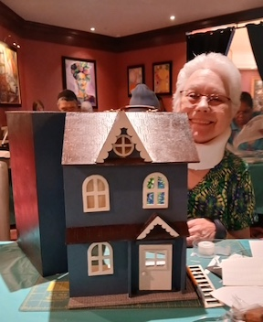
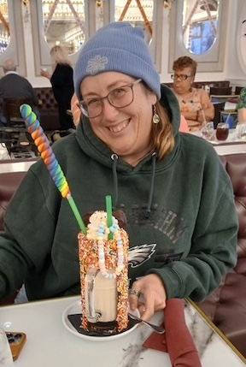
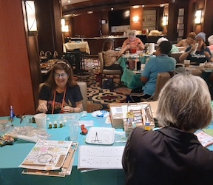
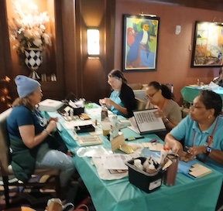
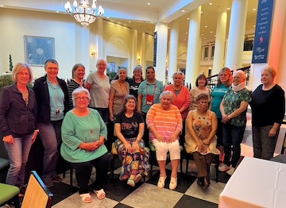

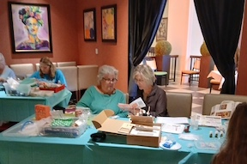
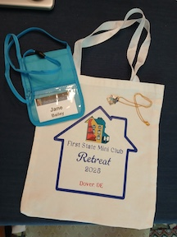

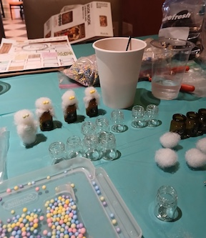
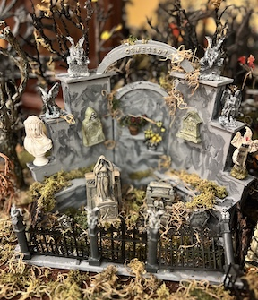

•••
ZOOM ACCESS TO IN-PERSON OCTOBER MEETING
Time: Oct 23, 2025 07:00 PM Eastern Time (US and Canada)
Join Zoom Meeting
https://us06web.zoom.us/j/86981471864?pwd=EbAjFFVcRTaArlwJC4uqb1aYUaaRAT.1
Meeting ID: 869 8147 1864
Passcode: 037910
•••
BIRTHDAYS
Happy October Birthday to Leslie Shaffner.
Angie Phillips, Membership
•••
OUR ACTIVITIES
People’s Choice: A Miniature Trip to Sesame Street
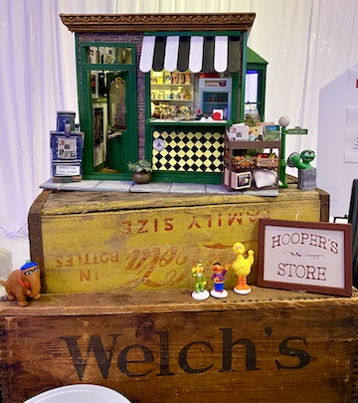
Sunny days, sweepin' the clouds away, on my way to where the air is sweet! 
This month, we're making a special trip down memory lane to Mary McCarthy's miniature re-creation of Hooper's Store on Sesame Street. The store and overall display featuring vintage crates were a big hit with People's Choice voters, earning Mary second place in the awards! Now, we're asking her all about it. Join us for a special Q&A with Mary to find out how she captured the magic of Sesame Street in miniature form.
Q: What is the name of your display and what inspired you to choose this subject?
A: Hooper’s Store. I was born in 1969, the same year Sesame Street began and I grew up watching it.
Q: What did you enjoy most about the project?
A: Falling in love with the process and creating many authentic details from the original Hooper’s Store from Sesame Street.
Q: Did you encounter any challenges in the process of making it?
A: This was my first completed mini build so I had to learn to use many tools and ran into many challenges!
Q. Did you use any or all the kit components?
A: I used every piece of the kit but learned the term “kit buster” because I completely modified and expanded the kit into the much larger concept of a vintage corner store.
Q: There is a lot to love about your market stall project, but two of my favorite components are the crates and the bay window. Can you tell me where you found the crates, and did you make or purchase the bay window?
A: I purchased the crates from various artists- I have a vintage wooden crate collection which is why my build was displayed on real ones, and I bought the bay window but it arrived late- two days before the show, so adding it was a bit of a construction challenge on my first build from scratch!
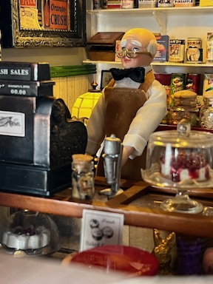
Q: Talk about any unusual items in your display.
A: There is a cigar box collection behind the counter because Mr. Hooper had one in his store, as well as Birdseed milkshakes for Big Bird which he also served. A framed photo of the original cast of Sesame Street appears on the wall. As a lifelong journalist it was fun to edit the “Sesame Street Times” newspaper with real articles that have appeared about the show over the years, including the appearance of Margaret Hamilton as the Wicked Witch of the West that scared children, etc.
Q: Care to share a brief how-to on an item that you made?
A: Patina was important to me; I aged all the interior and exterior surfaces with real dirt to give the building an aged appearance, and used real dead leaves from miniature scale plants to gather along the sides of the building. I made the awning out of popsicle sticks. Angela, who won first prize, helped me with a lot of construction support during my first build!
Q: Talk about your miniatures experience. How long have you been in the hobby?
A: I restored my childhood dollhouse for my daughter when she was born over 30 years ago which reignited my interest in the hobby. After I started my candle company during the pandemic, I started pouring miniature candles. I found my childhood dollhouse in the garage again in early 2024 prior to joining FSMC and started renovating a few rooms: a beachcomber’s lounge and a candlemaking studio. Then I built a miniature conservatory. My favorite things to make are miniature live plant arrangements and miniature gingerbread houses.
Q: I think the incredible level of detail in the store adds to its appeal. What kinds of items does Mr. Hooper sell?
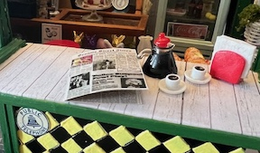
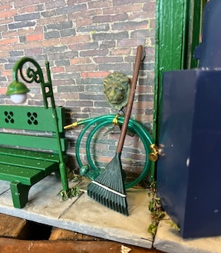
A: Since it was Easter at our show there are special Easter items and Hooper sells a variety of vintage groceries, more Easter eggs here include Campbell’s soup because my grandfather worked for the company, a can of “Blue Jay” (my daughter was the Blue Jay at Johns Hopkins and graduated the following month), and favorite products that helped me get through the build- like Doritos and Jack Daniels!
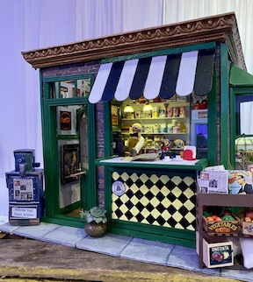
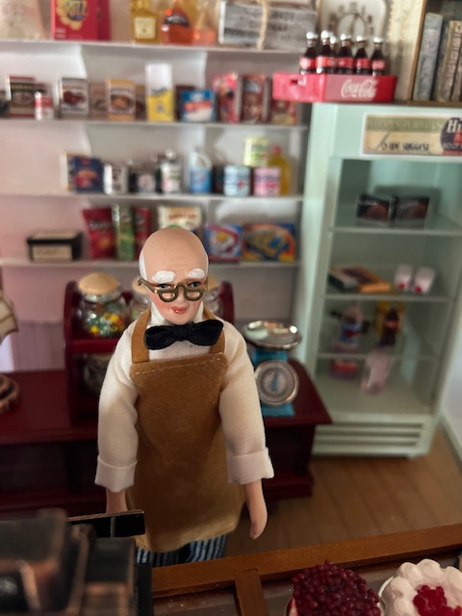

*****Anyone who would like to see their market stall project featured in a future newsletter, please contact me. My e-mail address is: oldhouseluvr@aol.com? I have one or two in the queue but I need several more to finish out the club year. Cyndi Charney
---
From Lois:
Five more Girl Scout troops have completed the Miniaturist badge this month. This program had been developed by Wanda Simons for the Chesapeake Bay Council but had been discontinued by the council 3 years ago. We have published instructions for these scenes in the Gazette for other clubs throughout the country to follow. We are now finishing up the remainder of the badges that FSMC had bought out from the council. Here are Ariana and Gianna of Troop 433, Kennett Square making camp scenes.
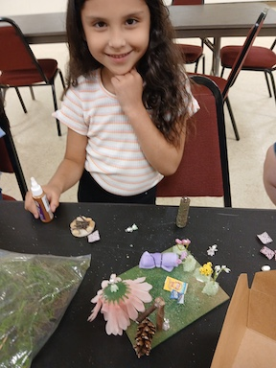
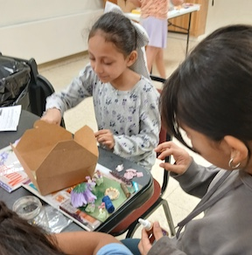

For Sale to club members
Dremel 14 in Table Saw, model 580: $25
Dremel Scroll Saw, model 571: $25
Dremel Moto-Lathe, model 700: $25
Black and Decker Workmate 8" Bench Top Work Center & Vise 79-025 and Dremel Motor Tool Holder: $25
There are no accessories to the above but all run. Reasonable offers will be considered.
I can bring them to the next meeting; any questions, you can contact me at 302-528-0181 or email me at dianaroy2@verizon.net.
Thanks, Diana DeWalt
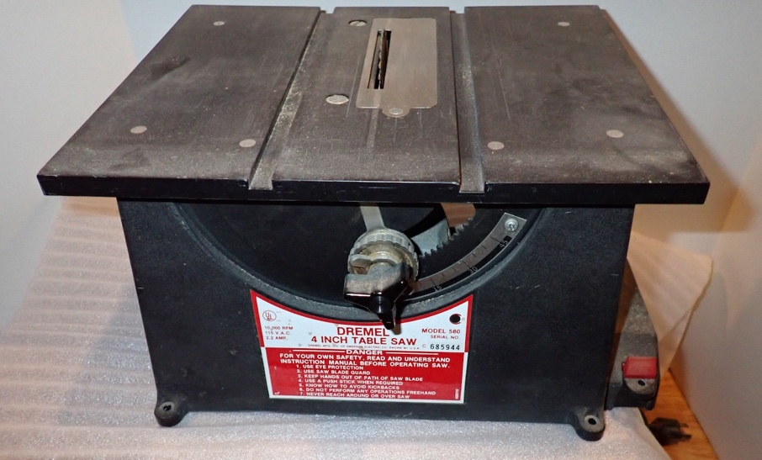
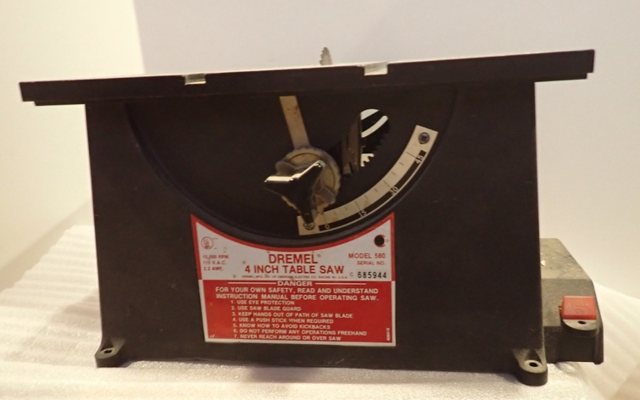
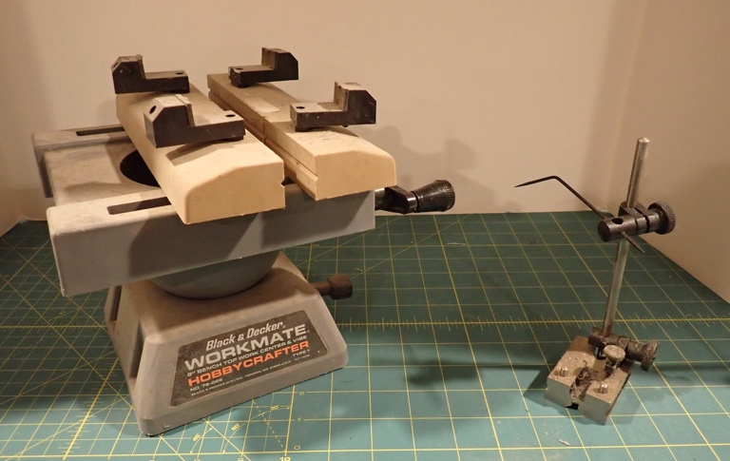
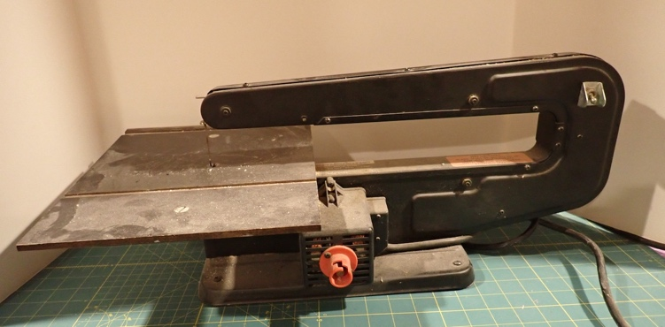

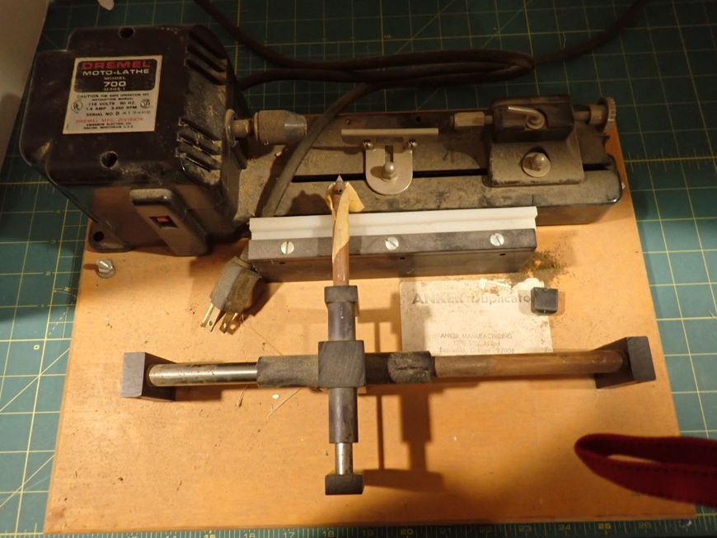
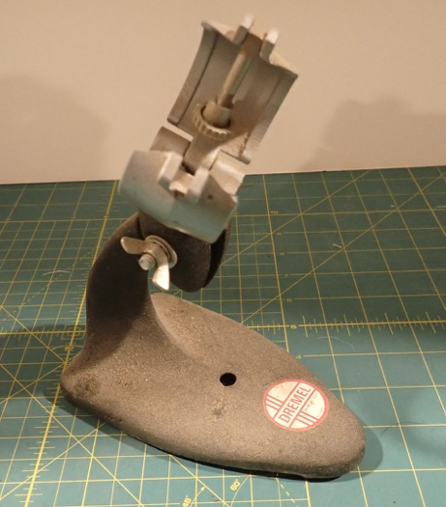

•••
CALENDAR OF EVENTS
NOVEMBER 7-9 – MINIATURIA, CHERRY HILL, NJ
NOVEMBER 15 - DELAWARE HOSPICE FESTIVAL OF TREES, WILMINGTON
NOVEMBER 20 - FSMC MEMBER IN-PERSON MEETING, NEW CASTLE SENIOR CENTER
DECEMBER 18 - FSMC MEMBER IN-PERSON MEETING, NEW CASTLE SENIOR CENTER
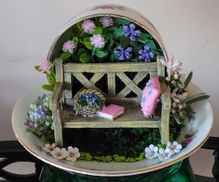
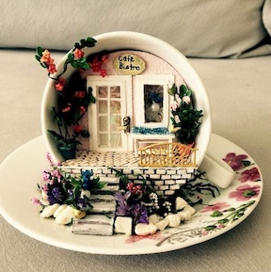
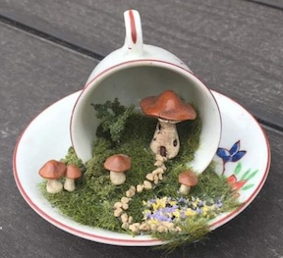
•••

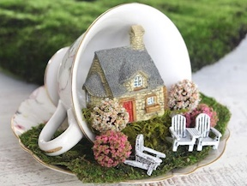

•••

FSMC Officers
President & Show Chair - Jane Bailey
Vice President, Membership & Newsletter Editor - Angie Phillips
Secretary - TBD
Treasurer, Webmaster - Lois Weyer with Cyndi Charney
State NAME Rep - Mary McCarthy
Program Chair & Exhibit Chair - Angela Hunt
Family News/Titbits Chair - DianeAlice Scheuer
Scholarship Program Chair & Handbook Committee Chair - Jane Bailey
New Show/Yard Sale Chair - Lynne Poindexter
Outreach Chair - Debbie Contravo
Publicity Committee Chair – Mary McCarthy

