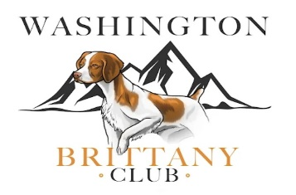
Washington Brittany Club
Membership Application

An affiliate of the American Brittany Club

Washington Brittany Club
12912 Silver Creek Dr. SE
Tenino, WA 98589
Phone: (253) 961-9529
http://wabrittanyclub.com

Full Member
Associate
Associate
Other ABC Membership
Address
City
State/Province
Zip Code
Member Email
Phone
Field Trial |  | Hunt Test |  | Show
Agility |  | Obedience/Rally |  | Training
Breeding |  | Brittany Rescue |  | Fun Day/Picnics

Registration Fees
Please indicate any other areas of interest
List name and ages of your Brittanys

Pay by Check to WBC  Print form and mail to: | The WBC Brittany Club 12912 Silver Creek Dr., Tenino, WA 98589
PayPal or Credit Card>>>  Email completed form to:  wabrittanyclub@gmail.com | >Pay Now> WBC Full Membership  >Pay Now> WBC Associate Member

Full Membership | $50.00 per/yr. |  | $
Assoc Member | $ 5.00 per/yr. |  | $
Total Due: |  |  | $

I hereby apply for Active Membership in the Washington Brittany Club (WBC), an affiliate of the American Brittany Club (ABC). Full US membership dues are $50.00 per year and carry an automatic membership in the American Brittany Club and will entitle you to the monthly magazine, The American Brittany. Application for an Associate Membership is available for $5.00 per year if a person is a Full member of another ABC Regional Club or the immediate family member of a Full member.
*For Canadian and/or foreign country applicants, contact us for the required dues

Membership in the Washington Brittany Club entitles a regular member to receive all communication and to vote in the American Brittany Club and the Washington Brittany Club Elections. Associate members may vote and hold office in the Washington Brittany Club. Club Member’s bitches are eligible to have their litters nominated for the American Brittany Club’s Futurity. The Washington Brittany Club holds meetings to discuss mutual problems, fun trials, training sessions and other events of interest to our members who are owners and enthusiast of the Brittany.

I agree to abide by the Constitution and By-Laws of the Washington Brittany Club.
_______________________________________________
Signed by

_______________________________________________
Date
_______________________________________________
Payment Options
Contact Information
Are you interested in:

