**FUN DAY!**

**What is it?** A day to bring your Brittany for some fun and meet other Brittany enthusiasts.

Activities include:

* a grooming demonstration

* try out Rally

* let your Brittany dive for hot dogs in the kiddie pool

* an introduction birds

* take a fun photo with your dog.

**When & Where?** Saturday, June 7 from 1 to 4 p.m.

12912 Silver Creek Drive, Tenino, WA 98589

**Cost? Free!**

**Snacks & Sodas will be provided**

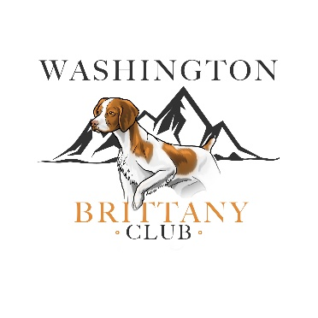 **Sponsored by the Washington Brittany Club**