Contents

Organisational structure 3

Directors Report 3

Activities 5

**Room Hire Facilities** 5

Projects and Partnerships 6

Community Engagement 7

Festivals 8

Membership 8

Website and Marketing 8

Finance 9

Conclusion 10

# Organisational structure

# Directors Report

**Ponders End Community Development Trust: Annual Report (July 2022 - June 2023)**

The Ponders End Community Development Trust has continued its mission to enhance community life, fostering a stronger, more vibrant environment for residents, workers, and students in Ponders End. Over the past year, our activities have remained focused on community development, offering a range of services, events, and projects that align with our vision of making Ponders End a better place to live, work, and study

Our year started by focusing on building capacity and we hosted a funders workshop run by the National Lottery and the Lottery heritage fund. Groups from all over Enfield came to learn about the funding opportunities available. We were able to speak to the funders ourselves and identified a funding stream that would help one of our existing projects. We were encouraged to apply as of July 2023 were still putting together our application. .

Our room hire activity is still has a steady flow of regular users we now have two new groups that offer Capoeira and yoga classes which adds to the Zumba and fitness classes on offer.

The café is still not opened as we had hoped but we are looking at setting up projects to get volunteers in to run community activities.

Overall it’s been a positive proactive year and has identified the need to form more partnerships is vital to meeting the needs of the local community.

M Drake (Chair)

# Activities

# Room Hire Facilities

Our room hire facilities have been pivotal in supporting the community's need for accessible space while also generating income to cover the Trust's operational costs. The Qube has been especially vital, hosting a diverse array of activities that benefit the local community. However, meeting rooms at Vincent House have seen a decline in popularity since the pandemic. Despite this, they have been effectively utilized by Community Aid for their advocacy services, ensuring that the space continues to serve important community needs.

# Projects and Partnerships

In March 2023, we were fortunate to secure £40,000 in funding from the People's Health Trust for our women's project, *Sisters In Mind*. This funding has enabled us to offer weekly hub sessions focused on arts and crafts, gardening, cooking, and health and well-being workshops. The project has seen continued success, with more women joining this unique support and development initiative. *Sisters In Mind* remains an organic and thriving environment where participants shape the project's direction, leading to the 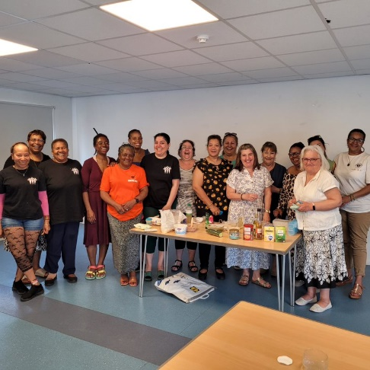formation of new friendships and connections.

Looking ahead, we are actively pursuing further funding from the National Lottery Community Fund. This additional support will help us to develop the infrastructure of the *Sisters In Mind* project, enabling us to enhance staff capabilities and peer support systems to meet the evolving needs of the women involved.

Our partnership work with Community Smiles continued over the past year to support local families suffering food poverty. Warm hubs were set up to offer a place where families could get a hot meal and a warm place to be during the winter months. We were also able to offer free meals to children during our summer festivals and subsidised the Christmas fair activities

# 

# Community Engagement

Our commitment to community engagement remains strong. Our Coordinator, Maria Aciyan, has chaired the CAPE (Community Action Panel Enfield) ward panel meetings, which are held six times a year. These meetings provide a platform for residents, local policing teams, and councillors to discuss crime and community safety issues. By setting shared priorities, we work together to create a safer Ponders End

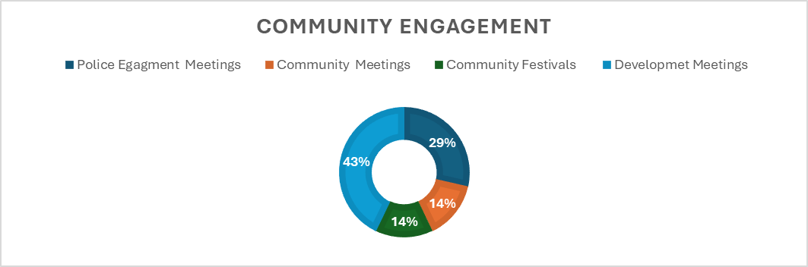.

In addition to these meetings, we have hosted community ward forums, which serve as another avenue for residents to engage with local council departments. Unfortunately, this year has been disappointing, as the current ward councillors have struggled to maintain regular meetings. We recognize the importance of this platform and are committed to improving communication and collaboration with the local authority to reinstate this essential service to its previous level of commitment.

As we approached summer we engaged with local stakeholders and Enfield council to address the issues of anti-social behaviour around the high street and Ponders End Park.

A plan of action was devised in partnership with friends of the park and the local council to create a list of actions that would improve the area.

# Festivals

Our summer and winter festivals, held at the Qube, were a highlight of the year. These events were designed to be affordable and accessible for families, particularly in an area where many face food and fuel poverty. The positive feedback we received underscores the importance of these community gatherings.

Despite the summer event being affected by torrential rain, the Qube's flexibility allowed us to move activities indoors, ensuring the event's success. As we look to the future, we plan to return to Ponders End Park for next year's festivals, reconnecting with the roots of these community celebrations. However, we continue to seek both physical and financial support to sustain these events as costs continue to rise.

# Membership

The Trust's structure is underpinned by a free membership scheme for local residents and organizations. This membership model helps us stay connected to the community and ensures that our activities are aligned with local needs and aspirations.

# Website and Marketing

One of the challenges we faced this year was the marketing and promotion of the Trust's activities. We recognize the need to improve in this area and are committed to addressing these issues through targeted training and volunteer recruitment in the coming year. Strengthening our online presence and communication channels will be a priority as we continue to expand our reach and impact within the community.

# Future Plans

PECDT realises the necessity to have space for the community to thrive. Our current facilities are reliant on good relationships with our local authorities and their willingness to engage and support the community. It is therefore important for us to work towards establishing a permanent space to continue our work supporting local people.

# 

# Finance

|  |  |  |  |  |  |  |  |  |
| --- | --- | --- | --- | --- | --- | --- | --- | --- |
|  |  |  |  | |  | 2023 |  | 2022 |
|  |  |  | Notes | |  | £ |  | £ |
| Fixed Assets |  |  |  | (4) |  | - |  | - |
|  |  |  |  |  |  |  |  |  |
|  |  |  |  |  |  |  |  |  |
| Current Assets: |  |  |  |  |  |  |  |  |
| Cash at bank and in hand |  |  |  |  |  | 59,845 |  | 66,005 |
| Debtors |  |  |  | (6) |  | 6,394 |  | 6,440 |
|  |  |  |  |  |  |  |  |  |
| Current Liability: |  |  |  |  |  |  |  |  |
| (amount falling due within one year) |  |  |  |  |  |  |  |  |
| Creditors and Accruals |  |  |  | (8) |  | 26,041 |  | 14,999 |
|  |  |  |  |  |  |  |  |  |
| Net Assets |  |  |  |  |  | 40,198 |  | 57,447 |
| As Represented By: |  |  |  |  |  |  |  |  |
| Restricted Fund |  |  |  | (7) |  | 13,401 |  | 6,556 |
| Unrestricted Fund |  |  |  |  |  | 26,796 |  | 50,891 |
| Total Funds |  |  |  |  |  | 40,198 |  | 57,447 |
| (The notes form part of this account) |  |  |  |  |  |  |  |  |

The directors are satisfied that the company is entitled to exemption from the provisions of the Companies Act 2006 (the Act) relating to the audit of the financial statements for the year by virtue of section 477, and that no member or members have requested an audit pursuant to section 476 of the Act.

The directors acknowledge their responsibilities for complying with the requirements of the Act with respect to accounting records and the preparation of financial statements

These financial statements have been prepared in accordance with the provisions applicable

The accounts were approved by the Directors on 21/03/2024 and signed on their behalf by: - M Drake

# Conclusion

The past year has been one of both challenges and successes for the Ponders End Community Development Trust. Our ongoing efforts to support and enhance community life in Ponders End have been met with positive outcomes, and we remain dedicated to our mission. As we move forward, we will continue to build on our achievements, address our challenges, and work tirelessly to make Ponders End a better place for all.

Top of Form

Bottom of Form