Nikki Dillard
Speaker Kit Companion
Revolutionizing how we love, connect, and commit.
Helping people design relationships with clarity, confidence, and choice, whether monogamy, polyamory, swinging, or beyond.

Mini Bio (1–2 sentences)
Nikki Dillard is the creator of Swinger’s Ed™ and a graduate student in Marriage & Family Therapy, helping people design intentional relationships with clarity, confidence, and the tools to sustain them.

Short Bio (~50 words)
Nikki Dillard is the founder of Swinger’s Ed™ and a graduate student in Marriage & Family Therapy with over 25 years of lived experience across diverse relationship structures. She blends therapy principles with a real-world perspective to help individuals and couples move past fantasy into intentional design, building relationships aligned with their authentic motivations.

Full Bio (~170 words)
Nikki Dillard is a Marriage & Family Therapy graduate student, relationship educator, and the unapologetic voice behind Swinger’s Ed™. With over 25 years of lived experience across monogamy, swinging, and polyamory, Nikki bridges the gap between therapy principles and the realities of modern relationships. Her work centers on three truths worth exploring before committing to any path: the difference between fantasy and reality, the importance of uncovering authentic motivations versus distraction, and whether a relationship has the strength to hold those truths. Known for her direct honesty, humor, and trauma-informed approach, Nikki creates conversations that are real, practical, and transformative. Through speaking, writing, and education, she helps people explore relationships without shame, align with their truth, and build partnerships rooted in trust, open communication, and intentional connection, regardless of the structure they choose.

Talk Blurbs

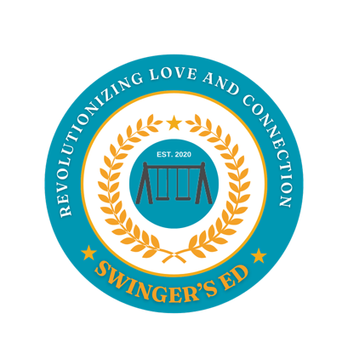
When Fantasy Meets Reality: The First Questions Couples Overlook
What happens when the fantasy of what a relationship could be collides with the reality of daily life? This talk unpacks the hard questions couples often avoid or don’t know who to ask, the ones that determine whether curiosity leads to collapse or deeper connection.

Desire or Distraction? Understanding Your Motivations
Are you in your relationship because you truly desire it, or because it distracts you from what’s missing? This talk helps audiences examine the motivations behind why they enter or stay in relationships, whether that means commitment in monogamy or opening up to something new.

Can Your Relationship Hold It? Assessing Capacity Before the Leap
Every relationship has limits. Whether it’s deepening intimacy in monogamy or expanding into non-monogamy, this session provides couples with practical tools to evaluate whether their partnership has the trust, communication, and alignment necessary to hold their vision before it cracks under pressure.

